**TASK 2 REPORT**

**Title:** Data Visualization.

**Description:** Customize Matplotlib plots with interactive widgets (e.g., sliders, buttons) using libraries like ipywidgets.

1. **Task Description:**

The task involves creating Interactive Sine Wave using ipywidgets. The user can adjust the wave's settings (amplitude, frequency, and phase) through sliders and reset the visual with a button. The workflow involves:

* + Creating sliders to manipulate the parameters of the wave (Amplitude, Frequency, Phase).
  + A plot of a sine wave that will change as the user enters the inputs.
  + Implementing a reset button to go back to default settings.

1. **Task output screenshot:**

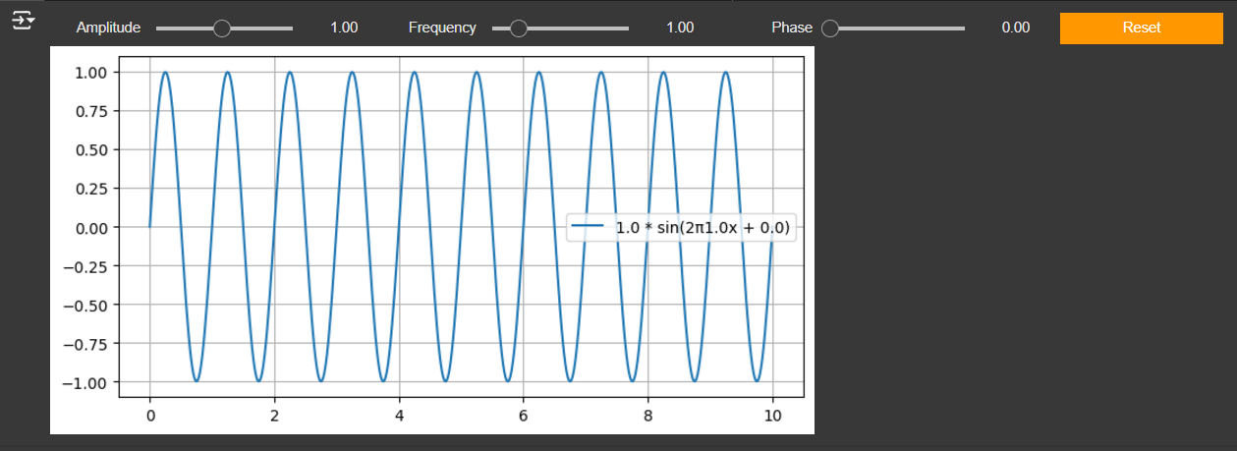

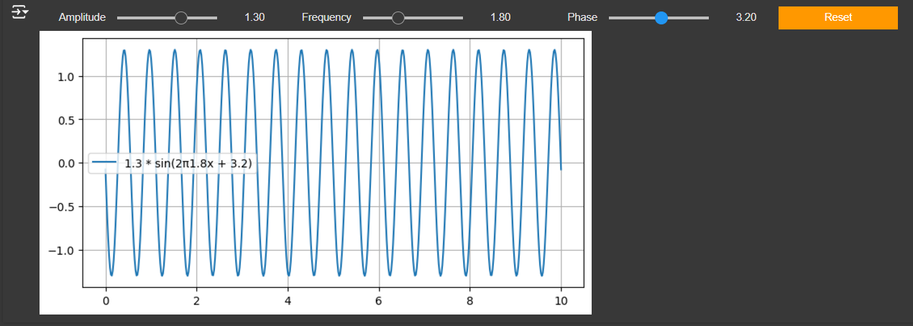

1. **Widgets/Algorithms used in task:**

* Sliders for adjusting Amplitude, Frequency, and Phase values dynamically.
* Button that resets all sliders to default values.
* Interactive that links the plotting function to the slider widgets for dynamic updates.