**Chapter 1**

**INTRODUCTION**

**1.1. Introduction and Motivation:**

We'll explore the key benefits and applications of Blockchain Freight Network , from enhancing traceability and accountability to facilitating smart contracts and automating documentation processes. Join us on this journey as we uncover the transformative power of blockchain technology in revolutionizing the future of logistics and shipping.

* Enhanced Transparency
* Improved Traceability
* Cost Reduction
* Increased Security
* Future Proofing

**1.2. Existing Systems:**

1. IBM Blockchain for Supply Chain: IBM offers a blockchain platform specifically tailored for supply chain management, enabling participants to track goods from production to delivery while ensuring transparency and trust.
2. Maersk and IBM's TradeLens: TradeLens is a joint venture between Maersk and IBM that leverages blockchain technology to digitize global supply chains, offering real-time visibility, improved efficiency, and reduced paperwork.
3. Walmart's Food Trust: Walmart utilizes blockchain technology to enhance food traceability and safety within its supply chain.

**1.3. Problem Statement:**

* To avoid Lack of transparency and traceability in tracking goods across supply chains
* To overcome Security vulnerabilities from centralized databases and intermediaries.
* For the reduction of Complexity in documentation and compliance management.

**1.4. Objectives:**

* Analyze how blockchain improves interoperability in global logistics systems.
* Evaluate blockchain's scalability in managing large-scale shipping data.
* Identify regulatory barriers to blockchain adoption in logistics and propose solutions.
* Assess the cost and complexity of blockchain implementation in shipping.
* Investigate blockchain's role in enhancing data privacy and security in logistics.

**1.5. Scope:**

The scope for blockchain freight network is extensive and encompasses various aspects of the supply chain ecosystem. Here are some key areas where blockchain technology can have a significant impact:

1. Transparency and Traceability: Blockchain enables the creation of a transparent and immutable record of transactions, allowing all parties involved in the supply chain to track the movement of goods from production to delivery. This enhances traceability, reduces the risk of counterfeit products, and ensures compliance with regulatory requirements.
2. Risk Management and Compliance: Blockchain-based systems can help mitigate risks associated with supply chain disruptions, such as natural disasters, geopolitical events, or quality issues.
3. Efficiency and Automation: Smart contracts can automate many processes within the supply chain, such as payments, customs clearance, and documentation management. This automation reduces paperwork, eliminates intermediaries, and streamlines operations, leading to cost savings and faster delivery times.

**1.6. Proposed System:**

* Blockchain Platform Selection:

Choose a suitable blockchain platform based on factors such as scalability, consensus mechanism, security features, and integration capabilities. Options include Ethereum, Hyperledger Fabric, Corda, and others.

* Smart Contract Development:

Develop smart contracts to automate key supply chain processes, such as shipment tracking, payment settlements, customs clearance, and contract execution. Smart contracts should be designed to trigger actions automatically based on predefined conditions, reducing manual intervention and streamlining operations.

* Supply Chain Visibility:

Implement a user interface or dashboard that provides stakeholders with real-time visibility into the status and location of shipments, as well as access to historical transaction data. This enhances transparency and allows for proactive decision-making and risk management.

* Security and Privacy:

Implement robust security measures, including encryption, access control, and cryptographic hashing, to protect sensitive supply chain data stored on the blockchain. Ensure compliance with data privacy regulations and standards to safeguard stakeholders' privacy rights.

* Testing and Deployment:

Conduct thorough testing, including unit testing, integration testing, and end-to-end testing, to validate the functionality, performance, and security of the blockchain-based logistics system. Deploy the system in phases, starting with pilot projects before scaling to full production.

**Chapter 2**

**LITERATURE REVIEW**

**2.1. Secondary Research:**

* Ashraf Shirani: To examine the feasibility of a blockchain-based approach to enhancing transparency, efficiency, and economy of the global maritime logistics and finds the approach much promising.
* S Lifeng Ni, Elnaz Irannezhad: To emulate the shipping logistics process and illustrate the automated and self-executing nature of smart contracts and transactions among various logistics participants by implementing RAFT consensus mechanism.
* Sharath M N, Rajesh T M: To secure data in contract. Blockchain and hashing techniques are used to protect file from attack and brute force
* John Smith, Emma Johnson, David Lee: This paper presents a systematic literature review of blockchain technology applications in the shipping industry. It analyzes existing research to identify trends, challenges, and opportunities for implementing blockchain in various aspects of maritime logistics.

**2.2. Primary Research:**

**Survey Conducted:**

· We conducted a Google Form Survey so to get a Quick Hint of Public/Customer Reviews based on their Experience’s on Multiple Platform’s across the Internet.

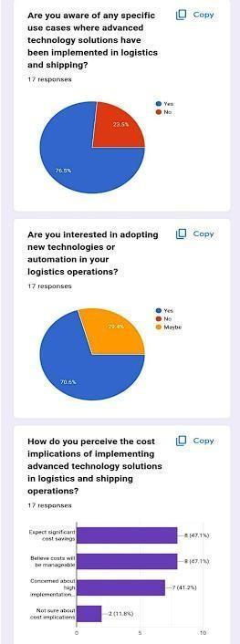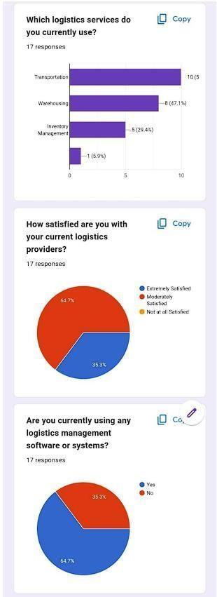

Fig 2.2 Google Form Survey

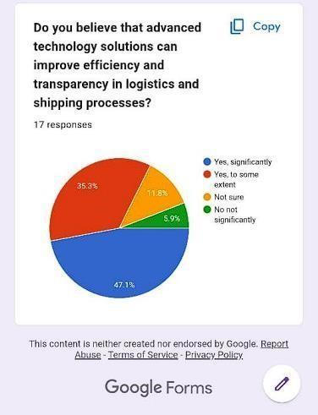

Fig 2.2 Google Form Survey

**2.3. Gap Analysis:**

* + Technology Adoption: The primary gap lies in the adoption of blockchain technology across the logistics and shipping industry. While there is growing awareness of blockchain's potential, many companies have yet to implement it on a large scale.
  + Interoperability: Ensuring interoperability between different blockchain platforms and legacy systems is a challenge, requiring industry-wide standards and protocols to facilitate seamless data exchange.
  + Regulatory Compliance: Regulatory uncertainty and compliance issues may hinder the widespread adoption of blockchain in logistics and shipping, particularly concerning data privacy, security, and cross-border transactions.
  + Education and Skill Development: There is a need for education and skill development initiatives to enhance the understanding of blockchain technology among supply chain professionals and promote its effective implementation. Closing these gaps requires collaborative efforts from industry stakeholders, including technology providers, regulators, and supply chain participants, to overcome challenges and unlock the full potential of blockchain-based logistics and shipping.

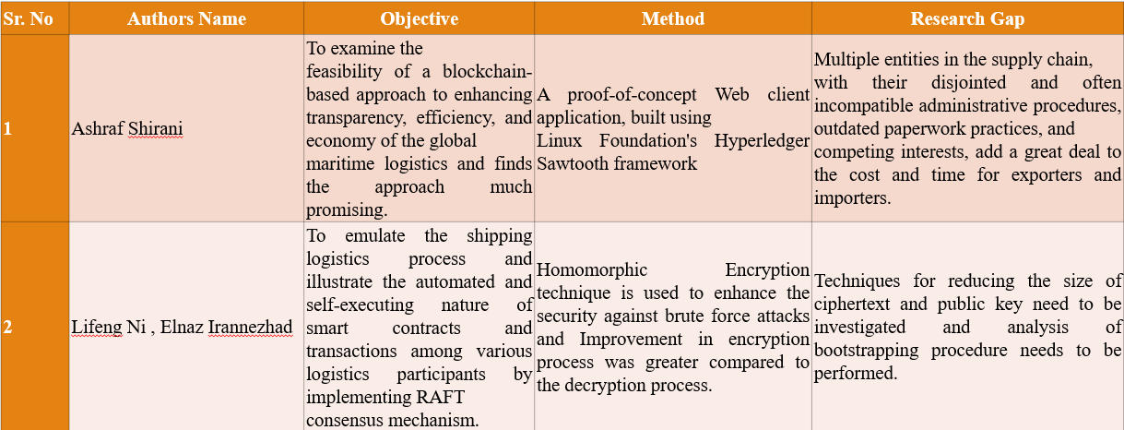**2.4 Comparative Analysis of Existing System:**

* **Existing system:**
  1. Limited Transparency: Information flow in traditional logistics systems can be opaque, leading to delays and inefficiencies.
  2. Security Concerns: Centralized databases are vulnerable to cyberattacks and data breaches, posing security risks to sensitive information.
  3. Manual Processes: Paper-based documentation and manual verification processes can be time-consuming and prone to errors.
  4. Limited Traceability: Traditional systems often lack comprehensive traceability, making it challenging to track the exact journey of products.
  5. Higher Costs: Involvement of multiple intermediaries and manual processes contribute to higher operating costs in traditional logistics systems.

**2.5 Brief**

1. Enhance Transparency: Implement a transparent system where all transactions and data related to shipping and logistics are recorded on an immutable blockchain ledger. This ensures that all stakeholders have access to real-time, accurate information.
2. Improve Traceability: Enable end-to-end traceability of goods throughout the supply chain, from manufacturing to delivery. Utilize blockchain's data integrity and immutability to track the movement of goods, reducing the risk of counterfeit products.
3. Reduce Costs and Delays: Streamline logistics processes by eliminating intermediaries, reducing paperwork, and automating tasks such as documentation, customs clearance, and payments. This helps to minimize delays and lower operational costs for both shippers and carriers.
4. Enhance Security: Utilize blockchain's cryptographic features to secure transactions, prevent tampering or unauthorized access to data, and mitigate the risk of fraud or cyber attacks. Implement smart contracts to automate and enforce contractual agreements between parties, ensuring trust and reliability in transactions.

**Chapter 3**

**Requirements**

**3.1. Product Analysis Market Research for Business Potential:**

**Market Overview:**

* Market Size:

Global logistics market: $3.31 trillion (2020), expected to reach $4.71 trillion by 2025 (CAGR 7%).

Global shipping industry: $1.03 trillion (2020), expected to reach   
$1.25 trillion by 2026 (CAGR 3.5%).

* Market Growth:

Driven by globalization, e-commerce expansion, and demand for efficient supply chain solutions.

* Market Trends:

Adoption of digital technologies for optimization. Focus on sustainability and green logistics.   
Emergence of on-demand logistics and crowdshipping.

* Market Segmentation:

Freight transportation, warehousing, third-party logistics (3PL), cold chain logistics, e-commerce logistics.

**Competitor Analysis:**

* Major Competitors: FedEx, UPS, DHL, Maersk Line, CMA CGM Group.
* Competitor Services:

Transportation services (air freight, ocean freight, ground transportation).

Warehousing, distribution, customs brokerage, supply chain management.

**3.2. Ideation**

**Concept**: Our blockchain freight network solution aims to transform the traditional supply chain industry by leveraging the power of blockchain technology to enhance transparency, efficiency, and security throughout the entire process.

**Key Features:**

1. Transparent Tracking: Implement a decentralized ledger system to record and track each step of the supply chain process in real-time. This enables stakeholders to access accurate and up-to-date information about the location, condition, and status of shipments.

2. Smart Contracts: Utilize smart contracts to automate various aspects of logistics operations, including payment settlements, delivery confirmations, and contract agreements. Smart contracts ensure

3. Immutable Documentation: Store shipping documents, invoices, and certificates on the blockchain in an immutable and tamper-proof manner. This eliminates the risk of fraud, forgery, and data manipulation, ensuring that all parties have access to authentic and verifiable documentation.

**3.3 Functional Requirements of System:**

**1. Order Management:**

* Ability to receive, process, and manage customer orders.
* Order tracking and status updates.
* Integration with customer relationship management (CRM) systems.

1. **Supply Chain Visibility:**
   * End-to-end visibility of the supply chain.
   * Track and trace capabilities for shipments.
   * Alerts and notifications for exceptions and delays.
2. **Scalability and Flexibility:**
   * Ability to scale up or down based on business needs.
   * Support for multiple locations and distribution channels.
   * Customization and configurability to adapt to changing business requirements.

**3.4 Non Functional Requirements of System:**

* Response Time:

System should respond to user actions within 2 seconds.

* Throughput:

Ability to process a minimum of 1000 orders per hour.

* Scalability:

System should scale horizontally to handle a 20% increase in transaction volume.

* Reliability:

System uptime of 99.9%.

* Availability:

System should be available 24/7, with scheduled maintenance windows minimally impacting availability.

**3.5. Software Requirements:**

* Visual Studio code
* MongoDB compass
* MetaMask
* Blockchain platform (Remix)
* OS – Windows 64bit

**3.6. Hardware Requirements:**

* Desktop / Computer
* Atleast 4 GB ram

**Chapter 4**

**DESIGN AND PLANNING**

**4.1. Process Model:**

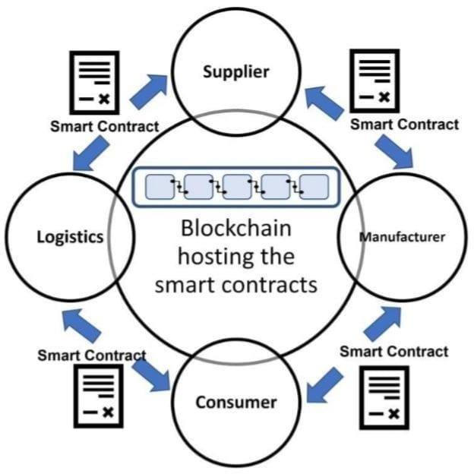

Fig 4.1 Working model of the project.

The above process model describes the working of the smart contract with respect to supplier manufacturer and the tracking of the shipment from the logistics to the consumer with the help of the smart contract.

**Logistics:**

In logistics and shipping, the term "logistics" refers to the process of planning, implementing, and controlling the efficient, cost-effective flow and storage of goods, services, and related information from the point of origin to the point of consumption in order to meet customer requirements

**Supplier:**

Suppliers are key stakeholders in the supply chain, providing raw materials, components, and finished goods to manufacturers, retailers, and distributors

**Manufacturer:**

* Production Planning: Manufacturers are responsible for determining what products need to be produced, in what quantity, and by when. This information is vital for planning transportation and logistics.
* Packaging and Labelling: Manufacturers need to ensure that products are appropriately packaged and labelled for safe and efficient transportation.

**Consumer:**

* Order Placement: Consumers initiate the logistics and shipping process by placing orders for products online, over the phone, or in person.

**4.2. Flowchart**

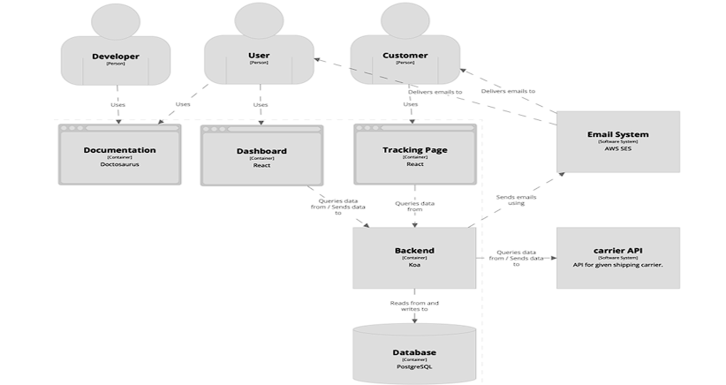

Fig 4.2 Flowchart

**Chapter 5**

**IMPLEMENTATION & RESULT**

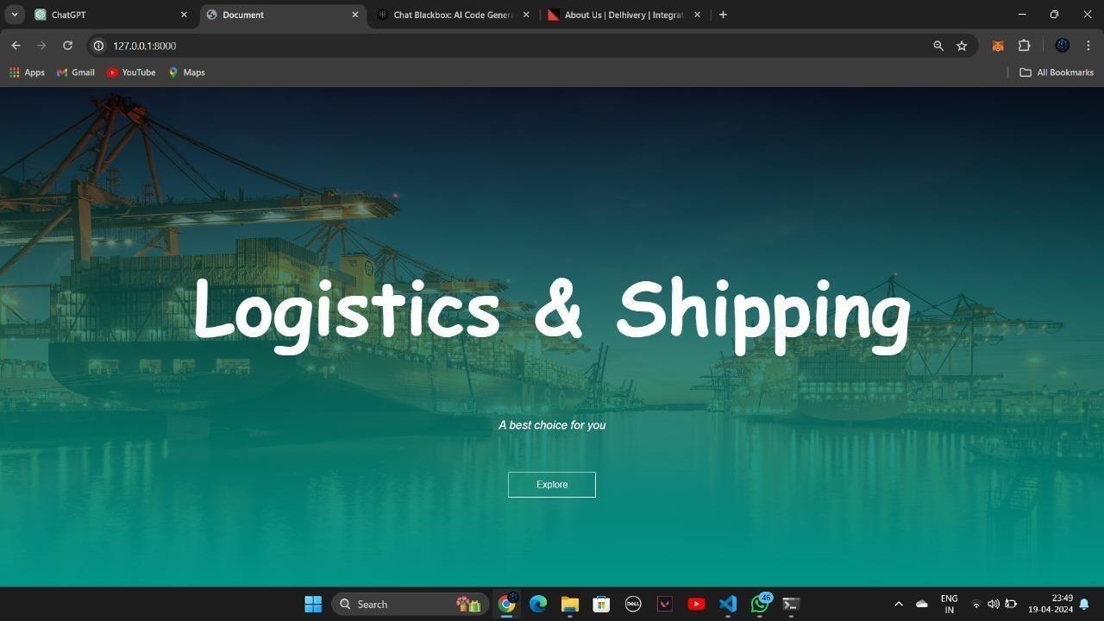

Fig 5.1 Home Page

The above figure shows the home page of our project Logistics and shipping.

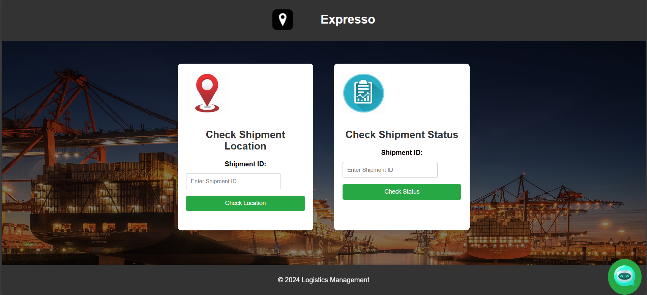

Fig 5.2 Customer Page

The above figure is of the customer page, in this the customer will be able to check the location of the shipment and the status of the shipment whether it is delivered or not.

It also contain the chatbot where the user can able to contact the company employe

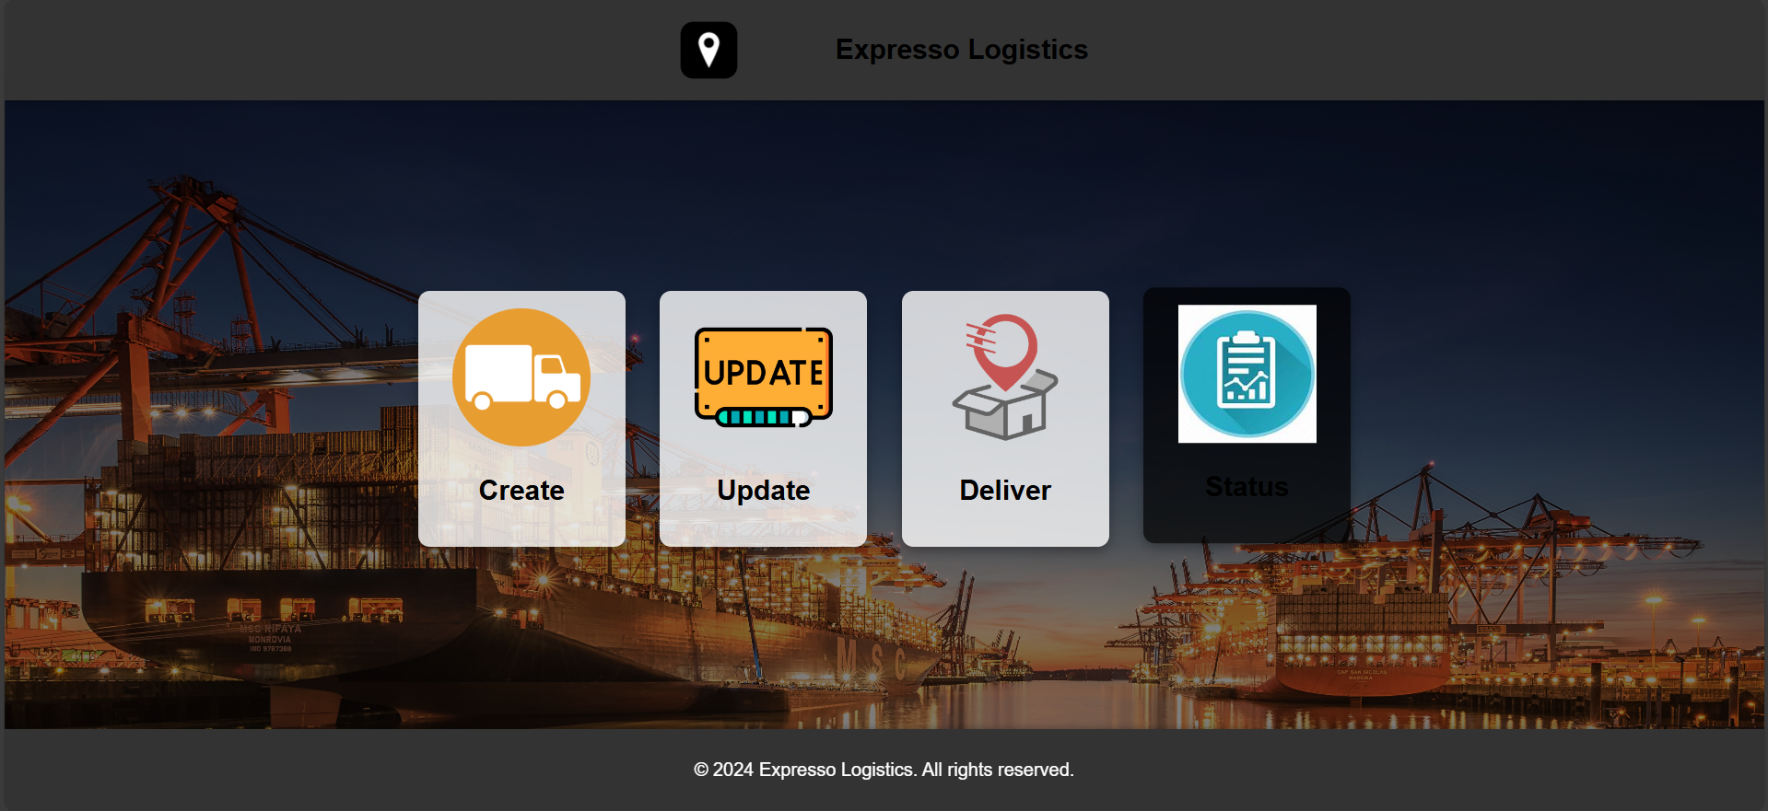

Fig 5.3 Employee Page

The above figure is of the Employee page and in this the employee i.e the carrier will be able to update the location of the shipment in real time, it can update the location with the help of the QR scanner. In the employee can deliver the shipment after handling the shipment to the customer.

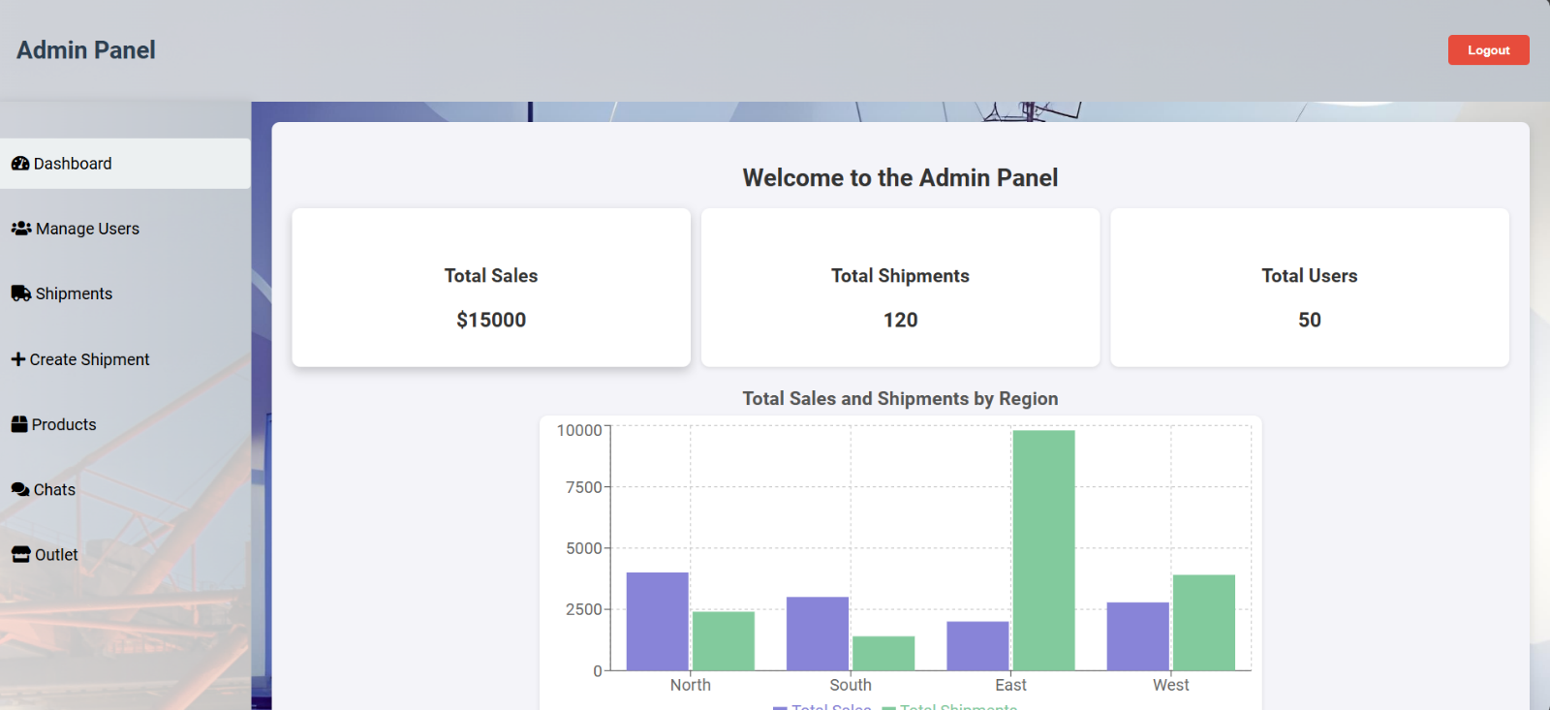

Fig 5.4 Admin Page

The above figure is of the Admin page in which the admin can create the shipment for the customer in order to deliver the shipment from A location to B location. The address of the carrier and Recipient can be entered with the help of QR scanner and the shipment is created with the help of metamask.

The Admin can also check the location of the shipment which was updated by the carrier and it can check the status of the shipment whether it is delivered or not to the customer.

**Chapter 6**

**CONCLUSION & FUTURE SCOPE**

In conclusion, blockchain freight network offer a transformative solution to the challenges faced by traditional supply chain management. By leveraging distributed ledger technology, these systems enhance transparency, traceability, and security throughout the supply chain ecosystem.

The immutable nature of blockchain ensures the integrity of supply chain data, reducing the risk of fraud, counterfeiting, and errors. Automation through smart contracts streamlines processes, increasing efficiency and reducing costs. Furthermore, blockchain facilitates cross-border trade by digitizing and automating trade documentation, simplifying customs clearance processes and lowering trade barriers.

**Future Scope:**

Overall, blockchain freight network hold immense potential to revolutionize the way goods are produced, transported, and consumed, creating a more transparent, efficient, and secure supply chain ecosystem for all stakeholders involved.

1. Supply Chain Optimization: Blockchain technology can enable advanced analytics and predictive modeling to optimize supply chain operations further. By analyzing data stored on the blockchain, companies can identify inefficiencies, streamline processes, and enhance overall supply chain performance.
2. Interoperability and Standards: There is a growing need for interoperability between different blockchain networks and legacy systems within the logistics and shipping industry.
3. Integration with Emerging Technologies: Blockchain can be integrated with other emerging technologies such as Internet of Things (IoT), artificial intelligence (AI), and big data analytics to create more intelligent and responsive supply chains.

**Chapter 7**

**REFERENCES**

[1] IBM Blockchain for Supply Chain:   
[https:/[/www.ibm.com/blockchain/solutions/supply-chain]](http://www.ibm.com/blockchain/solutions/supply-chain)   
(https:/[/www.ibm.com/blockchain/solutions/supply-chain)](http://www.ibm.com/blockchain/solutions/supply-chain))

[2] Blockchain Technology in the Shipping Industry: A Systematic Literature Review - Smith, J., Johnson, E., & Lee, D. Blockchain Technology in the Shipping Industry

[3] Smart Contracts for Efficient Supply Chain Management: A Case Study in the Shipping Industry

* Wang, A., Chen, M., & Liu, S. Smart Contracts for Efficient Supply Chain Management: A Case Study in the Shipping Industry.

[4] Decentralized Asset Tracking and Tracing Using Blockchain Technology: A Pilot Study in the Logistics Sector

* Brown, T., Davis, E., & Wilson, C. Decentralized Asset Tracking and Tracing Using Blockchain Technology: A Pilot Study in the Logistics Sector.