COSMETIC RESTORATION - Hand

Patient Registration Number

Cause of Amputation

Type – Pre Fabricated Customised

Skin Code for – Palmar Side Dorsal Side. Knuckles

Hand Casting – Alginate Other

Hand Measurements –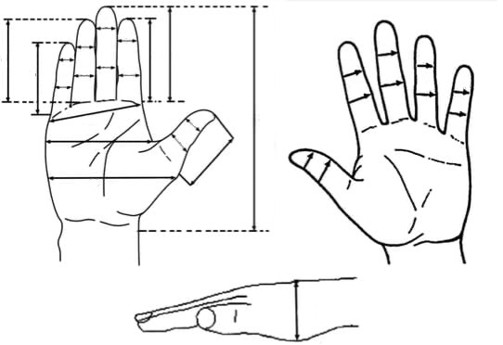

Circumferential Measurements

At wrist level

2 cm above wrist

4 cm above wrist

At metacarpophalangeal level

DIP - 1 2 3 4 5

PIP - 1 2 3 4 5

Linear Measurements

Wrist crease to tip of middle finger

MCP to tip of finger - 1 2. 3 4 5

Picture of hand in sunlight

Hand Tracing