- ER Diagram.

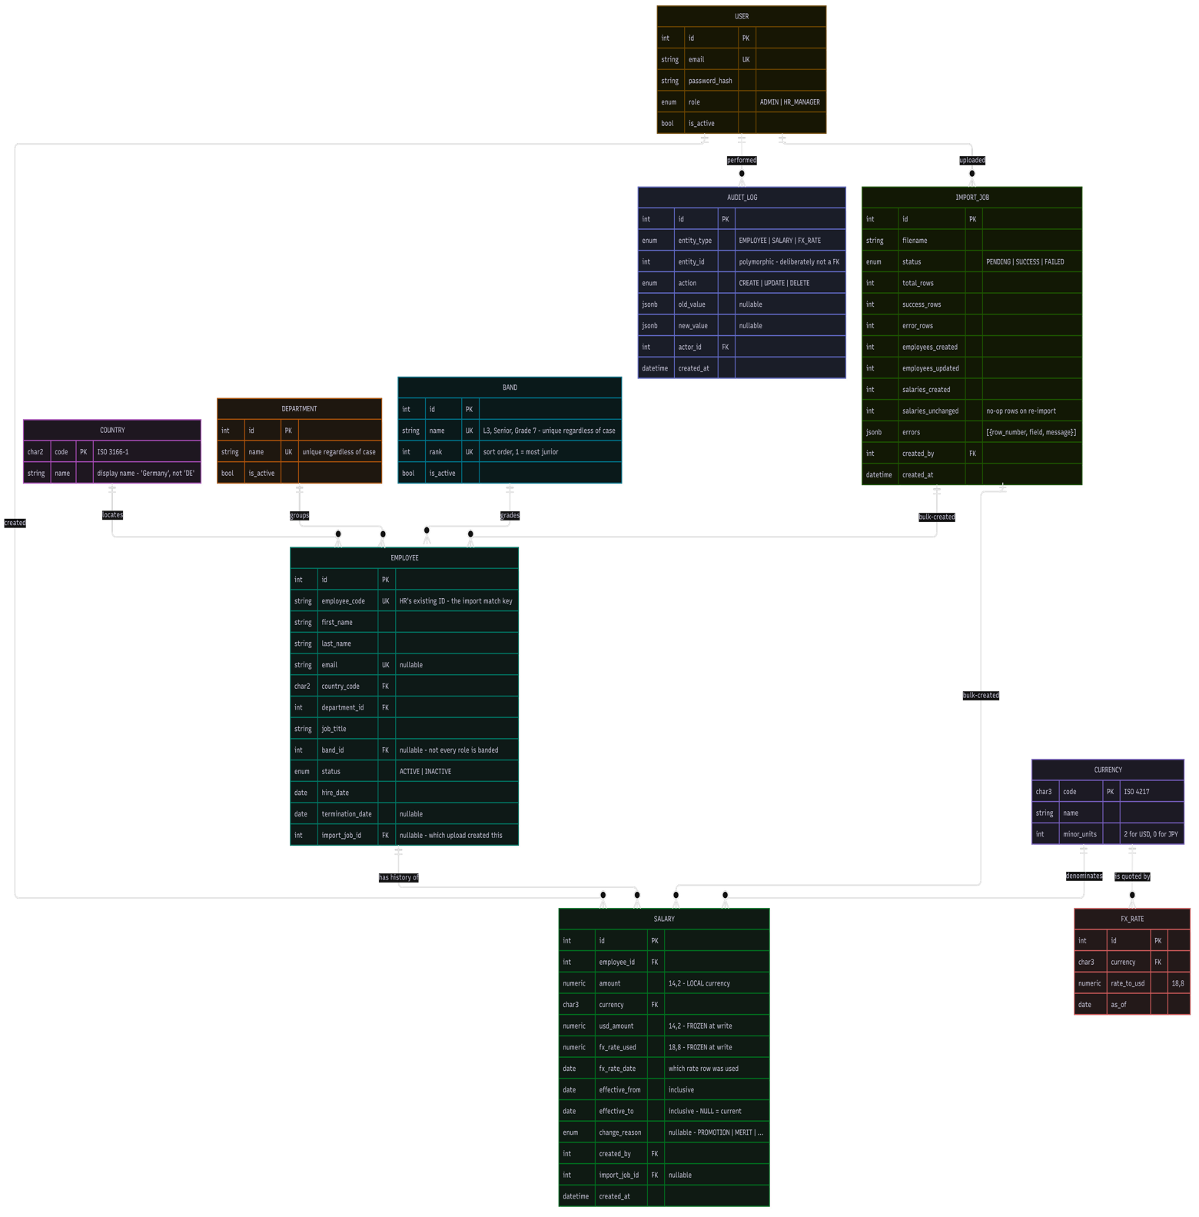

Relationship | Cardinality | Why it exists
Employee → Salary | 1: 0..N | Salary is a history, not a field. Exactly one row is open at a time. Zero, because an imported employee can exist before their pay is agreed.
Country → Employee | 1: 0..N | Validates import and gives the dashboard a display name
Department → Employee | 1: 0..N | Keeps dashboard grouping from splitting on Excel typos
Currency → Salary | 1: 0..N | The local currency the amount is stored in
Currency → FxRate | 1: 0..N | One rate series per currency, one rate per day
User → Salary (created_by) | 1: 0..N | Who entered the figure — a business fact
User → Audit Log (actor_id) | 1: 0..N | Who made the change — a compliance fact
User → ImportJob | 1: 0..N | Who uploaded the file
ImportJob → Employee | 1: 0..N | Import creates employees, not just salaries — the only viable migration path
ImportJob → Salary | 1: 0..N | "Which rows did that file create"
Band → Employee | 1: 0..N | Pay grade. Nullable, because contractors and executives often sit outside the banding system. Carries an explicit rank, since L1, L10, L11, L2 is how text sorts and a band chart in that order is unreadable.
FxRate → Salary | none | Deliberately no foreign key. The rate is copied onto the salary row, not referenced. A reference would let an edited rate change a historical figure — the thing this whole design exists to prevent.

Table Structures
Nine tables. Three are small static reference tables; the rest carry the data. PK = primary key, FK = foreign key, UK = unique key.
COUNTRY

Column | Type | Notes
code | CHAR(2) | PK. ISO 3166-1 alpha-2 — IN, DE, US.
name | VARCHAR(100) | Display name. The dashboard shows "Germany", not "DE".

DEPARTMENT

Column | Type | Notes
id | INT | PK.
name | VARCHAR(100) | UK, unique regardless of case. "Engineering" and "engineering" cannot coexist.
is_active | BOOLEAN | A retired department stays readable in historical reports.
BAND

Column | Type | Notes
id | INT | PK.
name | VARCHAR(50) | UK, unique regardless of case. L3, Senior, Grade 7 - whatever ACME already uses.
rank | INT | UK. Sort order, 1 is most junior. This is why band is a table and not an enum: bands are ordered and text is not, so a text column sorts L1, L10, L11, L2 and an average-pay-by-band chart in that order is meaningless.
is_active | BOOLEAN | A retired band stays readable in historical reports.
CURRENCY

Column | Type | Notes
code | CHAR(3) | PK. ISO 4217 alphabetic code — USD, INR, EUR, JPY.
name | VARCHAR(100) | "Indian Rupee".
minor_units | INT | Decimal places: 2 for USD, 0 for JPY, 3 for KWD. Drives display and catches cents in a zero-decimal currency.
EMPLOYEE

Column | Type | Notes
id | INT | PK.
employee_code | VARCHAR(50) | UK. The ID HR already uses in their spreadsheets, and the match key every import row is resolved by.
first_name | VARCHAR(100) | Required.
last_name | VARCHAR(100) | Required. Indexed lower-case for search.
email | VARCHAR(255) | UK, nullable.
country_code | CHAR(2) | FK to COUNTRY. The employing entity’s country.
department_id | INT | FK to DEPARTMENT.
job_title | VARCHAR(150) | Required.
band_id | INT | FK to BAND, nullable. Contractors and executives commonly sit outside a banding system; junk in a required field is worse than an empty one.
status | ENUM | ACTIVE | INACTIVE. Every payroll aggregate filters on ACTIVE.
hire_date | DATE | Required.
termination_date | DATE | Nullable, but required when status is INACTIVE. Setting it closes the open salary row in the same transaction.
import_job_id | INT | FK to IMPORT_JOB, nullable. Which upload created this row.
SALARY

Column | Type | Notes
id | INT | PK.
employee_id | INT | FK to EMPLOYEE.
amount | NUMERIC(14,3) | The figure, in the currency the employee is paid in. Never a float. Three decimal places because KWD, BHD, OMR and JOD have three minor units; at two, a Kuwaiti salary silently loses its last digit.
currency | CHAR(3) | FK to CURRENCY. What the employee is paid in — not inferred from country.
usd_amount | NUMERIC(14,2) | The same money in USD. FROZEN at write time; never recomputed.
fx_units_per_usd | NUMERIC(18,8) | The rate that did the conversion, FROZEN. Units of local currency per 1 USD, so usd_amount = amount / fx_units_per_usd.
fx_rate_date | DATE | Which FX_RATE row was used.
effective_from | DATE | Inclusive. The date this pay took effect.
effective_to | DATE | Inclusive. NULL means this is the current salary.
change_reason | ENUM | Nullable. NEW_HIRE | PROMOTION | MERIT | MARKET_ADJUSTMENT | CORRECTION | IMPORT.
created_by | INT | FK to USER. Who entered the figure.
import_job_id | INT | FK to IMPORT_JOB, nullable.
created_at | TIMESTAMP | Required.
FX_RATE

Column | Type | Notes
id | INT | PK.
currency | CHAR(3) | FK to CURRENCY. Unique together with as_of.
units_per_usd | NUMERIC(18,8) | 83.45 means 83.45 INR per 1 USD.
as_of | DATE | The date this rate applies from. Lookup takes the most recent rate on or before the salary date.
APP_USER

Column | Type | Notes
id | INT | PK.
external_id | VARCHAR(255) | UK. The Keycloak subject claim. Keyed on this rather than email, because people change email and an audit trail keyed on a mutable field is not an audit trail.
email | VARCHAR(255) | Copied from the token for display. Refreshed on login, deliberately not authoritative.
display_name | VARCHAR(200) | As above.
created_at | TIMESTAMPTZ | The row is created just-in-time on the first valid token for an unseen sub.
AUDIT_LOG

Column | Type | Notes
id | INT | PK.
entity_type | ENUM | EMPLOYEE | SALARY | FX_RATE.
entity_id | INT | Polymorphic, so deliberately not a foreign key. Only the audit service writes this table.
action | ENUM | CREATE | UPDATE | DELETE.
old_value | JSONB | Nullable. Decimals stored as strings so no precision is lost.
new_value | JSONB | Nullable.
actor_id | INT | FK to USER. Who made the change.
created_at | TIMESTAMP | Written in the same transaction as the change it describes.
IMPORT_JOB

Column | Type | Notes
id | INT | PK.
filename | VARCHAR(255) | As uploaded.
status | ENUM | PENDING | SUCCESS | FAILED.
total_rows | INT | Rows in the file.
success_rows | INT | Rows committed.
error_rows | INT | Rows rejected. If this is above zero, nothing was committed at all.
employees_created | INT | Reported separately, because "10,000 rows succeeded" does not say what happened to the data.
employees_updated | INT | An unexpected figure here during a pay review is the warning sign.
salaries_created | INT | New salary rows written.
salaries_unchanged | INT | Rows whose pay matched the current open row. No row written, no audit. This is what makes re-uploading an export safe.
errors | JSONB | [{row_number, field, message}] — precise enough to fix in Excel and re-upload.
created_by | INT | FK to USER.
created_at | TIMESTAMP | Required.

- Component Diagram

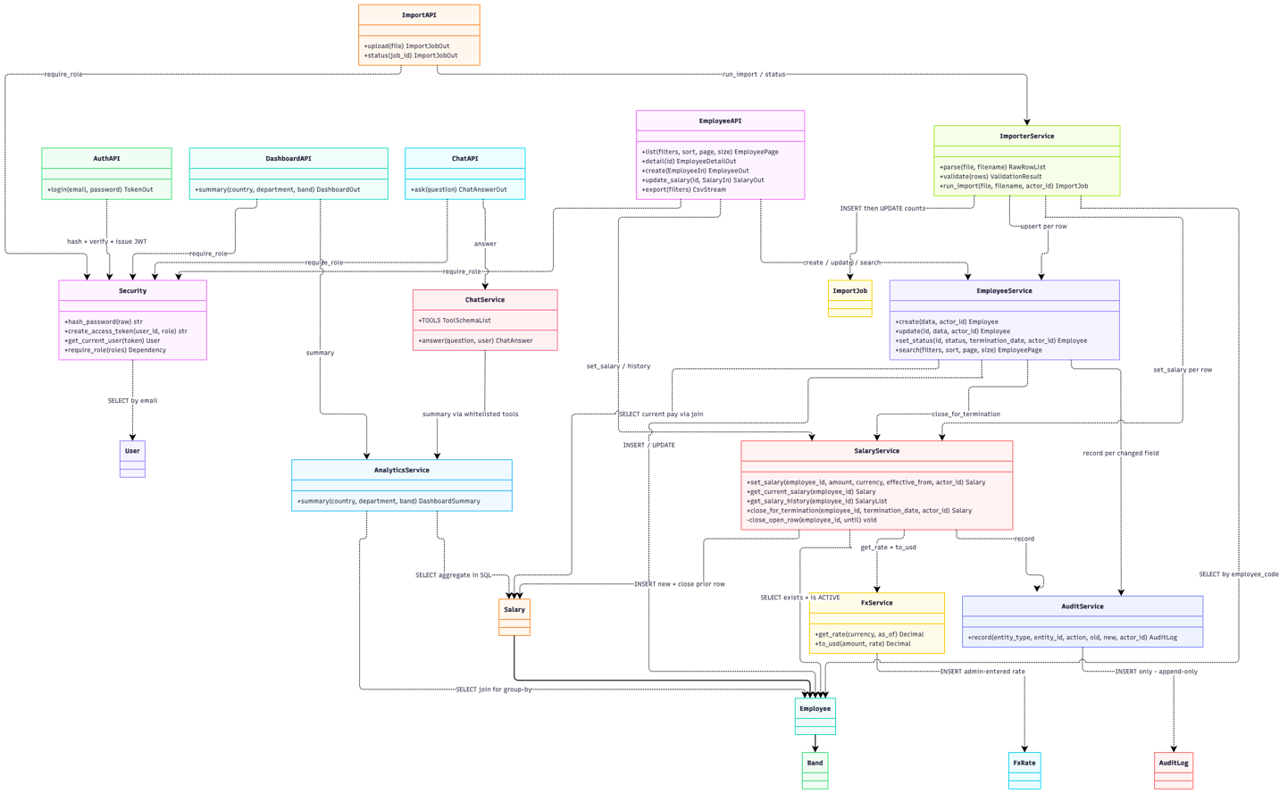

- Sequence Diagram Save Salary
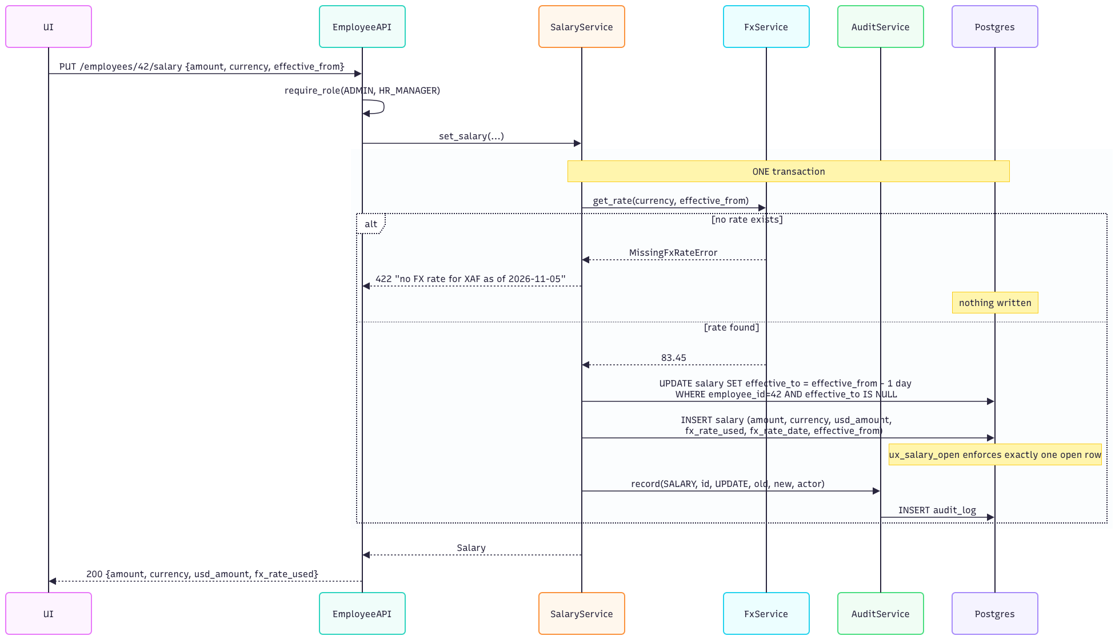

- Import Employee file


