1. Install GIT.

2. Project on https://github.com/gaurav1781/vicroad

3. Install VS Studio 2019 from https://visualstudio.microsoft.com/downloads/

4. Install following extensions in VS Studio

* 1. Install specflow : Extensions-> Manage extensions
  2. Project -> manage nuget packages -> Install Selenium webdriver
  3. Project -> manage nuget packages -> Install specrun.specflow
  4. Project -> manage nuget packages -> Install NUNIT3 adapter

5. Open the existing Git project from VS Studio:

5.1 Open VS Studio 2019

5.2 On the start window, select Clone a repository.

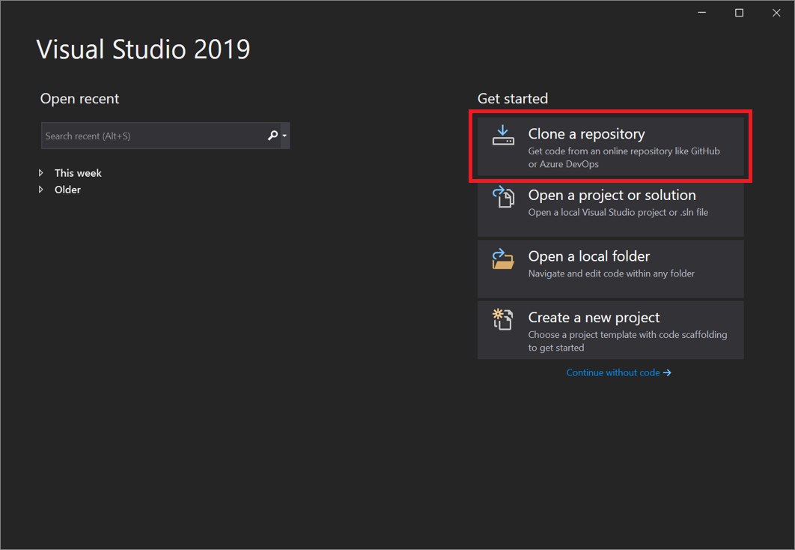

**5.3** Enter or type the repository location(https://github.com/gaurav1781/vicroad), and then select **Clone**.

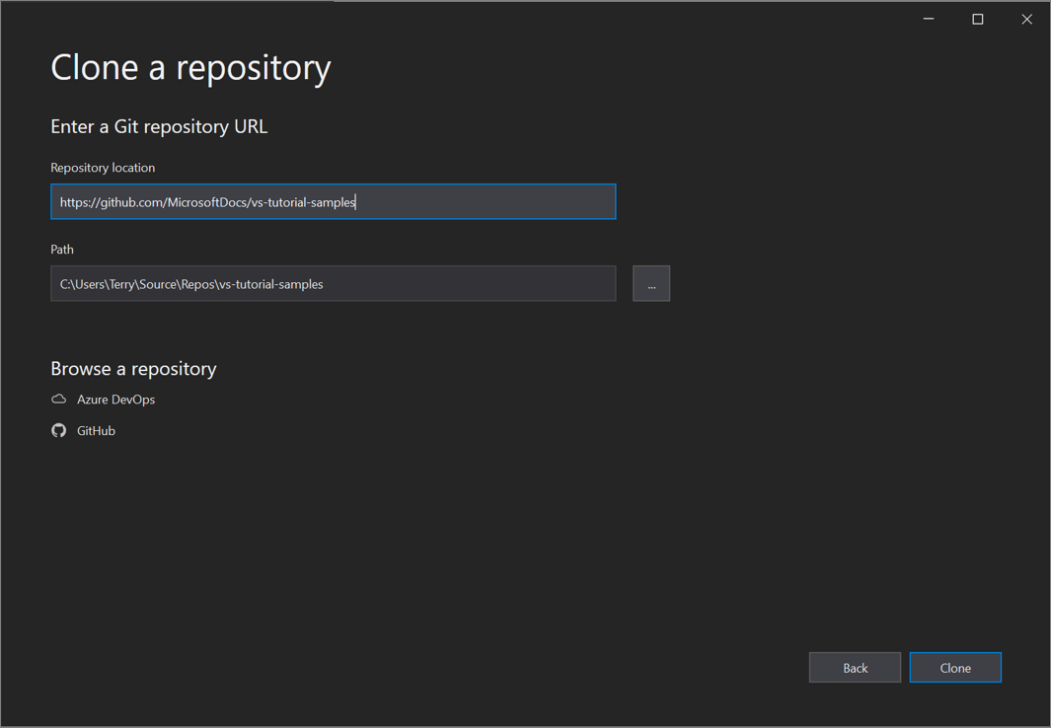

**5.4** You might be asked for your user sign-in information in the **Git User Information** dialog box. You can either add your information or edit the default information it provides.

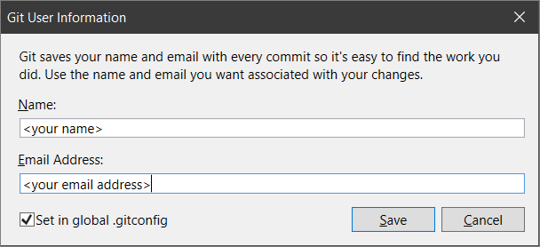

**5.5 Select save**

Next, Visual Studio automatically loads and opens the solution from the repository.

**6. Open your solution explorer.** 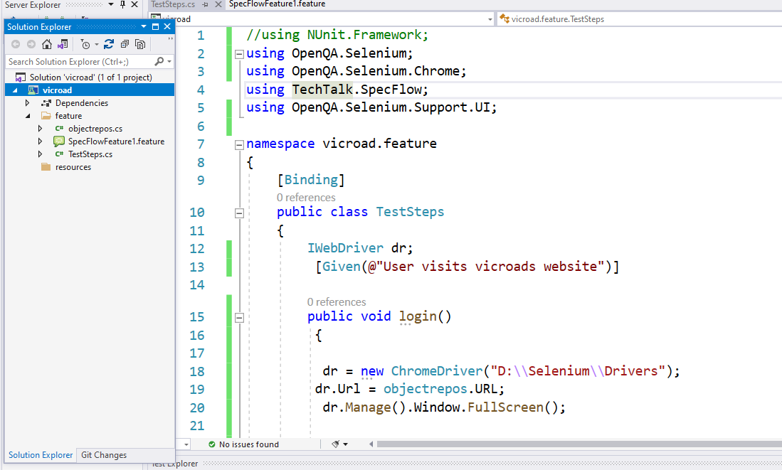

**7. System should have chrome v92.0**

**8. Change the path of chromedriver in the java program(testcase2.java-> line18) to wherever chromedriver is saved on local drive.**

**9. Run the project as JUNIT Test. Right click on project -> Run Tests**

**10. Verify results at your local drive path(Project Directory) : /vicroad/TestResults -> HTML Report and logs should be created showing results.**

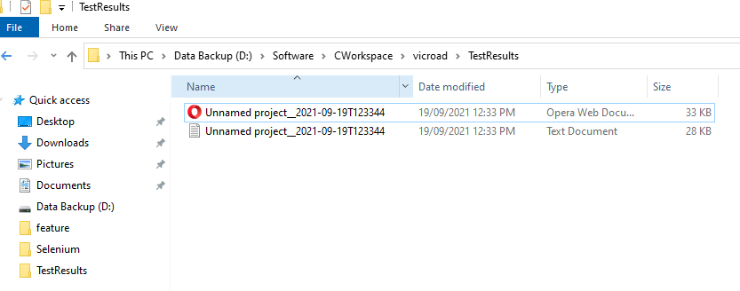

**HTML Report:**

