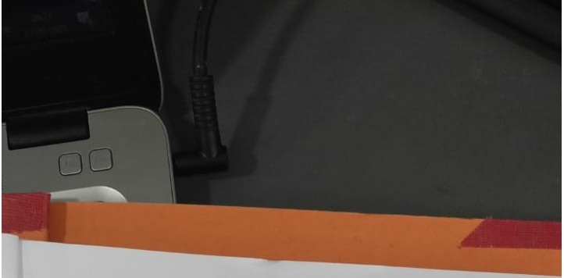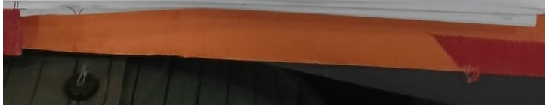

**Personal Profile**

|  |  |
| --- | --- |
| Nwne | Mr. Gaurav K. Mistry |
| Educational  OuaJification | lnfonnation & Technology (B.B.) Dioloma (T.T.) |
| Department | BCA |
| Industrial Experience | 3 Month |
| Work Experience | 2 Years 8 Month |
| Designation | Lab Assistant |
| Area of lnteres\ | Programming in C language, Web Designing- HTML,CSS,BOOTSTRAP, React JS, MondoDB,  Node JS. |
| Webinar *I* Seminar *I*  Achievement | * Attended webinar at Gujarat Technological University,on "Design Innovation Center". * Attended Webtnar on Ethical Hacking-Learn the Website Hacks and Provide Better Security. |
| Email-id | [gauravdodil'.a67 @gmail.com](mailto:gauravdodil%27.a67@gmail.com) |
| About Yourself | *Mr.* Gaurav Mistry has 2 years and 8 months of experience as a Lab Assistant. His expertise spans computer hardware, software installation, operating systems, lab practicals , performance evaluation, problem-solving, and program.ming. Additionally,he teaches practical subjects, providing students with hands-on learning experiences and technical |
| - --- guidance_._ -- -- - - | |