**How to Run Project manually through Eclipse:**

**Dependencies:**

1. Selenium Jars.
2. TestNG Library.
3. Eclipse or any other Java IDE.

**Summary :** Before running the project we have to export if from Git and add the dependent jars in eclipse IDE.

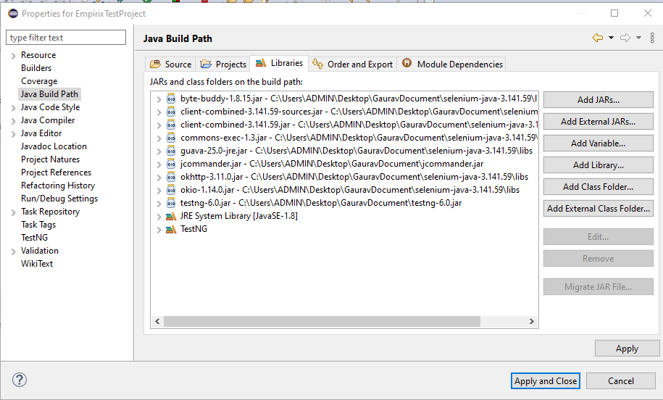

If we want to run it manually from IDE then there is testing.xml available in project location then click on right mouse button and run as a test NG suite available in the attached screenshot. 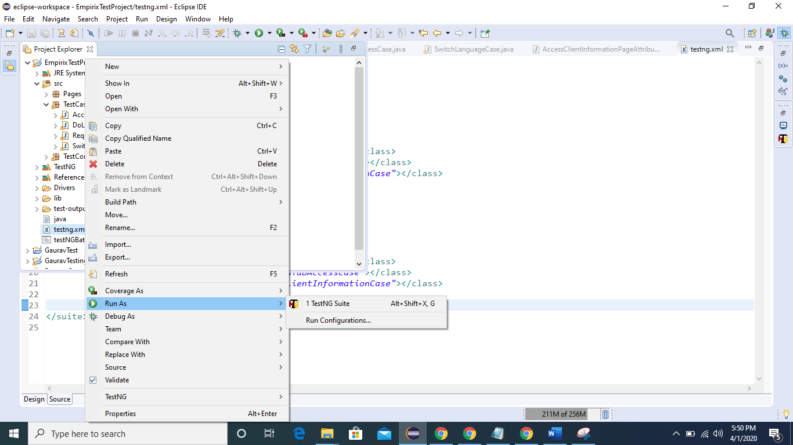

Once project will run then it will launch a respective browsers and if we want to run the testcases in parallel manner then we have to change the parrallel attribute available in <suite> tag and change it value to “tests”.

Or if we don’t want to run it parrallely then value should be none for parralel attribute. Available in attached screenshot.

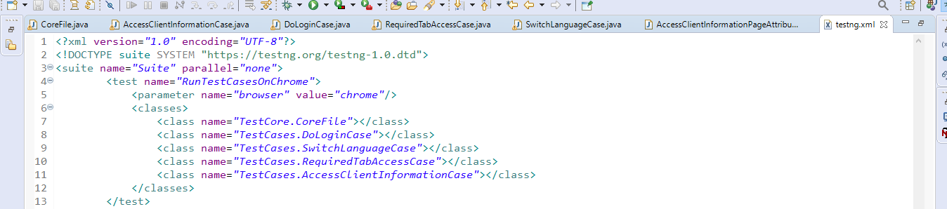

After running the cases it will give results in testNG Report format, available in project location inside test-output folder.

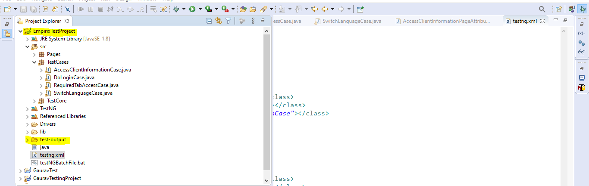

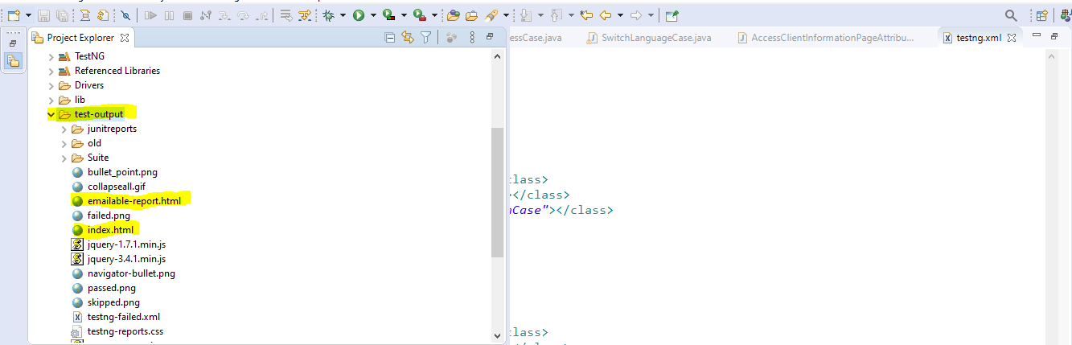

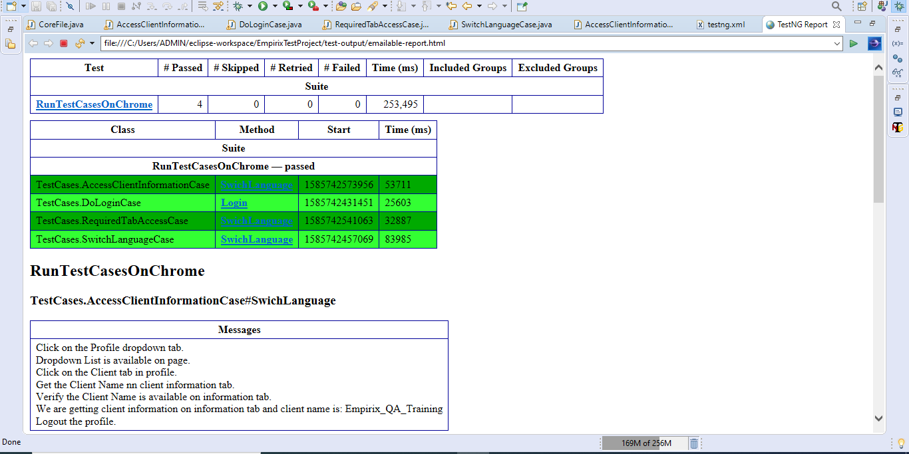

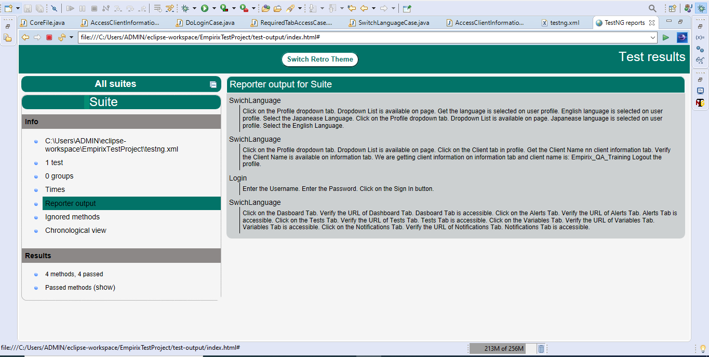

Report will show the Results whether Test Case is passed or not and it will show the respective messages.

**Integration of Automation suite through Jenkins:**

**Dependencies:**

1. Jenkins.
2. Create Batch File.
3. Jars (Available in attached screenshot)

**Summary:**  If we want to integrate our automation suite through Jenkins then we have to download or install it in our local system.

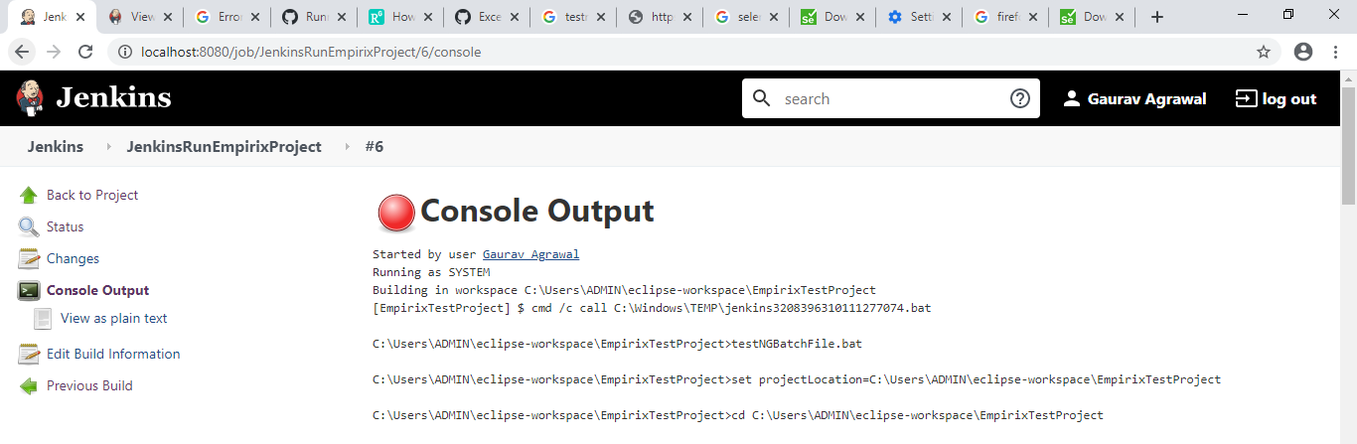

After installation and configuration, we need to create a job by clicking on “Create Job” link.

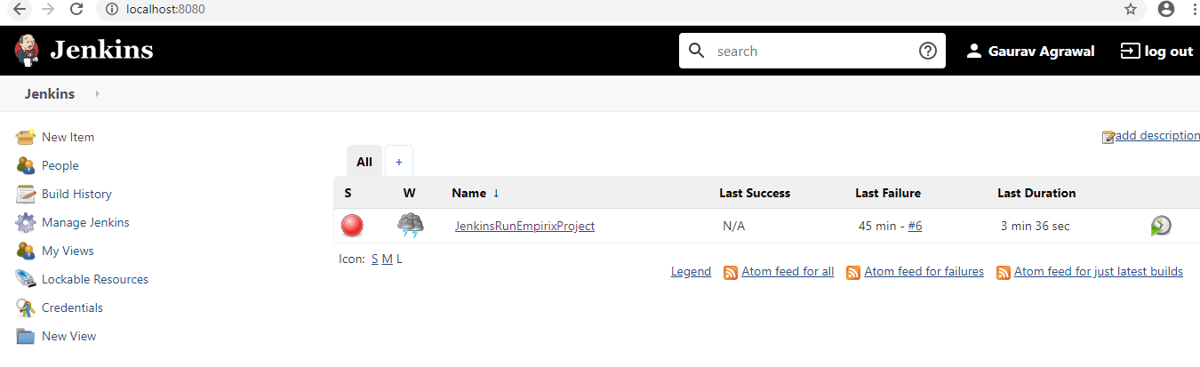

After creating job, we have to configure it:

1. Provide the project location path in “Use Custom Workspace” field. Available in the screenshot.

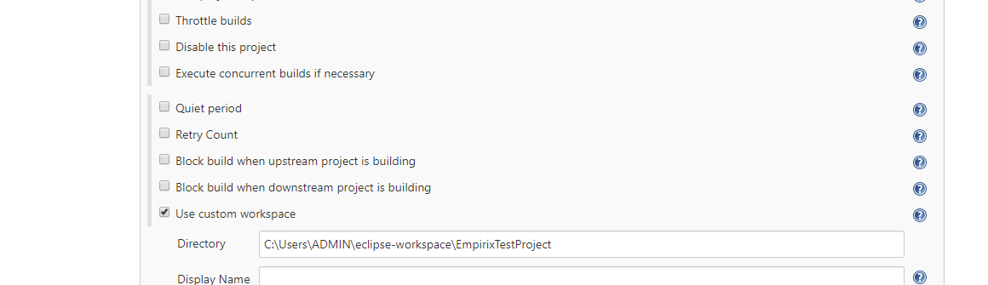

1. Provide the batch file name i.e. available in project location in Build tab. Screenshot is attached.

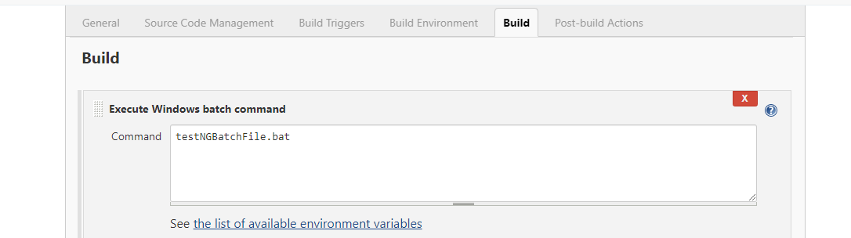

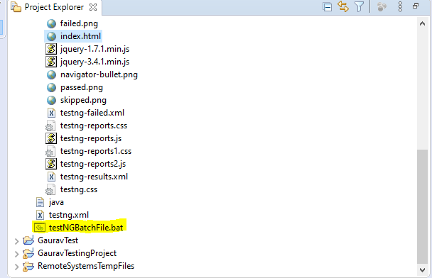

This batch file contain the project location and libraries which we need to run it on integration.

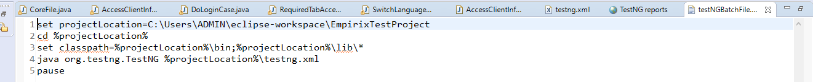

And libraries are available in lib folder in project location.

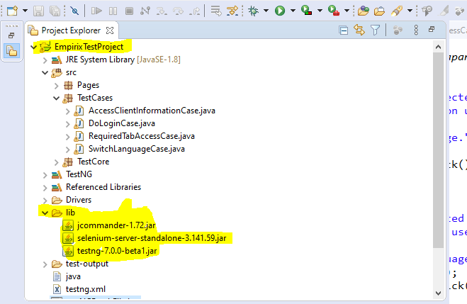

If we want to run our suite through Jenkins then click on Build button.

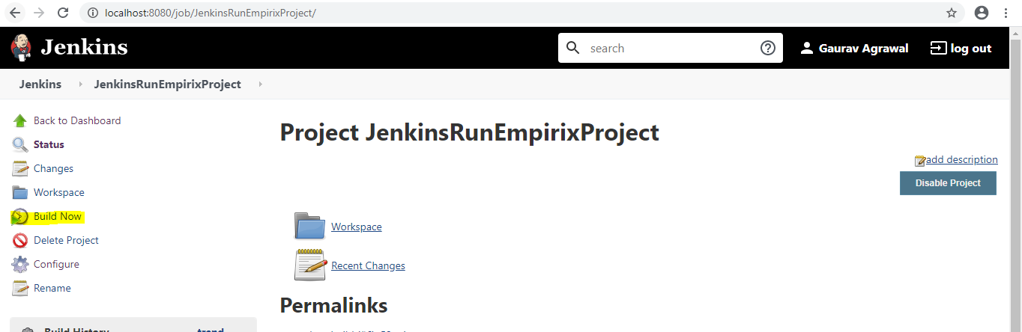

And if we want to verify the output result then click on console out and verify the logs.

