# PRACTICAL 7

Name: Gaurav Nilawar

Batch& Roll_no.: B3 37

AIM: Implementation of SIFT, SURF and Canny for edge detection THEORY:

SIFT (Scale-Invariant Feature Transform): Detects and describes keypoints in an image using Difference of Gaussians (DoG), making it scale- and rotation-invariant.

SURF (Speeded-Up Robust Features): A faster alternative to SIFT, using the Hessian matrix and integral images for efficient keypoint detection.

Canny Edge Detection: Identifies edges by smoothing, gradient detection, non-maximum

suppression, double thresholding, and hysteresis, ensuring accurate and noise-resistant edge detection.

# CODE:

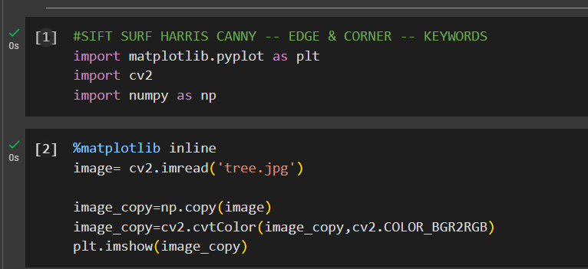

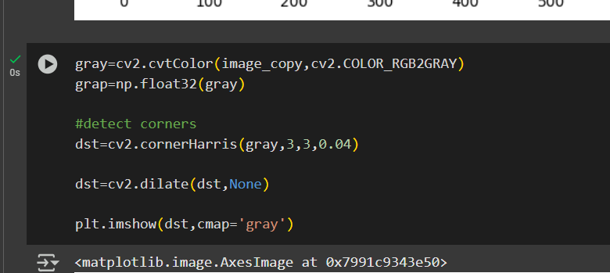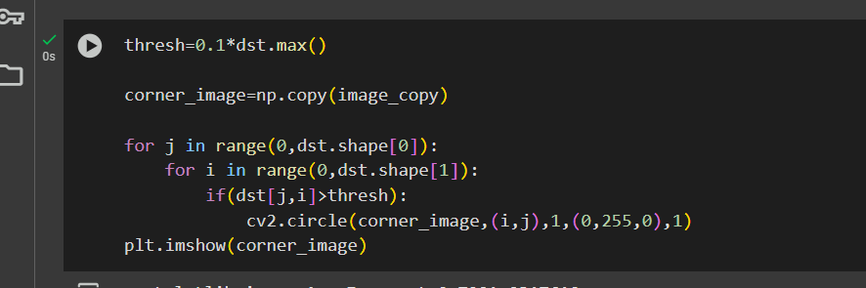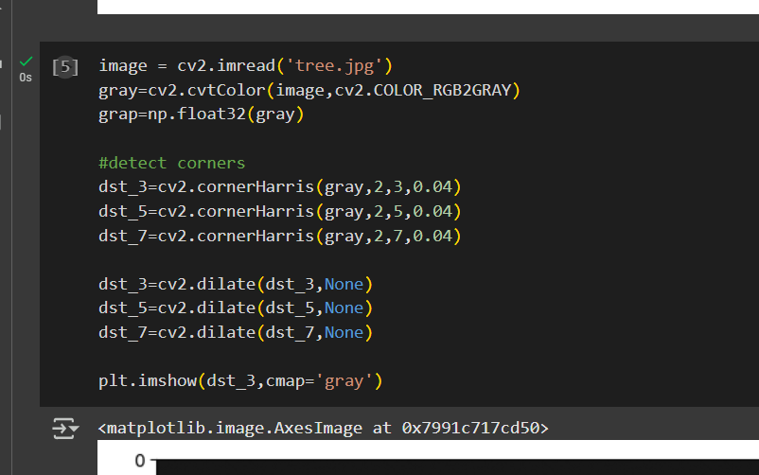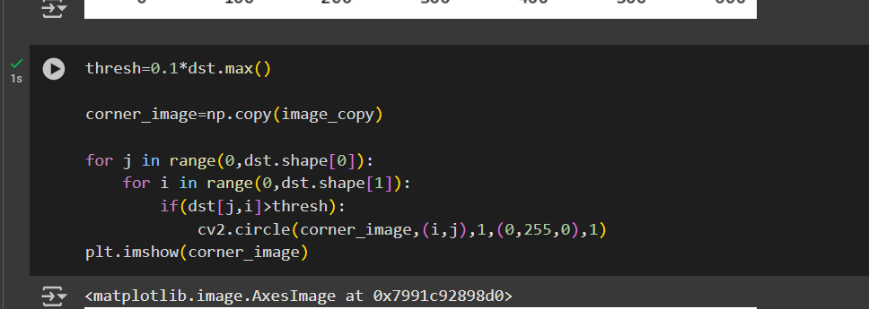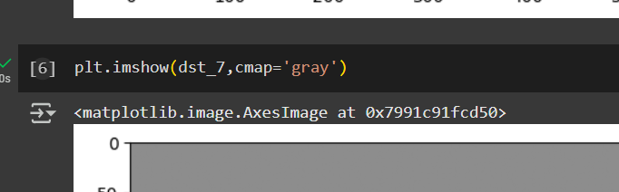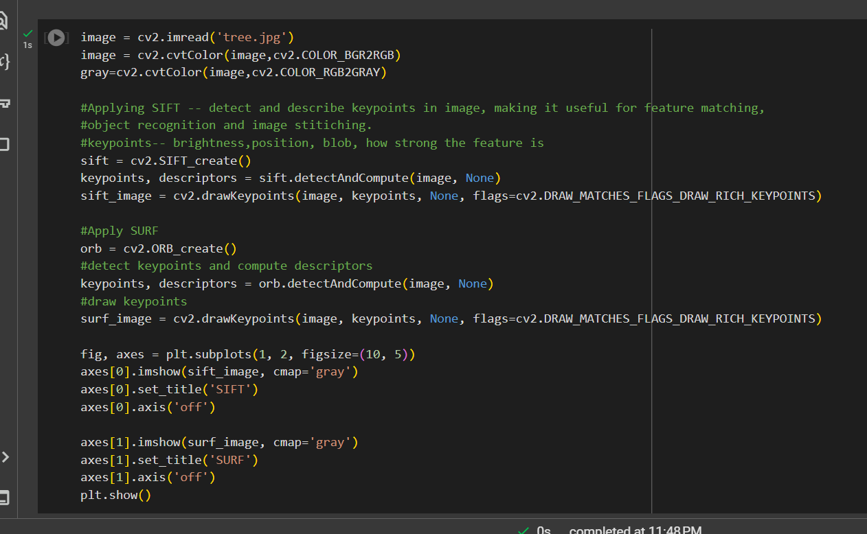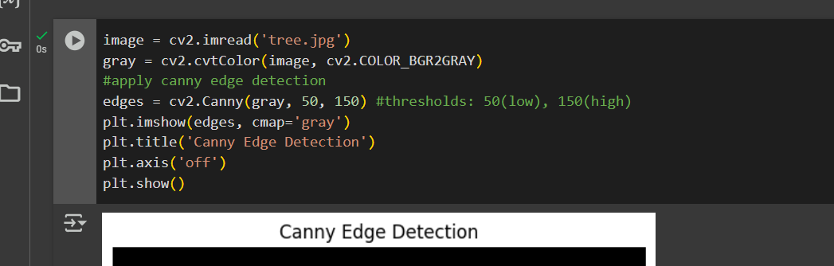

OUTPUTS:

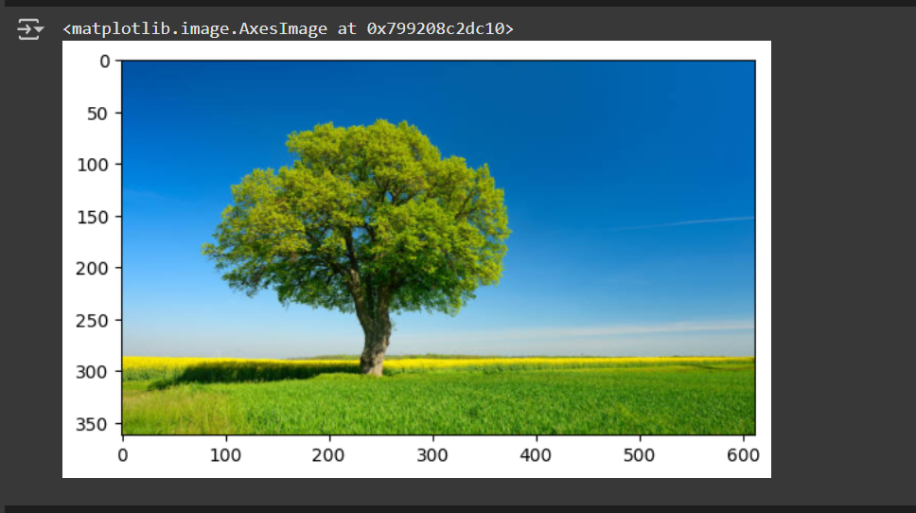

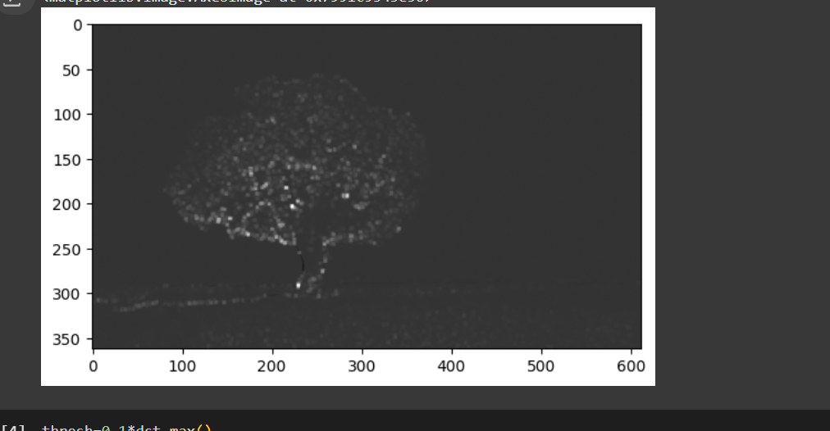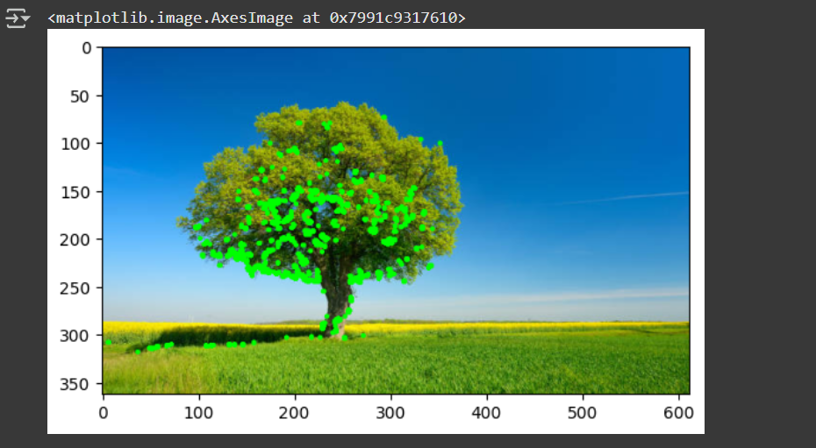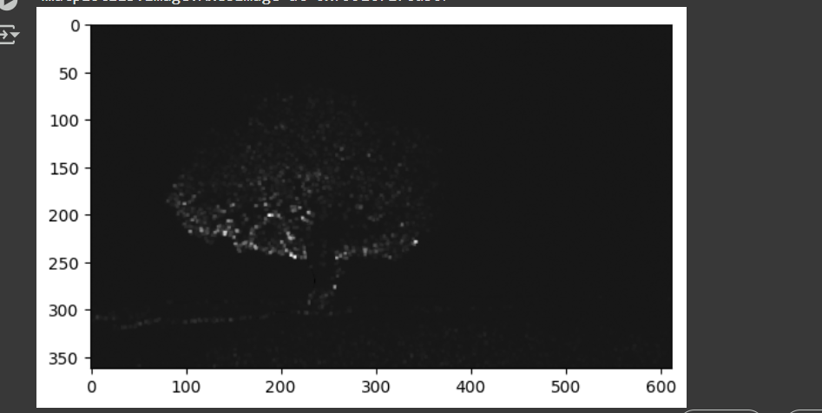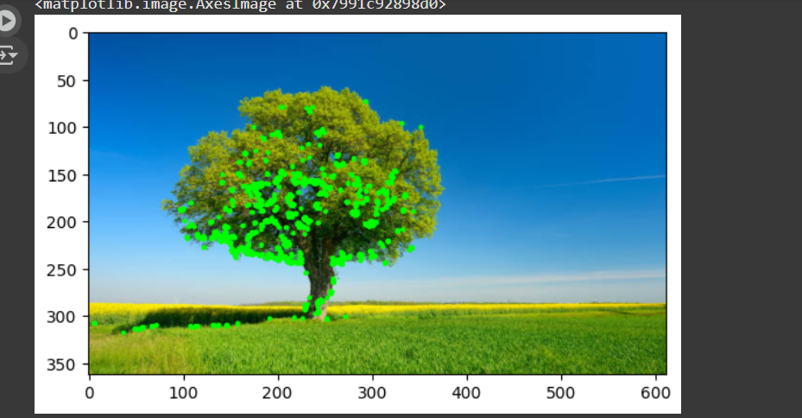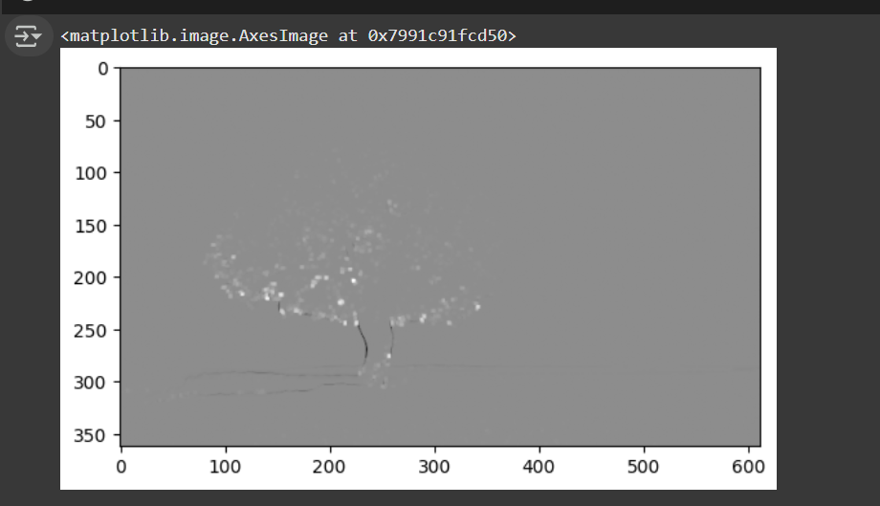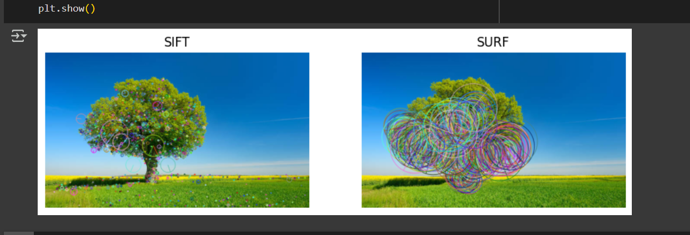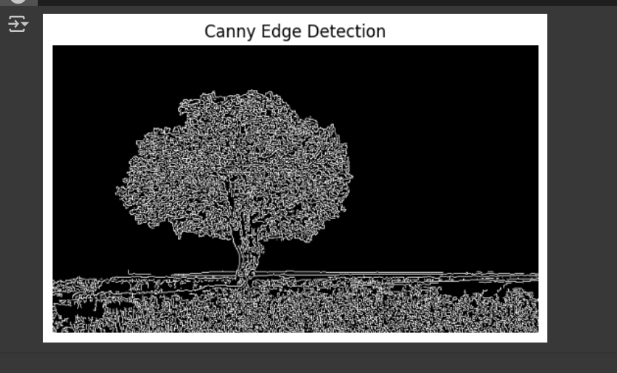

CONCLUSION: SIFT and SURF are feature detection algorithms that are scale- and rotation- invariant, with SURF being faster. Canny Edge Detection is a robust method for detecting

edges with high accuracy and noise resistance.