PRACTICAL 6

Name : Gaurav Nilawar

Roll No. 37

Batch : B3

Aim : Write programs to apply 2D transformations such as Negative, Logarithmic, Gamma, Affine, and Cropping on images to simulate real-world applications like enhancing low-light photos, correcting geometric distortions, and extracting regions of interest in satellite imagery.

Theory :

Here's a rephrased version, focusing on clarity, conciseness, and highlighting the benefits:

**Image Enhancement and Geometric Adjustments:**

* **Negative Inversion:**
  + This technique produces a photographic negative by reversing pixel intensities.
  + **Benefit:** Effectively reveals details hidden within dark regions of low-light images by brightening them.
* **Logarithmic Compression:**
  + Applies a logarithmic function to reduce the dynamic range of pixel values.
  + **Benefit:** Enhances details in dark areas while preserving the integrity of bright regions, making it ideal for improving visibility in low-light scenarios.
* **Gamma Correction:**
  + A non-linear transformation that adjusts image brightness based on a gamma value.
  + **Benefit:** Improves image contrast and corrects for underexposed or overexposed images, resulting in a more visually balanced image.
* **Affine Transformations:**
  + Linear transformations, including rotation, scaling, and translation, that preserve parallel lines and collinear points.
  + **Benefit:** Corrects geometric distortions such as skewed perspectives or misalignments, ensuring accurate image geometry.
* **Region of Interest Cropping:**
  + Extracts a specific portion of an image.
  + **Benefit:** Allows focused analysis of particular areas, such as isolating features in satellite imagery or removing unwanted portions of an image

**Output :** 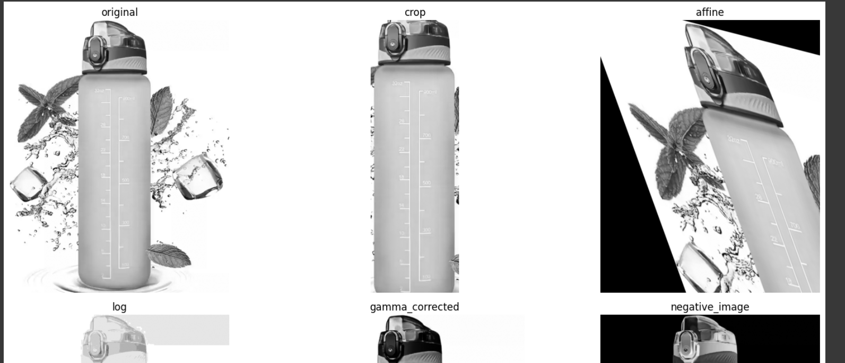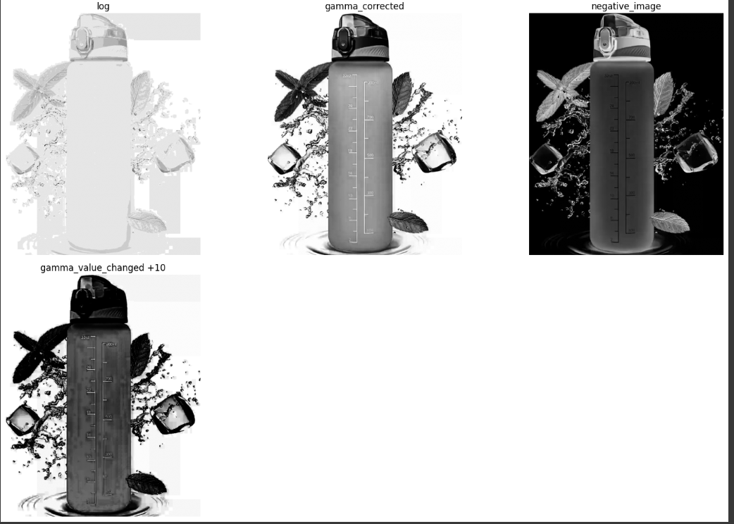

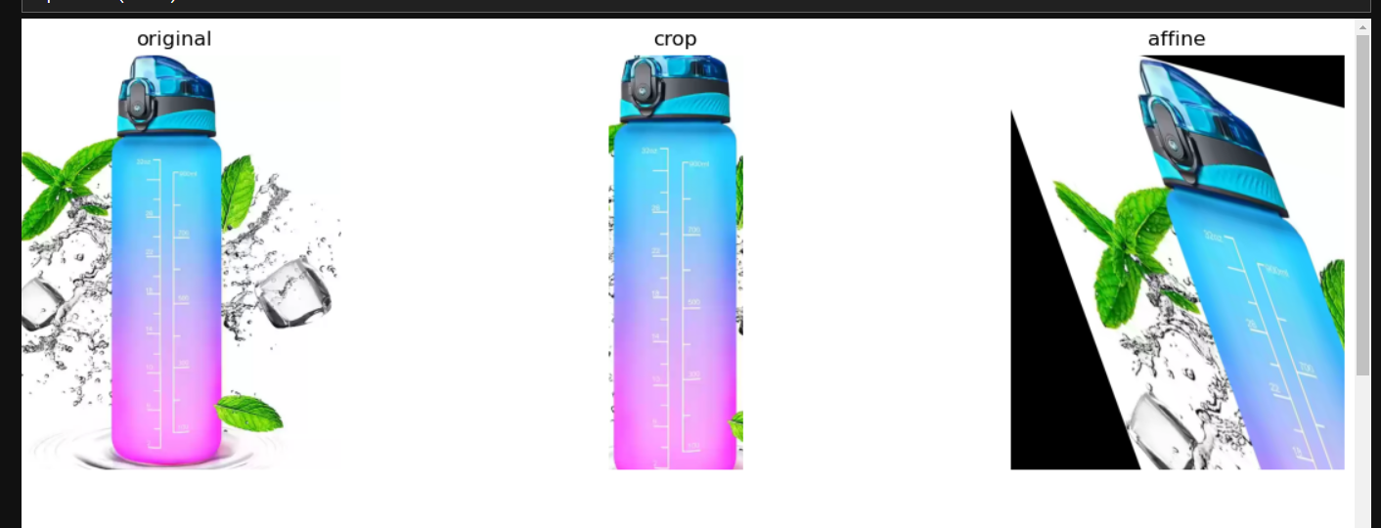

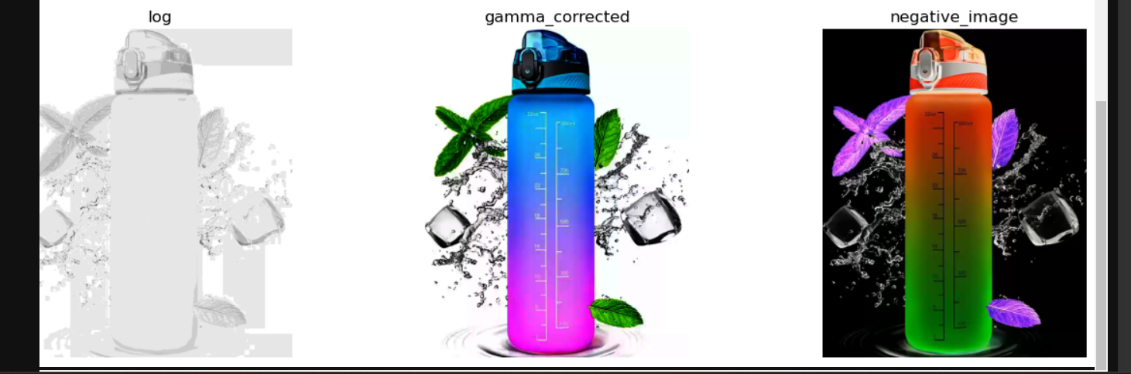

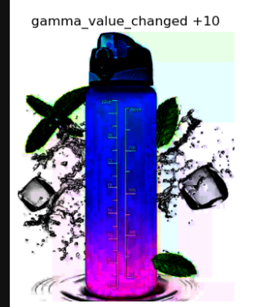

**CODE :** 