Introduction_To_OPPS_Programming
Session-1

Q1.Write a simple C program tasklist_c.c that allows you to add up to 5 tasks (as strings) to a global array and print all tasks using a for loop.

Ans=>
Code:
#include <stdio.h>
char tasks[5][100]; // Global Variable is declared so it can be used by any fuction that need it.
int taskCount = 0;
int main()
{
int i;
printf("How many tasks do you want to add? ");
scanf("%d", &taskCount);
getchar();
if (taskCount < 1 || taskCount > 5)
{
printf("Please enter a number between 1 and 5.\n");
return 0;
}
for (i = 0; i < taskCount; i++)
{
printf("Enter task %d: ", i + 1);
fgets(tasks[i], 100, stdin);
}
printf("\nYour Task List:\n");
for (i = 0; i < taskCount; i++)
{
printf("%d. %s", i + 1, tasks[i]);
}
return 0;
}

Output:
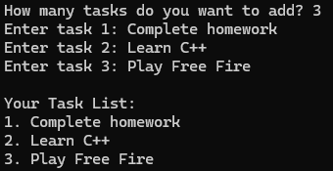

Q2.Modify your tasklist_c.c to add a function markTaskDone(int index) that sets the selected task to 'DONE' in the array, then print the updated list. Hint: Use a separate status array or append ' - DONE' to the task string.

Ans=>
Code:
#include <stdio.h>
char tasks[5][100];
int status[5] = {0};
int taskCount = 0;
void markTaskDone(int index)
{
if (index >= 0 && index < taskCount)
{
status[index] = 1;
}
else
{
printf("Invalid task number!\n");
}
}
int main()
{
int i, taskNumber;
printf("How many tasks do you want to add? ");
scanf("%d", &taskCount);
getchar();
if (taskCount < 1 || taskCount > 5)
{
printf("Please enter a number between 1 and 5.\n");
return 0;
}
for (i = 0; i < taskCount; i++)
{
printf("Enter task %d: ", i + 1);
fgets(tasks[i], 100, stdin);
}
printf("\nEnter the task number to mark as done: ");
scanf("%d", &taskNumber);
markTaskDone(taskNumber - 1);
printf("\nUpdated Task List:\n");
for (i = 0; i < taskCount; i++)
{
printf("%d. %s - %s", i + 1, tasks[i],
status[i] ? "DONE\n" : "PENDING\n");
}
return 0;
}

Output:
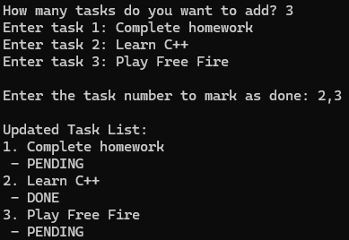

Q3.Create a Task class in your favorite OOP language (Java, Python, or C++) with properties: title and isDone. Add a method markDone() that sets isDone to true, and a method display() that prints the task with its status.

Ans=>
Code:
#include <iostream>
#include <string>
using namespace std;
class Task
{
public:
string title;
bool isDone;
Task(string t)
{
title = t;
isDone = false;
}
void markDone()
{
isDone = true;
}
void display()
{
cout << title << " - ";

if (isDone)
cout << "DONE" << endl;
else
cout << "PENDING" << endl;
}
};
int main()
{
Task t1("Complete homework");
Task t2("Play Free Fire");
t1.display();
t1.markDone();

t2.display();
t2.markDone();
t2.display();
return 0;
}

Output:
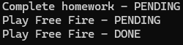
play free fire is displayed 2 times one is to show what the tasks are pending and other is to show what are the tasks that are done .

Q4.Build a simple TaskList class/object that stores multiple Task objects and provides addTask(title), markTaskDone(index), and showTasks() methods. Demonstrate adding 3 tasks, marking one as done, and displaying all tasks with their statuses.

Ans=>
Code:
#include <iostream>
#include <string>
using namespace std;
class Task
{
public:
string title;
bool isDone;
Task(string t)
{
title = t;
isDone = false;
}
void markDone()
{
isDone = true;
}
void display()
{
cout << title << " - ";

if (isDone)
cout << "DONE" << endl;
else
cout << "PENDING" << endl;
}
};
class TaskList
{
private:
Task tasks[5];
int taskCount;
public:
TaskList() : tasks{ Task(""), Task(""), Task(""), Task(""), Task("") }, taskCount(0){}
void addTask(string title)
{
if (taskCount < 5)
{
tasks[taskCount] = Task(title);
taskCount++;
}
else
{
cout << "Task list is full!" << endl;
}
}
void markTaskDone(int index)
{
if (index >= 0 && index < taskCount)
{
tasks[index].markDone();
}
else
{
cout << "Invalid task number!" << endl;
}
}
void showTasks()
{
cout << "\nTask List:" << endl;

for (int i = 0; i < taskCount; i++)
{
cout << i + 1 << ". ";
tasks[i].display();
}
}
};
int main()
{
TaskList list;
list.addTask("Complete homework");
list.addTask("Learn C++");
list.addTask("Play Free Fire");
list.markTaskDone(1);
list.showTasks();
return 0;
}

Output:
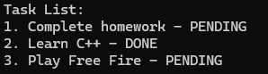

Q5.Compare your procedural C version and OOP TaskList version: List 3 problems you faced in the C version that were solved by using classes and methods in the OOP version.

Ans=>

Sr.No. | TOPIC’S | IN C | IN C++
1. | Data is stored separately. | Task titles and their statuses are stored in separate arrays. We must keep their indexes synchronized. | The Task class stores titles and isDone together in one object. This makes the code easier to organize.
2. | More responsibility is placed on the programmer. | We must manage the task arrays and status array separately and make sure each function updates the correct index. | Each Task object has its own markDone() method, so the task's completion status can be updated through the object.
3. | Code becomes harder to maintain as features increase. | As we add more operations, we may need more functions and additional arrays that must remain consistent. | The Task and TaskList classes group related data and operations together, making it easier to extend the program.

