Images Quotation

leveraging cutting-edge technologies

harnessing the power of satellite imagery delivering decision intelligence

Innovation and Technology

Industry Solutions

Customer-Centric Approach

Our Vision

We aim to be the most successful organization for solving and harnessing the geospatial technology with an approach of intensive professional and Research and Development.

Our Mission

To work on the solutions with state-of-the-art innovations to achieve qualitative excellence in client solving problems, satisfaction, quality product and standard geospatial activities.

Our Founder

Praveen has over 20 years of experience in the field of geospatial industry, he hold masters, along with a bachelor’s degree.

He is always passionate about technology, innovation, & research. He has the overall responsibility for developing the company’s vision and strategic direction.

He is a visionary leader and always leading the company from the front has played an important role in the company’s growth and business expansion.  
**Praveen Kumar Giri**

**Founder**

Our Core Values

Teamwork

We believe in the power of collaboration and cooperation to solve problems better. It’s the team that wins and not individuals.

Respect

Ensure respect and dignity for individuals by providing everyone an equal opportunity to grow without any discrimination or bias

Do not mislead

Conduct all our business in a transparent, ethical and fair manner in compliance with laws of all the countries that we operate in

We Never Give Up

Good is not enough. Always try to do better. We are always pushing the boundaries to create extraordinary outcomes.

Innovation

We never stop learning. We are always looking to unearth new insights, understand the system better, connect the dots differently, identify unsolved problems and experiment with promising new solutions. Perfection for us is a journey and not a destination.

Who We Are (About Us)

We are here to provide comprehensive suite of services and solutions in GIS, Remote Sensing, , Imagery Analytics, Photogrammetry, LIDAR & IT services to our clients. MapSmart is executing projects, providing consultancy services with comprehensive and scientific report writing and various other IT solutions from developing customized Software’s, Mobile Applications & Web GIS solutions.

We are aggressive customer-proactive, employee-oriented technology company whose quintessential drive is growth where MapSmart seeks opportunity, pursues dreams, and targets global expansion.

The direction and control of affairs are vested with its management committee, for providing cost-effective solutions & quality product. We are a team of Young energetic, talented, and multi-disciplinary professionals from a diverse background to bring change in this tech environment.

MapSmart addresses the good marketplace based on a solid foundation of technology. We are a growing organization with a passion to make a mark in the Geospatial Industry with a blend of change and defining new paths for ourselves. We achieve great results by bringing the best resources & solutions to the table and creating vibrant partnerships with the Client.

Core Purpose

**“To bring revolution in the Geospatial Industry”**

**Solutions**

**Telecom**

Build telecom clutter at different resolutions to support telecom planning activities with various clutter classes

**Agritech**

Agritech solutions from crop acreage, crop yield & crop health monitoring reports and analytics

**Land & Infrastructure**

The solutions involves various spatial information integrated with vital attributes ie. cadastral land records, administrative shapefiles.

**Weather**

Climate data such as rainfall and temperature accessed and provided on requirement basis to various clients

**Web development**

The visualization and data speaks when we plot it, the web development team is always bring create ideas and suggestions

**Education**

The geospatial education is need for the hour, we are arranging different courses from basics to professional level along with capstone project.

**Services**

**GIS Management**

We provide various types of GIS management services, base data preparation and data conversion services. Our GIS Management services include Base Map Creation, Parcel Mapping, Layout Designing & Indexing, Navigation Mapping and Digital Data Conversion enabling the integration of spatial data and enhancing user experience. Efficient GIS management ensures data accuracy and reliability.

**Imagery Services**

We provide various image processing services, rectification, interpretation, processing and analysis for various projects and for a variety of users. Our Imagery services includes Rectification/Georeferencing, Seamless Raster data preparation Land use/Landcover (LULC) Classification for telecom clients while providing them different resolution of 2D & 2.5D dataset, Terrain Mapping and Digital Elevation Modeling.

**Digital Cartography and Mapping**

We provide digitalization of CAD drafting and GIS based Digital Cartographic and Thematic mapping. All the digital cartograpi

**Photogrammetry & LiDAR Data Processing Services**

We provide LiDAR data processing services on various traits. Our Geospatial Education Services include Feature Classification, Noise Removal, Ground Editing, DEM/DTM Generation, Vectorization, Electrical Network and Hydro-Capture.

**Geospatial Education & Workshop**

We provide best quality Education in GIS & Remote Sensing, we are having a team of young professional and industry experts onboard to train the students, Research Scholars & Academicians. We have good projects to provide a practical experience on working on various live projects.

Clients

Careers

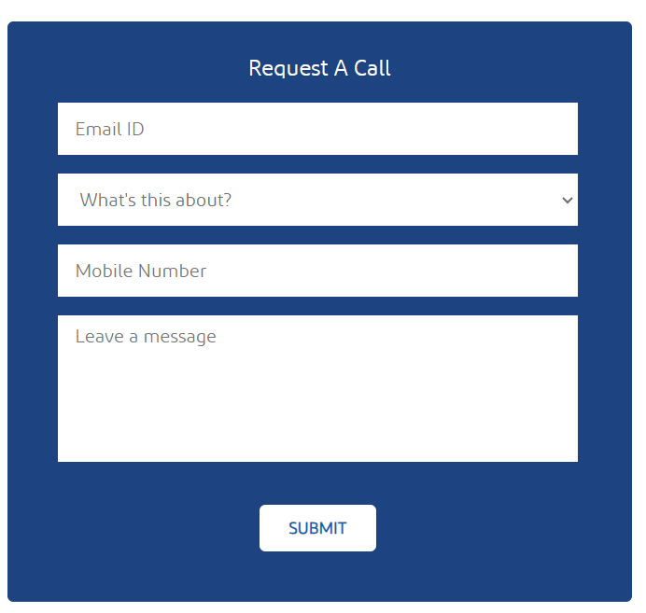Contact Us

**Registered Address**

MapSmart Geosolutions Pvt. Ltd.

187/A Barasat Road

P.O. NC Pukur, 24 Parganas(N)

Barrackpore - 743102

West Bengal, India

Email ID info@mapsmartgeosolutions.com

Call :+91 9891937316Monday-Saturday (10am-6pm)

<https://www.space4good.com/>

https://wrmsglobal.com/about-us/index.html