FINANCIAL CREDIT RISK ANALYSIS
Power BI Dashboard — Project Documentation

1. Project Title
Financial Credit Risk Analysis — Customer Credit Scoring Dashboard (Policybazaar Dataset)

2. Dataset Name and Description
Dataset name: Policybazaar Credit Scoring Dataset.
The dataset contains monthly financial and demographic records for approximately 12,500 unique customers (roughly 100,000 rows across multiple months), sourced to model consumer credit risk. Each record captures a customer's income, banking behaviour, loan exposure, repayment history and an assigned Credit_Score category, making it well suited to a risk-monitoring dashboard.
Key fields used in the dashboard
Field | Description
Customer_ID / Month | Unique customer identifier and the reporting month for each record
Occupation | Customer's profession (e.g. Accountant, Architect, Engineer, Scientist)
Annual_Income / Monthly_Inhand_Salary | Customer's declared income figures
Credit_Mix | Categorisation of the customer's mix of credit products (Good / Standard / Bad)
Type_of_Loan | One or more loan products held by the customer (Auto, Payday, Mortgage, Student, Home Equity, Credit-Builder, etc.)
Outstanding_Debt | Total outstanding debt balance
Credit_Utilization_Ratio | Percentage of available credit currently in use
Payment_Behaviour | Spending and payment-value segment (e.g. Low_spent_Small_value, High_spent_Large_value)
Total_EMI_per_month | Total monthly EMI obligation across loans
Monthly_Balance | Average monthly account balance
Credit_Score | Target field — Good, Standard, or Poor credit rating

3. Dashboard Objective
The dashboard was built to help a lending or insurance business understand who its riskiest customers are and why, so that credit and collections decisions can be made faster and with more confidence. Specifically it aims to:
- Give a single-glance view of the customer base split by credit score (Good / Standard / Poor).
- Identify which occupations, income bands, and loan types are associated with higher risk.
- Track how average balances and outstanding debt move over the months.
- Allow analysts to filter and drill down into payment behaviour, credit mix, and debt patterns for any customer segment.
- Translate the patterns found into concrete, actionable business recommendations.

4. Dashboard Screenshots

4.1 SCREENSHOT 1 — Financial Credit Risk Analysis (Overview)
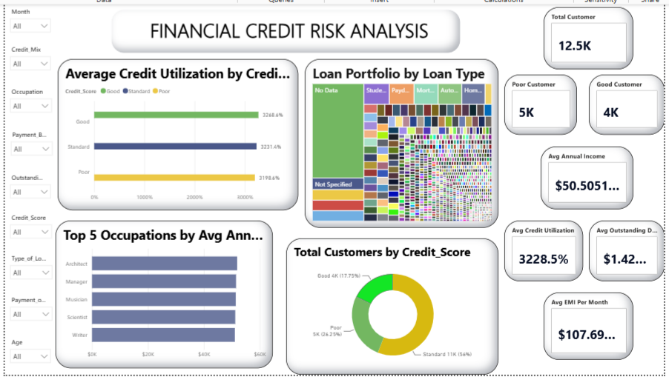
Figure 1: Overview page — KPI cards, credit utilization, loan portfolio, top occupations, and credit score split.
Visuals on this page
- KPI cards (top right): Total Customers (12.5K), Poor Customers (5K), Good Customers (4K), Average Annual Income ($50.51K), Average Credit Utilization (32.29%), Average Outstanding Debt ($1.43K), and Average EMI per Month ($107.70). These give an at-a-glance summary of the whole portfolio before any filtering.
- Average Credit Utilization by Credit Score (bar chart): compares utilization across the three score bands — Good, Standard, Poor. Utilization is fairly close across all three (32–33%), showing that utilization alone does not strongly separate the segments.
- Loan Portfolio by Loan Type (tree/icon chart): shows the relative share of each loan product held by customers, including a large "No Data"/"Not Specified" segment, alongside product types such as Payday Loan, Student Loan, Mortgage, Auto Loan and Home Equity Loan.
- Top 5 Occupations by Average Annual Income (bar chart): ranks Architect, Manager, Musician, Scientist and Writer as the highest average-income occupations in the dataset.
- Total Customers by Credit_Score (donut chart): breaks the full customer base into Good (4K, 17.75%), Standard (11K, 56%) and Poor (5K, 26.25%), showing that only around 1 in 6 customers currently hold a Good score.

4.2 SCREENSHOT 2 — Payment Behaviour & Debt Drill-Down
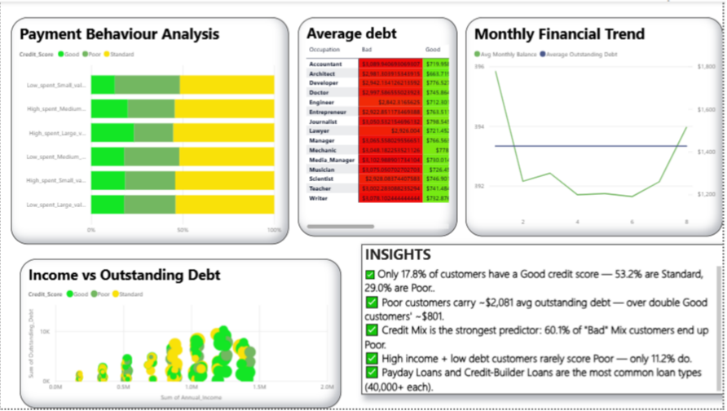
Figure 2: Drill-down page — payment behaviour, average debt by occupation, monthly trend, income vs debt, and key insights.
Visuals on this page
- Payment Behaviour Analysis (100% stacked bar): breaks each spend/value segment (e.g. Low_spent_Small_value, High_spent_Large_value) into the share of Good, Poor and Standard customers, revealing which spending patterns skew toward poor credit.
- Average Debt table by Occupation: lists average outstanding debt separately for Bad, Good and Standard credit-mix customers per occupation, with conditional (red-to-green) formatting so occupations and mixes with the highest debt stand out immediately.
- Monthly Financial Trend (combo line chart): tracks the average monthly balance across months against a flat reference line for average outstanding debt, showing balances dip mid-year and recover toward month 8.
- Income vs Outstanding Debt (scatter plot): plots each customer's annual income against outstanding debt, coloured by credit score, to visualise where Poor, Standard and Good customers cluster relative to income and debt levels.
- Insights panel: a curated text box summarising the headline findings drawn from the visuals on this page (see Section 5 below).
Filters, buttons and interactions
- Slicers (left rail on Page 1): Month, Credit_Mix, Occupation, Payment_Behaviour, Outstanding_Debt, Credit_Score, Type_of_Loan, Payment_of_Min_Amount and Age. Selecting any value cross-filters every visual on the page, so an analyst can isolate, for example, only "Poor" credit-mix customers in a given occupation.
- Cross-highlighting: clicking a bar or donut slice (e.g. the Poor segment of the credit-score donut) highlights the matching customers across the other visuals on the same page.
- Page navigation button ("Page 2", bottom-left of Page 1): takes the user from the KPI overview page through to the payment-behaviour and debt drill-down page, so the two pages work as a linked overview-to-detail flow rather than standalone reports.
- Tooltips: hovering over any bar, donut segment, table cell or scatter point surfaces the exact underlying value (count, percentage, or dollar figure) behind that element.
5. Key Insights and Explanations
- Only 17.8% of customers have a Good credit score, while 53.2% are Standard and 29.0% are Poor — meaning the majority of the portfolio sits in the two riskier bands, which should concern underwriting and collections teams.
- Poor-credit customers carry roughly $2,081 in average outstanding debt, more than double the ~$801 held by Good-credit customers — outstanding debt is one of the clearest separators between the segments.
- Credit Mix is the strongest predictor of risk in the data: 60.1% of customers with a "Bad" credit mix end up with a Poor credit score, far higher than any other single factor examined.
- Customers who combine high income with low debt rarely score Poor — only 11.2% do — confirming that income alone does not protect a customer from risk unless debt is also kept low.
- Payday Loans and Credit-Builder Loans are the most common loan types in the portfolio, each held by 40,000+ customers, both of which are products typically associated with higher-risk borrowers.
- Average credit utilization is nearly identical across Good, Standard and Poor customers (32–33%), so utilization alone is a weak differentiator compared to credit mix and outstanding debt.
- Average monthly balances dip around the middle of the year before recovering, while average outstanding debt stays flat — a signal worth monitoring for seasonal cash-flow stress.

6. Business Impact Summary
Taken together, the dashboard turns a large, granular transaction-level dataset into a small number of decisions a credit or risk team can act on immediately:
- Prioritise credit-mix cleanup: because a Bad credit mix is the single biggest driver of a Poor score, campaigns encouraging customers to diversify or restructure their credit mix (rather than simply increasing income) are likely to have the largest impact on reducing future defaults.
- Target high-debt occupations and loan types: the occupation-level debt table and the Payday/Credit-Builder loan concentration point to specific customer groups worth prioritising for proactive outreach, restructuring offers, or tighter underwriting criteria.
- Refine underwriting beyond income: since high income alone does not guarantee a Good score, income-based approval rules should be paired with debt and credit-mix thresholds to avoid under-pricing risk.
- Monitor seasonal balance dips: the mid-year dip in average monthly balance suggests a window where customers may be more likely to miss payments, useful for timing collections or hardship communications.
- Reallocate portfolio strategy: with over 80% of customers in Standard or Poor bands, the business can use this view to set realistic risk-adjusted targets and track whether interventions are shifting customers toward Good over time.

Overall, the dashboard supports faster, evidence-based decisions on loan approvals, pricing, and collections prioritisation, replacing manual, ad-hoc review of raw customer data with a single interactive view refreshed each month.
PPROJECT
BY KUMAR GAURAV
Mail: gaurav21237262@gmail.com
Contact no: 6205529390

