**OBJECTIVE**

The main objective of the project is to demonstrate the visualization of algorithm . Algorithm visualization graphically illustrates how algorithms work and hence easily depicts working of the typical algorithms.

**SCOPE**

This project will currently visualise the quick sort algorithm , but we can further add popular algorithm on this project . We can further add comparison of multiple algorithm in this project. This will ease the understanding of the working procedure of different algorithms.

**ARCHITECTURE**

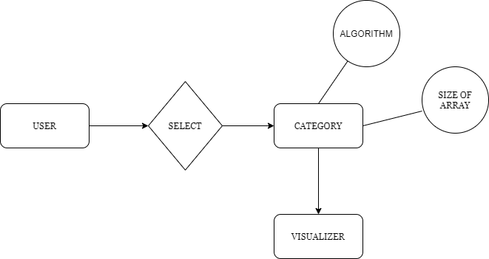

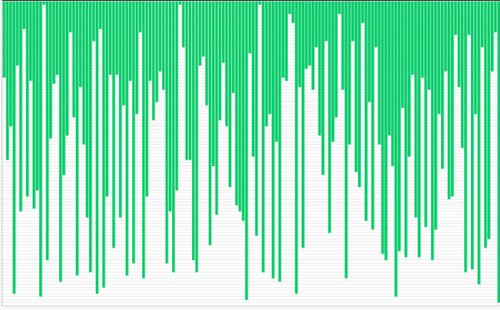

(A snap of the working of visualizionS of algorithm)

1. User will first give the size of the array , and will further provide the algorithm based on which sorting will be done.
2. Based on the option opted by the user , following elements will be sorted and visualized.

This will also provide visualtisation of the working of algorithm, this will help user to understand working of the particular algorithm . For visualisation we will use libraries: **random,matplotlib pyplot,animation** .

* random module in order to generate a random array of numbers to be sorted.
* The matplotlib pyplot and animation modules will be used to animate the sorting algorithm.

**TECHNOLOGY**

* PYTHON
* HTML
* CSS