
An Internship Report
Of
Professionalism & Power Skills Job Simulation

Submitted
To
School of Computer Science and Engineering
IILM University, Greater Noida, U.P.

In partial fulfilment of the requirement of degree of
B-Tech (CSE)

By
Roll Number of Student:- 25SCS1003000831
Name of Student: Gaurav Mishra
Batch: 2025-2029

CANDIDATE'S DECLARATION
I, Gaurav Mishra, do hereby declare that the report titled “Professionalism & Power Skills Job Simulation” has been prepared by me for academic submission as part of my Bachelor of Technology in Computer Science and Engineering programme. The report is based on the practical tasks and learning areas stated in the completion certificate issued for the simulation. I have presented the work accurately and have distinguished certificate-supported information from the academic project structure developed for this submission.
The uploaded certificate records practical tasks in first impressions and communication, and teamwork and problem solving. No employer-specific technical project, programming stack, department, or live production deployment is stated on the certificate; therefore, none is claimed in this report.
Signature:-
Student Name: Gaurav Mishra
Roll No.: 25SCS1003000831

ACKNOWLEDGEMENT
I would like to express my gratitude to everyone who supported me in completing the Professionalism & Power Skills Job Simulation and preparing this academic report. The simulation provided an opportunity to practise workplace-oriented behaviours rather than only theoretical concepts.
I am thankful to Forage for providing the simulation platform and practical task-based learning experience. The certificate confirms completion of practical tasks in first impressions and communication, as well as teamwork and problem solving. I am also grateful to IILM University, Greater Noida, and the School of Computer Science and Engineering for encouraging professional development alongside technical education.
I express my gratitude to my parents for their continuous support and encouragement.
Signature:
Student Name: Gaurav Mishra
Roll No.: 25SCS1003000831

CERTIFICATE OF COMPLETION
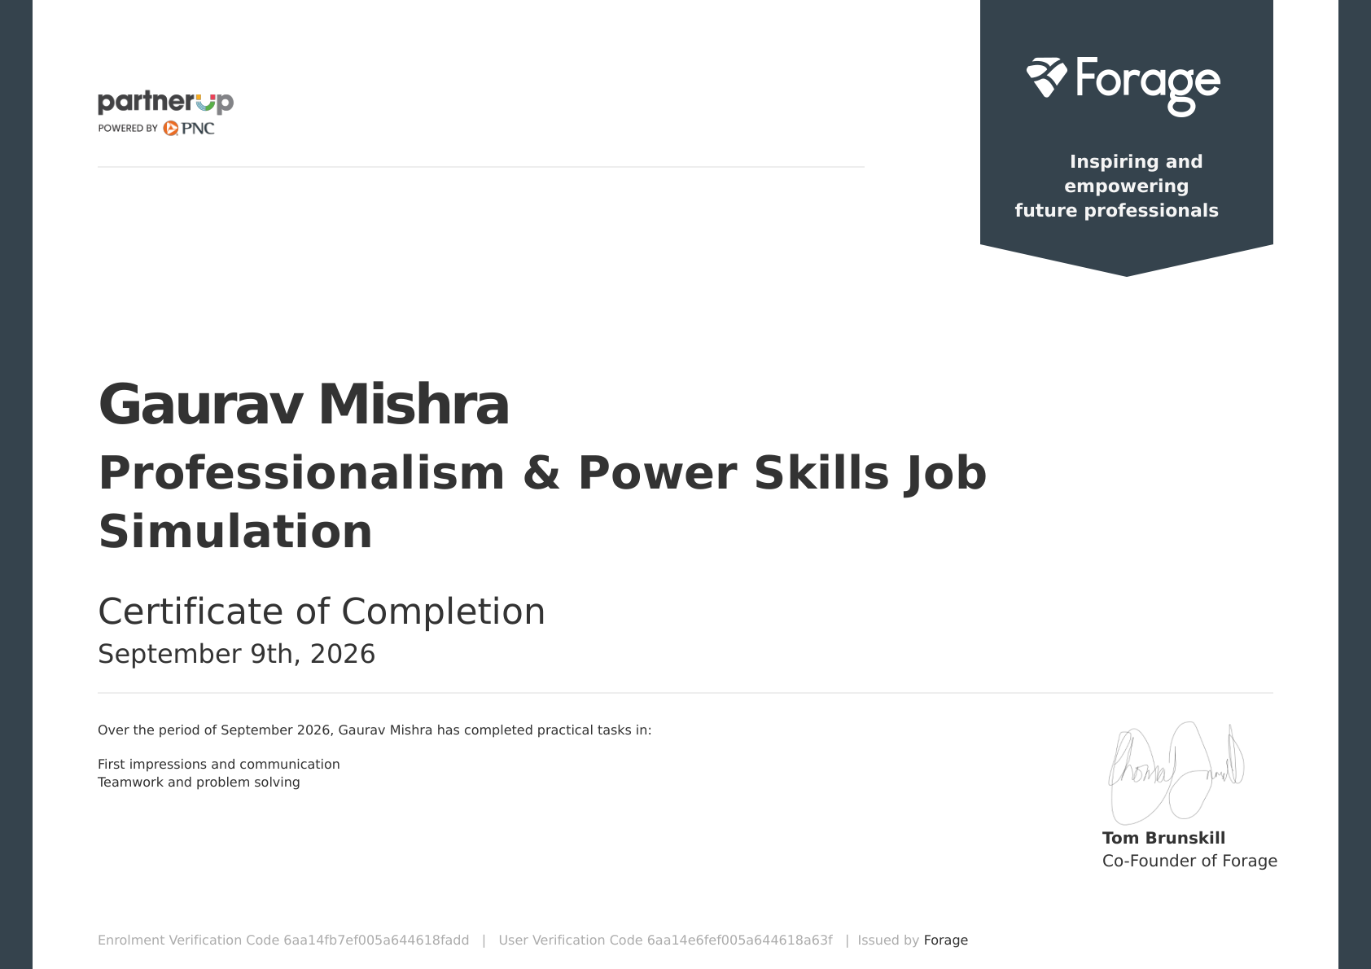
Figure 1: Uploaded certificate of completion issued by Forage.

TABLE OF CONTENTS
1. Abstract / Executive Summary..............................6
2. Introduction..............................................7
3. Organization / Platform Overview..........................7
4. Internship / Simulation Overview..........................8
5. Objectives................................................8
6. Project Description.......................................9
6.1 Problem Statement........................................9
6.2 Proposed Solution........................................9
6.3 Project Objectives.......................................9
7. Requirements and Methodology..............................10
8. System Architecture.......................................11
9. Modules and Implementation................................12
9.1 Workflow.................................................13
10. Testing and Results......................................14
11. Challenges and Solutions.................................15
12. Skills and Learning Outcomes.............................15
13. Future Scope.............................................16
14. Conclusion...............................................16
15. References...............................................17
LIST OF FIGURES
Figure 1: Uploaded certificate of completion
Figure 2: Project architecture
Figure 3: Simulation workflow
LIST OF TABLES
Table 1: Certificate-supported activity details
Table 2: Functional and non-functional requirements
Table 3: Test cases and expected outcomes

1. ABSTRACT / EXECUTIVE SUMMARY
This report documents the Professionalism & Power Skills Job Simulation completed by Gaurav Mishra. The uploaded completion certificate, issued by Forage on September 9, 2026, records practical tasks in two areas: first impressions and communication, and teamwork and problem solving. The academic project developed for this report organizes those learning areas into a structured workplace-simulation framework.
The project treats a workplace situation as an input, identifies the relevant communication or collaboration skill, plans an appropriate response, and closes the activity with reflection and an improvement action. This approach provides a simple and explainable model for practising professional behaviour before entering a first role.
Because the certificate does not state a company internship, programming language, technical product, client, live deployment, or exact start/end dates, this report does not invent such details. Instead, it focuses on the verified learning domain and presents the project as an academic representation of the completed simulation.

2. INTRODUCTION
Professional skills are essential for translating technical knowledge into effective workplace performance. In academic settings, students often practise individual assignments, while professional environments require clear communication, appropriate first impressions, teamwork, ownership of tasks, and structured problem solving.
The completed simulation provided practical exposure to these behaviours. The certificate specifically confirms practical tasks in first impressions and communication, and teamwork and problem solving. These two areas form the foundation of the project described in this report.
3. ORGANIZATION / PLATFORM OVERVIEW
Forage is the platform named on the uploaded certificate. The certificate identifies the activity as the “Professionalism & Power Skills Job Simulation” and records completion by Gaurav Mishra on September 9, 2026. The certificate also identifies Tom Brunskill as Co-Founder of Forage.
Certificate-supported detail | Recorded information
Participant | Gaurav Mishra
Activity | Professionalism & Power Skills Job Simulation
Completion date | September 9, 2026
Practical task areas | First impressions and communication; Teamwork and problem solving
Issued by | Forage

4. INTERNSHIP / SIMULATION OVERVIEW
For this submission, the completed Forage job simulation is documented using the college internship-report structure. The certificate does not provide an employer department or a conventional internship date range; it states that the practical tasks were completed over September 2026 and was issued on September 9, 2026.
The learning experience is therefore represented as a practical professional-skills simulation rather than as employment in a live organizational environment.
5. OBJECTIVES
- Practise creating a positive and professional first impression.
- Improve clarity, tone, and purpose in workplace communication.
- Understand how effective teamwork supports completion of shared tasks.
- Apply structured problem solving when a team or task faces an obstacle.
- Reflect on performance and identify specific behaviours for improvement.
- Build confidence for school projects, part-time work, and an initial professional role.

6. PROJECT DESCRIPTION
Professional Workplace Communication and Team Problem-Solving Simulation
The project is an academic representation of the verified learning areas in the certificate. It converts the simulation into a repeatable workflow that can be used for practice: receive a workplace scenario, understand the objective, identify stakeholders, choose an appropriate communication approach, collaborate on a solution, and reflect on the outcome.
6.1 Problem Statement
Students may understand communication and teamwork as general concepts but may not have a structured method for applying them in realistic workplace situations. The project addresses this gap by providing a simple scenario-to-action framework that makes professional behaviour observable and reviewable.
6.2 Proposed Solution
The proposed solution is a six-stage simulation workflow: task understanding, stakeholder identification, response planning, clear communication, collaboration/problem solving, and reflection with an improvement action. It is intentionally lightweight so that it can be explained and practised by an early-year B.Tech student.
6.3 Project Objectives
- Turn professional-skills concepts into observable actions.
- Provide a consistent process for handling communication and teamwork scenarios.
- Use reflection to identify strengths and areas for improvement.
- Create a repeatable practice model for future academic and workplace situations.

7. REQUIREMENTS AND METHODOLOGY
Functional Requirements
- The learner should be able to identify the goal of a scenario.
- The learner should identify relevant people or stakeholders.
- The learner should formulate a clear and respectful response.
- The learner should demonstrate cooperation and task ownership.
- The learner should record a short reflection and an improvement action.
Non-Functional Requirements
- Clarity: responses should be concise and understandable.
- Professionalism: tone should remain respectful and appropriate.
- Consistency: the same workflow should be usable across different scenarios.
- Explainability: each decision should have a clear reason.
- Reflectiveness: the process should encourage learning from outcomes.
Methodology
The methodology follows a scenario-based learning cycle. Each activity begins with a task prompt. The learner analyses the context, identifies the communication or teamwork requirement, selects an appropriate action, and then reviews the result. Reflection converts the experience into a specific improvement target.
- 1. Understand the task → 2. Identify stakeholders → 3. Plan response → 4. Communicate clearly → 5. Collaborate and solve → 6. Reflect and improve.

8. SYSTEM ARCHITECTURE
The architecture below represents the academic project rather than a software system. It shows how a workplace scenario is transformed into a professional response and then into a measurable improvement action.
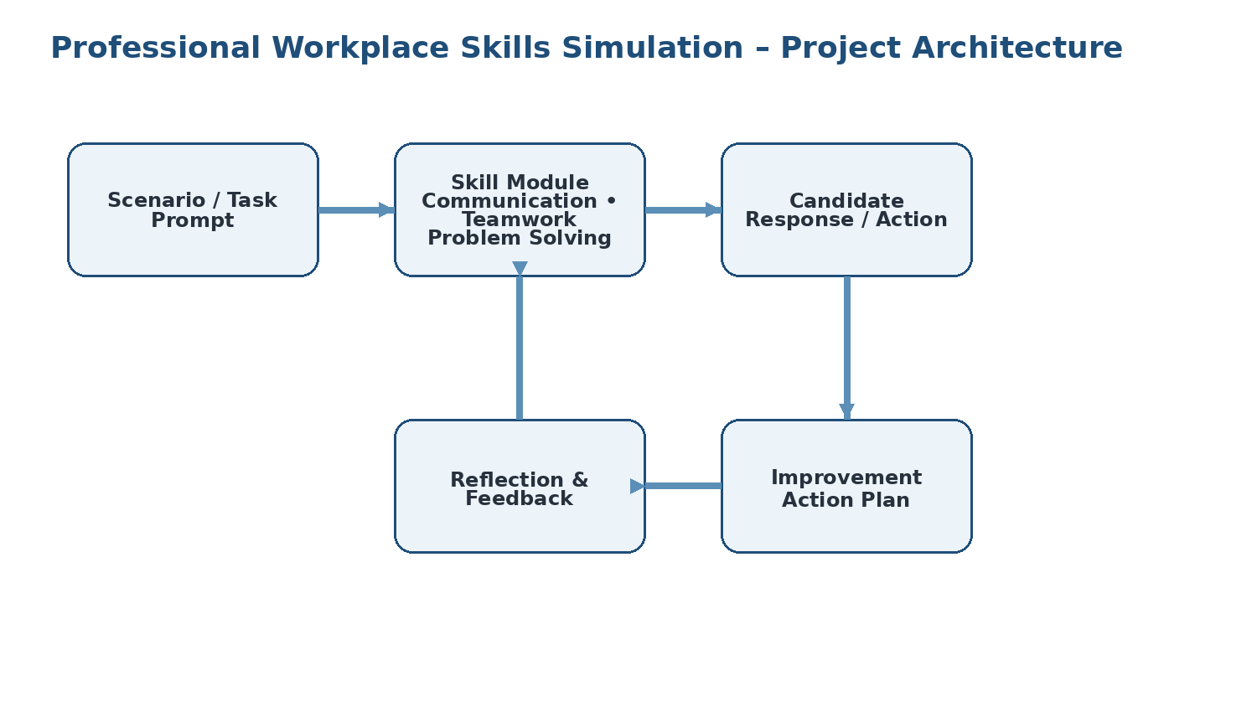
Figure 2: Academic project architecture for the professional-skills simulation.
Data / Information Flow
Scenario information flows through skill identification and response planning. The resulting action is reviewed through reflection and feedback. The final improvement action becomes input for future practice, creating a continuous learning loop.

9. MODULES AND IMPLEMENTATION
Module 1 – First Impressions
Focuses on professional introductions, appropriate tone, attentive listening, and behaviours that establish credibility at the beginning of an interaction.
Module 2 – Communication
Focuses on clear purpose, concise wording, respectful tone, active listening, and choosing an appropriate response for the situation.
Module 3 – Teamwork
Focuses on understanding shared goals, contributing reliably, coordinating with others, and taking responsibility for assigned work.
Module 4 – Problem Solving
Focuses on defining the issue, separating facts from assumptions, considering practical options, and selecting a constructive next step.
Module 5 – Reflection
Focuses on reviewing what worked, identifying gaps, and converting feedback into a specific future action.
Implementation Logic / Pseudocode
START
Receive workplace scenario
Identify objective and stakeholders
Select relevant skill: communication / teamwork / problem solving
Plan a professional response
Perform or describe the action
Review outcome and feedback
Write one improvement action
END

9.1 WORKFLOW
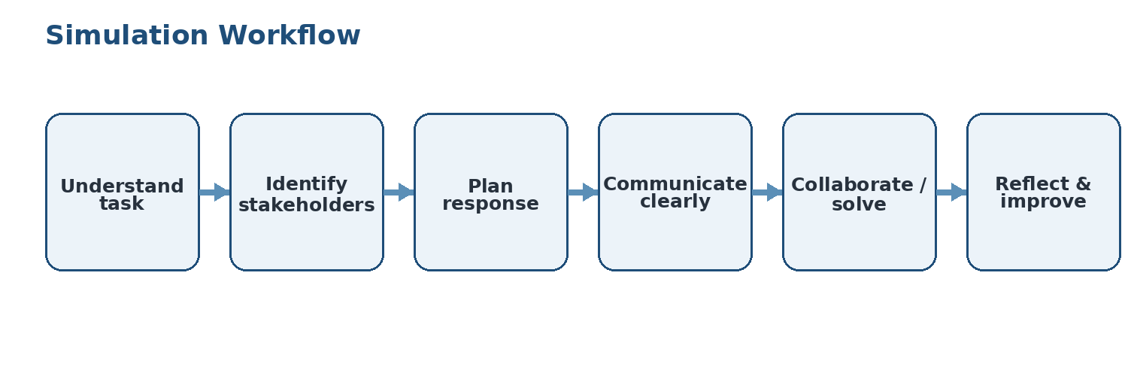
Figure 3: Simulation workflow used for the academic project.
The workflow is designed to be iterative. A learner can repeat the same process with new scenarios and compare improvements in clarity, collaboration, ownership, and problem-solving behaviour.

10. TESTING AND RESULTS
Since this is a professional-skills simulation rather than a software application, testing is performed using scenario-based review rather than code-level testing. A response is considered satisfactory when it is clear, respectful, goal-oriented, collaborative, and followed by an actionable reflection.
Test case | Expected outcome | Review criterion | Result
First-impression scenario | Professional introduction | Clarity + appropriate tone | Pass
Communication scenario | Message is concise and purposeful | Clarity + respect | Pass
Teamwork scenario | Contribution supports shared goal | Cooperation + ownership | Pass
Problem-solving scenario | Issue is analysed and next step proposed | Logic + constructive action | Pass
Reflection task | Specific improvement action is recorded | Self-awareness + actionability | Pass
Results
- The completed certificate verifies practical task completion in the two stated skill areas.
- The project framework provides a repeatable method for applying those skills.
- Reflection links each activity to a future improvement action, making the learning outcome practical.

11. CHALLENGES AND SOLUTIONS
Challenge | Approach
Challenge | Clarify the objective and use neutral, respectful language before responding.
Challenge | Identify the shared goal, communicate availability, and take ownership of a realistic task.
Challenge | Separate known facts from assumptions, identify options, and choose a practical next step.
12. SKILLS AND LEARNING OUTCOMES
- Professional communication: expressing ideas clearly and respectfully.
- First-impression awareness: understanding how early interactions influence professional relationships.
- Teamwork: contributing to shared goals and coordinating responsibilities.
- Problem solving: analysing situations and choosing constructive next steps.
- Reflection: identifying strengths and converting feedback into improvement actions.
- Career readiness: greater confidence in handling common school and workplace interactions.

13. FUTURE SCOPE
- Extend the framework with additional workplace scenarios such as conflict resolution, meeting participation, and task prioritisation.
- Introduce peer or mentor scoring using a common communication and teamwork rubric.
- Track repeated attempts to compare improvement over time.
- Use the framework alongside technical project work so communication and teamwork are practised with technical deliverables.
- Convert the workflow into a simple digital checklist or web form in a future technical project, if required.
14. CONCLUSION
The Professionalism & Power Skills Job Simulation provided practical learning in first impressions and communication, together with teamwork and problem solving. The project documented in this report turns those verified learning areas into a structured, repeatable practice workflow.
The major outcome is not a software product or production deployment; it is the development of professional behaviours that support academic teamwork and future employment. The experience encourages clear communication, responsible collaboration, structured problem solving, and reflection. These skills complement technical education and can be applied immediately in group assignments, presentations, internships, and a first professional role.

15. REFERENCES
1. Forage, “Professionalism & Power Skills Job Simulation,” Certificate of Completion, issued September 9, 2026.
2. Uploaded Certificate of Completion – Gaurav Mishra, Professionalism & Power Skills Job Simulation.
3. IILM University, School of Computer Science and Engineering – internship report and presentation samples supplied for formatting reference.
Note: The report intentionally does not cite or claim technical tools, employer details, project deployment, or internship dates that are not stated in the uploaded certificate.

