----------------------------------------------------EXCELL ASSIGNMENT NO -06-------------------------------------------------

Q1. What are the various elements of the Excel interface? Describe how they're used. ?

ANS: The various elements of excell interface are

*Ribbon Tab :Ribbon Tab is a tab that organizes commands by topic

*The Ribbon : Commands Underneath the tab .

*Ribbon Group : Groupping of related command .

*Dialog Box Launcher : Opens a Dialog box that inludes additional commands .

*Quick access toolbar :One click access to any frequently used command .

*Name Box :Displays cell location and can be used to navigate to a cell location .

*select all button : selects all the cells in the worksheet .

*Formula bar : View , enter or edit cell contents .

*insert function button : Displays insert function dialog box .

*scroll bars : Used to navigate up , down , left and right .

*Zoom sliders : zooms into the area of the worksheet .

*View buttons : switch between Normal , Page layout and page break preview views

*worksheet tabs : tabs used to select individual worksheets .

*The workspace : the area inside column and rows used in excell .

*Columns : columns uses letters .

* Rows : Rows uses numbers .

Q2) Write down the various applications of Excel in the industry.

Ans: *Data Entry and Storage

*Performing Calculations

*Data Analysis and Interpretation

*Reporting and Visualizations

*Accounting and Budgeting

*Collection and Verification of Business Data

*Calendars and Schedules

*Administrative and Managerial Duties

*Forecasting

*Automating Repetitive Tasks

Q3) On the ribbon, make a new tab. Add some different groups, insert commands in the groups and name them according to their commands added. Copy and paste the screenshot of the steps you followed.

Ans: right click on the home tab and select customise ribbons: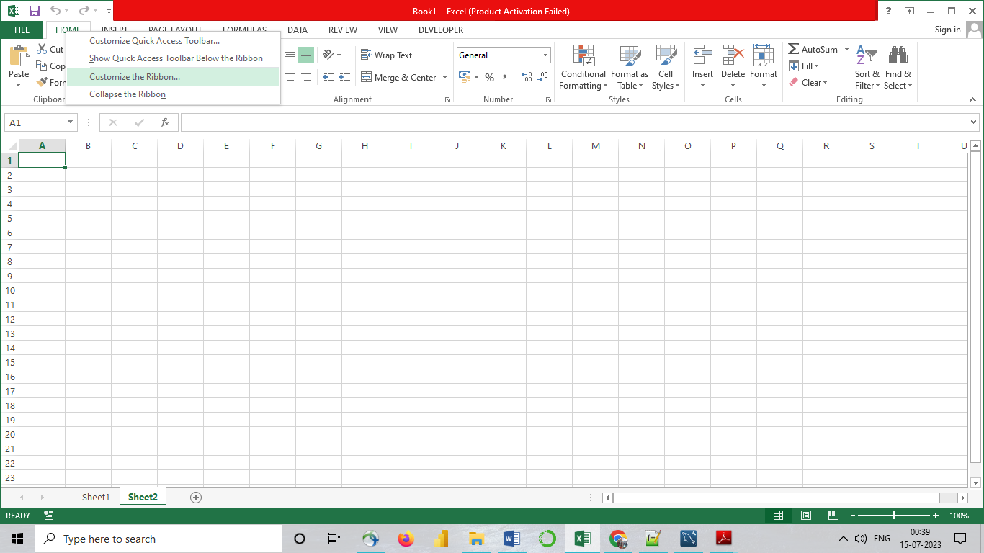

CREATE A NEW TAB

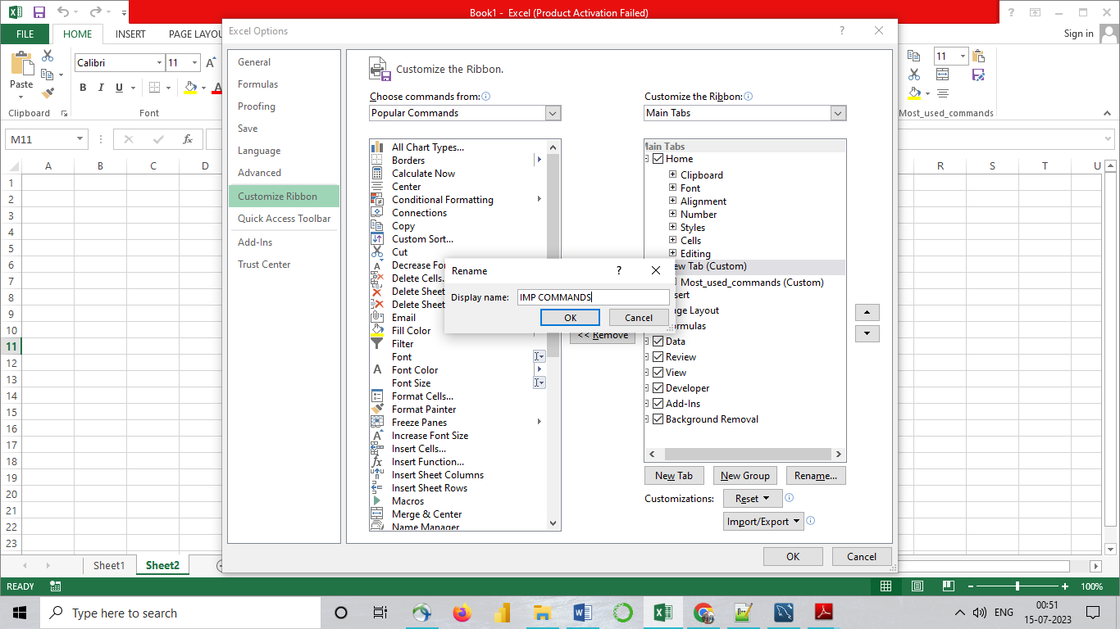

Select new groups

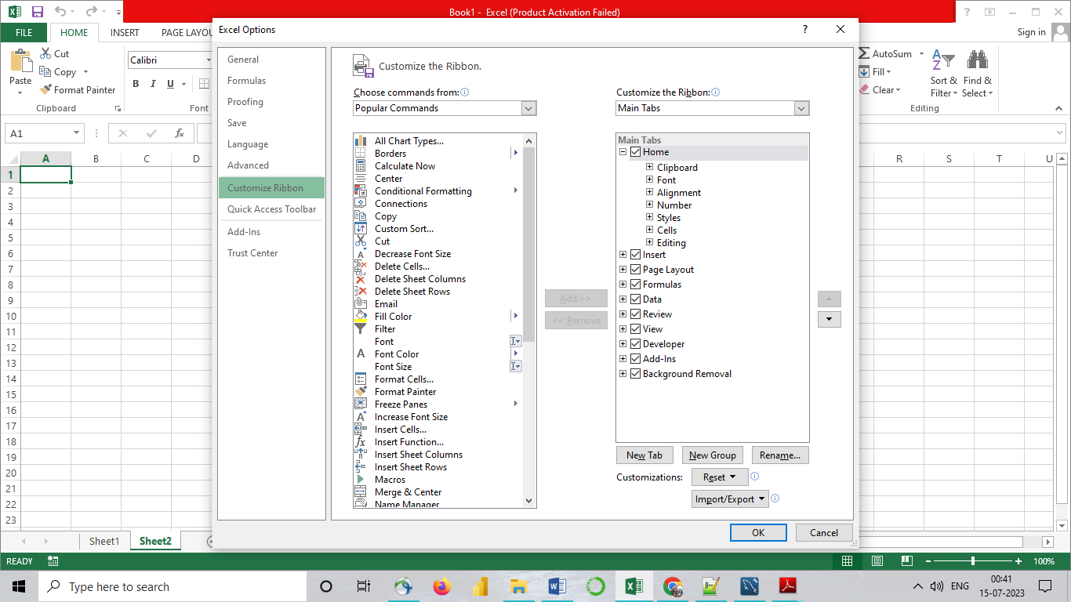

Create new groun with name Most _used_commands and add the commands in them

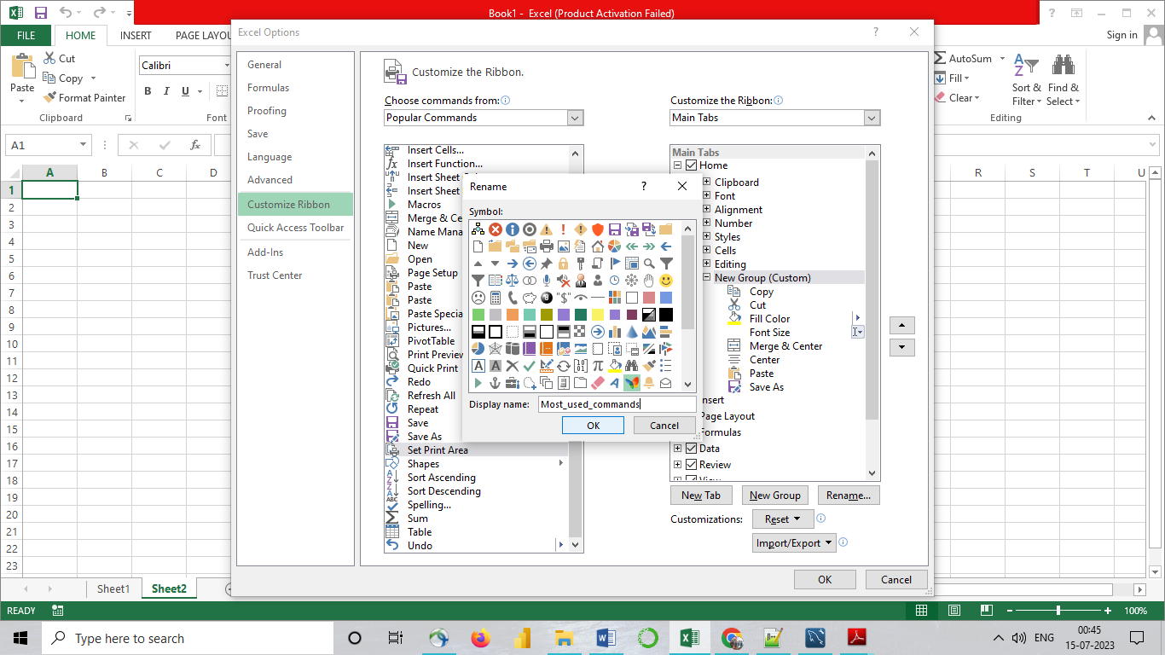

New tab is imp commands is created with most used commands

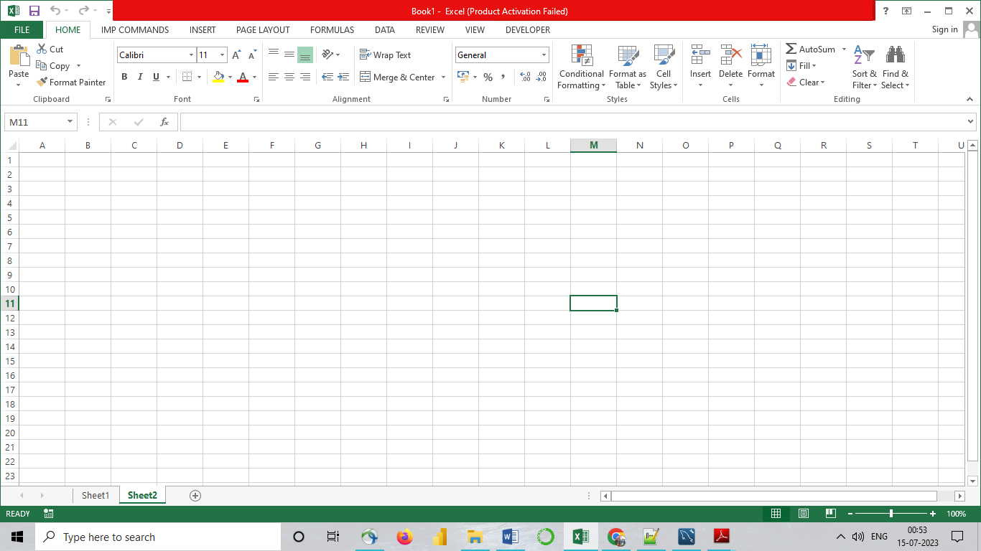

Q4) Make a list of different shortcut keys that are only connected to formatting with their functions.

Ans:

5. What distinguishes Excel from other analytical tools?

Ans : *Excel will use range of formulas to unlock the potential of data.

*You have to insert data in individual cells of columns and rows. In this way, data will be filtered and sorted and hence displayed in a presentable manner.

* Different types of charts like clustered columns, graphs and pie chart provide great visual presentation.

*It puts more emphasis to marketing material and business reports. Excel is a wonderful tool to represent data on X and Y axis.

*It provides different color shades, font types to format the spreadsheet and differentiate between rows and columns. It is good to present useful presenting information such as balance, tax profit etc. There is a quick analysis button to choose the appropriate coloring scheme.  
  
*You could combine the information from different files and documents to Excel. In this way, they will exist in a single location. Besides the regular information and raw data from spreadsheets, it is easy to import the images too. You just need to use the insert tab to add multiple objects to the spreadsheet.

*All your files will remain safe and secure from unauthorized access. It is brilliant software that can help you to save money on other costly software applications.

6. Create a table and add a custom header and footer to your table.

Ans:

