SRS on

Being Human Shop

- INTRODUCTION

- Being Human Shop, is a web based application that used to provide all detail about the product which we provides like Clothes, accessories, etc. & also helps customer to purchase products.

- Here, user has a brief look of the Being human brand collection without actually visiting the store.

- The website displays different kinds of Product collection, so user can easily get their expected product items.

  - Project Abstract

- This project is developed for users to visit the site & purchase the product which we provide on our website. User can see the product, there price, there overall descriptions & purchase product online on one click without going anywhere. It works online so user should have internet connection.

1. 2 Existing System and Need of System

Existing System

- In Existing System customer should have to visit particular shop for purchasing product item.
- It’s take too much time to visit the shop and purchase product items.

Need of System

- Purposed system provide the online shopping or product items which this site can provides
- It’s saves the customer time & easy to purchase product items.

  - Scope of Work

- In existing system purchasing product is take some time, customer have to visit that particular product. Here, customer can easily visit the site and purchase the Product items on one click.
- Customer can view the whole details of the product items. In this project we manage the details about the product items.
- Secure registration and profile management facilities for customer.
- Easy and quick access to particular items.
- This system is easy in handle and user friendly.
- Time required for accessing any detail will be very less.
- User can view different categories of product items at a single place.
Hence the system saves time, efforts and cost.

  - Operating Environment-Hardware and Software

Hardware Requirements

- An Intel based processor capable of running any short of windows operating system.
- Minimum 40 GB hard disk.
- Minimum 512 mb of RAM at workstation.
- Monitor for workstation.
Software Requirements

- The software requirement as follows.
- Window xp and above
- Browser
- Internet connection

  - Technology Used

- Front End :
- Html
- Css
- Bootstrap
- Back End:
- MySql

2. PROPOSED SYSTEM

2.1 Proposed System

The “Being Human Shop” Sells the product items like men/women clothes collection, accessories. & also helps customer to purchase product items. It can keep the information of customer details, who registered. And also product information is provided for easy to purchase.

This system hold the all information about the product, it takes the records to access the product to the customer as they required. Customer also gives there feedback.

2.2 Objective of System

- Provides the good user interface to easy of use and it also provides the security to the database.

- The system can view the details of any product items which we provide.

- To allow only authorized user to access various function and processed available in the system.

- User is allowed to give there feedback.
- Reduced clerical work as most of the work done by computer.
- Provide greater speed & reduced time consumption.

2.3 User Requirement

    - Basic knowledge about computer.
    - User should understand English language.

MODULES
- Customer management
- Product management
- Order management
- Feedback
- Report generation

3. ANALYSIS & DESIGN

3.1 Data Flow Diagram

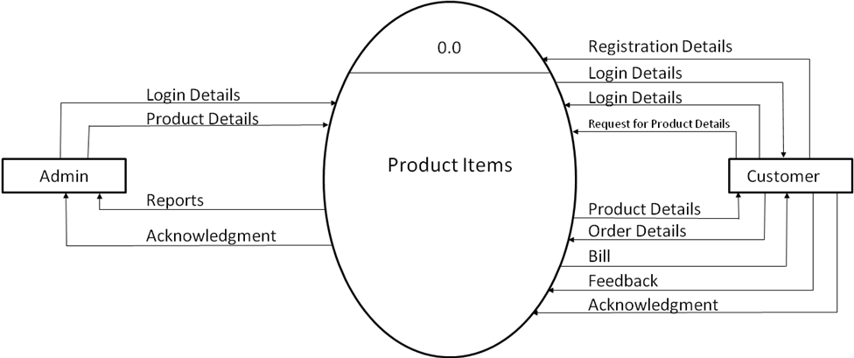

3.2 ERD Diagram

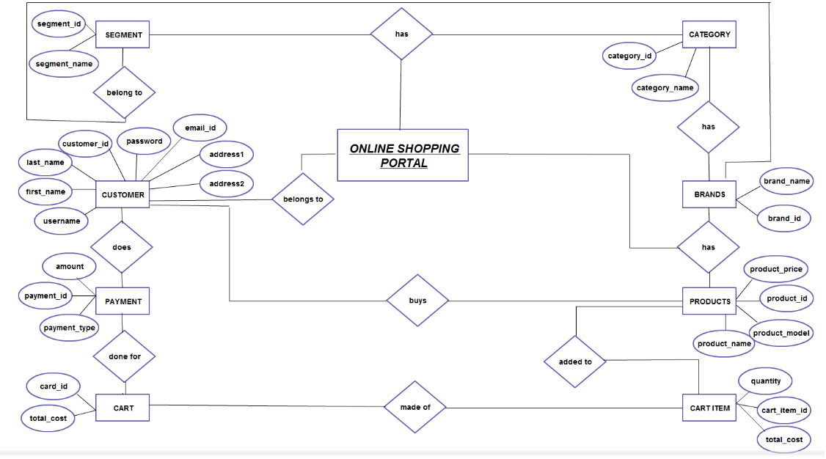
Being Human
Shop

3.3 Use Case Diagram
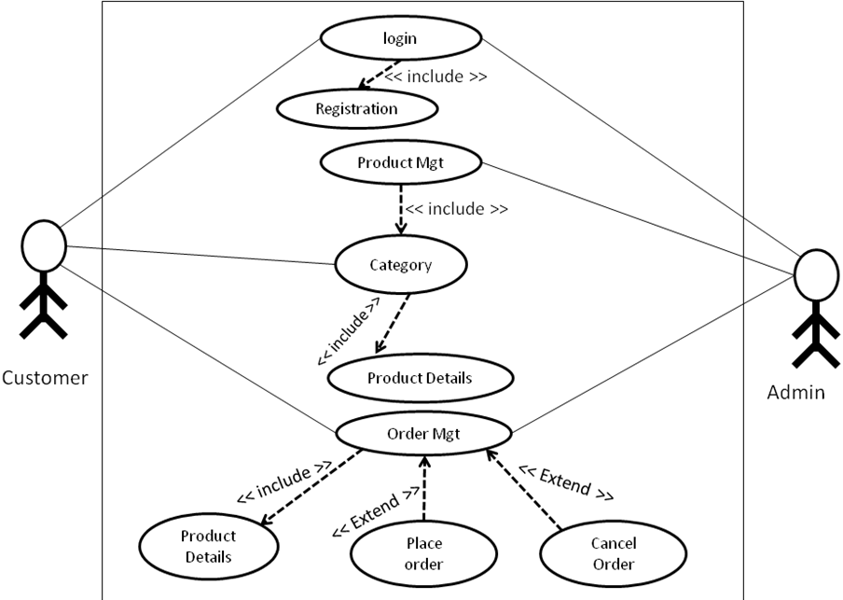

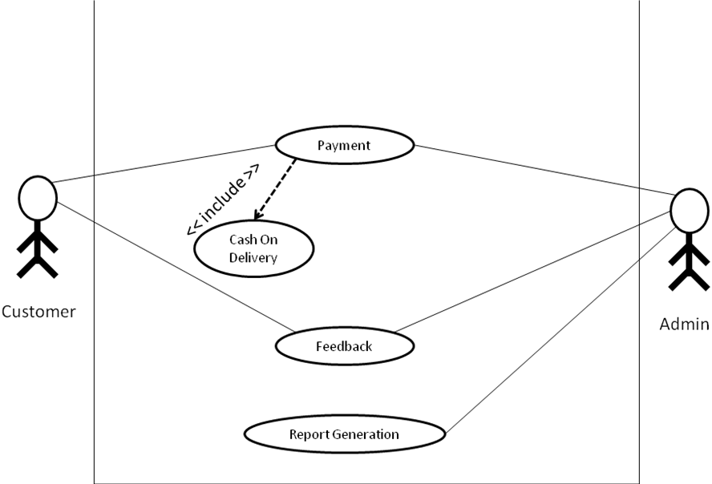

3.4 Sequence Diagram
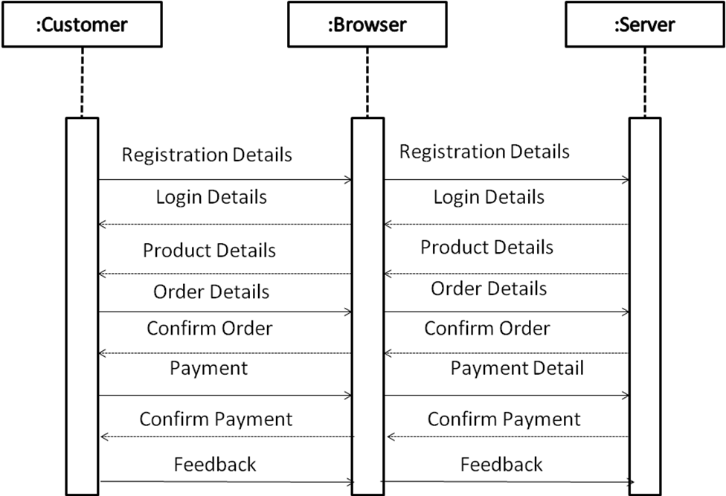

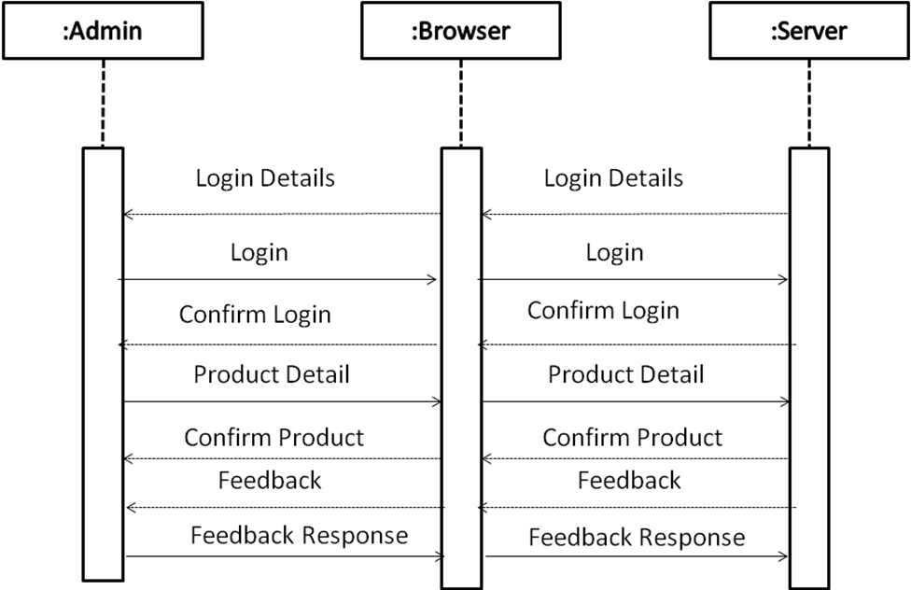

4. DRAWBACKS & LIMITATIONS

Project must be required a cart and online payment transaction, here that’s not fully executed & tested. System in not full dynamically so that admin can’t replace and modify the product, and admin can’t see the proper formatted report.
Also we are not developed the mobile application so user can’t buy the product by mobile phone, user have to access the website throw desktop or laptop.

5. PROPOSED ENHANCEMENTS

- No project is ever complete in itself; there are always minor or major changes in the project according to user requirements. This project could be enhanced in the sense that it can overcome its limitations in the future as sample scope for enhancement.

- Current system is developed according to current requirements which can be added later. In this system can be merged with another system to make bigger system invoking many functions on it.

- Latest electronic and software technologies can help to bring in more enhancement which would help to make the system more user friendly and also help to maintain adequate security

6. CONCLUSION

- The system can generate various reports useful for the management and as it is quite user friendly it saves time and reduce the chances of error occurrences. The co-ordination of various functions can be achieved and miss management does not take place.

- This system guide lines the user in maintaining proper and appropriate data, generation of report is easy and fast which can help the management to take quick decision. Proper security is maintained and data is protected from an unauthorized user.

7. BIBLIGRAPHY

Books :

HTML Bootstrap, CSS, MYSQL.

Websites :
www.w3school.com
www.google.com

