**School of Electronics and Communication Engineering**

**Second Year B. Tech.**

**Project Report on:**

**Spelling Checker using Trie**

**Group Members:**

1. Gaurav Prajapati – 1032221120
2. Sourabh Bhosale –
3. Vivaswan Sapre –

**Subject Teacher:** Dr. Alka Barhatte

**Subject:** Data Structures and Algorithms

**Div.:** B **Batch:** B3

**Academic Year:** 2023-24 (Semester-I)

**Problem Statement**

In today’s digital age, typing has become an integral part of communication with the advent of chatting tools such as WhatsApp, Telegram as well as Slack and Github. While typed communication is convenient, it is also simple to make spelling mitsakes while typing, and with English having over 600,000 words, checking if a word is correct sequentially against dictionary entries becomes an inefficient task.

Write a program in C using your Data Structure of choice to build a text-based application to check if a spelling is correct based on a external dictionary containing words separated by newlines[\n].

**Aim**

To check the grammatical correctness of a single word using a predefined dictionary containing over 5000 words, and to provide the user with an easy and intuitive text UI.

**Objective**

To efficiently store over 5000 words in RAM, and compare easily a given word with the dictionary.

**Introduction**

The ‘Trie’ is a special type of Tree Data Structure whose node values are only letters of the alphabet [‘a’ to ‘z’ and ‘A’ to ‘Z’]. This type of data structure can be efficiently used to store multiple words efficiently and is perfect for storing words because some words have overlaps [eg. ‘hell’ and ‘hello’]. When words have similar prefixes, the trie just appends to the end of prefix instead of starting a new list for each word.

The Trie is also known as a ‘Prefix Tree’.

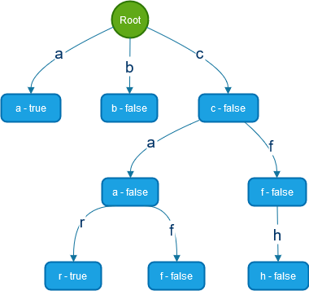

**Fig.:** Basic Structure of a Trie

Each node of a Trie contains a pointer to the child nodes which represent the possible characters that can follow the current node in a string. For our application, we have used a [struct](https://en.cppreference.com/w/c/language/struct) to hold a Boolean value and an array of pointers with each each representing the same indexed letter in the alphabet (a – 0, b – 1, … y – 24, z – 25)

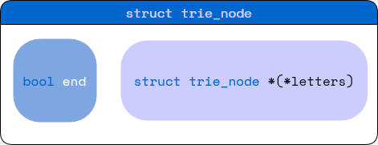

**Fig.:** struct representation of Trie Node

**Algorithm/Flowchart**

1. Flow of main()  
   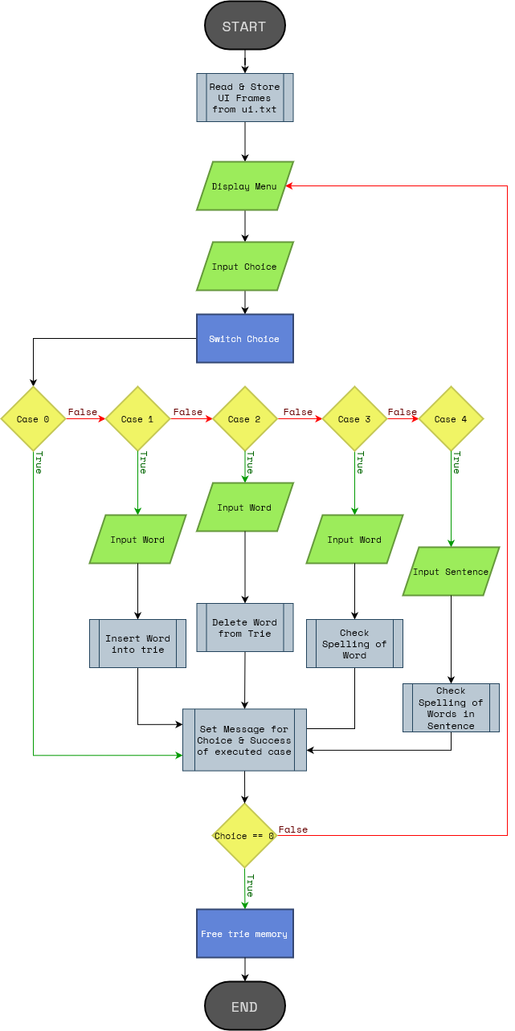
2. Trie Traversal for a given Word  
     
   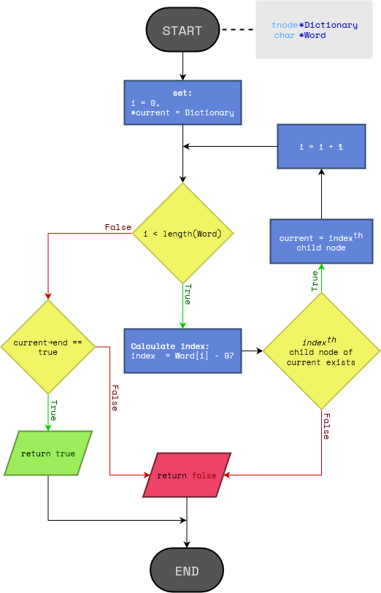

**Code**

#include *<string.h>*

#include *<assert.h>*

#include *<stdbool.h>*

#include *<stdlib.h>*

#include *<stdio.h>*

/***********************************************

|  * .-. .-. .-. .   .   .-. . . .-. .-. . .   |

|  * `-. |-' |-  |   |   |   |-| |-  |   |<    |

|  * `-' '   `-' `-' `-' `-' ' ` `-' `-' ' `   |

|  * Spelling Checker Application              |

|----------------------------------------------|

|  * *@author* Gaurav Prajapati   11             |

|  * *@author* Sourabh Bhosale    48             |

|  * *@author* Vivaswan Sapre     57             |

|----------------------------------------------|

|  * SY BTech ECE                              |

|  * Div. B - B3                               |

|----------------------------------------------|

|  * This is a C program to check correctness  |

|  * of an input spelling.                     |

|                                              |

|  * It uses a trie data structure having      |

|  * 27 subnodes for storing words.            |

***********************************************/

// structure definition for trie

*struct* trie_node {

*bool* end;

*struct* trie_node **letters;

}

tnode;

*int* tn_index(*char* *letter*) {

        switch (letter)

        {

        // if case range labels are OK:

        // case 'A' ... 'Z':

        //     letter += 32;

        // case 'a' ... 'z':

        //     index = letter - 97;

        //     break;

        // default:

        //     index = 26;

        //     break;

        case *'***\'***'*:

            return **26**;

        default:

            if(letter <= *'Z'*) letter += **32**;

            return (letter - **97**);

        }

        return -**1**;

}

/**

 * Node Creation Function for trie

 * *@retval* tnode*

 */

tnode *tn_new()

{

    tnode *new = (tnode *)calloc(**1**, sizeof(tnode));

    assert(new != **NULL**);

    // Set struct Values

    new->end = **false**;

    new->letters = (tnode **)malloc(**27** * sizeof(tnode *));

    // initialize garbage values to NULL

    for(*int* i = **0**; i < **27**; i++) new->letters[i] = **NULL**;

    return new;

}

/**

 * insert a word inside the dictionary

 * *@param* *Word pointer to Word to be added

 * *@param* *Dictionary Pointer to dictionary to add to

 */

*void* tn_insert(*char* \**Word*, tnode \**Dictionary*)

{

    tnode *current = Dictionary;

*int* index = **26**;

*int* len = strlen(Word);

*char* letter;

    for (*int* i = **0**; i < len && ((letter = Word[i]) != *'***\0***'*); i++)

    {

        if(letter == *' '* || letter == *'.'* || letter == *','*) break;

        index = tn_index(letter);

        if (current->letters[index] == **NULL**)

        {

            current->letters[index] = tn_new();

        }

        current = current->letters[index];

    }

    current->end = **true**;

}

/** Delete word from dicitionary

 * *@param* *Word word to remove

 * *@param* *Dictionary trie to delete from

 */

*bool* tn_delete(*char* \**Word*, tnode \**Dictionary*)

{

    tnode *current = Dictionary;

*int* index = **26**;

*int* len = strlen(Word);

*char* letter;

    for(*int* i = **0**; i < len && ((letter = Word[i]) != *'***\0***'*); i++)

    {

        if(letter == *' '* || letter == *'.'* || letter == *','*) break;

        index = tn_index(letter);

        // word does not exist

        if(current->letters[index] == **NULL**) return **false**;

        current = current->letters[index];

    }

    current->end = **false**;

    // successful deletion

    return **true**;

}

/** check spelling using trie

 * *@param* *Word pointer to Word to be checked

 * *@param* *Dictionary pointer to dictionary to check with

 */

*bool* check_word(*char* \**Word*, tnode \**Dictionary*)

{

    tnode *current;

    current = Dictionary;

*int* index = **26**;

*int* len = strlen(Word);

    // for (char *letter = Word; *letter != '\0' && *letter != ' ' && *letter != '\n'; letter++)

    for(*int* i = **0**; i < len; i++)

    {

*char* letter = Word[i];

        if(letter == *'***\0***'* || letter == *' '* || letter == *'***\n***'*) break;

        index = tn_index(letter);

        current = current->letters[index];

        if (current == **NULL**)

            return **false**;

    }

    return current->end;

}

/**

 * *@brief*  Check an english sentence against a dictionary

 * *@note* Uses check_word() which ends words at [',' '.' ' '] and so, only requires pointer to first character of word

 * *@param*  *Sentence: Sentence to be checked

 * *@param*  *Dictionary: Trie to check against

 * *@retval*  *true* if no wrongly spelled words, *false* otherwise

 */

*bool* check_sentence(*char* \**Sentence*, tnode \**Dictionary*)

{

*bool* res = **true**;

    for (*char* *lptr = Sentence; res && *lptr != *'***\0***'*; lptr++)

    {

        if (lptr == Sentence)

            res = check_word(lptr, Dictionary);

        else if (*lptr == *' '*)

            res = check_word(++lptr, Dictionary);

    }

    return res;

}

/**

 * *@brief*  Free up memory used by trie

 * *@note*   Similar to postorder traversal of BST

 * *@param*  **head: Pointer to a Pointer Variable containing address of root of tree

 * *@retval* None

 */

*void* tn_free(tnode \*\**head*)

{

    if (*head == **NULL**)

        return;

    for (*int* i = **0**; i < **27**; i++)

        tn_free(&((*head)->letters[i]));

    if((*head) != **NULL**) free((*head));

}

/**

 * Dictionary to be preloaded is stored

 * in Plaintext[.txt] format.

 *

 * Each word is on a new line

 *

 * FILE STRUCTURE

 * +-------------------+

 * | word1(\n)         |

 * | word2(\n)         |

 * | ...               |

 * | lastWord(EOF)     |

 * +-------------------+

 */

/**

 * *@brief*  preload words into trie from res/words.txt

 * *@retval* Address of head node of created trie

 */

tnode *file_to_trie()

{

    tnode *new = tn_new(), *current;

    current = new;

    FILE *dfile = fopen(*"./res/words.txt"*, *"r"*);

    // assert(dfile != NULL);

*char* letter;

*int* index;

    while ((letter = fgetc(dfile)) != EOF)

    {

        switch (letter)

        {

        // '\r' -> Carriage Return

        // This case is to fix any issues due to presence of \r

        case *'***\r***'*:

            break;

        case *'***\n***'*:

            current->end = **true**;

            current = new;

            break;

        default:

            index = tn_index(letter);

            if(current->letters[index] == **NULL**)

            {

                current->letters[index] = tn_new();

                current->letters[index]->end = **false**;

            }

            current = current->letters[index];

            break;

        }

    }

    current->end = **true**;

    fclose(dfile);

    current = **NULL**;

    return new;

}

/**

 * Frames for the UI are stored in ui.txt

 * Each frame is 44x15+8 ~ 700

 *   44 -> columns

 *   15 -> rows

 *   8 -> VT100 sequence terms

 * Total of 5 frames:

 *   1  -> STARTUP/IDLE

 *  2-5 -> MENU CHOICE

 */

// Array to hold frames of UI

static *char* frames[**5**][**700**];

// String holding output from last executed command

static *char* message[**70**];

// initialize frames from res/ui.txt

*void* init_frames()

{

*FILE* *ui_file = NULL;

    // open res/ui.txt for reading frames

    ui_file = fopen(*"./res/ui.txt"*, *"r+"*);

    if (ui_file == NULL)

        perror(*"Error opening file"*);

    for (*int* i = **0**; i < **5**; i++)

    {

*char* px = fgetc(ui_file);

*int* j, x_cnt = -**2**;

        for (j = **0**; x_cnt && px != EOF; j++)

        {

            switch (px)

            {

            case *'***\\***'*:

                fgetc(ui_file);

                frames[i][j] = *'***\033***'*;

                break;

            default:

                frames[i][j] = px;

                break;

            }

            px = fgetc(ui_file);

            if (px == *'X'*)

                x_cnt++;

        }

        frames[i][j] = *'***\0***'*;

        fgetc(ui_file);

    }

    fclose(ui_file);

}

// Display UI Frame

// @param Frame Frame number to be displayed

*void* display_ui(*int* *Frame*)

{

    if (!(*Frame* >= **0** && *Frame* < **5**))

        return;

    // reset cursor position and style

    printf(*"***\033***[2J***\033***[H***\033***[0;0m"*);

    // print frame

    printf(*"***%s***"*, frames[*Frame*]);

    // save input cursor position

    printf(*"***\033***[2A***\033***[6C***\033***[s"*);

    // move cursor to message area

    printf(*"***\033***[H***\033***[5B***\033***[4C"*);

    // print message

    printf(*"***%s***"*, message);

    // restore saved cursor position

    printf(*"***\033***[u"*);

}

// Set Message

// @param Key int

// @param success bool

// @param str char*

*void* set_message(*int* *Key*, bool *success*, *char* \**str*)

{

    // Clear str message

    strcpy(message, *"***\0***"*);

    switch (*Key*)

    {

    case **1**:

        if(*success*)

            sprintf(message, *"***\033***[32mSuccessfully added* **%s\033***[0;0m"*, *str*);

        else

            sprintf(message, *"***\033***[31mError in adding* **%s\033***[0;0m"*, *str*);

        break;

    case **2**:

        if(*success*)

            sprintf(message, *"***\033***[32mSuccessfully deleted* **%s\033***[0;0m"*, *str*);

        else

            sprintf(message, *"***\033***[31m***%s** *not in Dictionary***\033***[0;0m"*, *str*);

        break;

    case **3**:

        if (*success*)

            sprintf(message, *"***\033***[32m***%s** *is Correct!!***\033***[0;0m"*, *str*);

        else

            sprintf(message, *"***\033***[31m***%s** *is Wrong!!***\033***[0;0m"*, *str*);

        break;

    case **4**:

        if (*success*)

            sprintf(message, *"***\033***[32mSentence is spelled Correct!!***\033***[0;0m"*);

        else

            sprintf(message, *"***\033***[31mSentence has Wrong spellings!!***\033***[0;0m"*);

        break;

    default:

        sprintf(message, *"***\033***[31mInvalid Choice!!***\033***[0;0m"*);

        break;

    }

}

*int* main()

{

    init_frames();

*tnode* *DICT = file_to_trie();

*int* opt = **0**;

    bool res = false;

*char* buf[**32**],ch;

    // start alternative buffer

    printf(*"***\033***[?1049h"*);

    do

    {

        // display frame for menu [0]

        display_ui(**0**);

        fflush(stdin);

        scanf(*"***%d***"*, &opt);

        // display selected option [opt]

        display_ui(opt);

        fflush(stdin);

        switch (opt)

        {

        case **1**:

            scanf(*"***%s***"*, buf);

            tn_insert(buf, DICT);

            if(check_word(buf,DICT)) res = true;

            else res = false;

            break;

        case **2**:

            scanf(*"***%s***"*, buf);

            res = tn_delete(buf, DICT);

            break;

        case **3**:

            scanf(*"***%s***"*, buf);

            res = check_word(buf, DICT);

            break;

        case **4**:

            // get rid of leading \n in input buffer

            while((ch = fgetc(stdin)) == *'***\n***'*);

            buf[**0**] = ch;

            buf[**1**] = *'***\0***'*;

            scanf(*"*%*[^***\n***]"*, buf+**1**);

            res = check_sentence(buf, DICT);

            break;

        default:

            break;

        }

        // set message line

        set_message(opt,res,buf);

    } while (opt);

    // close alternate buffer

    printf(*"***\033***[?1049l"*);

    // free up memory taken by trie

    tn_free(&DICT);

    return **0**;

}

**Input**

|  |  |
| --- | --- |
| **Input Field** | **Datatype** |
| Choice of operation to perform from user | int |
| Word to be checked/inserted | char[] |

**Output**

1. Menu
2. Success Messages

**Applications**

1. **Autocomplete Suggestions:**   
   Tries are commonly used in search engines and text editors to provide autocomplete suggestions for words or phrases as users type. By traversing the trie and matching prefixes, the system can quickly suggest relevant completions based on the user's input.
2. **Spell Checkers:**   
   Tries are employed in spell checkers to identify and correct misspelled words. By comparing a word against the trie dictionary, the spell checker can determine if the word exists and suggest alternatives if necessary.
3. **Routing Tables:**   
   Tries are used in routing tables to efficiently route network traffic. The trie structure allows for efficient matching of IP addresses to determine the appropriate routing path for data packets.
4. **Data Compression:**Tries can be used for data compression by identifying common prefixes and representing them as shared nodes. This technique can reduce the overall storage space required for text data.
5. **Dictionary Lookup:**   
   Tries can be used to implement efficient dictionary lookup, enabling fast search and retrieval of words and their definitions. The trie structure allows for quick matching of words against the dictionary.
6. **IP Address Matching:**   
   Tries are used in IP address lookup tables to efficiently find the corresponding location or organization associated with a given IP address. The trie structure allows for quick matching of IP addresses to the corresponding entries in the lookup table.

**Conclusion**

Tries have proven to be a valuable data structure for implementing spelling checkers due to their efficient insertion, searching, and pattern matching capabilities. Their ability to handle large dictionaries and suggest alternative spellings makes them well-suited for this task. The trie-based spelling checker offers several advantages over traditional dictionary-based approaches, including:

* Efficient lookup of words and their corresponding suggestions
* Ability to handle misspellings with insertions, deletions, or transpositions
* Adaptability to new words and spellings through continuous learning

The versatility and efficiency of tries make them a powerful tool for ensuring error-free communication in the digital age.

**References**

<https://www.scaler.com/topics/data-structures/trie-data-structure/>

<https://www.toptal.com/java/the-trie-a-neglected-data-structure>

<https://www.digitalocean.com/community/tutorials/trie-data-structure-in-c-plus-plus>

<https://medium.com/basecs/trying-to-understand-tries-3ec6bede0014>

<https://draw.io>