Agentic AI for Security Scan Analysis
Personal Project Report by GAURAV

1. Project Objective
This project was created to understand how an Agentic AI system can be integrated into a cybersecurity workflow. Instead of creating a large commercial vulnerability assessment platform, the objective was to build a small proof-of-concept that demonstrates how Artificial Intelligence can work alongside traditional security tools.
The project integrates the Nmap network scanner with Google's Gemini API. After scanning a target system, the AI agent interprets the results, identifies potential security risks, recommends remediation, and suggests appropriate follow-up penetration testing activities.
The primary learning objective was to understand AI integration, prompt engineering, workflow design, and practical cybersecurity automation.

2. Introduction
Artificial Intelligence is rapidly changing cybersecurity. Security analysts often spend significant time interpreting scan results generated by tools such as Nmap. While these tools identify open ports and running services, they do not explain what the findings mean or recommend the next testing steps.
This project demonstrates how an AI agent can bridge that gap. Instead of replacing the analyst, the AI acts as an assistant that converts technical scan results into structured security recommendations.
The application was intentionally kept small so that the focus remained on understanding the integration rather than building a complex platform.

3. Problem Statement
Network scanning tools generate technical output that can be difficult for beginners to understand. New cybersecurity learners may know how to execute an Nmap scan but may struggle to interpret the results.
This project addresses that challenge by allowing an AI agent to analyze the scan output and generate a structured explanation including risks, remediation, and recommended next actions.

4. Objectives
• Understand Agentic AI concepts.
• Integrate AI with Nmap.
• Learn Flask web development.
• Perform automated network scanning.
• Use prompt engineering.
• Generate professional security reports.
• Recommend follow-up VAPT activities.

5. Technology Stack
Programming Language: Python
Backend Framework: Flask
Frontend: HTML and CSS
AI Model: Google Gemini API
Security Tool: Nmap
Development Environment: Visual Studio Code
Version Control: Git and GitHub
Python manages the application logic, Flask provides the web interface, Nmap performs reconnaissance, and Gemini provides intelligent analysis.

6. Project Workflow
Step 1: User enters an IP address or domain.
Step 2: Flask receives the request.
Step 3: Python executes an Nmap scan.
Step 4: Scan results are collected.
Step 5: Results are sent to Gemini.
Step 6: AI generates a structured report.
Step 7: Results are displayed on the web page.
The workflow separates scanning from reasoning, making the architecture modular and easy to extend.

7. Agentic AI Workflow (Observe → Reason → Decide → Act)
Observe: Read and understand the Nmap scan output.
Reason: Analyze open ports, running services, versions, and possible attack surfaces.
Decide: Prioritize risks and determine the most relevant next security assessments.
Act: Produce a professional report containing executive summary, risk analysis, remediation, and recommended testing activities.
This workflow demonstrates that an AI agent performs structured decision-making rather than simply answering questions.

8. Key Features
• Web interface for entering targets.
• Automated Nmap scanning.
• AI-powered security analysis.
• Executive summary generation.
• Risk prioritization.
• Remediation recommendations.
• Suggested next penetration testing steps.
• Simple modular architecture.

9. Project File Descriptions
app.py: Handles HTTP requests and coordinates the workflow.
nmap_tool.py: Executes Nmap using Python subprocess.
security_agent.py: Connects to Gemini API and performs AI analysis.
prompts.py: Stores the system prompt for consistent responses.
templates/index.html: User interface.
static/style.css: Visual styling.
.env: Stores API key securely.
requirements.txt: Lists project dependencies.
README.md: Documents the project.

10. Testing
The application was tested using localhost, scanme.nmap.org, and a Metasploitable virtual machine.
Functional testing confirmed successful execution of Nmap scans, API communication with Gemini, rendering of AI reports, and graceful handling of common errors such as unreachable hosts and temporary AI service failures.

11. Screenshots

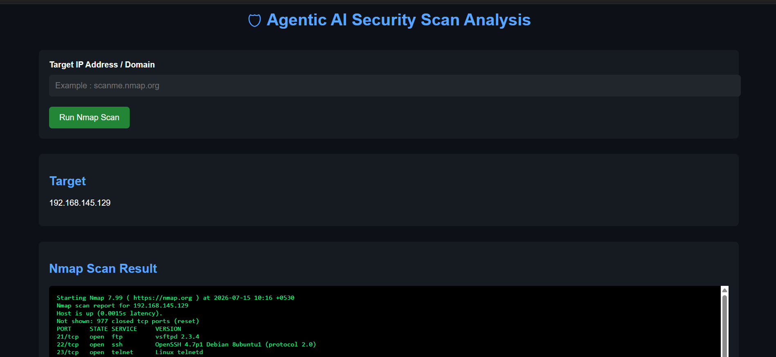
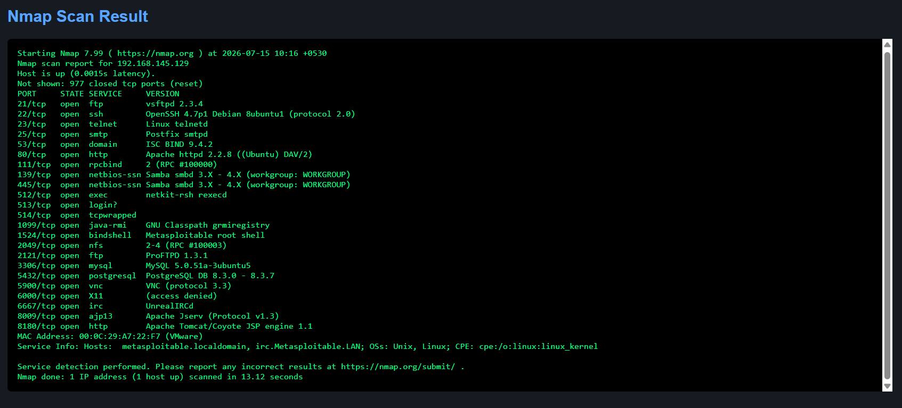

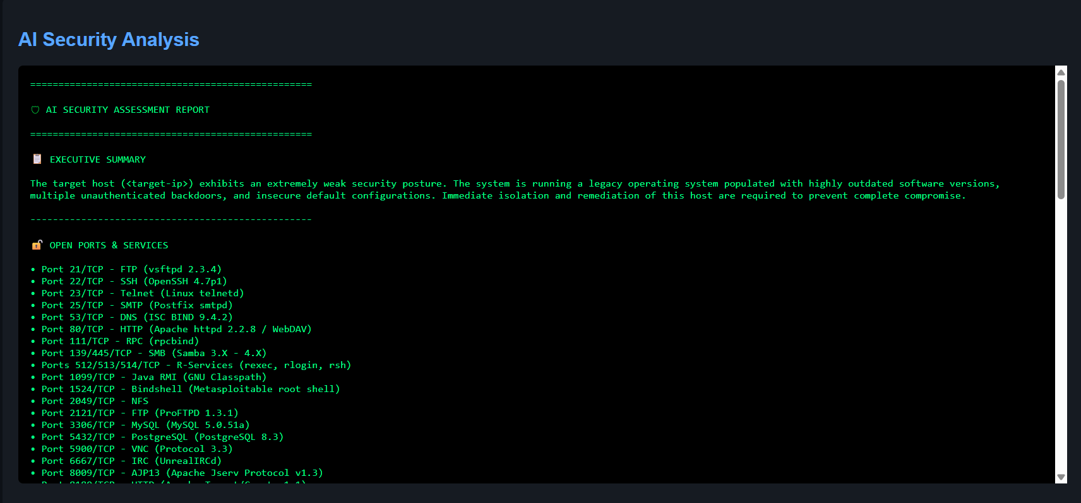

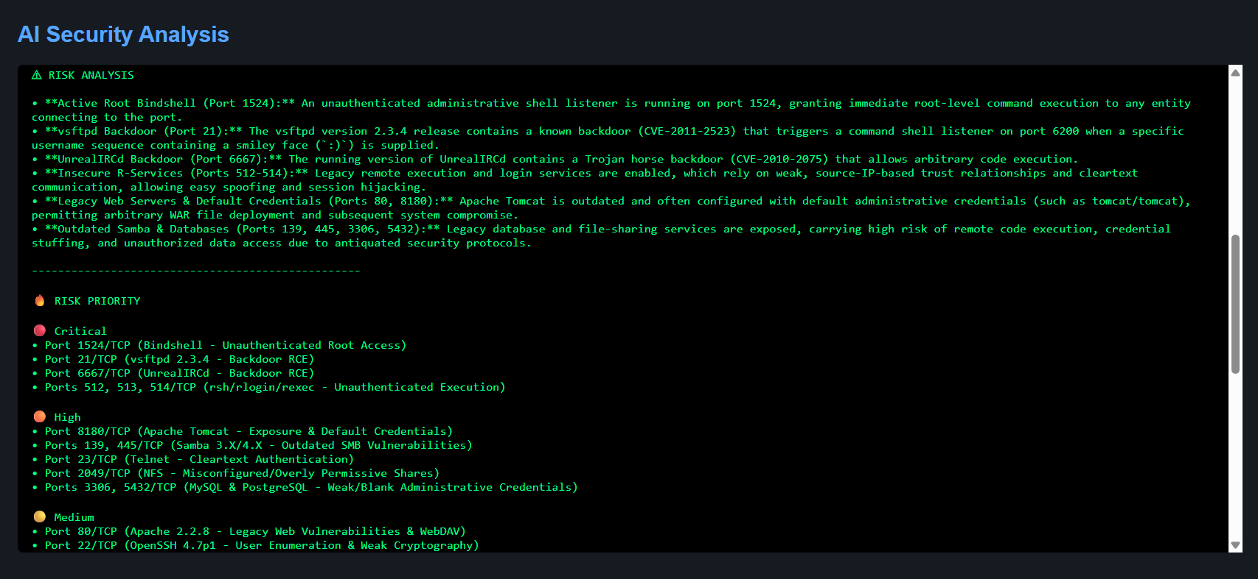

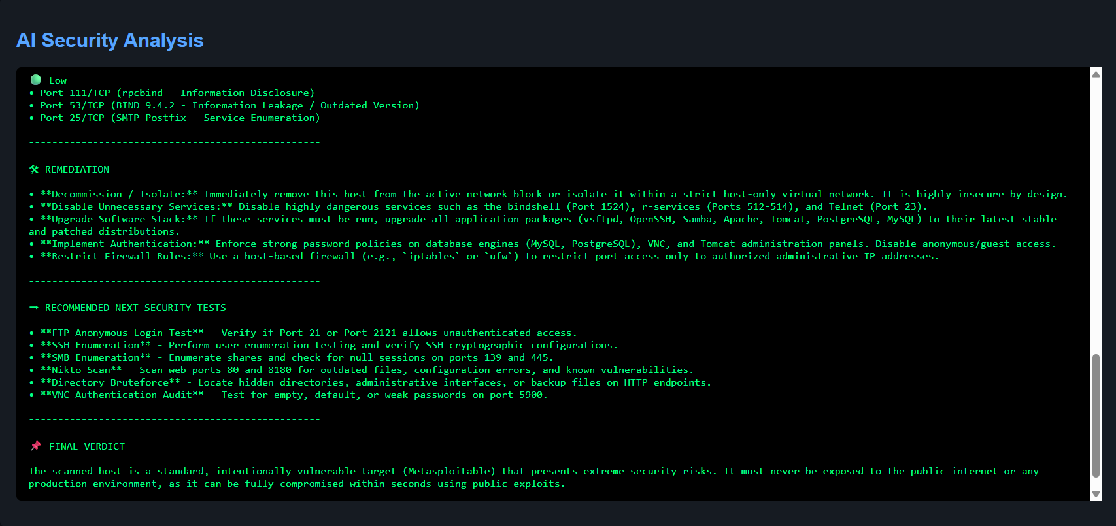

12. Learning Outcomes
This project strengthened practical knowledge of Flask, Python subprocess execution, environment variable management, AI API integration, prompt engineering, and cybersecurity workflows.
It also demonstrated the difference between a chatbot and an AI agent by introducing a structured Observe → Reason → Decide → Act process.

13. Future Scope
Possible improvements include integration with OWASP ZAP, Nuclei, Burp Suite, automated PDF reports, CVSS scoring, historical scan comparison, multi-tool orchestration, and richer dashboards.
These were intentionally excluded to keep the project focused on understanding Agentic AI.

14. Conclusion
The project successfully demonstrates how a lightweight AI agent can assist a cybersecurity analyst by interpreting Nmap scan results and producing actionable recommendations.
Although simple, it provides a solid foundation for understanding AI-assisted security workflows and can be extended into a larger VAPT automation platform in the future.

