**SENSORS**

**SENSOR LIST**

* SOIL MOISTRURE SENSOR
* PIR MOTION SENSOR

**SOIL MOISTURE SENSOR:**

Block diagram:

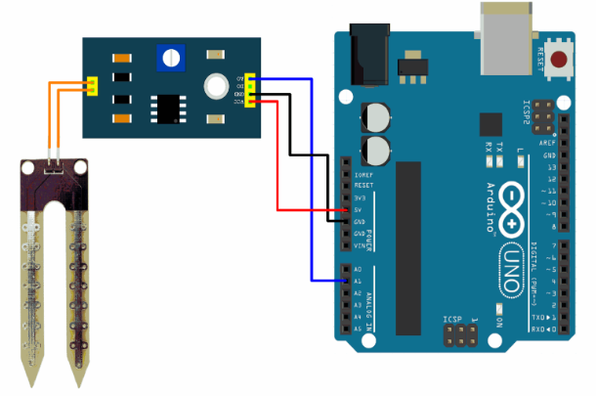

**CODE:**

const int sensor_pin = A1; /* Soil moisture sensor O/P pin */

void setup() {

Serial.begin(9600); /* Define baud rate for serial communication */

}

void loop() {

float moisture_percentage;

int sensor_analog;

sensor_analog = analogRead(sensor_pin);

moisture_percentage = ( 100 - ( (sensor_analog/1023.00) * 100 ) );

Serial.print("Moisture Percentage = ");

Serial.print(moisture_percentage);

Serial.print("%\n\n");

delay(1000);

}

**LOGIC**

Formula :moisture_percentage = ( 100 - ( (sensor_analog/1023.00) * 100 ) );

Here

**DATA SHEET:**

Features:

Operating principle: This module is an application of the current amplification by a transistor. When the water in the soil is sufficient enough to conduct the current between the base and the positive power supply, a certain amount of current is generated between the base and the emitter. And in a mean while, an electric current is produced in a certain amplification factor between the collector and the emitter, and applied to the resistant in the emitter to produce a voltage. Then, this voltage will be collected by an AD converter.

**Specification:**

* Sensitivity is adjustable via the blue digital potentiometer
* Operating voltage 3.3V-5V
* Module dual output mode: digital output or analog output giving more accuracy
* Has pre-drilled hole for easy installation
* Small board PCB size: 3cm * 1.6cm
* Power indicator (red) and digital switching output indicator (green)
* Uses the LM393 comparator chip

*Signals and connections of the soil moisture sensor YL-69, FC-28 or HL-69*

**VCC (5V)** - connect to 3.3 V or 5V pin of Arduino board.

**GND** **(or G)** - ground pin of Arduino board

**SIG -**an analog signal out that can be attached to the ADC pin on any microcontroller. The value read on SIG will vary depending on the voltage with which you power the sensor

**D0**- Digital output to Arduino board

**A0** - Analog output to Arduino board

The "A0", is a serial signal 0-5 volts that when fully dry it outputs 5 volts, when fully wet, 0 volts. The "D0", is configured with the trim pot and is brought high when the moisture level reaches a desired point.

**PIR SENSOR:**

**Block diagram:**

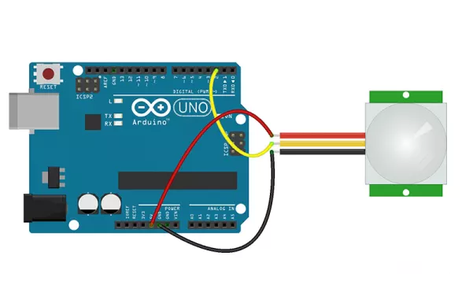

**CODE:**

int ledPin = 13; // LED

int pirPin = 2; // PIR Out pin

int pirStat = 0; // PIR status

void setup() {

pinMode(ledPin, OUTPUT);

pinMode(pirPin, INPUT);

Serial.begin(9600);

}

void loop(){

pirStat = digitalRead(pirPin);

if (pirStat == HIGH) { // if motion detected

digitalWrite(ledPin, HIGH); // turn LED ON

Serial.println("Hey I got you!!!");

}

else {

digitalWrite(ledPin, LOW); // turn LED OFF if we have no motion

}

}

**LOGIC:**

If the pin is high give out corresponding message. Here it is “he ,I got you”

**DATA SHEET**

**PIR Sensor Features**

* Wide range on input voltage varying from 4.V to 12V (+5V recommended)
* Output voltage is High/Low (3.3V TTL)
* Can distinguish between object movement and human movement
* Has to operating modes - Repeatable(H) and Non- Repeatable(H)
* Cover distance of about 120° and 7 meters
* Low power consumption of 65mA
* Operating temperature from -20° to +80° Celsius

### ****How to use PIR Motion Sensor****

The PIR sensor stands for Passive Infrared sensor. It is a low cost sensor which can detect the presence of Human beings or animals. This sensor has three output pins Vcc, Output and Ground as shown in the pin diagram above. Since the output pin is 3.3V TTL logic it can be used with any platforms like Arduino, Raspberry, [PIC](https://components101.com/pic16f877a-pin-diagram-description-features-datasheet), ARM, 8051 etc..

The module can be powered from voltage 4.5V to 20V but, typically 5V is used. Once the module is powered allow the module to calibrate itself for few minutes, 2 minutes is a well settled time. Then observe the output on the output pin. Before we analyse the output we need to know that there are two operating modes in this sensor such as Repeatable(H) and Non- Repeatable(L) and mode. The Repeatable mode is the default mode.

The output of the sensor can be set by shorting any two pins on the left of the module as shown below. You can also notice two orange colour potentiometers that can be used to set the sensitivity and time which will be explained further below.

### Repeatable(H) mode

In Repeatable(H) mode the output pin Dout will go high (3.3V) when a person is detected within range and goes low after a particular time (time is set by “Off time control” potentiometer). In this mode the output pin will go high irrespective of whether the person is still present inside the range or has left the area. The sensitivity can be set using the “sensitivity control” potentiometer

### Non- Repeatable(L) mode

In “I” mode the output pin Dout will go high (3.3V) when  a person is detected within range and will stay high as long as he/she stays within the limit of the Sensors range. Once the person has left the area the pin will go low after the particular time which can be set using the potentiometer. The sensitivity can be set using the “sensitivity control” potentiometer

**PIR Sensor Applications**

* Automatic Street/Garage/Warehouse or Garden Lights
* Burglar Alarms
* Security cams as motion detectors
* Industrial Automation Control