Input:

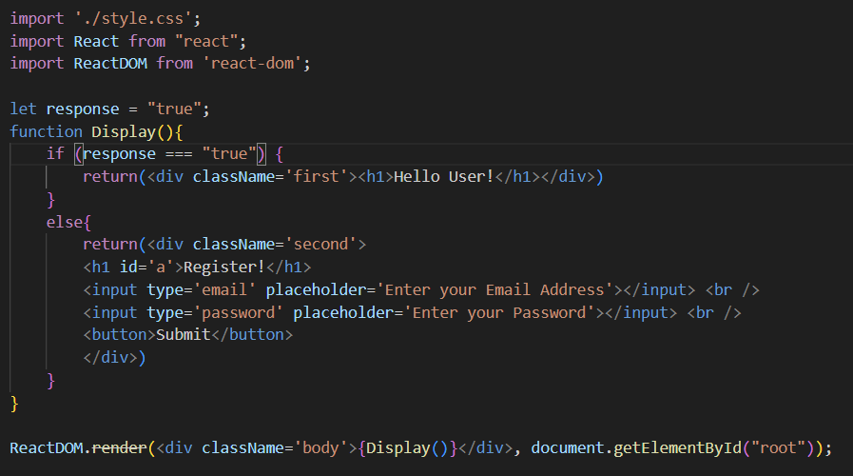

When we put true value in response variable then the output will be:



Input:

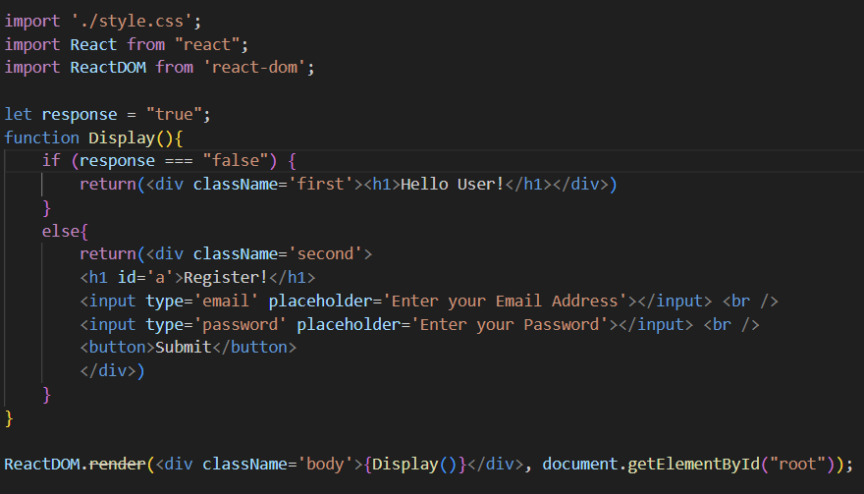

And when user enters false in the response variable then the output will be:



Basically, it is the practice of conditional statements and functions in the ReactJS