Input:

 function print(){

        console.log("Javascript");

        }

        print()

Output:



Input:

//Function to print the sum of numbers by taking input from the user

        function sum(){

            console.log("sum of two numbers:", + a+b);

        }

            let a = Number(prompt("Enter 1st number"));

            let b = Number(prompt("Enter 2nd number"));

        sum()

Output:



Input:

// Function to print the whole table of number entered by the user

        function multiplication(){

            for (let i=1; i<=10; i++) {

                console.log(`${number} \* ${i} = ${number\*i}`);

            }

        }

        let number = Number(prompt("Enter the number which generates its own table"));

        multiplication()

Output:

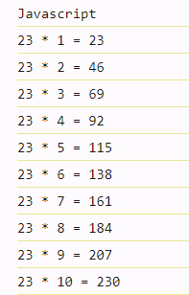

Input:

// Function to tell how many vowels are there in a inputed string by the user

        function vowel(){

            let count=0;

            for (const i of string) {

                if (i==="a" || i==="e" || i==="i" || i==="o" || i==="u") {

                    count = count+1;

                }

            }

            console.log("No. of vowels in the string:", + count)

        }

        let string = prompt("Enter any word");

        vowel()

Output:

Word Entered: Hii how are you?



Input:

// Function to calculate the factorial of the entered number

        function factorial(){

            let fact= 1 ;

            for (let i=1; i<=num; i++) {

                fact= fact\*i;

            }

            console.log("Factorial of the inputed number is:", + fact);

        }

        let num = Number(prompt("Enter the number:"))

        factorial()

Output:

No. entered: 5

