Input:

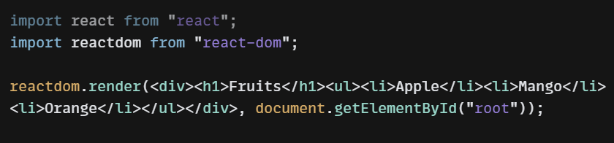

Output:

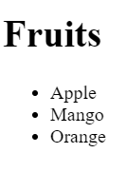

Input:

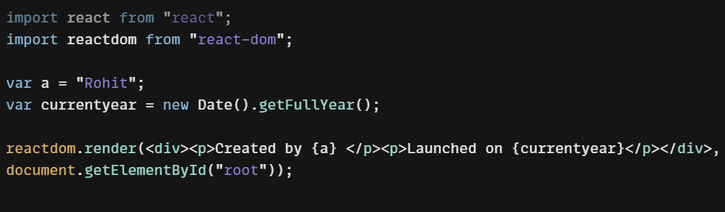

In JS we use ${} to select an element but in react we only use {}

Output:

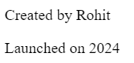

Input:

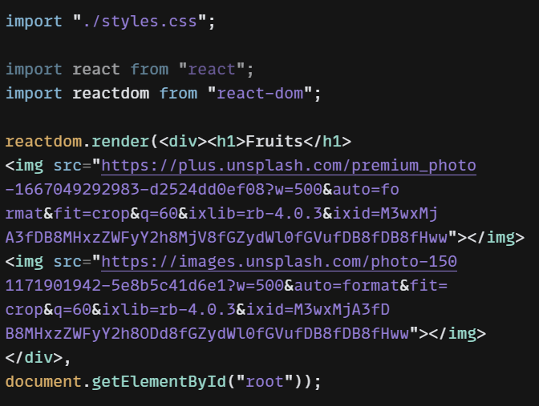

Also used external CSS in the code

Output:

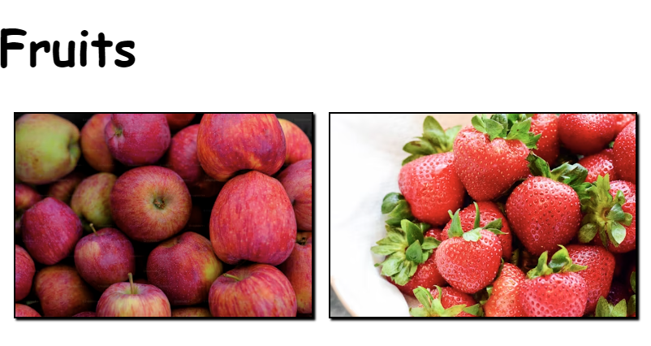

Input:

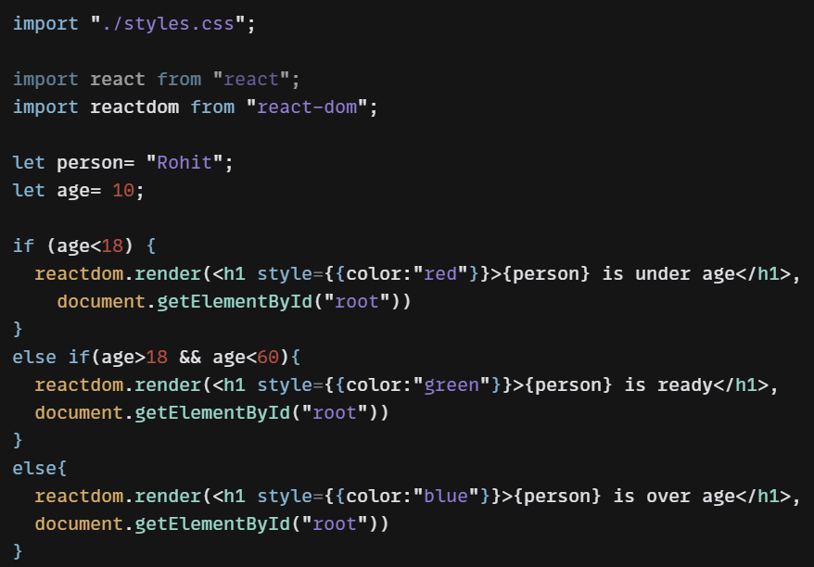

Inline CSS is there with the help of curly braces

Output:

When age is 10



When age is 40



When age is 80

