Input:

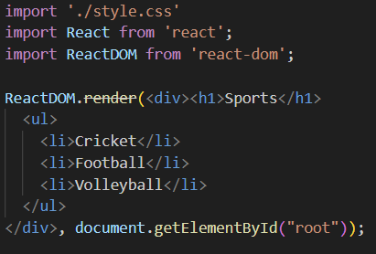

Output:

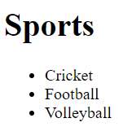

Instead of this code, we can make new components and place them in this code so, that this code will look more prettier than this one

Input:

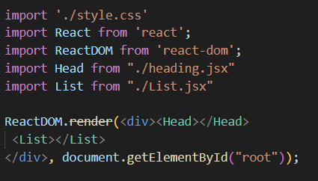

Created two components of JSX

Output:



Added some styling also with the help of CSS