Input:

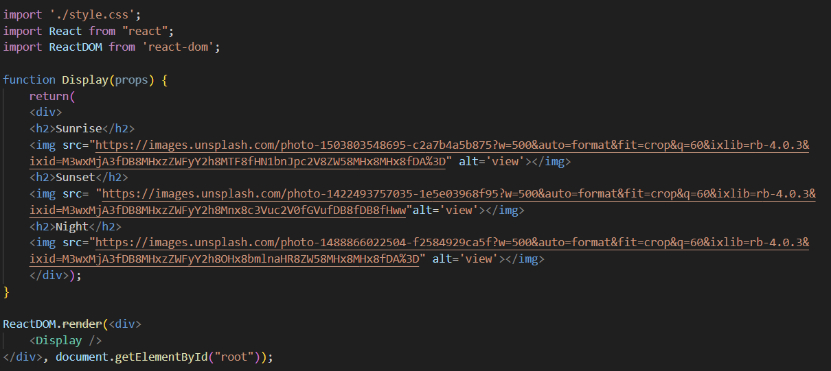

As this code will present the data but it seems like repetition of the input code.

To eliminate that we will use props which are same as HTML attributes.

Input:

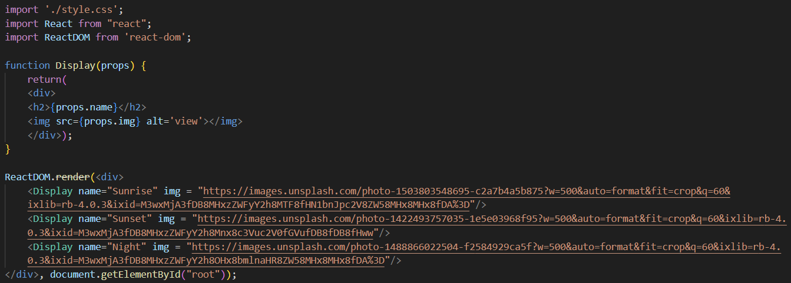

Output:

