**Normalization Assignment**

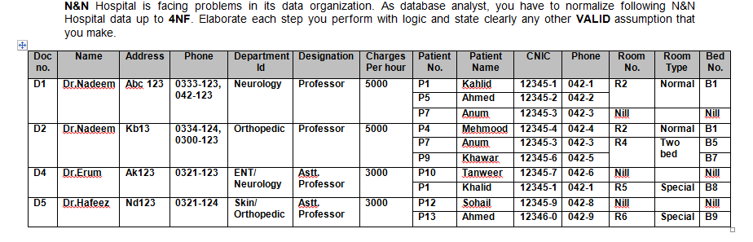

1. In order to convert the given table into first normal form, we remove the multi-valued attirbutes, which are the phone number of the doctor and the patient names. We achieve this by separating the table into three different tables and reference the separated attributes by a reference in the different tables.
2. The schema has partial dependency as room type is dependant on the room number, and not the main candidate key of the table. We remove this and achieve the second normal form.
3. The final normalization is achieved by removing the dependency of the non-prime attribute and creating new tables to ensure only the superkeys are the determinants.

