Sr. No. | Date | Title | Images / Videos
1 | 26-06-2024 | CERT-In and Mastercard India signed an MoU on 19 June 2024 for collaboration in the area of cyber security to enhance India’s cyber-resilience in the Financial Sector through CSIRT-Fin in the presence of Hon'ble MoS for MOCI & MeitY. | 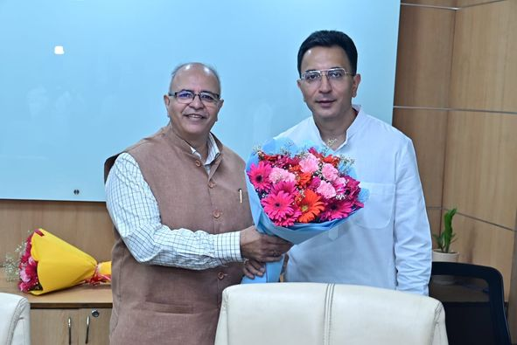
 |  |  | 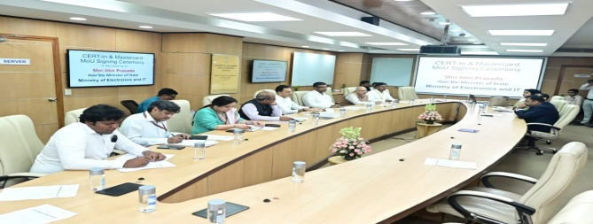
 |  |  | 
Details of Social Media posts (01/12/2023 to 25/07/2024)
CeG (MeitY)

