CHAPTER 1
INTRODUCTION
1.1 | Introduction About the company
1.2 | Problem Statement
1.3 | Proposed Solution
1.4 | Deliverables

1. Introduction
1.1 Introduction about the company

IFFCO Kisan Sanchar Limited is an innovative concept promoted by Indian Farmers Fertiliser Cooperative Limited (IFFCO), world's largest producer and distributor of Fertilisers, to promote rural communications with value added services.
The company is empowering farmers with timely, relevant, high quality information and services by leveraging mobile telephone.
Airtel is extending its network backbone to IFFCO Kisan Sanchar Limited and also provide a sustainable income generating business opportunity to Cooperative Societies. In this model, the telecom products of Airtel are made available to farmers and people living in villages through cooperative societies. The same SIM Card which is used for communication is turned into a powerhouse of knowledge for empowering people living in villages through relevant and pertinent information which is being provided by IFFCO Kisan Sanchar Limited through Value Added Service (VAS).
To improve informed decision making by farmers which could result in reduction in costs, improvement in quality, increase in income and enhanced opportunities for livelihood.
The services provided by IFFCO KISAN are as follows:-
- IFFCO Kisan Agriculture Mobile Application, available on IOS and Google Play Store provides weather forecasts, market rates, agricultural market information, customized advisories, news etc. in 11 different Indian languages. One can also post their queries through the app which would be answered by our Agri Experts.
- IFFCO Kisan is managing the Kisan Call centre service on behalf of Department of Agriculture & Cooperation (DAC), Ministry of Agriculture (MOA). Farmers from any part of the country using any telecom operator can contact the Kisan Call Centre by dialling the Toll free number 18001801551 and ask their queries related to farming.
- IFFCO Kisan Urban Green (IKUG) is a customized informational mobile application and web portal service for all gardening enthusiasts which guides people who are interested in growing flowers & vegetables in their home yard or kitchen garden. One can also purchase different plants through the portal/mobile app and can also post their problem which would be attended by our experts.
- IFFCO Kisan provides customized software solutions for Human Capital Management, HRMS and Payroll to effectively engage, manage and monitor employee in an organization. Am-Pro offers customized solutions to monitor and track manpower, end to end recruitment and exit solutions, leave and tour management solutions, employee engagement, LMS and all other HR solutions through a web portal and mobile application.
1.2 Problem Statement
In earlier times, before the advent of web-based applications and web-based, database technologies any company had to maintain cumbersome files and records of all its sold products and purchases. These were troubled times as trivial billing issue are hard to note and logged in a file. It wasted much of company’s resources providing less productivity. These files needed to be stored and archived properly for future use which was all the more troublesome as they needed huge space over the years for any large company. The task was cut out, to develop an efficient system that manages the purchase, sales, dead stock and all the functionalities that could be provide by a well-designed billing system. The system should maintain a secure database for orders and issues could be resolved through a user friendly UI.
1.3 Proposed Solution
The objective of this project is to manage the sales of Urban Green products i.e. Pots, plants, manure and tools. Managing these resources may itself be sufficient enough to give any company a big jump in terms of productivity and efficiency. Objective is to build a web-application for organization that manages such tasks and synchronizes whole billing process. Portal has three types of users:-
- Billing person
- Accountant
- Admin User
Billing person is has the following rights in the application –
- Login to the system using their “User Name” and “Password”.
- Place order for the consumer
- View pending orders
- Update the price of the products
- Can Print labels for products
- View payment Status Report
- Order status report
- Gate Pass (Used for granting permission to display the plants at an exhibition and bill according to the sale done)
Accountant has the following rights in the application –
- Login to the system using their “User Name” and “Password”.
- View payment Status Report
- Order status report
- Post In ERP
Admin Users have all rights throughout the application. They have following additional right in the application along with employee rights:-
- Login to the system using their admin “User Name” and “Password”.
- Grant access of modules to the employees according to their job assigned.
- Has full access to the database and all the rights any of the employees has.
1.4 Deliverables
The list of deliverables is provided in Table 1.1.
Table 1.1: List of deliverables
S. No. | Phase | Deliverables | Page No.
1. | Requirement Analysis | Use Case | 53
2. | Design | Entity Relationship Diagram | 14
3. | Design | Data Flow Diagrams | 55
4. | Unit Testing | Test Results | 43

CHAPTER 2
PROJECT DESCRIPTION
2.1 | System Interfaces
2.2 | System Specifications
 | 2.2.1 H/W Requirement
 | 2.2.2 S/W Requirement
2.3 | Methodology and Tools used
 | 2.3.1 Requirement Phase
 | 2.3.2 Design Phase
 | 2.3.3 Development Phase
 | 2.3.4 Implementation Phase
 | 2.3.5 Testing Phase
2.4 | Constraints
2.5 | Assumptions & Dependencies
2.6 | User Characteristics

2. Project Description
2.1 System Interfaces
The overall System has the following Interfaces:
- Login Page:
  - This interface allows user to login to the system.
  - Provides Form based authentication.
  - Performs the authentication and authorization process.
- Home Page:
- This is the landing page after the user is logged in
  - This page will be accessible to both employee and admin user.
  - This section displays all the tabs like Order Processing, Label Printing, and Accounts.
- Create Order Page:
- This page is reached in case Admin/User clicks on Order Processing Tab.
  - This section allows the billing person to create the order.
  - This is the initial step for the creation of order.
- Pending Order Page:
  - This page is reached in case Admin/user clicks on Order Processing Tab.
  - After the order is created, it is displayed in pending orders where all the details can be viewed unless the payment is made.
- Print Label Page:
  - This page is reached in case Admin/user clicks on Label Printing Tab.
  - This page allows the billing person to create a label with the ‘QR code’ to be pasted on the product.
- Payment Status Report Page:
- This page is reached in case Accountant/Admin clicks on Accounts Tab.
  - The report gives us the information about the payments made in cash or card.
  - The sales order no. And voucher order number could be viewed.
- Order Status Report Page:
- This page is reached when the Accountant /user clicks Accounts tab.
  - The report gives us the information about the orders which were approved, kept pending or rejected during the asked interval.
- Post in ERP page:
  - This page is reached when the Accountant/Admin clicks on the Accounts tab.
  - Sales order, voucher number, sales invoice is created, by clicking on Post in ERP button.
  - All the accounting details are posted in ERP.
- Create Gate Pass Page:
- This page is reached in case User/Admin clicks on Order Processing Tab.
  - Gate pass is used when the products are sent out of the store for display or gifts.
- Pending Gate Pass Page: This page is reached when the Admin/user clicks Order Processing tab.
  - The gate pass is kept in pending until the products return to the store or if they are sold the process carries out accordingly.
2.2 System Specification
2.2.1 H/W Requirements
- Architecture:
  - X86 or X86-64 bit hardware architecture
  - Intel/AMD processor with compatible Motherboards
- Processing Power
  - Core2Duo 2.4-gigahertz (GHz) processor or faster
- Memory
  - 4 GB of RAM (8 GB is recommended)
- Secondary Storage
  - 40 GB of available space on the hard disk
2.2.2 S/W Requirements
- Platform:
  - Web Browser compatible with 1024 x 768 or better resolution
  - .NET compatible Web server
- API and Drivers
  - Dot Net Framework 4.5 or advanced
  - IIS services 7.0
- Web Browser
  - Browser compatible to request active server pages over HTTP.
2.3 Methodology and Tools used
The concerned Project uses agile methodology of iterative development where requirements and solutions evolve through collaboration between self-organizing cross-functional teams.
Agile web development is a model for development of web applications. It is more efficient and powerful within a shorter timeline than other models and incorporates face-to-face communication, and includes technical personnel as well as customers as part of the team. Agile web development uses project managers, business analysts, emphases on clear goals, planning, and iterative delivery. Agile web development ensures the successful completion of product at the end of iteration.
2.3.1 Requirement Phase
The requirement phase guided the development team through designing a prototype and setting goals.
The discovery phase included these steps:
- Built the employee wish list
- Performed interviews, group discussions, brain storming sessions
- Identified the project team
- Established the development environment
- Identify client requirements
- Set the project scope and schedule
Requirements of the System:
- All users must login with their user name and password.
- Role Based Security Needed: Admin and User
- Administrator manages Issues, Notices and Employees and Attendance.
- User can view and manage his Profile on the application.
- Validate the information entered by the user on web pages.
- Role based security should be there. An employee should not be able to edit the information of other employee.
- System should save the state of the application persistently by monitoring database transactions having multiple queries.
Thus the first deliverable functionality will be divided into following 3 parts:
- Authentication and Authorization: This includes login functionality which includes that there should be some security provided on the way users login so that only Admin has access to the administration page where employees, notices and issues can be modified, added or deleted.
- Administration Functionality: This includes a functionality where user can administer the software and is able to modify the records.
- Billing Employee Functionality: This includes functionality where billing employee can create order and print labels.
2.3.2 Design Phase
Design phase was commenced after the requirements were finalised and frozen. The design phase attempts to uncover various entities involved in the system and their associated behaviour and also the interfaces that would be provided by the system. ER Diagram and Data Flow Diagrams for the system were developed. Database tables and the relationship were also identified during this phase.
2.3.3 Development Phase
The System was developed by following 3-tier architecture with bottom up strategy defined as follows:
- Data Access Layer: A data context was defined on this layer which manages connections to the tables in data base. It provides easy access. A framework had been created at this layer which defines a database context class which manages flow of information within and out of this layer.
- Business Logic Layer: This layer acts as a bridge between interface layer and the data access layer. All business and modification logic has been applied under this layer.
- Presentation Layer: This layer defines the generic interface with which user interacts. It has classes which define functions for presentation of data retrieved from Business Access Layer to user in required formats.
The tools which were used are as follows:
- Microsoft Visual Studio 2017 Express for Web
It is an integrated development environment (IDE) from Microsoft.
- MS SQL SERVER 2014 for Database Management
Microsoft SQL Server is a relational model database server produced by Microsoft.
2.3.4 Implementation Phase
The System was implemented on a web server with IIS component installed. The Data base was maintained under SQL Server 2014. User Interacts via a web Browser which sends HTTP request to the server which replies back after processing the requested page. Thus, the system is implemented as a Client server model. To access the data the server connects to the SQL SERVER which replies with requested Data Sets.
2.3.5 Testing Phase
Bottom up testing was performed on deliverable of the project starting from Data Access Layer.
- Unit Testing
  - Unit testing at Data Access Layer was performed on the Procedures before being added to context to check their direct working on Databases.
  - At Business Logic Layer Unit Testing was performed on Various Business and Edit Objects using Drivers at Interface Layer to test the retrieval and accuracy of data at the data Access Layer.
- Integration Testing
  - Integration testing within the deliverable involved integrating all the layers and to check the secure flow of Information under the defined roles defined.
  - Integrity checks were tested on the Data Passed to the Data Access Layer from the User Interface Layer.
  - Constraints
- Display of content varies from Browser to Browser it is recommended to use Google Chrome or similar browsers to view the site perfectly.
- Data should be posted in ERP so that there is no mismatch left.
- Testing process is carried out on a limited number of hosts.
2.5 Assumptions and dependencies
We assume that the client will make available the required software and access permissions for all the environments required for the purpose of project execution.
The client will provide all documents that are relevant to the application and are within the scope of the project. These documents include but are not limited to the following:
- Signed-Off Requirement documents.
- Signed-Off Screen Mock-ups and working Prototype (wherever available) approved by business users.
- Signed-Off Use Case.
- Signed-Off Design and Architecture document and list of batches/interfaces.
- All design documents for all components.
- The client would provide Test data for testing purposes.
Dependencies will be as follows:
- Design Specifications sign-off.
- Attendance data should be posted in ERP for the processing of salary.
- The client’s resources should be available for any query/clarification.
2.6 User Characteristics
Under Role Based Security two types of Users have been defined: The Admin user and the Employee user.
Billing person is has the following rights in the application –
- Login to the system using their “User Name” and “Password”.
- Place order for the consumer
- View pending orders
- Update the price of the products
- Can Print labels for products
- View payment Status Report
- Order status report
- Gate Pass (Used for granting permission to display the plants at an exhibition and bill according to the sale done)
Accountant has the following rights in the application –
- Login to the system using their “User Name” and “Password”.
- View payment Status Report
- Order status report
- Post In ERP
Admin Users have all rights throughout the application. They have following additional right in the application along with employee rights:-
- Login to the system using their admin “User Name” and “Password”.
- Grant access of modules to the employees according to their job assigned.
- Has full access to the database and all the rights any of the employee has.

CHAPTER 3
FUNCTIONALITY
3.1 | Logical Database Design
 | 3.1.1 ERD
 | 3.1.1Table Structures
3.2 | Input and Output Design
3.3 | Use case Description

3. FUNCTIONALITY
3.1 Local Database Design
3.1.1Entity Relation Diagram (ERD)
The ER diagram of the developed system is shown in Figure 3.1.
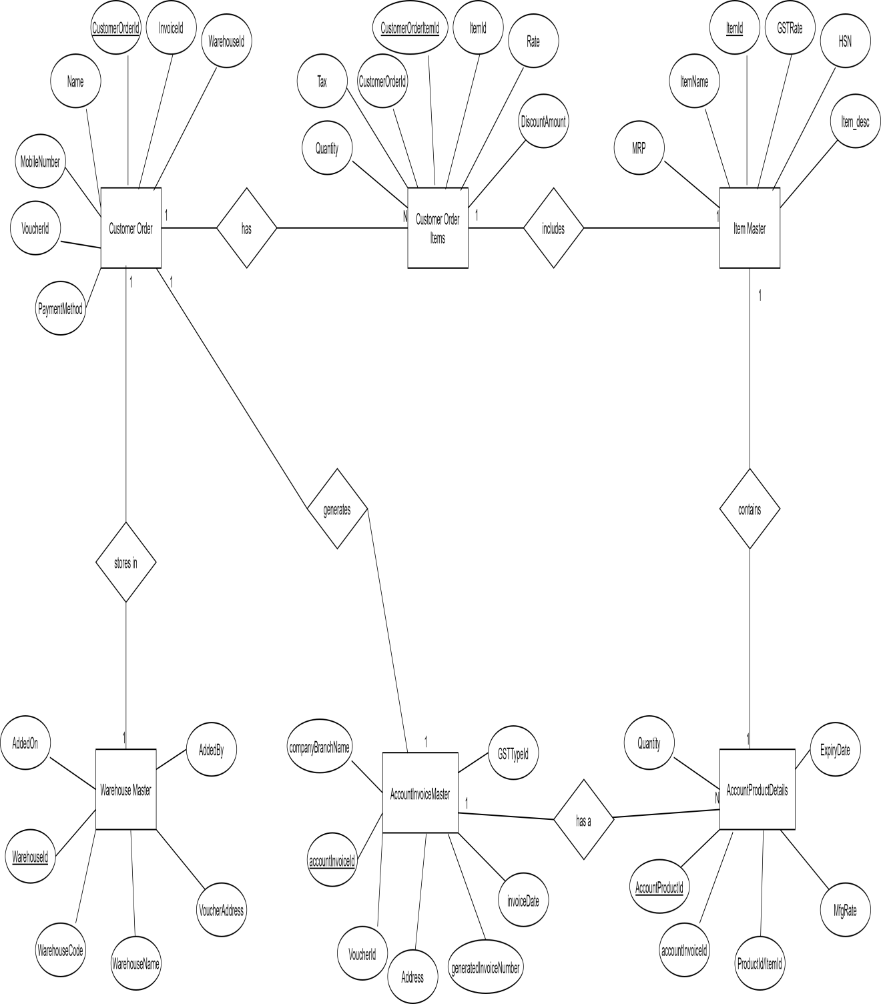
Figure 3.1 E-R Diagram of System
3.1.2 Table Structures
The structure of various database tables designed for “My Urban Green” is described in Table 3.1 to 3.6.
Table 3.1: Structure of Customer Order Database table
S. No. | Name of Column | Data Type | Description
 | CustomerOrderId | Big Int | Primary Key, Auto Increment
 | Name | varchar(300) | Name of the Customer
 | MobileNo | varchar(10) | Mobile Number of the Customer
 | EmailId | nvarchar(150) | EmailId of the Customer
 | OrderDate | Date | Date of Order
 | GSTNo | varchar(30) | GSTNo of the Customer
 | Address | varchar(500) | Address of the Customer
 | PaymentMethod | Varchar(30) | Bill payment mode
 | OrderTotalAmount | decimal(18, 2) | Total amount of the order
 | WareHouseId | Int | Link to WareHouseId in Warehouse table
 | CompanyBranch | nvarchar(255) | State of the Billing Sore
 | OrderStatus | char(1) | Holds the department to which employee
 | WareHouseId | Int | Link to WareHouseId in Warehouse table.
 | OrderStatus | char(1) | Current Status of the order
 | CreatedBy | varchar(50) | Billing Person Id
 | CreatedOn | Datetime | Date on which record created
 | voucherId | Bigint | Link to VoucherId in Voucher table
 | InvoiceId | Bigint | Link to Generated invoice no. in account invoice Table
 | DiscountType | Int | Type of Discount
 | Pancard | nvarchar(50) | PanCard of the Customer

Table 3.2: Structure of Customer Order Items Database table
S. No. | Name of Column | Data Type | Description
 | CustomerOrderItemId | BigInt | Primary Key, Auto Increment
 | CustomerOrderId | BigInt | Foreign key, Link to CustomerOrderId in Create order table.
 | ItemId | Int | Link to Item_id in Item Master Table
 | Quantity | Int | Number of Products
 | Rate | decimal(18,2) | Selling Price of Product
 | DiscountAmount | decimal(18,2) | Discount amount on product
 | Tax | decimal(18,2) | Amount of Tax on Each product
 | TotalAmount | varchar(50) | Total amount of each product

Table 3.3: Structure of Warehouse Master Database table
S. No. | Name of Column | Data Type | Description
 | Warehouse_id | Int | Primary Key, Auto Increment
 | Warehouse _code | varchar(50) | Unique code for each warehouse
 | Warehouse _name | varchar(50) | Name of Warehouse
 | Warehouse _address | varchar(250) | Complete address
 | company_branch_name | Int | Branch of State
 | added_by | varchar(50) | Who created this warehouse
 | added_on | varchar(50) | On which date it is created

Table 3.4: Structure of Item Master Database table
S. No. | Name of Column | Data Type | Description
 | item_id | int | Primary Key, Auto Increment
 | item_name | varchar(250) | Name of Product
 | item_desc | varchar(255) | Full Description of product
 | HSN | varchar(50) | Harmonized System of Nomenclature
 | GST_Rate | decimal(18, 2) | Rate of GST tax on each product
 | MRP | decimal(18, 2) | MRP of the Product

Table 3.5: Structure of Account Invoice Master Database table
S. No. | Name of Column | Data Type | Description
 | account_invoice_id | int | Primary Key, Auto Increment
 | voucher_id | int | Voucher code for each type of ledger
 | address | varchar(50) | Complete address of customer
 | invoice_date | datetime | Date on which invoice is created
 | generated_invoice_No | varchar(50) | Unique invoice number for every generated invoice
 | company_branch_name | varchar(50) | Branch of State
 | GST_Type_id | varchar(50) | Type of GST(Exclusive or inclusive)

Table 3.6: Structure of Account Product Details Master Database table
S. No. | Name of Column | Data Type | Description
 | account_product_id | int | Primary Key, Auto Increment
 | account_invoice_id | int | Link to account_invoice_id in Account Invoice Master Table
 | product_id | int | Link to Item_id in Item Master Table
 | Quantity | Bigint | Number of quantity of each product
 | Rate | decimal(18, 2) | Selling price of each product
 | Amount | decimal(18, 2) | Multiplication of Quantity and Rate
 | discount_amount | decimal(18, 2) | Disount on Amount column
 | total_amount | decimal(18, 2) | After Discounted amount
 | Mrp | decimal(18, 2) | MRP of the product
 | GST_rate | decimal(18, 2) | Rate of GST tax on each product
 | Order_value | decimal(18, 2) | Total amount of each product including GST
 | mfg_date | datetime | Manufacturing date of product
 | expiry_date | datetime | Expiry date of the product

3.2 Input Output Design
The Input Output Design of various Screens designed for “My Urban Green” is described in Table 3.7 to 3.15.
Table 3.7: Input Output Design of Login Screen
Purpose | - Enables Employee or Administrator to log into the System
Description of field(s) | - User Name: User enters his/her login name to log into the System.  - Password: User enters Password.  - Login Button: Logs the user in or displays an error on mis-match of username and password.
Validation Checks | - Username should be a registered User Name.  - Password should match the entered username in the database.

Table 3.8: Input Output Design of Pending Order Screen
Purpose | - Enables billing person to put the order in pending until order is approved.
Description of field(s) | - All the orders are displayed here.  - By clicking on view button we can see the details of the order and mark them as approved or rejected.
Validation Checks | - This is a report.  - Employee cannot edit but view the details and jump to next page.

Table 3.9: Input Output Design of Create Order Screen
Purpose | - Enables billing person to create the order.
Description of field(s) | - Billing person creates the order by selecting the item, giving discounts if applicable and adding the personal details of the customer.
Validation Checks | - All fields are mandatory with an asterisk symbol.  - Mobile number should be of 10 digits.  - Name length should be of 300 characters or less.

Table 3.10: Input Output Design of Gate Pass Screen
Purpose | - Enables to take out the products temporarily without payment.
Description of field(s) | - Need to specify about the gate pass  - Upon return of products necessary action needs to be taken.
Validation Checks | - All fields are mandatory.

Table 3.11: Input Output Design of Pending Gate Pass Screen
Purpose | - Enables billing person to put the Gate Pass in pending until Gate Pass is returned.
Description of field(s) | - All the Gate Passes are displayed here.  - By clicking on view button we can see the details of the Gate Pass and mark them as approved or rejected.
Validation Checks | - This is a Gate Pass Pending report.  - Employee cannot edit but view the details and jump to next page.

Table 3.12: Input Output Design of Print Label Screen
Purpose | - Used to create the labels to stick on the products.
Description of field(s) | - QR code is created by the item number.  - Label is designed and printed according to the need.
Validation Checks | - Item field is mandatory.

Table 3.13: Input Output Design of Order Status Report Screen
Purpose | - Gives the status of all the orders placed till asked date.
Description of field(s) | - According to the status orders can be viewed.  - From Date and To date should be given as a filter.
Validation Checks | - To date should not be less than from date.
Table 3.14: Input Output Design of Payment Status Report Screen
Purpose | - To show the payment status of all the orders.
Description of field(s) | - Report is filtered according to the date or can be altered according to the status.
Validation Checks | - From Date and To Date should be a valid date.  - From Date should be less than To Date.

Table 3.15: Input Output Design of Post In ERP Screen
Purpose | - Enables accountant to post the details in ERP.
Description of field(s) | - POST IN ERP button is clicked to send the details in ERP.  - Voucher code, sales order number is automatically created.
Validation Checks | - None.

3.2 Use Case Description
The Use Case Description for “My Urban Green” is described in Table 3.16 to 3.24.
Table 3.16: Use Case Description of Login Process
Purpose | - This use case defines registration and Login process of Administration and General user.
Actors | - Billing employee  - Admin  - Accountant
Preconditions | - User should be registered in case of login, retrieve Password, change password.  - In case of Admin Login the User should be registered under Admin Role.
Post Conditions | - Home pages are displayed depending on the successful login depending on the role of the username.
Basic Flow | - On Failure Error Message is displayed.  - The system requests the actor to enter his/her username and Password. The role can be any one of the admin and the User.  - The actor enters his/her username and password.  - The system validates the entered name and password and Logs in the actor into the system.
Alternate Flows | - User is shown an error message on invalid username or Password.

Table 3.17: Use Case Description of Create Order Process
Purpose | - Enables billing person to create the order.
Actors | - Administrator  - Billing person
Preconditions | - User should be logged into the system.  - Item should be present in the stock.
Post Conditions | - Order is created if all the details are filled.
Basic Flow | - Order is displayed in pending orders  - Actor clicks on ‘Create Order’  - Fills the necessary details and click on Create Order  - All the correct details filled takes you to the successful creation of order
Alternate Flows | - After the creation of order, it is sent to the pending orders.  - Invalid details are entered and an appropriate error message is displayed.

Table 3.18: Use Case Description of Pending Order Process
Purpose | - Enables billing person to put the order in pending until order is approved.
Actors | - Billing person  - Admin
Preconditions | - User should be logged into the system  - Order should already be created
Post Conditions | - All the orders are displayed.
Basic Flow | - Actor clicks on pending order tab.  - All the orders are displayed with a view button.  - On clicking view button, details are displayed.  - Status could be updated of the order as per the payment made.
Alternate Flows | - None

Table 3.19: Use Case Description of Gate Pass Process
Purpose | - Enables to take out the products temporarily without payment.
Actors | - Billing person  - Admin
Preconditions | - User should be logged into the system.
Post Conditions | - Necessary action is taken on Each item taken out on gate pass
Basic Flow | - User clicks on the Gate pass tab.  - All the details are filled and in bill or discount type gate pass is set.  - Gate pass is granted
Alternate Flows | - In case of erroneous data error message is shown.

Table 3.20: Use Case Description of Pending gate Pass Process
Purpose | - Enables billing person to put the Gate Pass in pending until Gate pass is returned.
Actors | - Billing person  - Admin
Preconditions | - User should be logged into the system  - Gate pass should be granted.
Post Conditions | - Action is taken upon the arrival of the products taken out on gate pass
Basic Flow | - Actor will click on Pending gate pass.  - A list is displayed, view button is clicked and quantity is entered in ‘issue quantity’ of the products that need to be entered back in the inventory.
Alternate Flows | - None

Table 3.21: Use Case Description of Print Label Process
Purpose | - Used to create the labels to stick on the products.
Actors | - Billing person  - Admin
Preconditions | - User should be logged into the system
Post Conditions | - Label is printed and pasted on the product
Basic Flow | - The actor clicks on Print Label tab.  - All the details are filled.  - QR code is generated on the basis of item code.  - Number is specified of the labels required.  - Print command is given.
Alternate Flows | - None

Table 3.22: Use Case Description of Order status report Process
Purpose | - Gives the status of all the orders placed till asked date.
Actors | - Billing person  - Admin  - Accountant
Preconditions | - User should be logged into the system.  - Order should be first created to be viewed.  - From Date and to date should be entered.
Post Conditions | - Report is displayed
Basic Flow | - User clicks on the Order Status Report  - From Date and To Date is entered
Alternate Flows | - In case of erroneous data error message is shown

Table 3.23: Use Case Description of Payment Status Report Process
Purpose | - To show the payment status of all the orders
Actors | - Admin  - Billing person  - Accountant
Preconditions | - User should be logged into the system.  - Order should be created already
Post Conditions | - Report is displayed
Basic Flow | - User clicks on the Payment status report  - From Date and To Date is entered.
Alternate Flows | - In case of erroneous data error message is shown

Table 3.24: Use Case Description of Post in ERP Process
Purpose | - Enables accountant to post the details in ERP.
Actors | - Accountant
Preconditions | - User should be logged into the system.  - Orders should be previously created.
Post Conditions | - Sales order number, voucher number are automatically created  - Appropriate message is displayed.
Basic Flow | - Accountant clicks on the POST IN ERP tab.  - The POST IN ERP button is displayed  - The data is posted in ERP.
Alternate Flows | - In case of erroneous data error message is shown

CHAPTER 4
TESTING
4.1 | Test Activities
4.2 | Unit Testing
4.3 | System Testing
 | 4.3.1 Functional Testing
4.4 | Test Reports and Debugging

4. Testing
4.1 Testing Activities
Testing is a process rather than a single activity. Testing must be planned, and it requires discipline to act upon it. The quality and effectiveness of software testing are primarily determined by the quality of the test processes used.
The activities of testing can be divided into the following basic steps:
- Planning and Control
- Analysis and Design
- Implementation and Execution
- Evaluating exit criteria and Reporting
- Test Closure activities
Test planning involves producing a document that describes an overall approach and test objectives. It involves reviewing the test basis, identifying the test conditions based on analysis of test items, writing test cases and designing the test environment. Completion or exit criteria must be specified so that we know when testing (at any stage) is complete.

Purpose:
      - To determine the scope and risks and identify the objectives of testing.
      - To determine the required test resources like people, test environments etc.
      - To schedule test analysis and design tasks, test implementation, execution.
Control is the activity of comparing actual progress against the plan, and reporting the status, including deviations from the plan. It involves taking actions necessary to meet the mission and objectives of the project.
Test analysis and Test Design has the following major tasks:
- To review the test basis. The test basis is the information on which test cases are based, such as requirements, design specifications, product risk analysis, architecture and interfaces.
- To identify test conditions.
- To design the tests.
- To design the test environment set-up and identify the required infrastructure and tools.
Test execution involves running the specified test on a computer system either manually or by using an automated test tool. It is a Fundamental Test Process in which actual work is done. Test implementation has the following major task:
      - To develop and prioritize test cases by using techniques and create test data for those tests.
      - To create test suites from the test cases for efficient test execution.
      - Test suite is a collection of test cases that are used to test a software program
      - To re-execute the tests that previously failed in order to confirm a fix.
      - To log the outcome of the test execution. A test log is the status of the test case (pass/fail).
      - To compare actual results with expected result.
Evaluating exit criteria is a process defining when to stop testing. It depends on coverage of code, functionality or risk. Basically, it also depends on business risk, cost and time and vary from project to project. Exit criteria come into picture, when:
      - Maximum test cases are executed with certain pass percentage
      - Bug rate falls below certain level
      - When we achieve the deadlines
Test closure activities are done when software is ready to be delivered. The testing can be closed for the other reasons also like:
- When a project is cancelled
- When some target is achieved
  - When a maintenance release or update is done
4.2 Unit Testing
It is a level of software testing where individual units/ components of software are tested. The purpose is to validate that each unit of the software performs as designed. A unit is the smallest testable part of any software. It usually has one or a few inputs and usually a single output. In procedural programming, a unit may be an individual program, function, procedure, etc. In object-oriented programming, the smallest unit is a method, which may belong to a base/super class.
- Methodology Used
Unit testing was carried out at the developer environment only. Manual testing was done. The developers review their code to check whether their respective units under tests behave as expected.
- Tools Used
No tools were used to do the Testing as manual testing was carried out for Unit Testing of all the modules. As Manual Testing doesn’t require any tools, so Tools are not applicable.
4.3 System Testing
System Testing (ST) is a black box testing technique performed to evaluate the complete system, the system’s compliance against specified requirements. In System testing, the functionalities of the system are tested from an end-to-end perspective. System Testing is usually carried out by a team that is independent of the development team in order to measure the quality of the system unbiased. It includes both functional and Non- Functional testing.
4.3.1 Functional Testing
- Methodology Used
Under this the whole system was tested under the development team. Basically, all functionalities as per requirements are tested here.
- Tools Used
No tools were used to do the Testing as manual testing was carried out for Functional Testing. As Manual Testing doesn’t require any tools, so Tools are not applicable.
- Test Cases
Table 4.1: Functional Testing Test Cases
Id | Test Item(s) | Test Case Name | Test Case Description
 | Create Order | Order successfully created | Billing person/Admin can successfully create the order
 | Pending Order | Created orders are displayed | All the orders that are successfully created should be displayed here.
 | Print Label | Correct Label is printed | Label with correct QR code and item no. Is generated.
 | Order status Report | Appropriate status of orders | After the successful payment of orders, correct status of orders should be displayed.
 | Payment status report | Payment status | How the payment is made and whether made or not should be displayed here
 | Post into ERP | Posted in ERP | All the correct details are posted in ERP.

4.4 Test Reports and Debugging
Table 4.1: Functional Testing Report
Id | Test Case  Description | Test Case  Input | Test Results |  | Status | Corrective  Measure
Id | Test Case  Description | Test Case  Input | Expected | Actual | Status | Corrective  Measure
 | Billing person/Admin can successfully create the order | All the fields asked in the create order page are filled properly. | Order is created successfully | Order is created  successfully | Pass | None
 | All the orders that are successfully created should be displayed here. | No input | Successfully created orders are displayed. | Successfully created orders are displayed. | Pass | None
 | Label with correct QR code and item no. is generated. | Warehouse ID, Item no. | Label is printed correctly. | Label is printed correctly | Pass | None
 | After the successful payment of orders, correct status of orders should be displayed. | From date and To date | Report is correctly generated | Report is correctly generated | Pass | None
 | How the payment is made and whether made or not should be displayed here | None | Report is correctly generated | Report is correctly generated | Pass | None
 | All the correct details are posted in ERP. | None | Data is successfully posted in | Data is successfully posted in | Pass | None

CHAPTER 5
CONCLUSION AND FUTURE SCOPE
5.1 | Conclusion
5.2 | Limitations of the System
5.3 | Future Scope for Modification

5. Conclusion and References
5.1 Conclusion
MY URBAN GREENS application is developed which is based upon Relational Database Management System and it provides a platform enabling the Billing person and accounts department to manage their work. The architecture used is the Layered Application Architecture.3 Tier Architecture divides the projects under 3 layers User Interface, Business Logic and Data Access. All these 3 layers work independently of each other.
The system has an admin role, Billing person role and Accountant role.
The Admin Role has the following rights in the application –
- Can administer the complete website
- Can modify delete and add orders
- Can handle issues, Billing information and Admin Grant access of modules to the employees according to their job assigned.
Billing person Role has the following rights in the application –
- Place order for the consumer
- View pending orders
- Update the price of the products
- Can print labels for products
- View payment Status Report
- Order status report
- Gate Pass (Used for granting permission to display the plants at an exhibition and bill according to the sale done)
Accountant Role has the following rights in the application –
- View payment Status Report
- Order status report
- Post In ERP
  - Limitations of the System
- This application cannot be used for other organization as it is customized according to the IFFCO KISAN SANCHAR LIMITED.
- DEPENDENCY–Accounts section is dependent upon ERP. All the data is posted in ERP to maintain balance sheet, ledgers etc., which not done may lead to serious concerns.
5.3 Future Scope for modification
- Analytical reports can be made from all the billing information which can help to grow the Business.
- Performance tuning to handle large number of users to keep the user experience as responsive as possible.
BIBLIOGRAPHY
Books:
- Andrew Troelsen, “Pro C# 5.0 And The .Net 4.5 Framework 6th Edition”, 2014, Apress
- Ben Forta, “Sams Teach Yourself Sql In 10 Minutes (4th Edition)”, paperback
- Mark J. Price, “C# 7 and .NET Core: Modern Cross-Platform Development”, 2017
- Ben Albahari, “C# 6.0 In A Nutshell: The Definitive Reference, 6/Ed”, 2016
Websites:
- http://www.w3schools.com/sql/
- http://www.w3schools.com/css/
- http://www.w3schools.com/js/
- http://www.w3schools.com/jquery/

ANNEXURES
A-1 | Design Diagram
A-2 | Data Flow Diagram
A-3 | Screenshots

A-1: Design Diagram
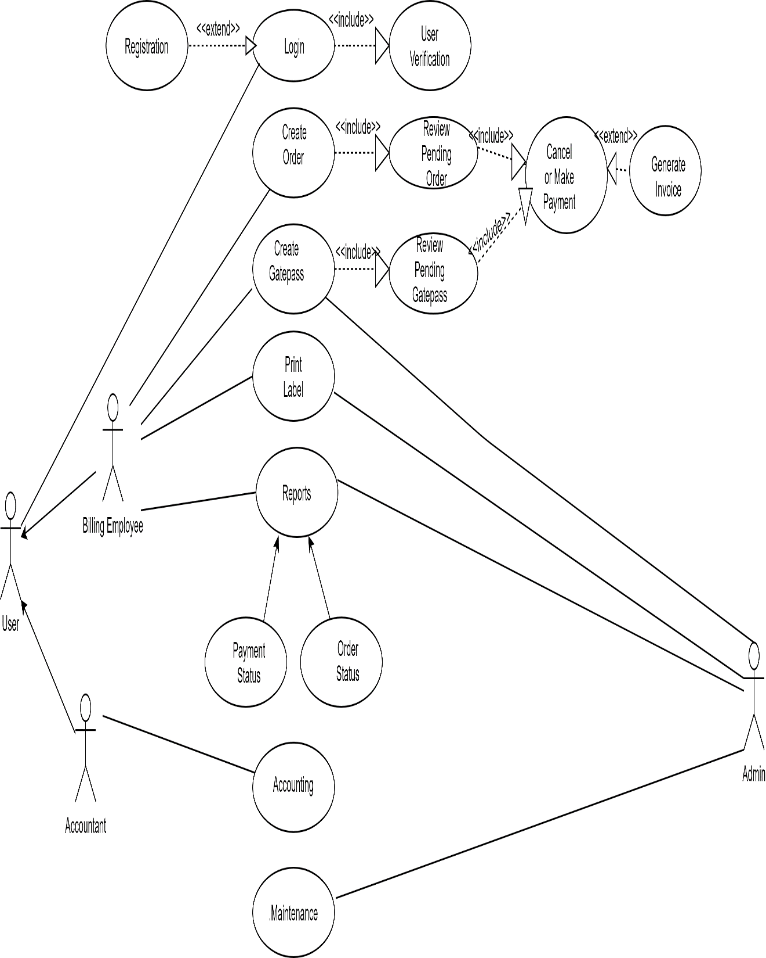
Figure A-1.1: Use case Diagram
A-2: Data Flow Diagram
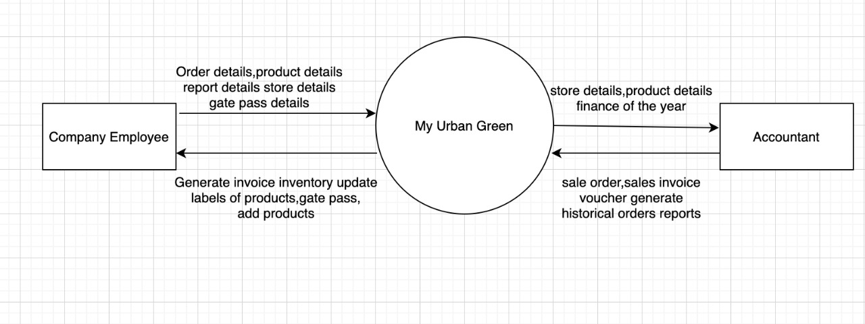
Figure A-2.1: DFD Level 0

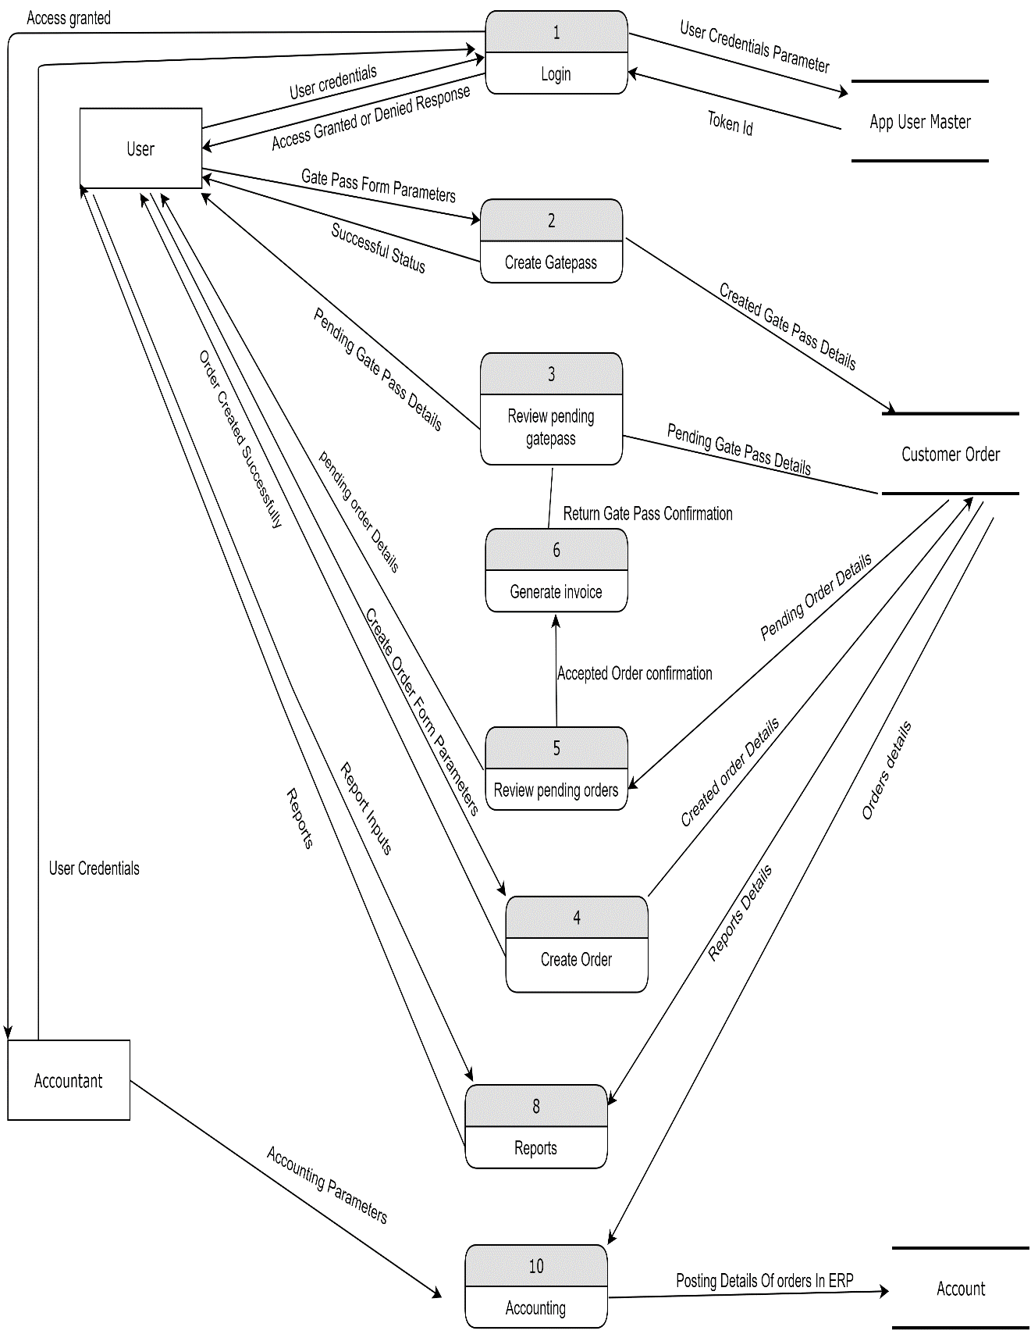
Figure A-2.2: DFD Level 1

A-3: Screenshots (Running View of the Forms/Pages)
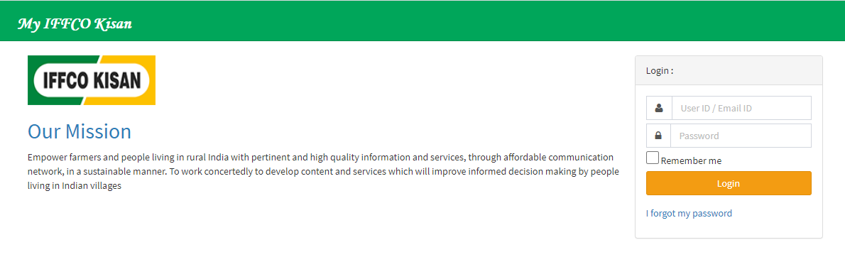
Figure A-3.1: Login Page
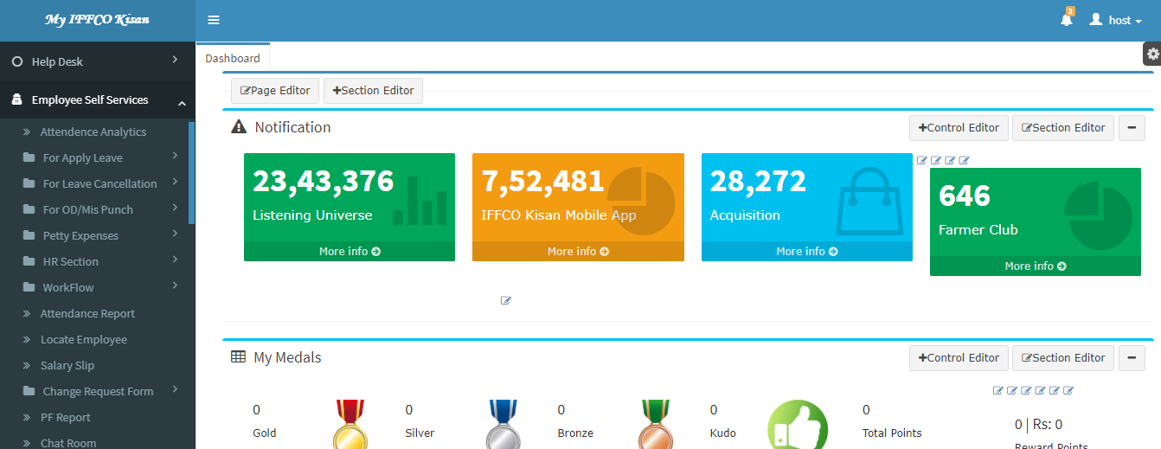
Figure A-3.2: Home Page
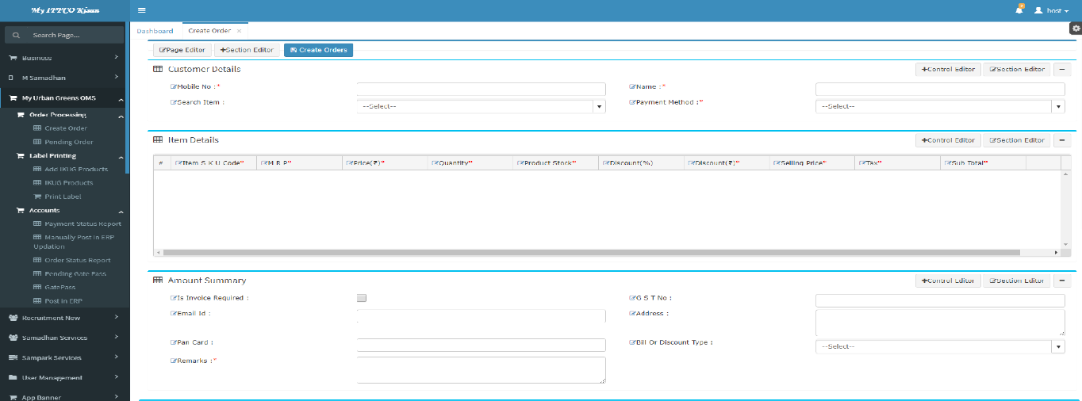
Figure A-3.3: Create Order Page

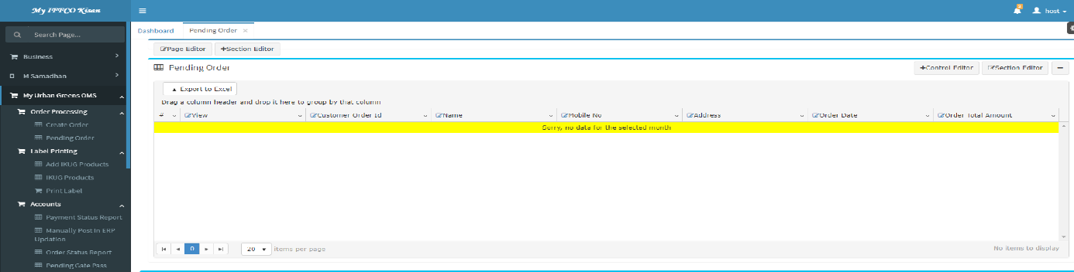
Figure A-3.4: Pending Order Page
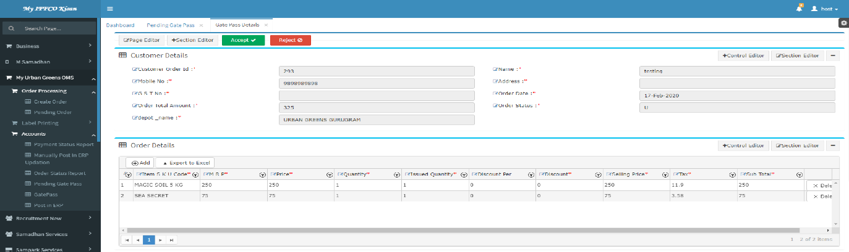
Figure A-3.5: Cancel Order and Accept Order Page

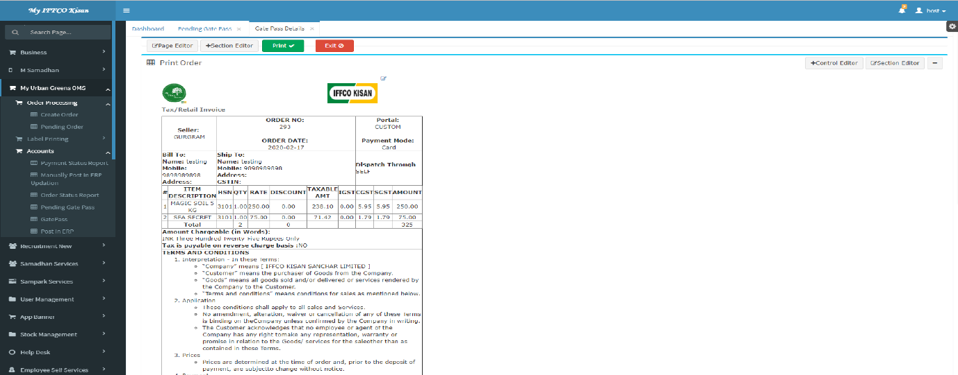
Figure A-3.6: Generate Invoice Page
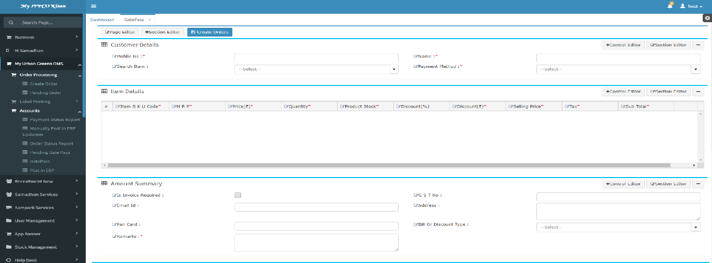
Figure A-3.7: Gate Pass Page

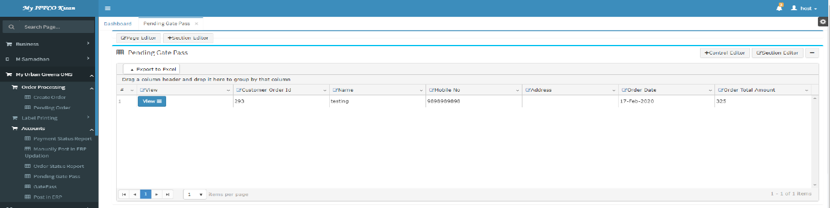
Figure A-3.8: Pending Gate Pass
Figure A-3.9: Cancel Gate Pass and Return Gate Pass Page

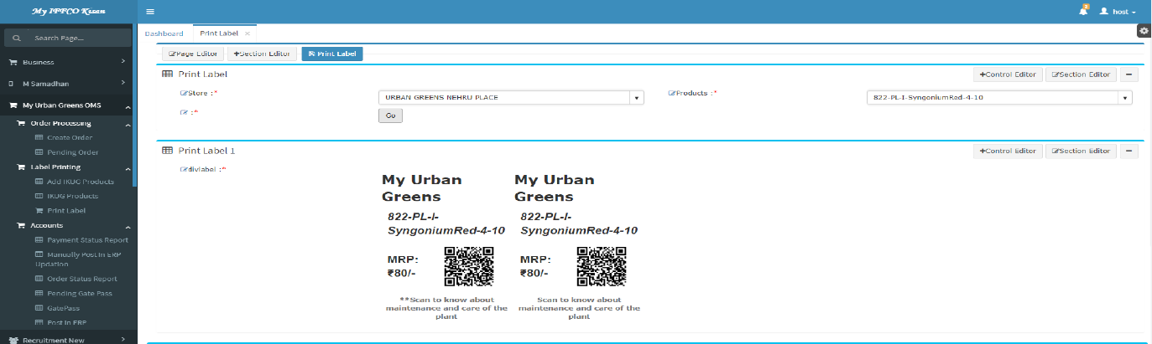
Figure A-3.10: Label Printing Page
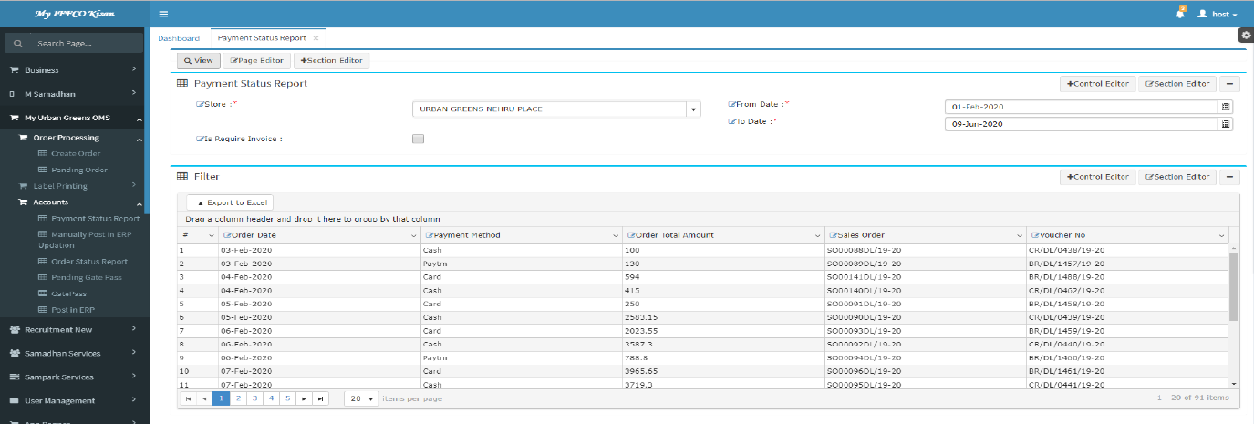
Figure A-3.11: Payment Status Report Page

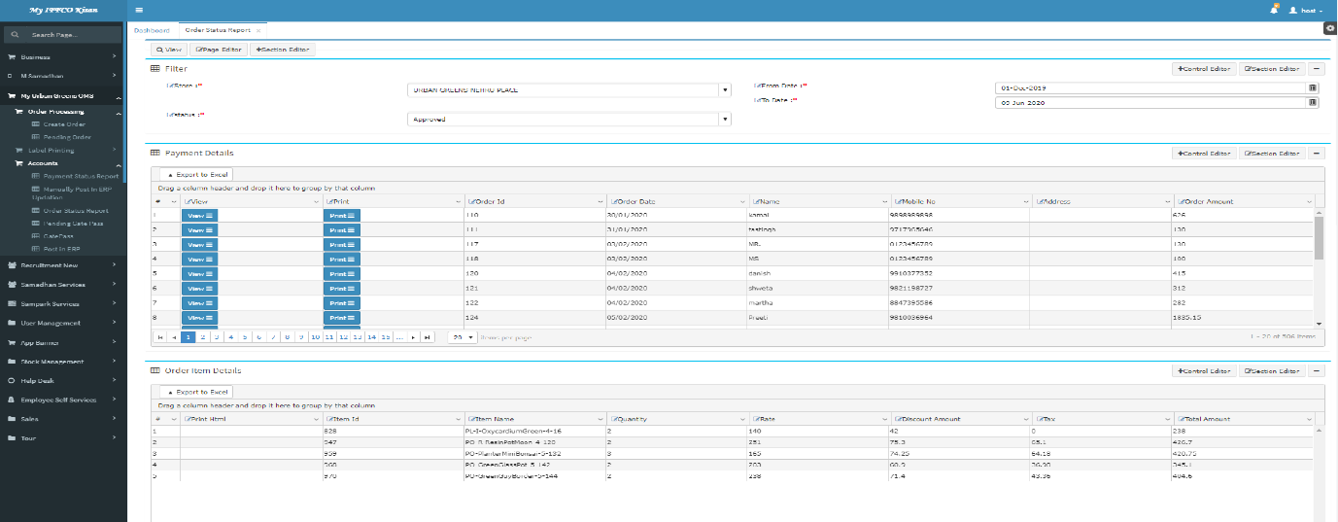
Figure A-3.12: Order Status Report Page
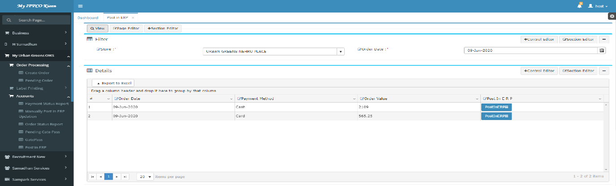
Figure A-3.13: Post in ERP (Accounting) Page

