Activity: Build a Cluster

Follow the instructions below to build your cluster.

**Install Your Own Cluster**

**1. Install Kubernetes Minikube**

On Windows, download and install minikube-installer.exe from: <https://github.com/kubernetes/minikube/releases>

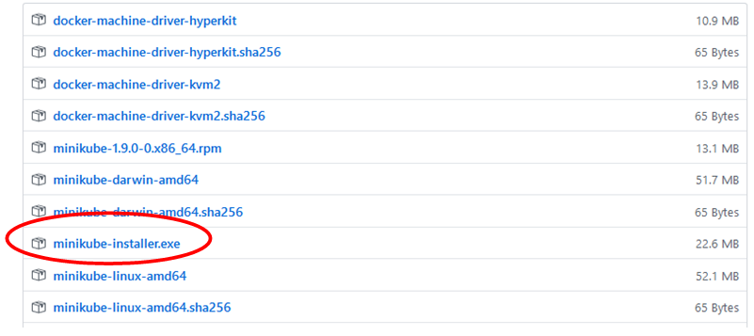

Open PowerShell as administrator cd to the directory where you downloaded the minikube-installer.exe file.

Run command: **minikube-installer.exe**

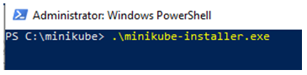

Run the Minikube setup wizard and take all the defaults.

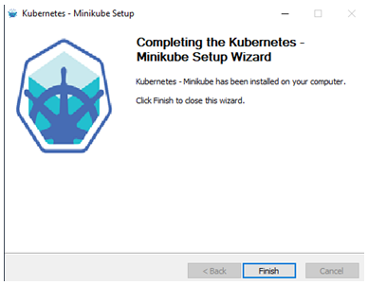

Run command: **minikube**. Review the returned command list.

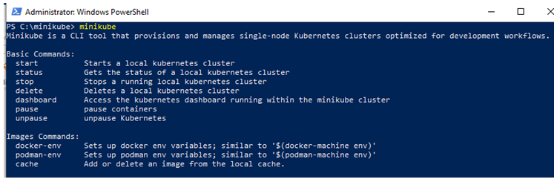

Start minikube, run command: **minikube start**

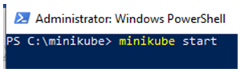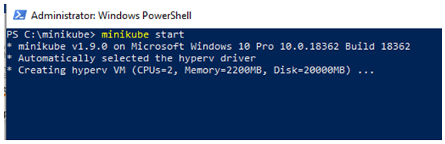

Validate that Minikube is running. Run: **minikube status**

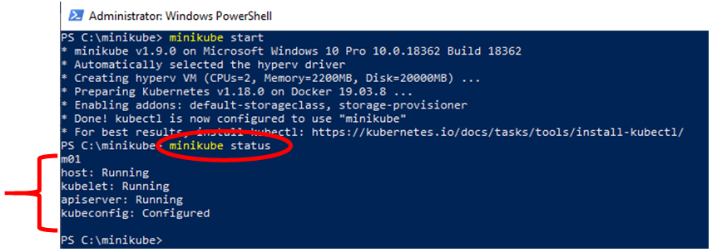

The command minikube status returns the node, which in this case is m01, and the running, and configured status.

**2. Install kubectl**

<https://storage.googleapis.com/kubernetes-release/release/v1.18.0/bin/windows/amd64/kubectl.exe>

Download into the directory, C:\Program Files\Kubernetes\Minikube. If prompted for administrator confirmation, continue the download.

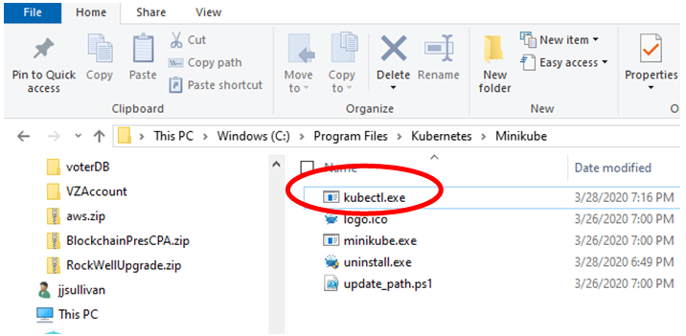

**You now have a Minikube cluster**

Run command: **kubectl cluster-info**

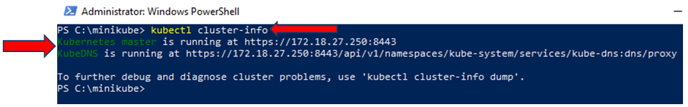

Observe the URL and port where the Kubernetes master node is running.

Run command: **kubectl version**

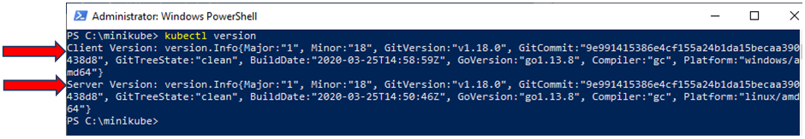

Observe the data returned.

**3. Open the Kubernetes Dashboard**

Run command: **minikube dashboard**

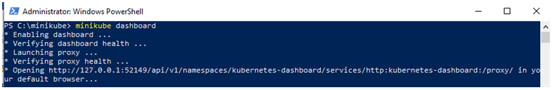

The Kubernetes Dashboard will open

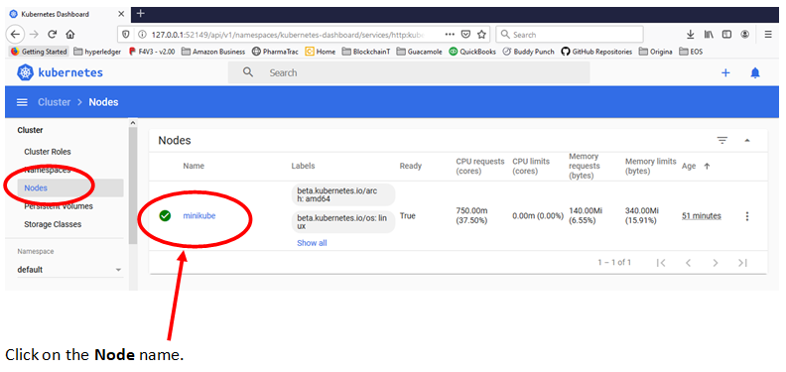

Observe the Metadata, data, and IP address under **Metadata** and **Resource Information.**

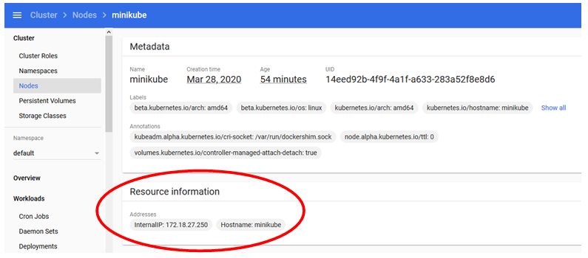

Review the **System Information**, review the virtual operating system.

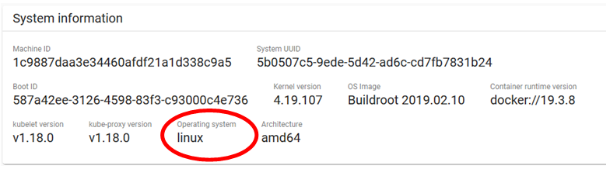

Review the **Allocation.**

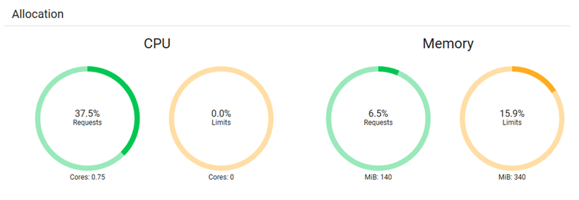

Review the **Conditions**.

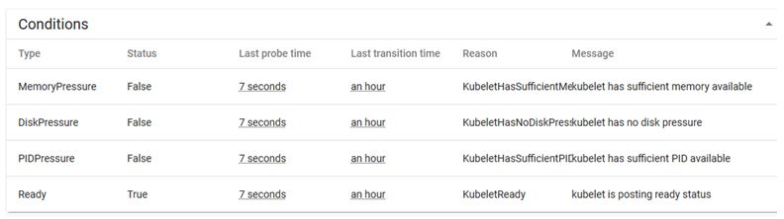

Review the **Pods.**

