Github==== jenkins ---- ansible ---- Docker server (run code on tomcat)

<https://github.com/gauravbhola/code.git>

\*/master

pom.xml

clean install package

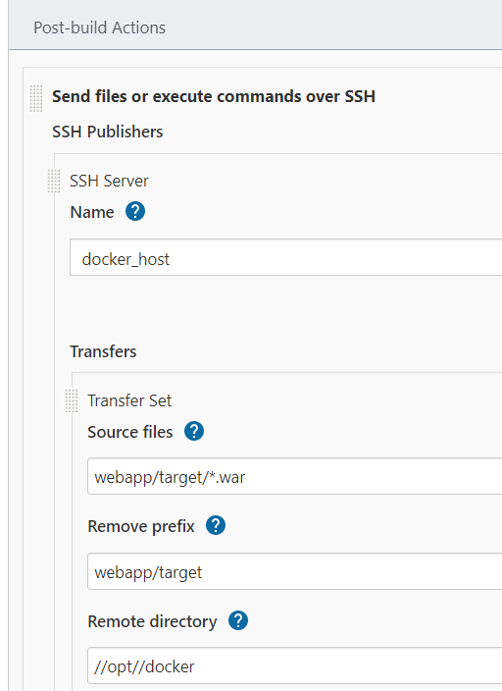

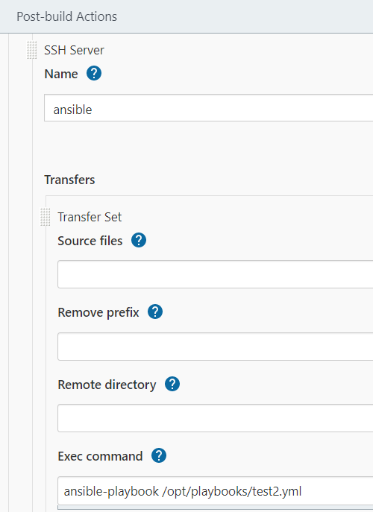

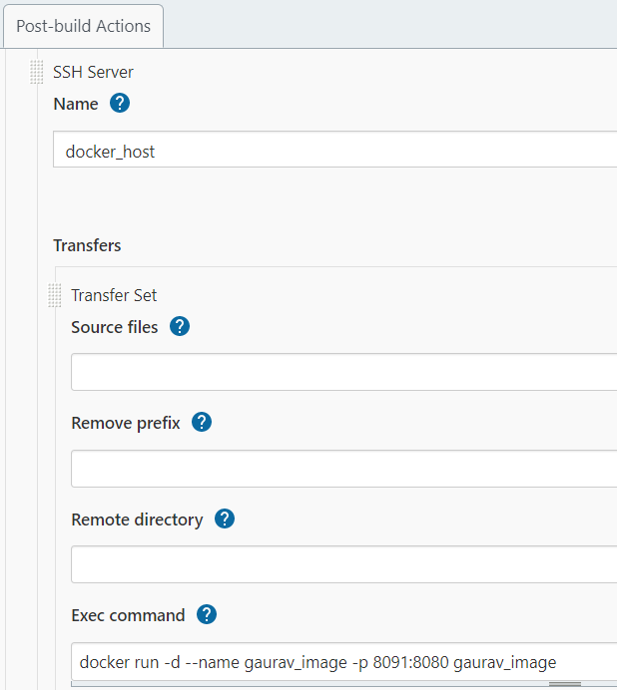

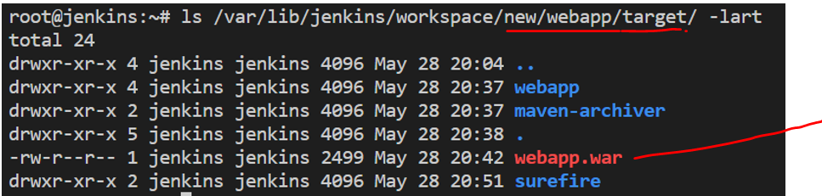

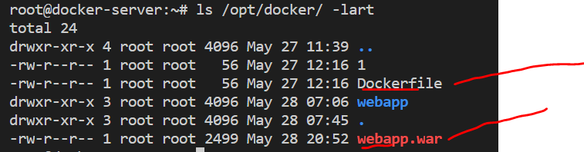

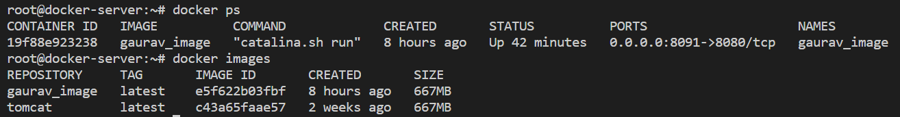

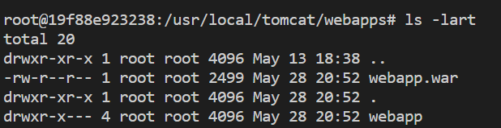

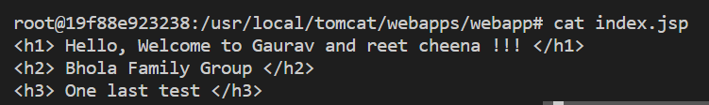

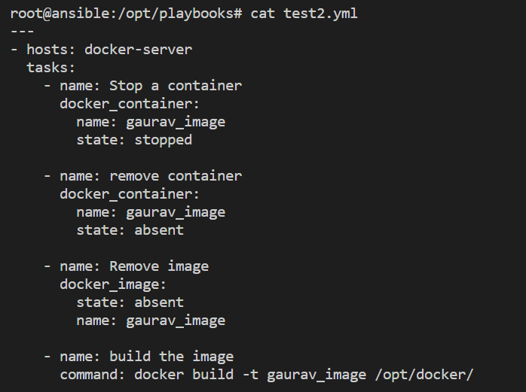

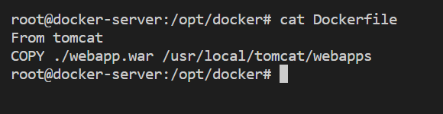

cat /etc/ansible/hosts

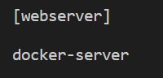

cat /etc/ansible/ansible.cfg



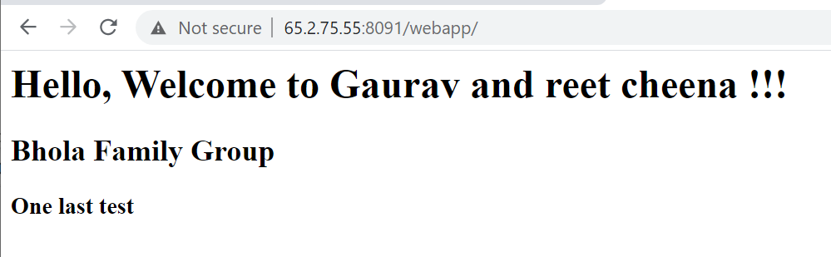

Now any modification in code which is in github .. build a new job

