<https://github.com/gauravbhola/code.git>

clean package

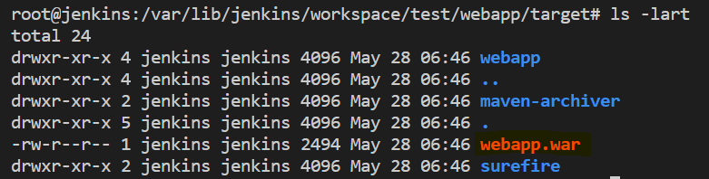

==============================================================================

<https://github.com/gauravbhola/code.git>

clean install package

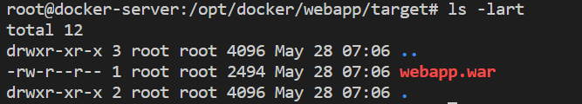

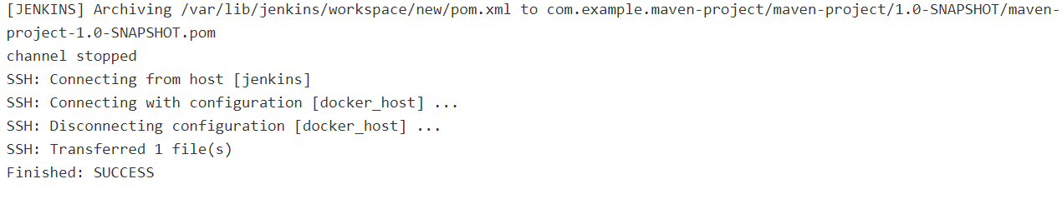

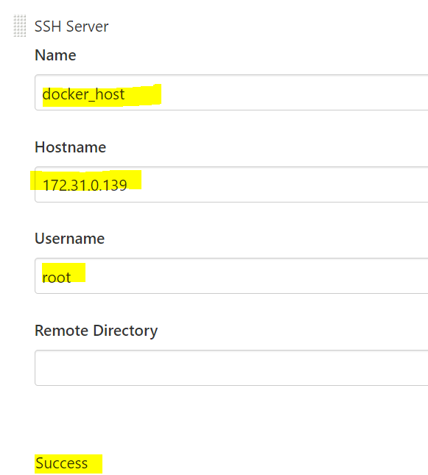

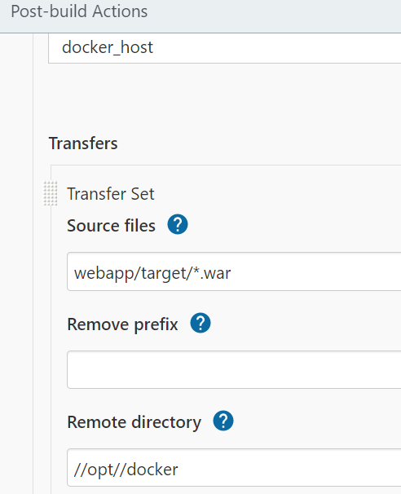

================================================================================

https://github.com/gauravbhola/code.git



