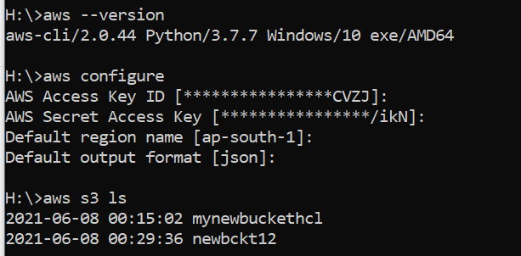

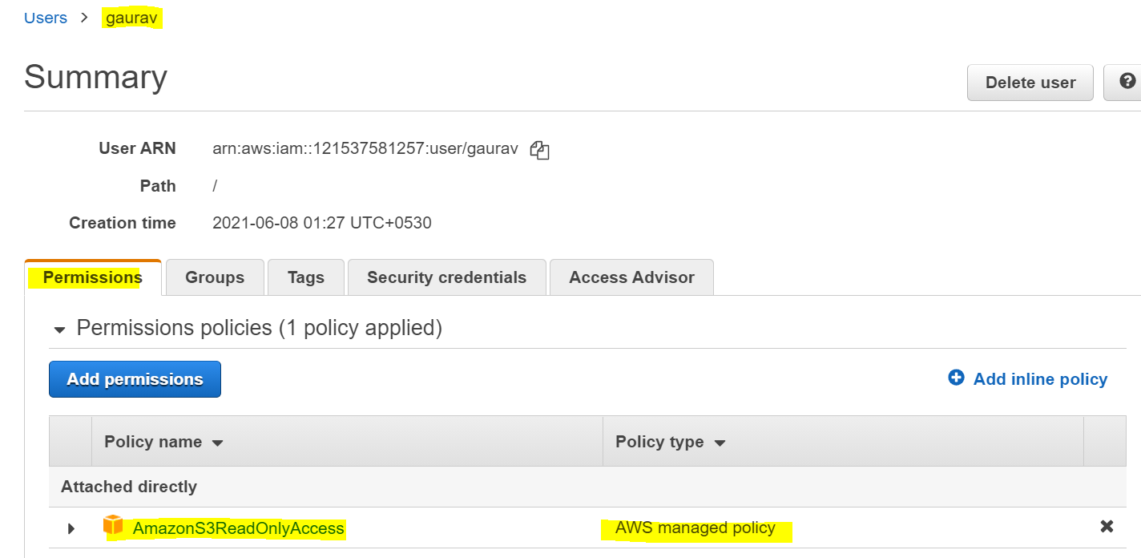

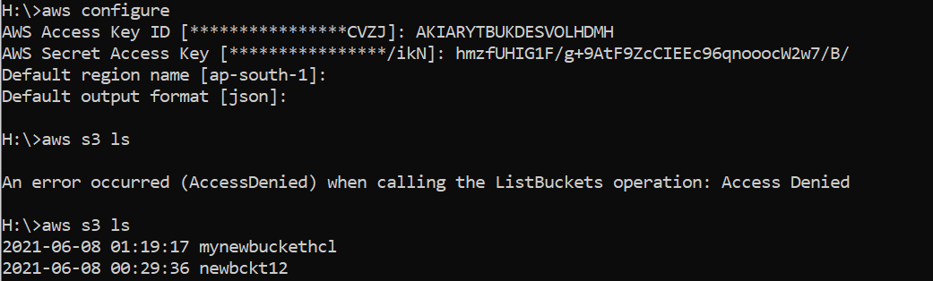

aws s3 mb s3://mybuckhcl03

aws s3 ls

2021-03-03 06:12:08 mybuckhcl02

aws s3 ls s3://mybuckhcl02

aws s3 cp "c:\New folder\file.html" s3://mybuckhcl02/

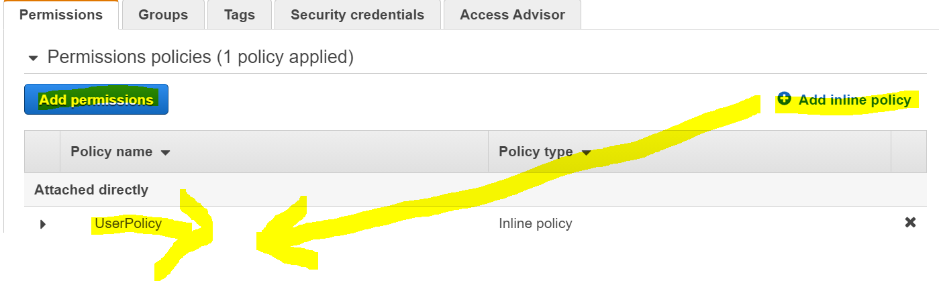

{

"Version": "2012-10-17",

"Statement": [

{

"Sid": "statement1",

"Effect": "Allow",

"Action": [

"s3:CreateBucket",

"s3:ListAllMyBuckets",

"s3:GetBucketLocation"

],

"Resource": "arn:aws:s3:::\*"

},

{

"Effect": "Allow",

"Action": ["s3:\*"],

"Resource": ["arn:aws:s3:::mybuckhcl02"]

},

{

"Effect": "Allow",

"Action": [

"s3:PutObject",

"s3:GetObject",

"s3:DeleteObject"

],

"Resource": [

"arn:aws:s3:::mybuckhcl02/\*"

]

}

]

}