JavaTpoint

1.Python installation & its applications.

First of all, we have to Know about what is Python and Its real word application with installation.

**Python:**

Python is an easy programming language. It is also called interpreted programming language. Python is a widely use high level language in the hole word. Its support multiple libraries as compare to C, C++, JAVA etc. so library make its easy language. So, Python was developed in 1991 by Guido Van Rossum at a National Research institute for Mathematics and Computer Science.

**Step of Installation**:

Step 1.

You have to select your version. Its support multiple Operating system (window, Linux, Mac etc.)

Search on your browser python download.

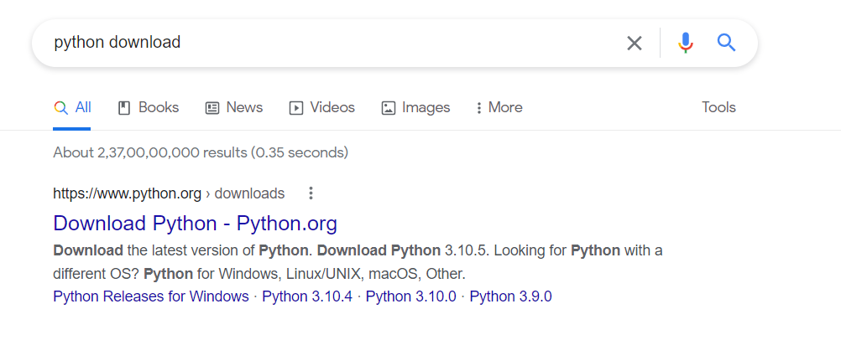

Then you have to click the official link of python download.

Step 2.

You select your **version** (3.6, 3.7 etc.) and Operating System.

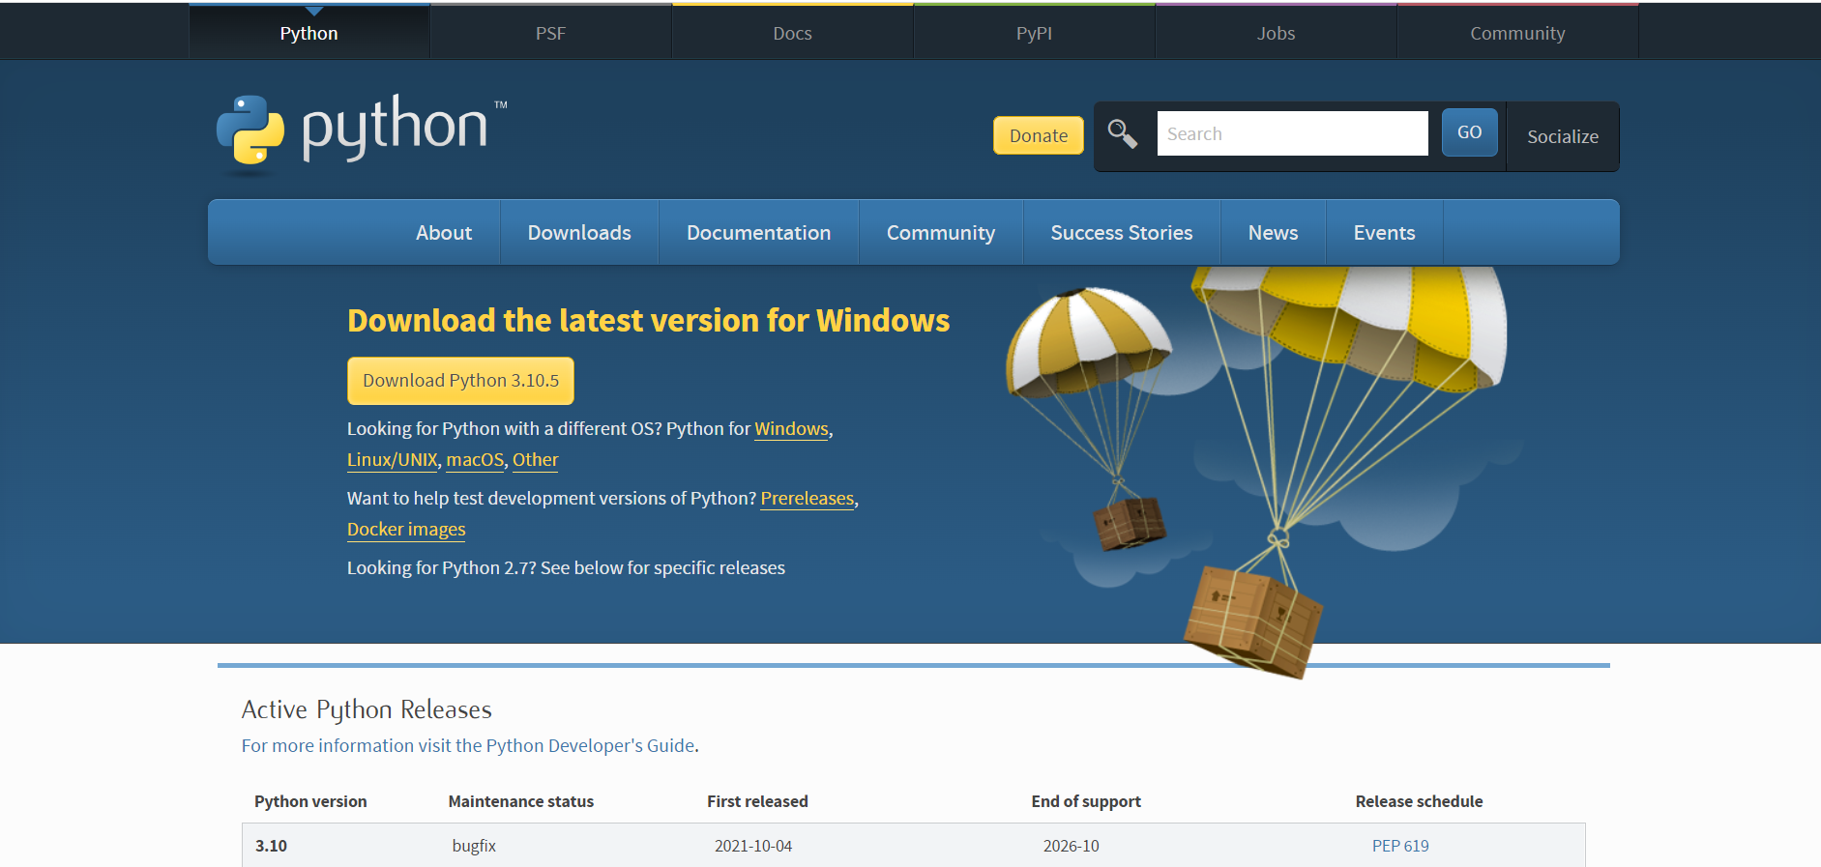

Step 3.

Click the download Button.

Step 4.

### You have to run Executable Installer.

### 

### You have to click on install Now and select all the check box.

### 

### Its installing…….

### 

### Its setup.

Step 5.

1.Find the python in your local system where Its Installed. So in my case

**C:\Users\Username\AppData\Local\Programs\Python\Python10.**

**2. click on python.exe**.

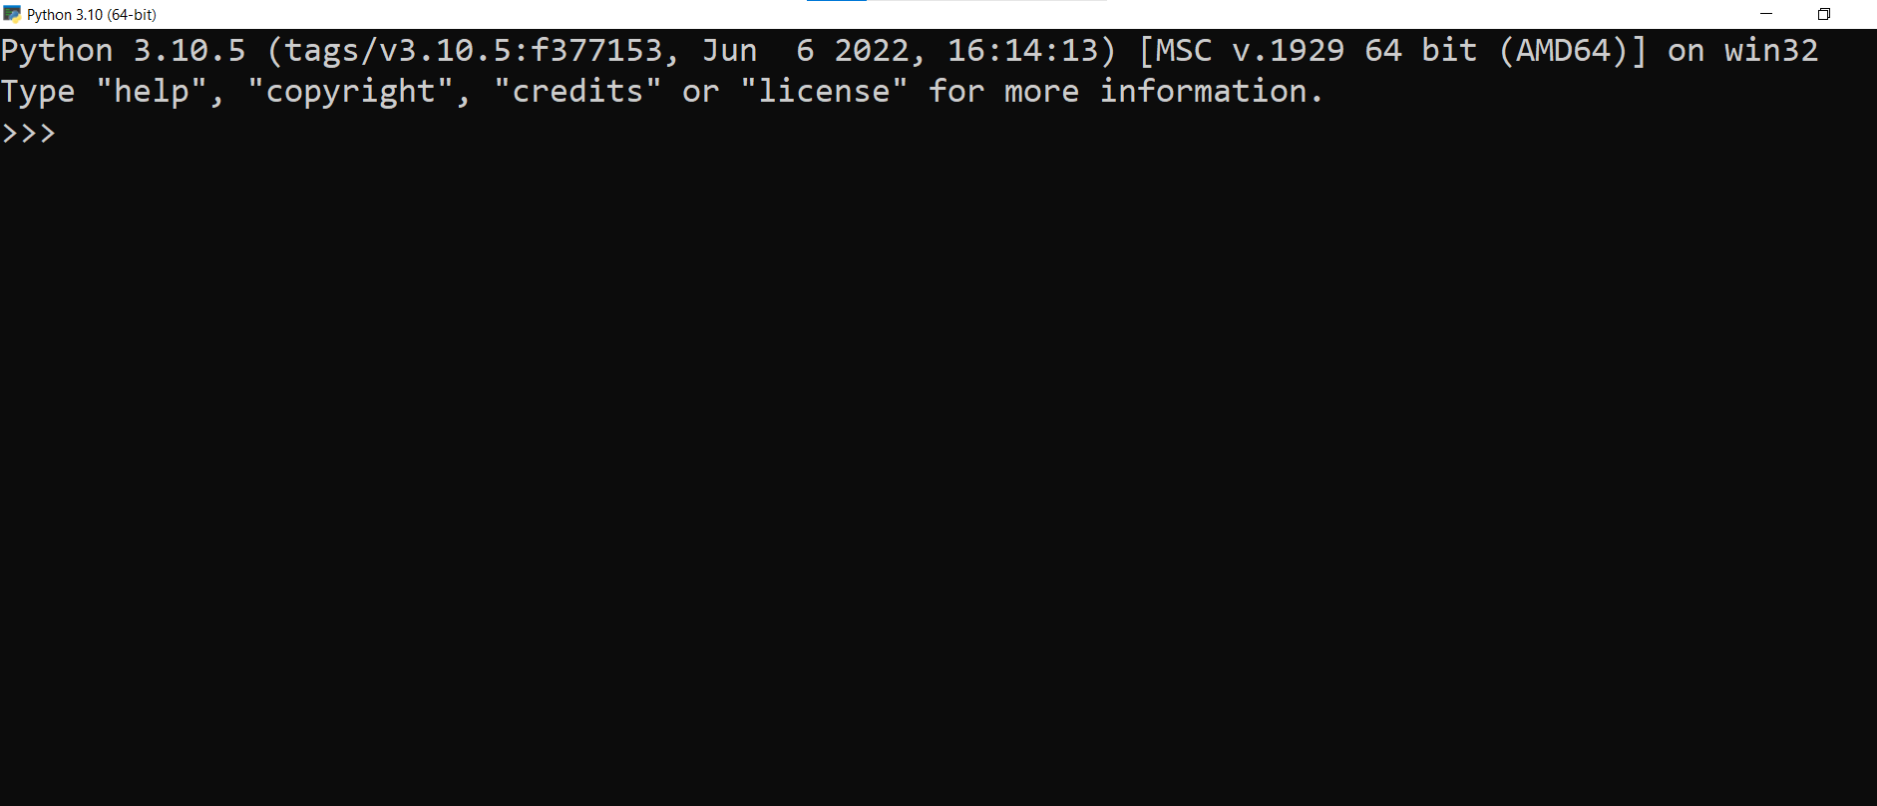

Also, you can open you CMD command prompt. Write the Python on cmd.

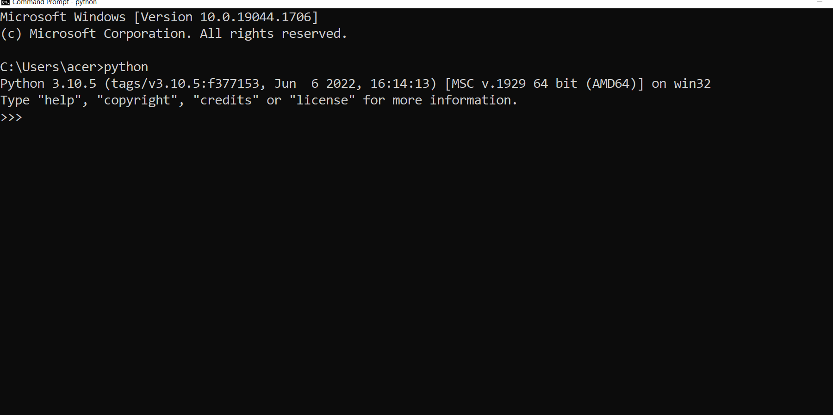

**Step 6.**

You have to verify pip was installed or not.

If you get this output its mean its installed.

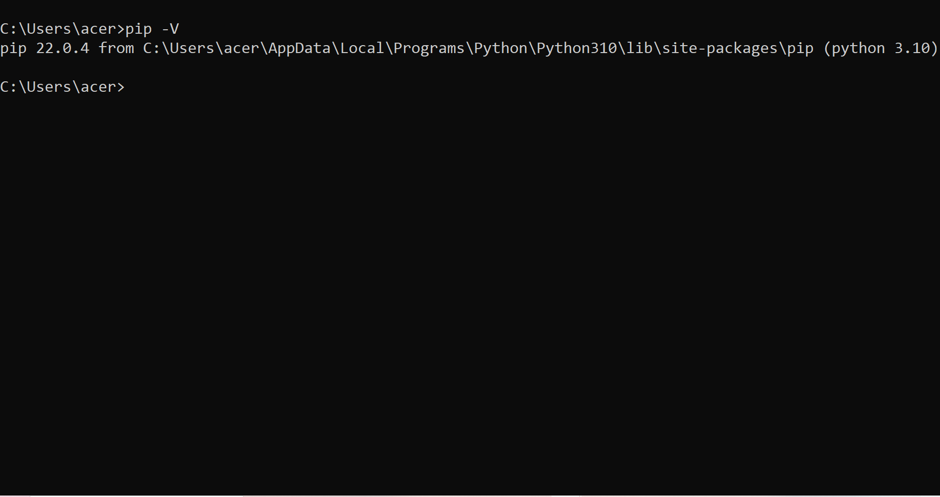

If you get this.

'pip' is not recognized as an internal or external command, Operable program or batch file

Go to this link - <https://phoenixnap.com/kb/install-pip-windows>.

**Step 7.**

You have to add Python path to environment variable(optional).

1. Go to the **start** menu and start the **run app**.

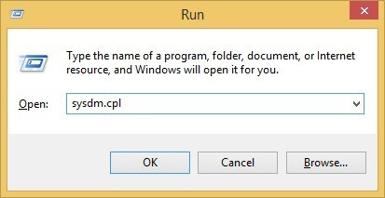

2. type the sysdm.cpl and you click.

3. go **advanced tap** and you select **Environment Variables**

4. under the **system variables**. you have to select the **Path variable**.

5. Click **edit**

6. Select the **Variable value** field. Add the path to the **python.exe** file preceded with a **semicolon** **(;)**. For example, in the image below, we have added "**;C:\Python34.**"

6. select you variable value field . and add the path of your Python.exe file with semicolon(;). For example you can see below image.

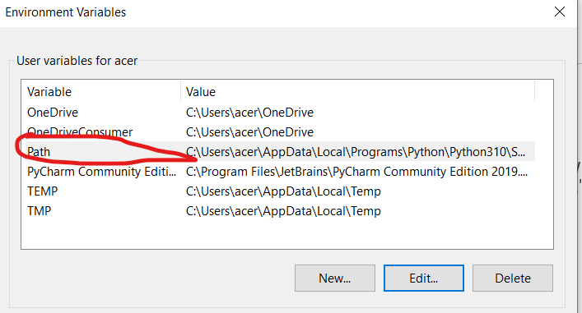

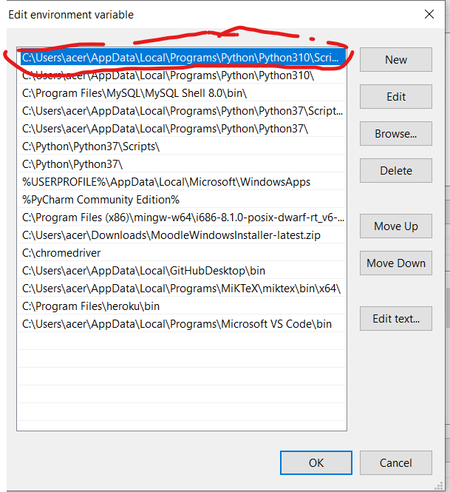

7. you have to click and closed the window.

**Step 8**

Installtheenvironments (optional).

1. type "**cmd**." In your start Manu.

2. open cmd.

3. Write the command.

pip install virtualenv.

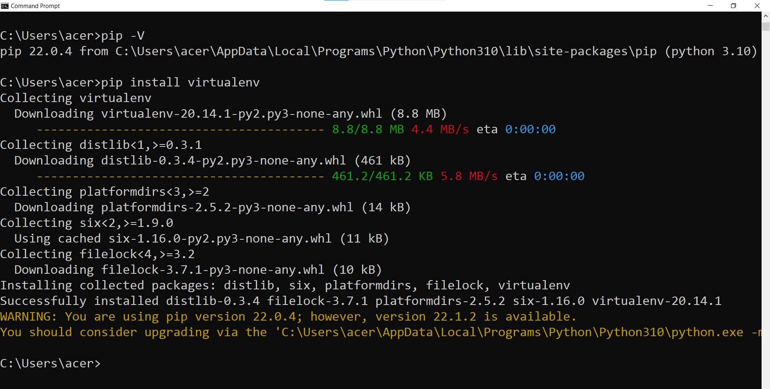

**Application of Python.**

Real word application of Python

1. **Machine leaning and Artificial Intelligence**.

You know in this world machine leaning and artificial intelligence importance. In this python language is using because the python has powerful library like pandas, NumPy, TensorFlow etc.

1. **Data Science**.

Data Science is like widely used in industry. Example like in finance, Business Decision. It has also use like pandas NumPy machine leaning algorithm for creation good model to predict the actual output. So, we can solve the real word problem. But in hole processes we have to used python programming language.

1. **Web Development.**

We know that today in this hole word what is the importance of web. Like you know Amazon, Flipkart, etc. This all are we b application. So basically, in python we have two types of Frameworks which is most use Django and Flask. This are use in web development.

Same as

1. Game Development.
2. Software Development
3. GUI Development
4. Scientific Application.
5. Operating system Development.
6. Graphic Design Application and Image Processing.
7. Language Developments.

**Conclusion** - How to use python and why we use Python.

**2.Artificial Intelligence vs Machine learning.**

**Artificial Intelligence:**

In this world we have a different type of work. So, we want to do fast but human can not do vary fast than computer that’s why AI comes in picture.

Basically, artificial intelligence is a part of computer science that use to make the real world fast by the use of machine algorithm. Also, we can say its set of algorithms to perform a task using machine.

**Types of Artificial intelligence**

### 1.Weak AI or Narrow Artificial Intelligence.

### 2. General Artificial Intelligence.

### 3. Super Artificial Intelligence.

**Machine Learning:**

Machine learning is a type of artificial intelligence that can use to perform the real word task. Machine leaning change the technological things. Machine leaning is use as a varies thing like gaming prediction, voice recognition, as per we can say that machine leaning is a subset of artificial intelligence.

**Types of Machines leaning:**

1. **Supervise machine leaning**
2. **Unsupervised machine leaning**
3. **Reinforcement machine leaning**

**Difference between Artificial Intelligence and Machine Learning**

