Ratio Data is defined as [quantitative data](https://www.questionpro.com/blog/quantitative-data/), having the same properties as [interval data](https://www.questionpro.com/blog/interval-data/), with an equal and definitive ratio between each data and absolute “zero” being treated as a point of origin. In other words, there can be no negative numerical value in ratio data.

For example:  
Four people are randomly selected and asked how much money they have with them. Here are the results: $20, $40, $60, and $80.

* Is there an order to this data? Yes, $20 < $40 < $60 < $80.
* Are the differences between the data values meaningful? Sure, the person who has $40 has $20 more than the person with $20.
* Can we calculate ratios based on this data? Yes, because $0 is the absolute minimum amount of money a person could have with them.
* The person with $80 has four times as much as the person with $20.

• **Absolute Point Zero:** It is measured on a [ratio scale](https://www.questionpro.com/blog/ratio-scale/). One of the distinctive characteristics is the true absolute zero point, which makes the data relevant and meaningful in a manner where it is right to say, “one object is twice as long as the other,” or 4 has twice the value as 2.

• **No Negative Numerical Value:** It has no negative numerical value. For a value to be a ratio data researcher, one must first evaluate if it meets all the criteria of interval data and has an absolute zero point. For example, weight cannot be negative; -20 Kg doesn’t exist.

• **Calculation:** Data values can be added, subtracted, divided, and multiplied. A unique statistical analysis is possible for this data.

**Interval Data Definition**

The interval data definition is simply a way of measuring something using equal intervals of time.

In other words, it’s a way of dividing up time so that we can better understand how things change over certain periods. There are many different ways to collect and analyze interval data.

## Interval Data Examples

1. Time of day in a 12-hour clock.
2. Temperature in degrees Fahrenheit or Celsius (not Kelvin).
3. IQ test.
4. SAT and ACT scores.
5. Age.
6. Income range.
7. Year.
8. Voltage.
9. Grade levels in school.

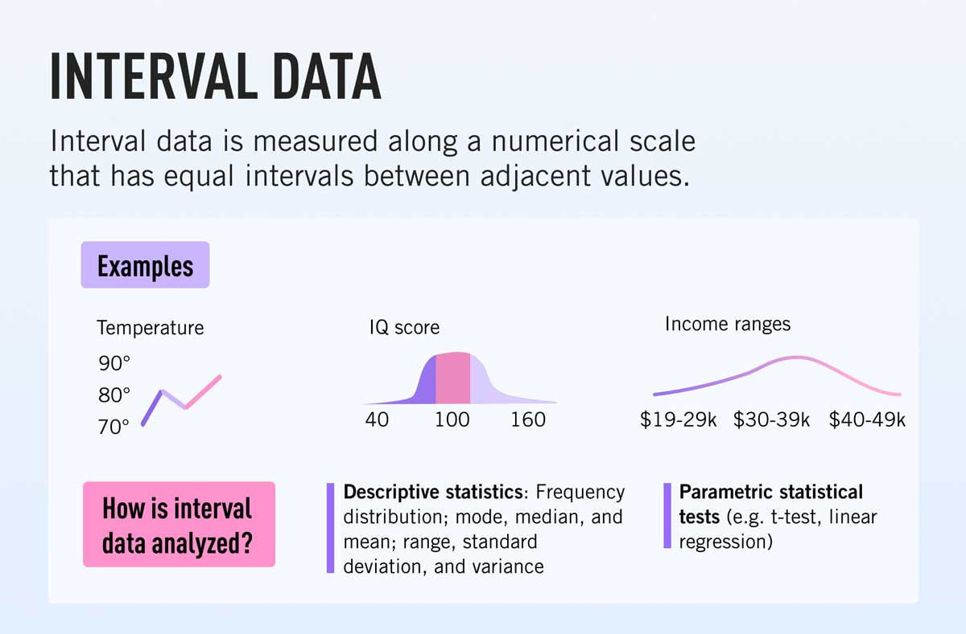

**Problem Statements:**

1. Identify the data type (continuous/discrete) for the following:

|  |  |
| --- | --- |
| Activity | Data Type(Discrete/Continuous) |
| Number of sheep counted while trying to sleep | Discrete |
| Results of rolling a dice | Discrete |
| Weight of a person | Continuous |
| Weight of Gold | Continuous |
| Distance between two places | Continuous |
| Length of a leaf | Continuous |
| Dog's weight | Continuous |
| Blue Color | Discrete |
| Number of kids | Discrete |
| Number of tickets in Indian railways | Discrete |
| Number of times married | Discrete |
| Gender (Male or Female) | Discrete |
| Voltage | Continuous |
| Speed of the car | Continuous |
| Distance between planets | Continuous |
| The size of a two a bedroom flat | Continuous |
| Wind speed | Continuous |
| Facebook likes | Discrete |
| Votes in election | Discrete |
| Make up kits purchased | Discrete |
| Death toll in flood disaster | Discrete |
| The waiting time of customers in bank | Continuous |
| Price of iPhone in the market | Discrete |
| Stolen Cars | Discrete |

1. Identify the data types (Nominal, Ordinal, Interval, and Ratio)

|  |  |
| --- | --- |
| Data | Data Type |
| Gender | N |
| High School Class Ranking | O |
| Celsius Temperature | I |
| Weight | R |
| Hair Color | N |
| Socioeconomic Status | O |
| Fahrenheit Temperature | I |
| Height | R |
| Type of living accommodation | N |
| Level of Agreement | O |
| IQ (Intelligence Scale) | I |
| Sales Figures | R |
| Blood Group | O |
| Time of Day | I |
| Time on a Clock with Hands | I |
| Number of Children | D |
| Religious Preference | N |
| Barometer Pressure | R |
| SAT Scores | I |
| Years of Education | I |
| Size of egg | R |
| Monthly Income | R |
| Unemployment rate | R |
| Military Rank | O |
| Shoe size | O |
| Pulse rate | I |
| Vital capacity | R |
| Favorite candy bar | N |
| Name of the Grains | N |
| Pesticides level | O |
| Tribe of origin | N |
| Help Desk Service Satisfaction Score | O |
| Ethnicity | N |
| Marital status | N |
| Type of Residence | O |
| Swimming level | O |
| Amount of Money | R |
| Colors of paint | N |
| Weekly Food spending | R |

1. Identify whether the data is qualitative or quantitative:

|  |  |
| --- | --- |
| Data | Data Type (Qualitative/Quantitative) |
| I bought Strawberry lipstick today | Qual |
| Happiness rating | Quan |
| Duration of red-light signal | Quan |
| I like butterscotch ice cream | Quan |
| Setosa belongs to Iris family of flowers | Qual |
| cold Coffee | Qual |
| The Tea smells good | Qual |
| Dress Size | Quan |

1. Identify whether the data is categorical or numerical for the following:

|  |  |
| --- | --- |
| Data | Data Type (Categorical / Numerical) |
| Product type | C |
| Native language | C |
| Type of teaching approach | C |
| Virus in a System | C |
| Covid-19 Positive Cases | N |
| Lockdown Days | N |

1. Identify whether the data is structured or unstructured for the following:

|  |  |
| --- | --- |
| Data | Data Type (Structured/Unstructured) |
| Credit card numbers | STRUCTURED |
| Transaction information | STRUCTURED |
| Text files | U |
| Images | U |
| Music files | U |
| Credit card numbers | STRUCTURED |