PROJECT REPORT
On
QUANTUM-INSPIRED SIMULATED BIFURCATION PORTFOLIO OPTIMIZER
A Project Report submitted to
Alliance University, Bengaluru
For the award of
BACHELOR OF TECHNOLOGY
in
COMPUTER SCIENCE AND ENGINEERING
by
Gaurav Bairwa — 2023BCSE07AED493
Kumar Krish Raj — 2023BCSE07AED490
Arya Rishi Roy — 2023BCSE07AED491
Abhishek Girish — 2023BCSE07AED376

Under the Supervision of
DR. ASHA KURIAN, [DESIGNATION], DEPARTMENT OF CSE


ALLIANCE SCHOOL OF ADVANCED COMPUTING
ALLIANCE UNIVERSITY - BENGALURU
Nov– 2026



COMPUTER SCIENCE AND ENGINEERING
ALLIANCE SCHOOL OF ADVANCED COMPUTING
CERTIFICATE
This is to certify that the project work entitled “QUANTUM-INSPIRED SIMULATED BIFURCATION PORTFOLIO OPTIMIZER” submitted by Gaurav Bairwa (2023BCSE07AED493), Kumar Krish Raj (2023BCSE07AED490), Arya Rishi Roy (2023BCSE07AED491), and Abhishek Girish (2023BCSE07AED376) in partial fulfillment for the award of the degree of Bachelor of Technology (Computer Science and Engineering) of Alliance University, is a bonafide work accomplished under our supervision and guidance during the academic year 2026–2027. This report embodies the result of original work and studies conducted by the student(s), and the contents do not form the basis for the award of any other degree to the candidate(s) or anybody else.

Dr. Asha Kurian | Dr. K Rama Lakshmi
[Designation]  Supervisor | Head of Department
Alliance School of Advanced Computing | Alliance School of Advanced Computing
External Examiners
1. Name: __________________________ Signature: __________________
2. Name: __________________________ Signature: __________________

COMPUTER SCIENCE AND ENGINEERING
ALLIANCE SCHOOL OF ADVANCED COMPUTING
DECLARATION
I/We hereby declare that the project entitled “QUANTUM-INSPIRED SIMULATED BIFURCATION PORTFOLIO OPTIMIZER” submitted by me/us in partial fulfillment of the requirements for the award of the degree of Bachelor of Technology (Computer Science and Engineering) of ASAC, Alliance University, is a record of our work carried under the supervision and guidance of Dr. Asha Kurian, [Designation].
We confirm that this report truly represents the work undertaken as a part of our project work. This work is not a replication of work done previously by any other person. We also confirm that the contents of the report and the views contained therein have been discussed and deliberated with the faculty guide.

Name of the Student | University Registration Number | Signature
Gaurav Bairwa | 2023BCSE07AED493 | ____________
Kumar Krish Raj | 2023BCSE07AED490 | ____________
Arya Rishi Roy | 2023BCSE07AED491 | ____________
Abhishek Girish | 2023BCSE07AED376 | ____________

ACKNOWLEDGEMENT
We express our sincere gratitude to all those who supported and guided us throughout the completion of this project. This project has been a significant learning experience, and we thank everyone who contributed to its progress.
First and foremost, we thank our project guide, Dr. Asha Kurian, for guidance, support and feedback throughout the project. We are grateful to the Dy. Director, Dr. V Vivek, for fostering an academic environment that encourages innovation and learning.
We also thank the Head of Department, Dr. K Rama Lakshmi, the program coordinator and the faculty members of Computer Science and Engineering, Alliance University, for providing a supportive learning environment. We acknowledge the contributions of teammates, friends and family for their encouragement.
Finally, we acknowledge the authors and researchers whose work informed this study.
Gaurav Bairwa — 2023BCSE07AED493
Kumar Krish Raj — 2023BCSE07AED490
Arya Rishi Roy — 2023BCSE07AED491
Abhishek Girish — 2023BCSE07AED376
Computer Science and Engineering, Alliance University

PREFACE
This report presents a classical optimization pipeline inspired by simulated bifurcation for portfolio construction. It brings together a C++20 numerical core, Python market-data ingestion, a POSIX shared-memory interface and a paper-trading ledger. The project studies how a dynamic oscillator-based heuristic can be integrated with risk estimation and practical data flows.
The report is organized into six chapters. Chapter 1 introduces the problem, objectives and scope. Chapter 2 reviews the relevant portfolio, fractional programming and quantum-inspired literature. Chapter 3 explains the architecture and design, while Chapter 4 describes the implementation. Chapter 5 reports the available observations and their limitations; Chapter 6 concludes and proposes future work.
The analysis is based on the checked-in repository and its logs, scripts and diagrams. No new live-market experiment, hardware benchmark, or independent optimization-quality comparison was performed while preparing this report. Claims that need further verification are identified rather than presented as established results.

ABSTRACT
Portfolio optimization seeks allocations that balance expected return and risk under operational constraints. This capstone presents a quantum-inspired simulated bifurcation portfolio optimizer implemented on classical computing hardware. It does not require qubits or machine learning. Its C++20 engine cleans a covariance estimate, constructs a low-rank factor approximation, evolves coupled oscillator states and applies a small projected-gradient polishing step.
Two execution paths are documented. In the live path, a Python WebSocket feed collects trade prices for ten cryptocurrency pairs, estimates rolling return moments, exchanges data with the C++ engine through shared memory, and records simulated rebalances. The backtest path replays synthetic LOBSTER-schema order messages for a 500-name universe, screens 30 candidates and logs stage timings. The repository also contains separate experimental modules whose presence should not be confused with integration into both paths.
The supplied live log contains 1,437 latency entries with a median of 215.6 microseconds; this is the engine’s measured processing interval, not network-to-trade latency. The supplied backtest log has 129 parseable timing lines with a median of 2,129.21 microseconds. These are repository artifacts rather than independently reproduced measurements. The approach is a heuristic prototype: global optimality, realized profitability, fair baseline superiority and production readiness are not established.

TABLE OF CONTENTS
Name of the Chapter | Page No.
Certificate | i
Declaration | ii
Acknowledgement | iii
Preface | iv
Abstract | v
List of Figures | viii
List of Tables | ix
List of Abbreviations & Symbols | x
Chapter 1 Introduction | 1
1.1 Background; 1.2 Problem Statement | 1
1.3 Objectives; 1.4 Scope | 2
Chapter 2 Literature Review | 3
2.1 Existing System; 2.2 Research Review | 3
2.3 Gap Analysis | 4
Chapter 3 System Analysis & Design | 5
3.1 System Architecture | 5
3.2 System Design | 6
3.2.3 UML Diagrams | 7
3.3 Module Description | 8

TABLE OF CONTENTS (CONTINUED)
Name of the Chapter | Page No.
Chapter 4 Implementation | 9
4.1 Technologies Used | 9
4.2 Algorithms / Models | 10
4.3 Working / Screens | 11
Chapter 5 Results and Discussion | 12
5.1 Outputs | 12
5.2 Performance Analysis | 14
5.3 Comparison | 14
Chapter 6 Conclusion & Future Scope | 15
6.1 Conclusion; 6.2 Future Scope | 15
References & Bibliography | 16
Appendix A: Front Page of Conference / Journal Paper | 17
Appendix B: Conference / Journal Acceptance Letter | 18
Appendix C: Source Code | 19

LIST OF FIGURES
Figure No. | Description | Page No.
3.1 | System architecture (repository diagram) | 5
3.2 | Data flow diagram | 6
3.3 | UML summary: use case, class and sequence | 7
4.1 | Optimization flowchart | 10
5.1 | Simulated portfolio value | 12
5.2 | Target-weight evolution | 12
5.3 | Relative saturation indicator | 13
5.4 | Recorded solver latency distribution | 13

LIST OF TABLES
Table No. | Description | Page No.
2.1 | Research gap analysis | 4
3.1 | System modules description | 8
4.1 | Tools and technologies used | 9
5.1 | Recorded performance observations | 14
5.2 | Qualitative comparison with existing approaches | 14

LIST OF ABBREVIATIONS & SYMBOLS
Abbreviation / Symbol | Meaning
SB | Simulated bifurcation
QUBO | Quadratic unconstrained binary optimization
RMT | Random matrix theory
PSD | Positive semidefinite
EWMA | Exponentially weighted moving average
ADMM | Alternating direction method of multipliers
PGD | Projected gradient descent
LOB | Limit order book
IPC | Inter-process communication
μ | Estimated vector of asset returns
Σ | Estimated return covariance matrix
w | Portfolio weight vector
λ | Ratio or penalty parameter, according to context
µs | Microseconds

CHAPTER 1
INTRODUCTION

1.1 Background

1.1.1 Domain Overview
Portfolio construction allocates capital among assets to balance expected return and risk. Mean–variance analysis uses return estimates and covariance to model this trade-off [1]. In practice, short samples, asynchronous market updates, transaction costs and discrete selection make the problem more difficult than the textbook model. Estimates may change faster than a computational pipeline can update its allocations.
Quantum finance literature explores both gate-based and annealing approaches [3–5]. Simulated bifurcation instead evolves classical oscillator variables inspired by quantum adiabatic dynamics [6]. Its implementation requires ordinary numerical computation; this project does not demonstrate quantum speedup or use a quantum device.

1.2 Problem Statement
The project investigates whether a classical, quantum-inspired heuristic can be integrated into an observable portfolio workflow that processes changing market moments, produces signed weights and records its computational latency. The challenge is to make the path inspectable while avoiding claims of real-world trading performance that the available evidence cannot substantiate.

1.3 Objectives
1. Build a C++20 oscillator-based optimization core with risk cleaning, factor modeling and a fractional-ratio iteration.
2. Connect Python data ingestion and paper trading to the numerical engine using shared memory; preserve a reproducible synthetic replay path.
3. Document the architecture, inputs, outputs and timing artifacts, distinguishing implemented modules from deployed behavior.
4. Identify limitations and experiments needed to establish solution quality, economic value and operational robustness.

1.4 Scope
The live example handles ten cryptocurrency trade streams and a rolling price-derived return matrix. The synthetic backtest models 500 symbols and screens the active set to 30. Output consists of candidate weights, timing information and a simulated cash/position ledger. These examples are prototypes rather than investment advice or a broker integration.
The repository includes additional cardinality, cost and higher-order risk components. They are discussed as components, not assumed to be fully integrated. Market data availability, dependencies, and operating-system configuration affect whether a demo can be reproduced. The repository’s synthetic backtest is not real LOBSTER historical data.

CHAPTER 2
LITERATURE REVIEW

2.1 Existing System

2.1.1 System Description
The Markowitz formulation minimizes variance for a chosen expected return or balances the two terms directly [1]. Conventional numerical optimizers can efficiently handle several convex portfolio formulations [2], but cardinality and trading constraints can introduce combinatorial complexity. Covariance shrinkage can improve conditioning when sample estimates are noisy [10].

2.2 Research Review
Rebentrost and Lloyd consider a quantum algorithm for portfolio optimization [3]. Cohen et al. examine a D-Wave annealer for a 40-stock portfolio [4], while Venturelli and Kondratyev study reverse annealing [5]. These studies use different formulations and computing models; their reported outcomes are not directly comparable with this prototype without matched data, objectives and measurement protocols.
Goto et al. introduce classical nonlinear simulated bifurcation [6], while Steinhauer et al. apply SB to trading trajectories [7]. Lu et al. investigate QUBO penalty estimation and two-stage search [11]. Kanao and Goto extend SB to higher-order cost functions [12] and study thermal fluctuations [13]. The project includes optional higher-order and noise mechanisms, but their equivalence to those papers is not established.
Tatsumura et al. demonstrate FPGA-based SB [14]; this project’s measured path is CPU-based. Egger et al. survey quantum finance applications and implementation challenges [15]. Fractional programming [8] and transaction-impact modeling [9] provide further context. The implemented solver remains a heuristic, not a proof of these methods’ guarantees.

2.3 Gap Analysis
Table 2.1: Research gap analysis
Practical issue | Prototype response | Remaining question
Cost of solving larger universes | Rank and screen assets before solving | Effect of screening on solution quality
Noisy or poorly conditioned risk | Eigenvalue cleaning and PSD ridge attempts | Out-of-sample stability and calibration
Ratio-based objective | Dinkelbach-style ratio update and SB heuristic | Exact subproblem solution is not shown
Data movement and observability | Shared-memory bridge and timing logs | Race safety and end-to-end measurement
Realistic trading costs | Separate cost-model component | Not wired into the active solve or paper ledger
The repository describes 21 research gaps. This report treats them as project motivations, not as 21 independently verified solutions. Some issues, such as physical qubit precision or embedding, do not arise in a CPU-only implementation; avoidance is not a solution to a hardware problem.
Dinkelbach-style convergence theory generally depends on assumptions and adequately solved subproblems [8]. Here the linear field and ratio updates in code are heuristic; the loop stops after at most six iterations and does not establish global Sharpe optimality. Similarly, five PGD steps alone do not prove convergence to a local optimum.

CHAPTER 3
SYSTEM ANALYSIS & DESIGN

3.1 System Architecture

3.1.1 Architecture Diagram
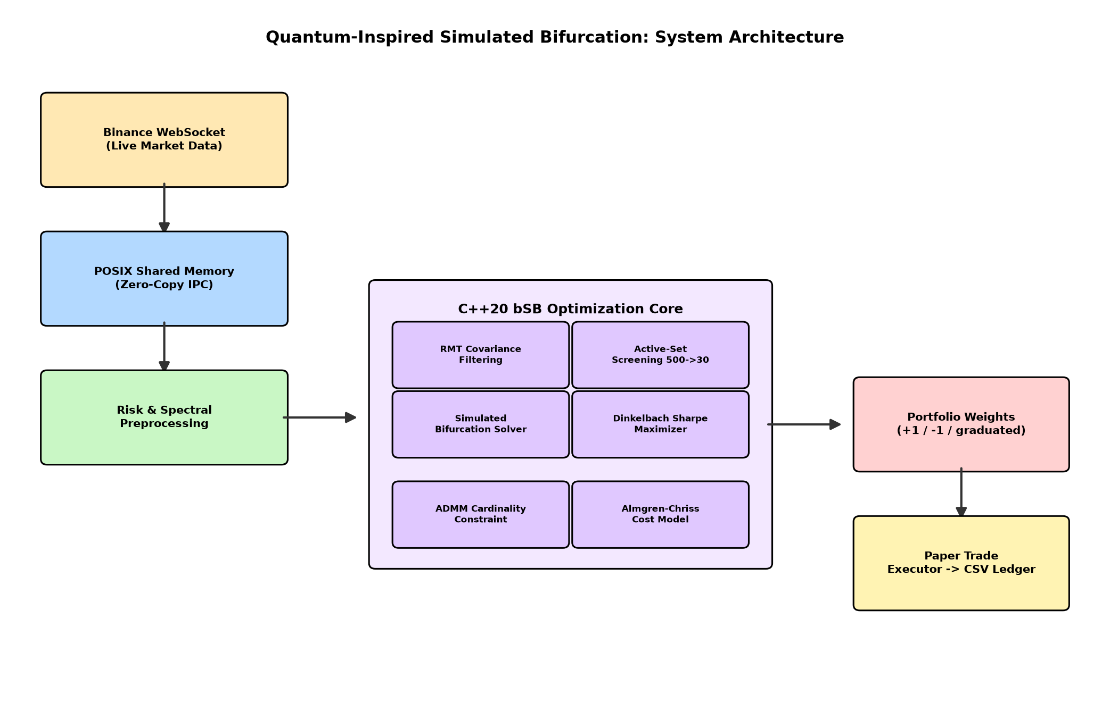
Figure 3.1: System architecture diagram (repository asset)

3.1.2 Workflow Description
The live feed receives trades, updates rolling price buffers and periodically calculates moments. The bridge publishes moments for the resident C++ engine, which computes weights and writes them back. Python reads the result and rebalances a simulated ledger. Separately, the backtest consumes generated message files, maintains order books and periodically rebuilds its optimization inputs.

3.1.3 Data Flow
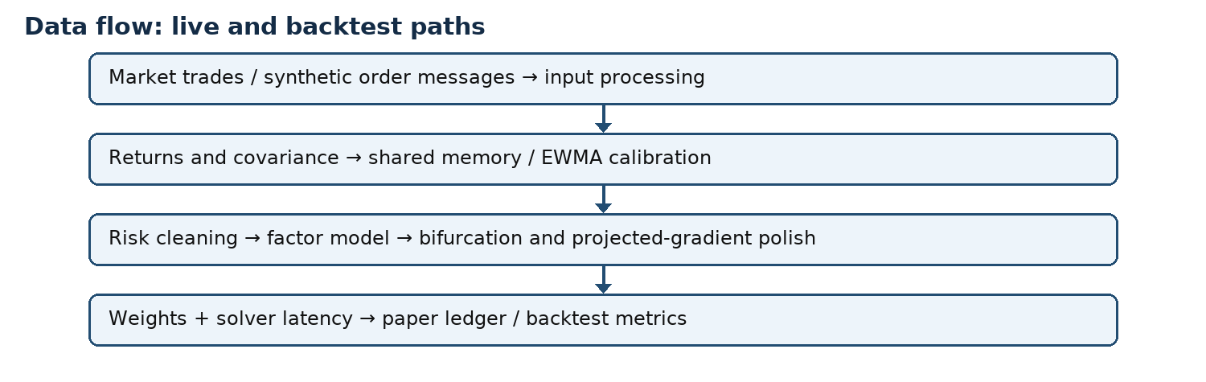
Figure 3.2: Data flow diagram

3.2 System Design

3.2.1 Design Approach
The implementation separates Python I/O from numerical optimization and uses a compact shared-memory array for the live interface. C++ headers encapsulate individual mathematical components; the live and replay entry points choose different pipelines. This structure makes stages inspectable, but it does not by itself establish thread safety or low end-to-end latency.

3.2.2 Database Design
There is no database in the checked-in live workflow. Shared memory holds a readiness flag, N, μ, a row-major N×N covariance matrix, output weights and latency. The CSV ledger stores ts, symbol, target_w, price, shares_delta and cash. Replaying or auditing trades requires preserving the generated CSV and its symbol ordering.

3.2.3 UML Diagrams (Use Case, Class, Sequence)
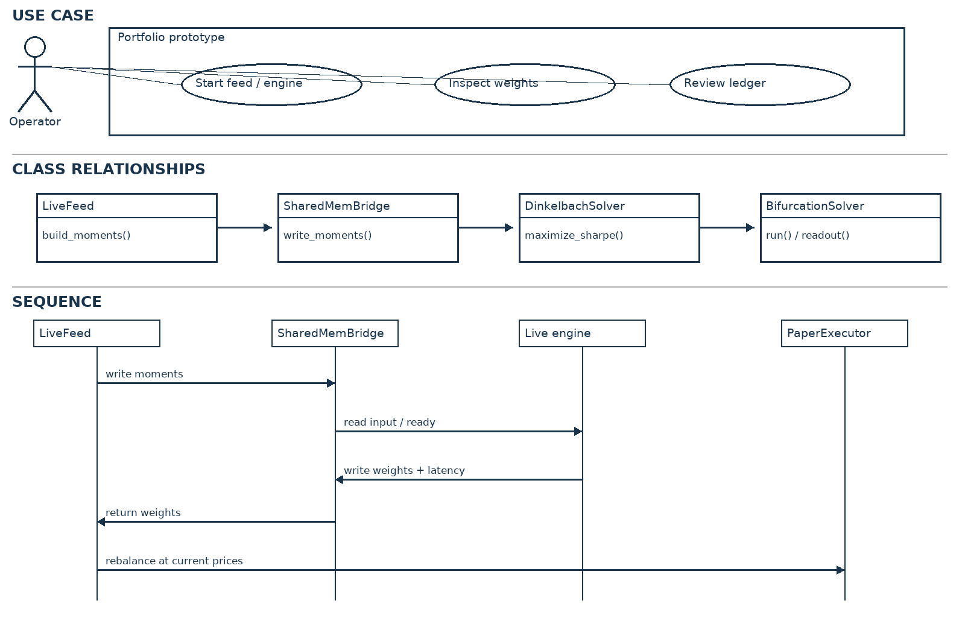
Figure 3.3: UML relationships and sequence summary
Use case: an operator starts the data feed and live engine and observes the printed weights and ledger. There is no login screen or authenticated user interface in the repository. The class-level view highlights composition and calls rather than suggesting an unimplemented database or trading gateway.
Sequence: LiveFeed writes moments and a ready flag; the C++ engine reads the array, computes and writes weights plus latency; LiveFeed polls for the result and invokes PaperExecutor. The handshake uses ordinary shared-memory values, so robust synchronization, crash recovery and memory-order guarantees require further engineering.

3.3 Module Description
Table 3.1: System modules description
Module | Responsibility / integration
binance_live_feed.py | Trade streams, rolling moments, periodic rebuild
shared_mem_bridge.py | Shared-memory layout and polling handshake
bifurcation_solver.hpp | Oscillator evolution and readout
rmt_filter.hpp / factor_model.hpp | Covariance cleaning and low-rank approximation
dinkelbach.hpp / pgd_polish.hpp | Ratio iteration and five-step polishing
active_set_screener.hpp | Backtest ranking and selection of 30 assets
paper_trade_executor.py | Gross normalization and simulated CSV ledger
almgren_chriss.hpp / coskew_tensor.hpp | Separate components; not passed into the shown active solve
The backtest updates a cardinality dual bias after counting nonzero polished weights. In the live engine the bias object is created but its update method is not called. The code therefore does not establish an exact-cardinality constraint in either path. The solver’s optional coskew interface is not supplied by the shown Dinkelbach calls.

CHAPTER 4
IMPLEMENTATION

4.1 Technologies Used
Table 4.1: Tools and technologies used
Category | Tools / role
Software tools | CMake, C++20 compiler, Python 3
Libraries | Eigen3, OpenMP, POSIX threads/shared memory; NumPy and websockets
Hardware requirements | CPU and memory sufficient for C++/Python workloads; Linux/POSIX environment for the live path
Data | Binance trade WebSocket; synthetic LOBSTER-schema messages
Outputs | Terminal logs, CSV paper ledger and repository PNG figures

4.1.1 Software Tools
CMake builds backtest_engine and live_engine with optimization flags. Python manages the feed and ledger. The README mentions a requirements.txt file, but that file is not tracked in this checkout; NumPy and websockets must therefore be installed separately and versions should be recorded for reproduction.

4.1.2 Hardware Requirements
The README reports CPU execution under WSL2 but does not specify a complete reproducible hardware configuration. The CUDA source exists, but the CMake configuration builds C++ targets only; GPU performance is not established.

4.1.3 Frameworks / Libraries
Eigen provides matrix operations and eigendecomposition. OpenMP is linked by the build. Python’s multiprocessing shared_memory provides the IPC region; no machine-learning framework is used.

4.2 Algorithms / Models

4.2.1 Algorithm Description
The engine filters the covariance spectrum, attempts positive-definiteness with diagonal ridges, fits a low-rank factor model and derives a timestep from a spectral-radius estimate. It evolves oscillator coordinates and momenta using a pump schedule and injected noise. DinkelbachSolver reuses an oscillator state across its ratio iterations within a single solve, then returns the best candidate ratio observed.

4.2.2 Flowchart
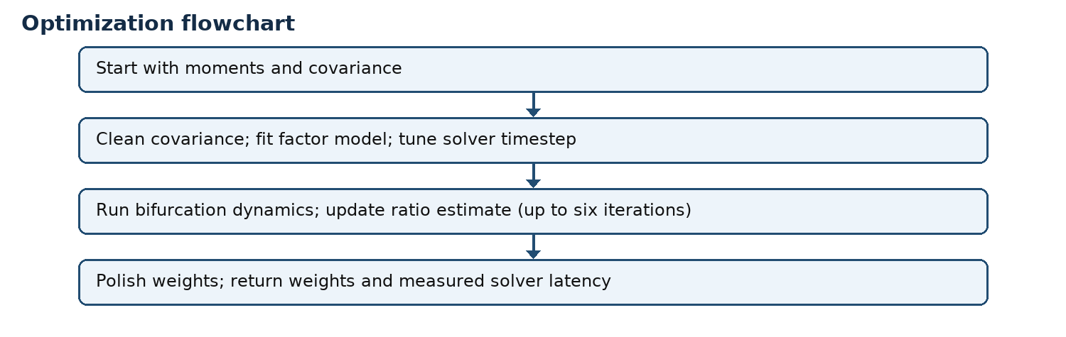
Figure 4.1: Optimization flowchart

4.2.3 Mathematical Model
For weights w, estimated return μ and covariance Σ, the reported ratio is S(w) = (wᵀμ) / √max(wᵀΣw, ε). A general fractional method considers f(w) − λg(w) and updates λ = f(w)/g(w) [8]. The implementation uses h = λμ − bias and an oscillator/factor-model field, so this expression is motivation rather than an exact derivation of the coded inner objective.

4.3 Working / Screens

4.3.1 Input Processing
LiveFeed maintains up to 500 prices per symbol, requires at least ten observations per symbol, forms simple consecutive returns, aligns by trailing observation count and estimates covariance with NumPy. The return observations are not synchronized by timestamp; this is a limitation for cross-asset covariance. Rebuilds are scheduled at roughly 200 ms intervals, subject to processing delays.

4.3.2 Execution Process
Build using the README’s CMake commands after installing Eigen3 and OpenMP. Start the Python feed before live_engine so the shared region exists. For replay, generate the expected synthetic message files and pass their directory to backtest_engine. Paths, Python dependencies and data must be configured locally; no run was performed for this report.

4.3.3 Output Generation
The live engine starts its timer after copying inputs from shared memory and stops after writing output weights. It excludes network ingestion, Python moment construction, polling delays and paper rebalancing. The paper executor scales weights if gross exposure exceeds 1, then adjusts simulated positions and cash. It assumes execution at the supplied prices and does not model fees, slippage, margin or borrow costs.
The console log is the working interface, not a graphical application. As an example of recorded output, the supplied log contains “latency_us=262.7” followed by a ten-element weight array. Figures in the next chapter are existing repository charts rather than screenshots produced during this report.

CHAPTER 5
RESULTS AND DISCUSSION

5.1 Outputs

5.1.1 Screenshots
The repository provides console logs and generated graphs, not application screenshots. The following figures are reproduced from its assets directory; their provenance is the repository, and their exact generation run is not independently established.

5.1.2 Graphical Results
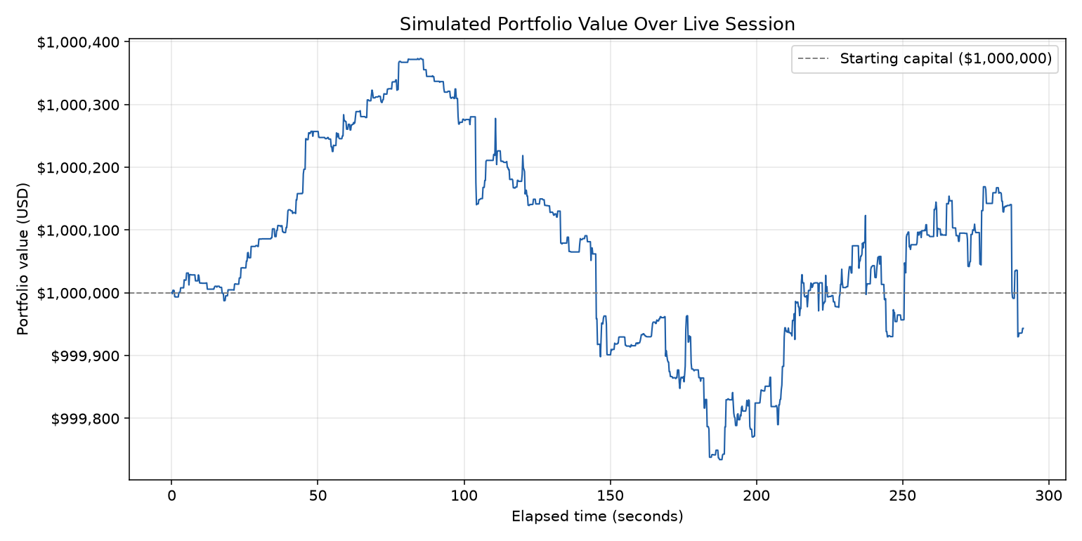
Figure 5.1: Simulated portfolio value (repository asset)
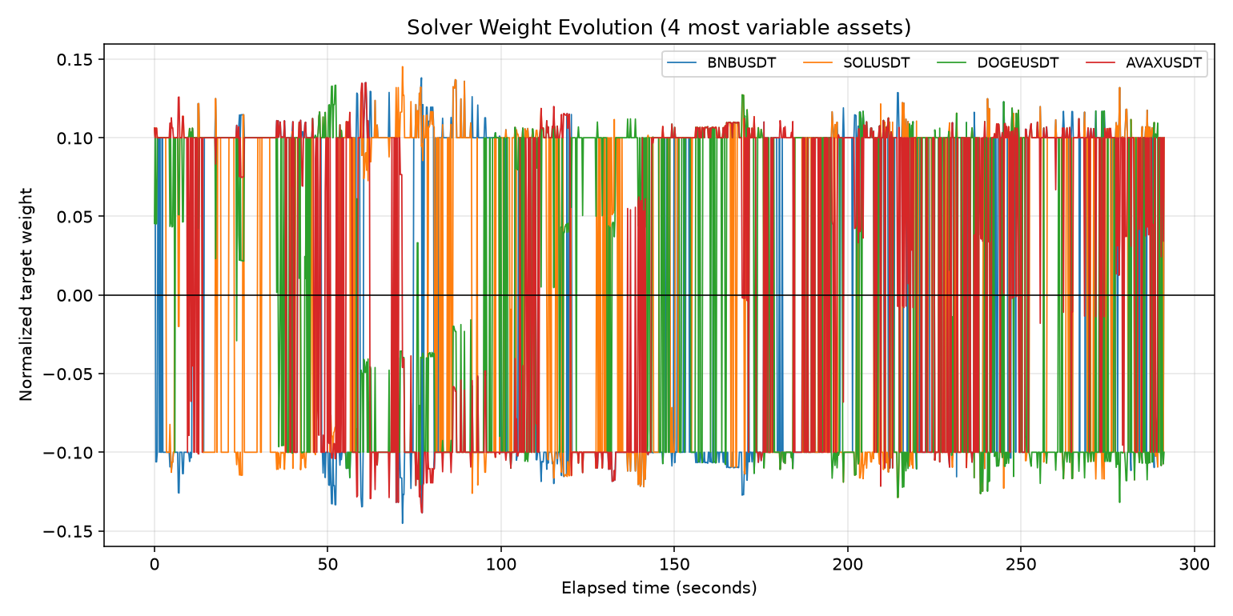
Figure 5.2: Target-weight evolution (repository asset)

5.1.3 Outputs
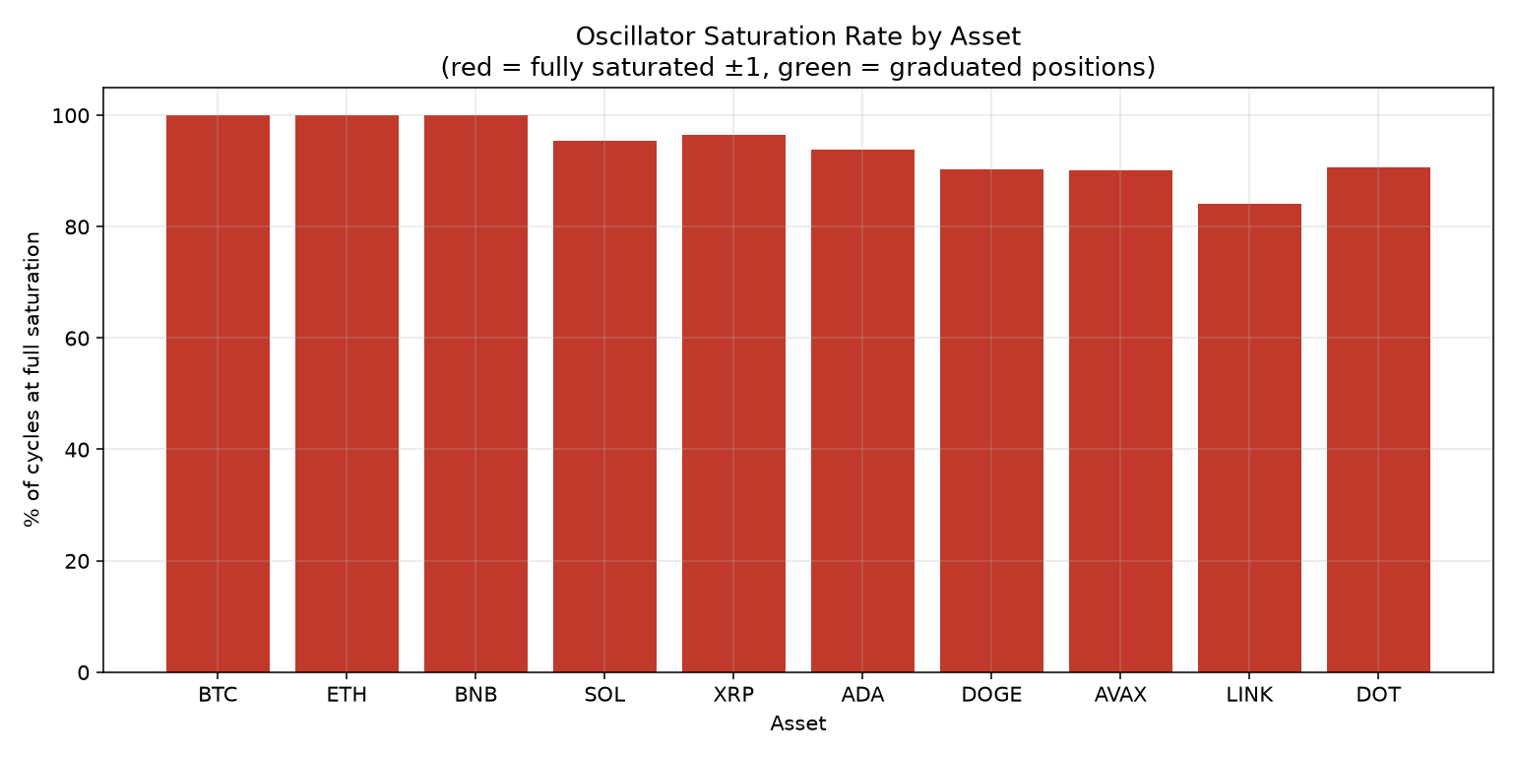
Figure 5.3: Relative saturation indicator (repository asset)
The chart script divides logged target weights by the largest absolute weight in each cycle; thus the indicator measures relative extremeness among normalized targets, not direct measurements of internal oscillator saturation. Its chart label should not be treated as proof of saturation at ±1.
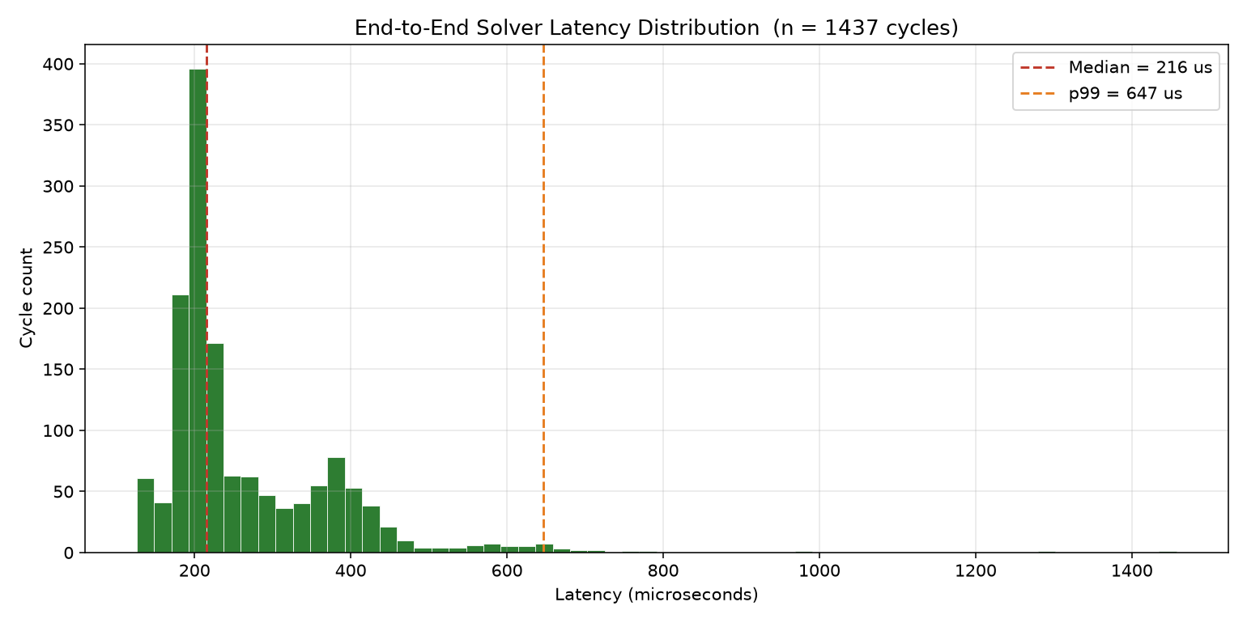
Figure 5.4: Recorded solver latency distribution (repository asset)
Although the existing chart uses “end-to-end” in its title, the timer in main_live.cpp measures only the C++ interval described in Section 4.3.3. The chart and checked-in log may not come from exactly the same run.

5.2 Performance Analysis

5.2.1 Metrics
Table 5.1: Recorded performance observations
Artifact / metric | Observation | Qualification
Live log: 1,437 latency entries | Median 215.6 µs; range 126.2–1,456.9 µs | C++ engine interval; not full cycle
Backtest log: 129 parseable lines | Median 2,129.21 µs; range 1,313.99–2,800.63 µs | Sampled output; final line truncated
Paper-trade CSV | 96,620 data rows in current checkout | Simulated fills; not proof of profit

5.2.2 Evaluation Results
Values above were calculated from the checked-in artifacts; no fresh benchmark was run. The README reports other typical latency ranges and 14,371 ledger rows, which do not describe the full currently checked-in ledger. Timing samples are not necessarily independent, and the supplied files do not document a controlled hardware and baseline protocol.

5.2.3 Observations
The log shows signed weights and repeated solve timings. Portfolio value charts use a simplified mark-to-market ledger, while paper trading uses immediate fills without realistic costs. A changing simulated value is not evidence of a deployable or profitable strategy.

5.3 Comparison
Table 5.2: Qualitative comparison with existing approaches
Approach | Distinction / evidence
Classical convex optimization | Useful baseline for compatible objectives; no matched benchmark supplied
Quantum annealing | Different hardware and encoding; no direct speed comparison established
This prototype | Classical oscillator heuristic and IPC; lacks proof of global optimum

5.3.2 Advantages / 5.3.3 Limitations
The code is inspectable and separates live and synthetic paths. Limitations include simplified execution, unsynchronized returns, incomplete constraint enforcement, absent baseline testing and no verified production-safe synchronization.

CHAPTER 6
CONCLUSION & FUTURE SCOPE

6.1 Conclusion

6.1.1 Summary of Work
The project combines a classical oscillator-based search with covariance processing, ratio iteration, shared-memory I/O and simulated portfolio rebalancing. The repository provides a useful prototype and recorded artifacts for studying engineering trade-offs, not evidence of quantum computation or financial profitability.

6.1.2 Advantages
Its modular organization, inspectable timing and separate replay path make it suitable for numerical experimentation. Reuse of oscillator state within a solve is an implementation optimization, though its benefit should be measured under a controlled benchmark.

6.1.3 Applications
Potential research applications include testing risk-estimator sensitivity, optimization heuristics and data-pipeline design. The paper-trading path is an educational simulation, not a brokerage or production execution system.

6.1.4 Limitations
Exact Sharpe maximization and formal convergence are not established. The cost and coskew components are not wired into the shown main solve; live cardinality bias is not updated. Synthetic history, simplified fills, limited provenance and missing comparable baselines restrict conclusions.

6.2 Future Scope
Use timestamp-aligned market data and real historical order-book feeds; implement robust atomic IPC, validation and lifecycle management; integrate and calibrate transaction costs and constraints; compare against convex, equal-weight and other heuristic baselines under identical assumptions; report quality, distributions and full end-to-end latency. Add transaction fees, borrow costs, stress tests and reproducible environment specifications before considering real deployment.

REFERENCES & BIBLIOGRAPHY
[1] H. Markowitz, “Portfolio Selection,” The Journal of Finance, 7(1), 77–91, 1952. doi:10.1111/j.1540-6261.1952.tb01525.x.
[2] S. Boyd and L. Vandenberghe, Convex Optimization, Cambridge University Press, 2004. https://web.stanford.edu/~boyd/cvxbook/.
[3] P. Rebentrost and S. Lloyd, “Quantum computational finance: Quantum algorithm for portfolio optimization,” arXiv:1811.03975, 2018.
[4] J. Cohen, A. Khan and C. Alexander, “Portfolio Optimization of 40 Stocks Using the DWave Quantum Annealer,” arXiv:2007.01430, 2020.
[5] D. Venturelli and A. Kondratyev, “Reverse quantum annealing approach to portfolio optimization problems,” Quantum Machine Intelligence, 1, 17–30, 2019.
[6] H. Goto, K. Tatsumura and A. R. Dixon, “Combinatorial optimization by simulating adiabatic bifurcations,” Science Advances, 5, eaav2372, 2019. doi:10.1126/sciadv.aav2372.
[7] K. Steinhauer, T. Fukadai and S. Yoshida, “Solving the Optimal Trading Trajectory Problem Using Simulated Bifurcation,” arXiv:2009.08412, 2020.
[8] W. Dinkelbach, “On Nonlinear Fractional Programming,” Management Science, 13(7), 492–498, 1967. doi:10.1287/mnsc.13.7.492.
[9] R. Almgren and N. Chriss, “Optimal execution of portfolio transactions,” The Journal of Risk, 3(2), 5–39, 2001.
[10] O. Ledoit and M. Wolf, “Improved estimation of the covariance matrix of stock returns with an application to portfolio selection,” Journal of Empirical Finance, 10(5), 603–621, 2003.
[11] Y.-C. Lu et al., “Quantum-Inspired Portfolio Optimization In The QUBO Framework,” arXiv:2410.05932, 2024.
[12] T. Kanao and H. Goto, “Simulated bifurcation for higher-order cost functions,” Applied Physics Express, 16, 014501, 2023. doi:10.35848/1882-0786/acaba9.
[13] T. Kanao and H. Goto, “Simulated bifurcation assisted by thermal fluctuation,” Communications Physics, 5, 153, 2022. doi:10.1038/s42005-022-00929-9.
[14] K. Tatsumura, A. R. Dixon and H. Goto, “FPGA-based Simulated Bifurcation Machine,” IEEE FPL, 59–66, 2019. doi:10.1109/FPL.2019.00019.
[15] D. J. Egger et al., “Quantum Computing for Finance: State of the Art and Future Prospects,” IEEE Transactions on Quantum Engineering, 2020. doi:10.1109/TQE.2020.3030314.
[16] Project repository, Quantum-Inspired Simulated Bifurcation Portfolio Optimizer, commit 11a41626. https://github.com/gauravbren2019/quantum-inspired-portfolio-optimizer.

APPENDICES
APPENDIX A
Front Page of the Conference / Journal Paper
[To be supplied by the students: insert the front page of their own submitted or published conference / journal paper, if applicable. The supplied research papers are literature sources and do not establish a paper by the project team.]

APPENDIX B
Conference / Journal Acceptance Letter
[To be supplied by the student: insert the actual conference / journal acceptance letter here, if applicable. No acceptance letter was provided; none is asserted or fabricated in this report.]

APPENDIX C
Source Code
The authoritative complete source code is in the project repository at commit 11a41626. The listing below identifies the principal implementation files; it is an index, not a full source-code printout.
• include/bifurcation_solver.hpp — oscillator state, integration and readout
• include/dinkelbach.hpp — ratio iteration and within-solve warm start
• include/rmt_filter.hpp; include/factor_model.hpp — risk processing
• src/main_live.cpp; src/main_backtest.cpp — live and replay entry points
• python/binance_live_feed.py; python/shared_mem_bridge.py — data and IPC
• python/paper_trade_executor.py — simulated portfolio ledger

Excerpt: target gross-exposure normalization
gross = sum(abs(w) for w in weights)
if gross > self.max_gross_leverage and gross > 0:
scale = self.max_gross_leverage / gross
return [w * scale for w in weights]
return weights
Source: python/paper_trade_executor.py. Repository: https://github.com/gauravbren2019/quantum-inspired-portfolio-optimizer
[If the university requires a full code printout, append the complete files separately; doing so will increase the page count beyond 30.]

