CAT II - Assignment 3

Internet and Web Programming

Group #: 3

Slot: B11 + B12 + B13

## 1.

The Document Object Model (DOM) is a programming interface for HTML documents. It defines the logical structure of documents and the way a document is accessed and manipulated.

DOM is a way to represent the webpage in the structured hierarchical way so that it will become easier for programmers and users to glide through the document. With DOM, we can easily access and manipulate tags, IDs, classes, Attributes or Elements using commands or methods provided by Document object.

**DOM Structure:**

DOM can be thought of as Tree or Forest (more than one tree). The term structure model is sometimes used to describe the tree-like representation of a document. One important property of DOM structure models is structural isomorphism: if any two DOM implementations are used to create a representation of the same document, they will create the same structure model, with precisely the same objects and relationships.

For example:-

<Table>

<ROWS>

<TR>

<TD>Car</TD>

<TD>Scooter</TD>

</TR>

<TR>

<TD>Motorbike</TD>

<TD>Bus</TD>

</TR>

</ROWS>

</Table>

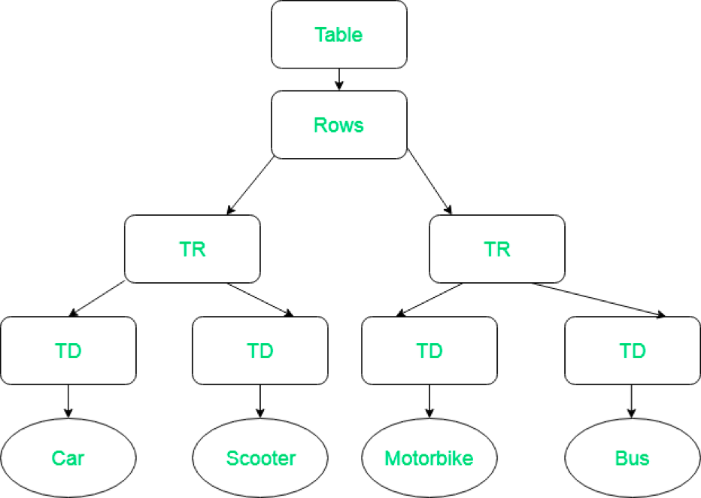

**Event Handling:**

Event handler is a block of code (usually a JavaScript function that you as a programmer create) that runs when the event fires. When such a block of code is defined to run in response to an event, we say we are registering an event handler.

In the following example, we have a single <button>, which when pressed, makes the background change to a random color:

<button>Change color</button>

The JavaScript looks like so:

const btn = document.querySelector('button');

function random(number) {

return Math.floor(Math.random() * (number+1));

}

btn.onclick = function() {

const rndCol = 'rgb(' + random(255) + ',' + random(255) + ',' + random(255) + ')';

document.body.style.backgroundColor = rndCol;

}

We are listening for the click event firing, by setting the onclick event handler property to equal an anonymous function containing code that generates a random RGB color and sets the <body> background-color equal to it.

## 2.

JSON is a subset of JavaScript that is used to transmit data between the server and client in a structured format. JSON package is built in Python. So, JSON data can be easily encoded and decode by using Python script by importing the JSON package. Primitive data types like string, number and compound data types like list, objects, etc. are supported by JSON.

Python object translates into a JSON object by using serialization and the JSON object translates into a Python object by using deserialization.

**Methods**:

load() : This method is used to load data from a JSON file into a python dict.

Loads( ) : This method is used to load data from a JSON variable into a python dict.

dump() : This method is used to load data from the python dictionary to the JSON file.

dumps(): This method is used to load data from the python dictionary to the JSON variable.

**Reading JSON data**

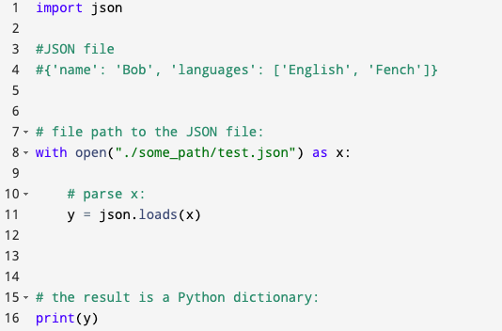

**Converting Python dictionary to JSON**

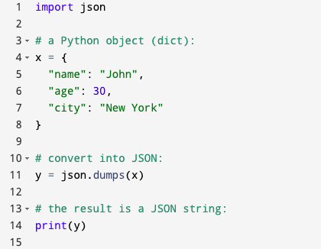

## 3.

jQuery is an open source JavaScript library that simplifies the interactions between an HTML/CSS document, or more precisely the Document Object Model (DOM), and JavaScript.

Elaborating the terms, jQuery simplifies HTML document traversing and manipulation, browser event handling, DOM animations, Ajax interactions, and cross-browser JavaScript development.

Some of the key points which supports the answer for why to use jQuery:

* It is incredibly popular, which is to say it has a large community of users and a healthy amount of contributors who participate as developers and evangelists.
* It normalizes the differences between web browsers so that you don’t have to.
* It is intentionally a lightweight footprint with a simple yet clever plugin architecture.
* Its repository of plugins is vast and has seen steady growth since jQuery’s release.
* Its API is fully documented, including inline code examples, which in the world of JavaScript libraries is a luxury.
* It is friendly, which is to say it provides helpful ways to avoid conflicts with other JavaScript libraries.