CAT II - Assignment 5

Internet and Web Programming

Group #: 3

Slot: B11 + B12 + B13

# 1.

index.html

<html lang="en">

<head>

<title>JSON</title>

</head>

<body>

<div id="root">

<h2 id="form-title">Enter details</h2>

<form id="form" name="form">

<table id="form-table">

<tr>

<th></th>

<th></th>

</tr>

<tr>

<td><label for="firstname">Firstname</label></td>

<td><input type="text" name="firstname" /></td>

</tr>

<tr>

<td><label for="lastname">Lastname</label></td>

<td><input type="text" name="lastname" /></td>

</tr>

<tr>

<td><label for="city">City</label></td>

<td><input type="text" name="city" /></td>

</tr>

<tr>

<td><input type="reset" value="Reset"></td>

<td><input type="button" value="Submit" onclick="result()"></td>

</tr>

</table>

</form>

</div>

<script src="index.js"></script>

<link rel="stylesheet" href="style.css">

<script src="https://ajax.googleapis.com/ajax/libs/jquery/3.5.1/jquery.min.js"></script>

</body>

</html>

index.js

function result() {

var form = document.form;

var firstName = form.firstname.value;

var lastName = form.lastname.value;

var city = form.city.value;

var originalJSON = {"Firstname": firstName, "Lastname": lastName, "City": city};

var stringifiedJSON = JSON.stringify(originalJSON);

$("#form").append("<h4>In JSON format: " + stringifiedJSON +"</h4><br>");

var parsedJSON = JSON.parse(stringifiedJSON);

$("#form").append("<h4>Each value in the JSON object<br>Firstname: " + parsedJSON.Firstname + ", Lastname: " + parsedJSON.Lastname + ", City: " + parsedJSON.City + "</h4>");

}

style.css

body {

font-family: -apple-system, BlinkMacSystemFont, 'Segoe UI', Roboto, Oxygen, Ubuntu, Cantarell, 'Open Sans', 'Helvetica Neue', sans-serif;

background-image: linear-gradient(to top left, turquoise , #4285F4);

height: 100%;

background-repeat: no-repeat;

}

#root {

background-color: whitesmoke;

margin: auto;

margin-top: auto;

text-align: center;

height: fit-content;

width: 50em;

border-radius: 1em;

}

#form-title {

text-align: center;

padding-top: 1em;

}

#form-table {

margin: auto;

}

td {

padding: 1em;

}

# 

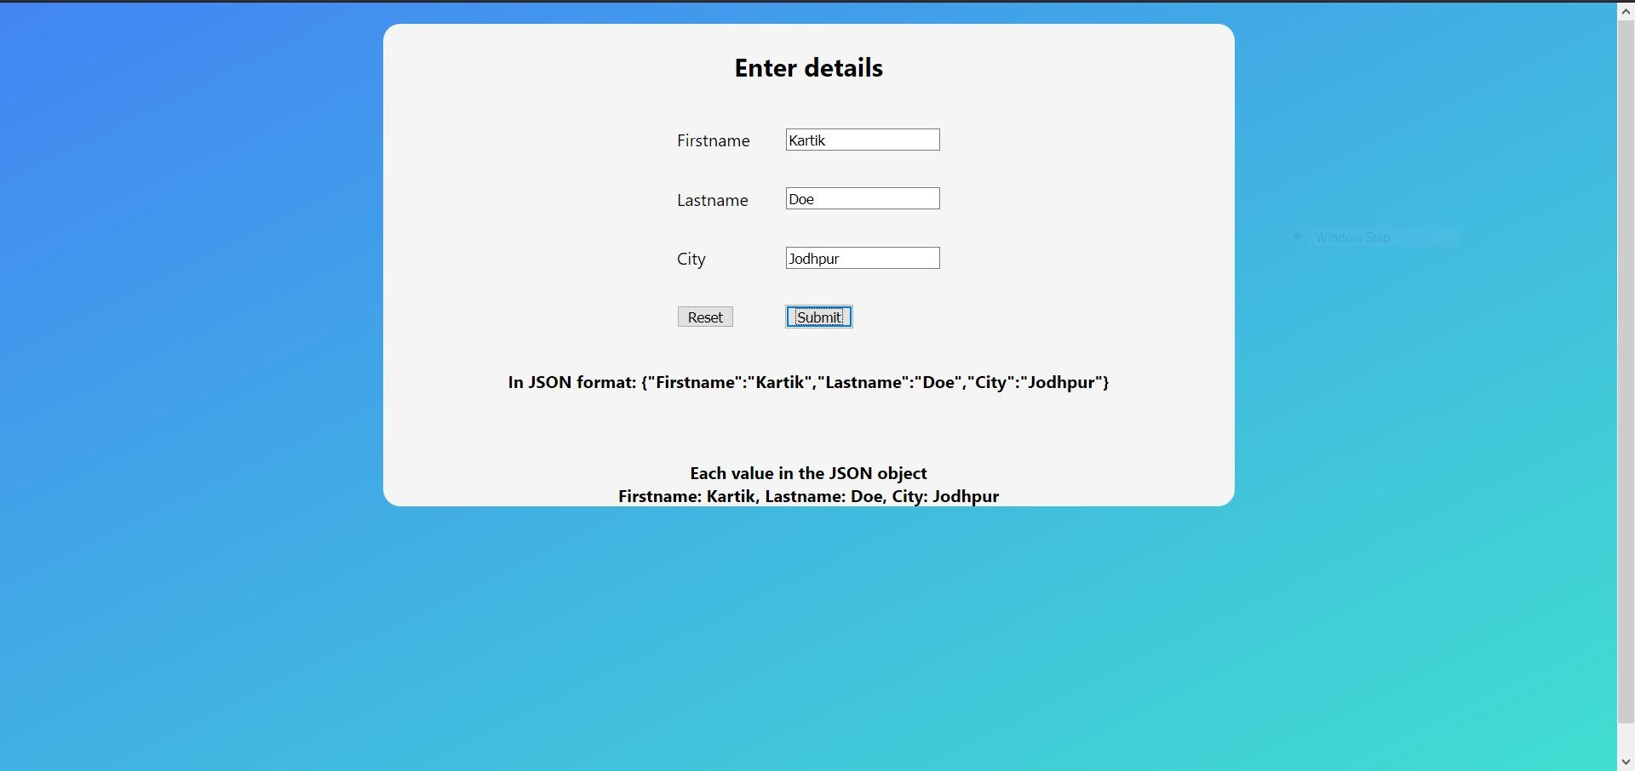

# 

# 2.

index.html

<html lang="en">

<head>

<title>Check bills</title>

</head>

<body>

<div id="root">

<h2 id="form-title">Enter details</h2>

<form id="form" name="form">

<table id="form-table">

<tr>

<th></th>

<th></th>

</tr>

<tr>

<td><label for="firstname">Firstname</label></td>

<td><input type="text" name="firstname" /></td>

</tr>

<tr>

<td><label for="lastname">Lastname</label></td>

<td><input type="text" name="lastname" /></td>

</tr>

<tr>

<td><label for="city">City</label></td>

<td><input type="text" name="city" /></td>

</tr>

<tr>

<td><input type="reset" value="Reset"></td>

<td><input type="button" value="Submit" onclick="result()"></td>

</tr>

</table>

</form>

</div>

<script src="index.js"></script>

<link rel="stylesheet" href="style.css">

</body>

</html>

index.js

function result() {

var form = document.form;

var firstName = form.firstname.value;

var lastName = form.lastname.value;

var city = form.city.value;

var person = {

"Firstname": firstName,

"Lastname": lastName,

"City": city,

"Bills": ["Rent", "Internet", "Water", "Electricity"]

};

var bills = '';

for (i in person.Bills) {

bills +="\n" + person.Bills[i];

}

alert("Hello, " + person.Firstname +".\nYour pending bills are:" + bills);

}

style.css

body {

font-family: -apple-system, BlinkMacSystemFont, 'Segoe UI', Roboto, Oxygen, Ubuntu, Cantarell, 'Open Sans', 'Helvetica Neue', sans-serif;

background-image: linear-gradient(to top left, turquoise , #4285F4);

height: 100%;

background-repeat: no-repeat;

}

#root {

background-color: whitesmoke;

margin: auto;

margin-top: auto;

text-align: center;

height: fit-content;

width: 50em;

border-radius: 1em;

}

#form-title {

text-align: center;

padding-top: 1em;

}

#form-table {

margin: auto;

}

td {

padding: 1em;

}

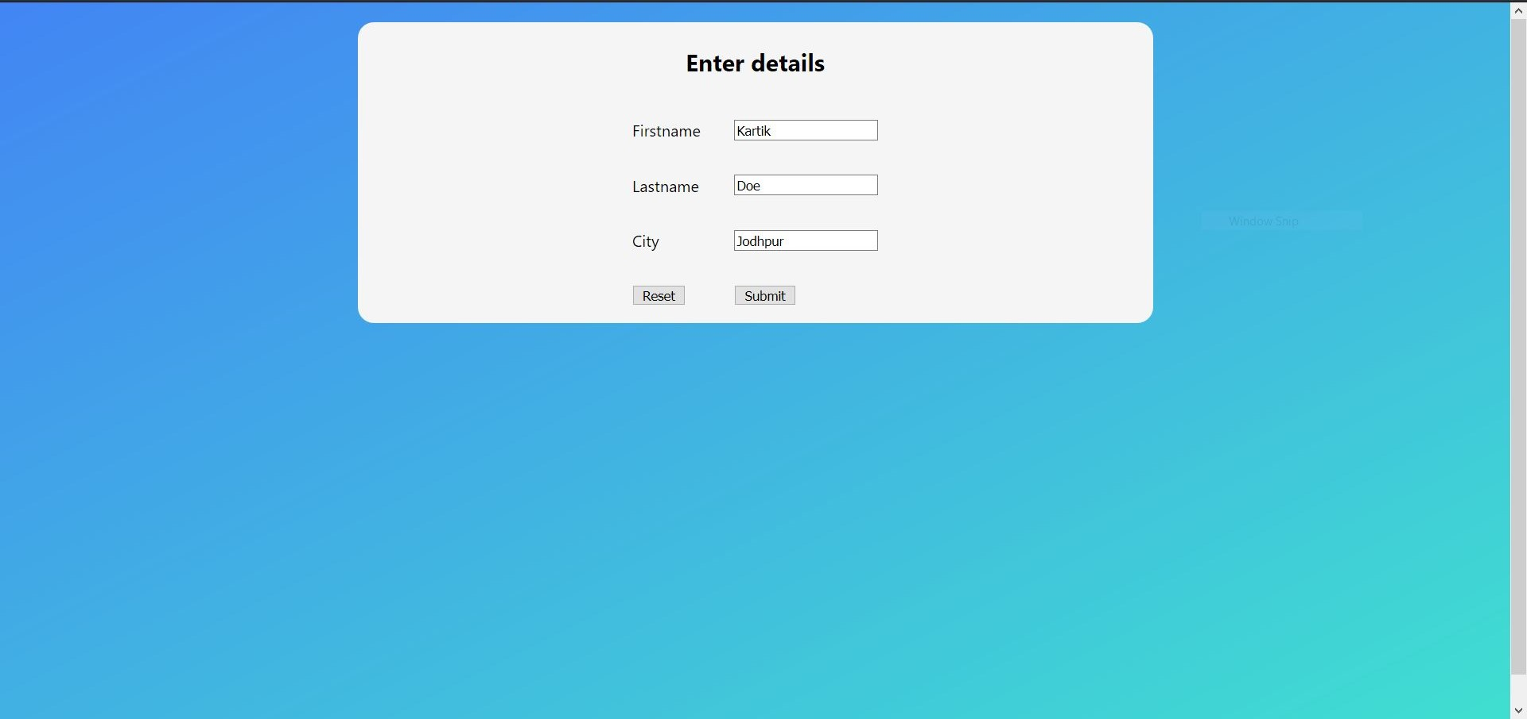

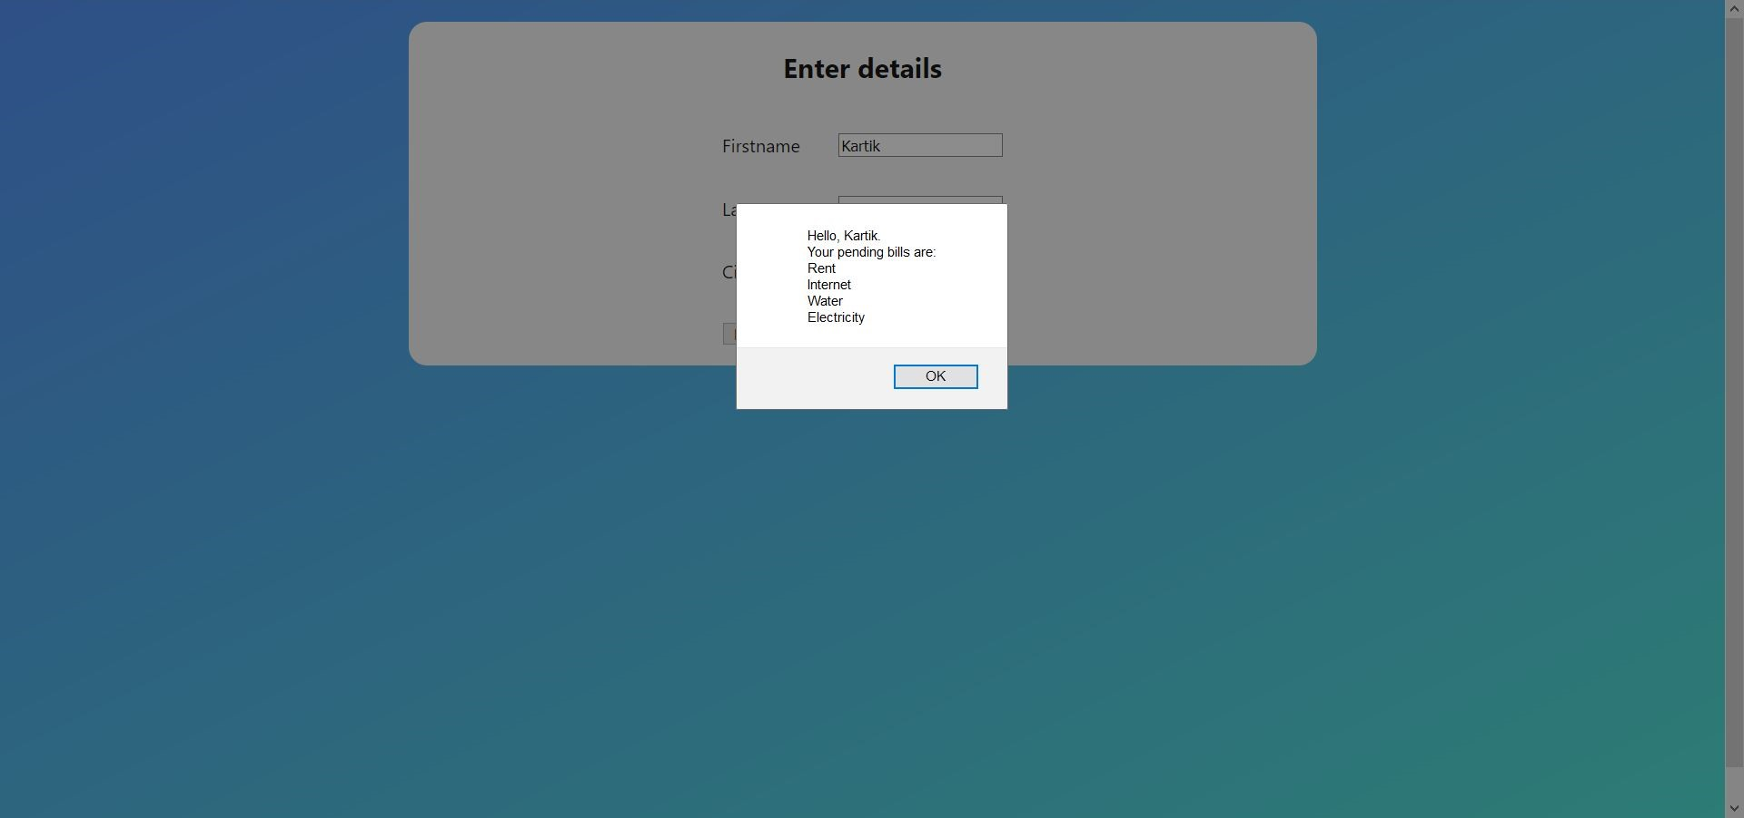

3.

## **cd.xml**

<?xml version="1.0" encoding="UTF-8"?>

<CATALOG>

<CD>

<TITLE>Empire Burlesque</TITLE>

<ARTIST>Bob Dylan</ARTIST>

<COUNTRY>USA</COUNTRY>

<COMPANY>Columbia</COMPANY>

<PRICE>10.90</PRICE>

<YEAR>1985</YEAR>

</CD>

<CD>

<TITLE>Hide your heart</TITLE>

<ARTIST>Bonnie Tyler</ARTIST>

<COUNTRY>UK</COUNTRY>

<COMPANY>CBS Records</COMPANY>

<PRICE>9.90</PRICE>

<YEAR>1988</YEAR>

</CD>

<CD>

<TITLE>Greatest Hits</TITLE>

<ARTIST>Dolly Parton</ARTIST>

<COUNTRY>USA</COUNTRY>

<COMPANY>RCA</COMPANY>

<PRICE>9.90</PRICE>

<YEAR>1982</YEAR>

</CD>

<CD>

<TITLE>Still got the blues</TITLE>

<ARTIST>Gary Moore</ARTIST>

<COUNTRY>UK</COUNTRY>

<COMPANY>Virgin records</COMPANY>

<PRICE>10.20</PRICE>

<YEAR>1990</YEAR>

</CD>

<CD>

<TITLE>Eros</TITLE>

<ARTIST>Eros Ramazzotti</ARTIST>

<COUNTRY>EU</COUNTRY>

<COMPANY>BMG</COMPANY>

<PRICE>9.90</PRICE>

<YEAR>1997</YEAR>

</CD>

<CD>

<TITLE>One night only</TITLE>

<ARTIST>Bee Gees</ARTIST>

<COUNTRY>UK</COUNTRY>

<COMPANY>Polydor</COMPANY>

<PRICE>10.90</PRICE>

<YEAR>1998</YEAR>

</CD>

<CD>

<TITLE>Sylvias Mother</TITLE>

<ARTIST>Dr.Hook</ARTIST>

<COUNTRY>UK</COUNTRY>

<COMPANY>CBS</COMPANY>

<PRICE>8.10</PRICE>

<YEAR>1973</YEAR>

</CD>

<CD>

<TITLE>Maggie May</TITLE>

<ARTIST>Rod Stewart</ARTIST>

<COUNTRY>UK</COUNTRY>

<COMPANY>Pickwick</COMPANY>

<PRICE>8.50</PRICE>

<YEAR>1990</YEAR>

</CD>

<CD>

<TITLE>Romanza</TITLE>

<ARTIST>Andrea Bocelli</ARTIST>

<COUNTRY>EU</COUNTRY>

<COMPANY>Polydor</COMPANY>

<PRICE>10.80</PRICE>

<YEAR>1996</YEAR>

</CD>

<CD>

<TITLE>When a man loves a woman</TITLE>

<ARTIST>Percy Sledge</ARTIST>

<COUNTRY>USA</COUNTRY>

<COMPANY>Atlantic</COMPANY>

<PRICE>8.70</PRICE>

<YEAR>1987</YEAR>

</CD>

<CD>

<TITLE>Black angel</TITLE>

<ARTIST>Savage Rose</ARTIST>

<COUNTRY>EU</COUNTRY>

<COMPANY>Mega</COMPANY>

<PRICE>10.90</PRICE>

<YEAR>1995</YEAR>

</CD>

<CD>

<TITLE>1999 Grammy Nominees</TITLE>

<ARTIST>Many</ARTIST>

<COUNTRY>USA</COUNTRY>

<COMPANY>Grammy</COMPANY>

<PRICE>10.20</PRICE>

<YEAR>1999</YEAR>

</CD>

<CD>

<TITLE>For the good times</TITLE>

<ARTIST>Kenny Rogers</ARTIST>

<COUNTRY>UK</COUNTRY>

<COMPANY>Mucik Master</COMPANY>

<PRICE>8.70</PRICE>

<YEAR>1995</YEAR>

</CD>

<CD>

<TITLE>Big Willie style</TITLE>

<ARTIST>Will Smith</ARTIST>

<COUNTRY>USA</COUNTRY>

<COMPANY>Columbia</COMPANY>

<PRICE>9.90</PRICE>

<YEAR>1997</YEAR>

</CD>

<CD>

<TITLE>Tupelo Honey</TITLE>

<ARTIST>Van Morrison</ARTIST>

<COUNTRY>UK</COUNTRY>

<COMPANY>Polydor</COMPANY>

<PRICE>8.20</PRICE>

<YEAR>1971</YEAR>

</CD>

</CATALOG>

## **Selecting nodes**

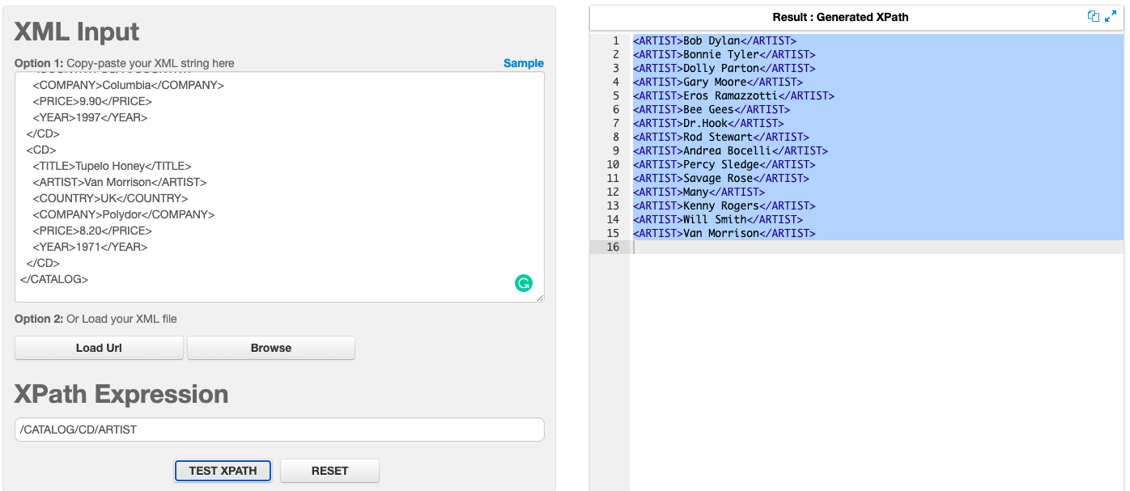

## **Applying predicates**

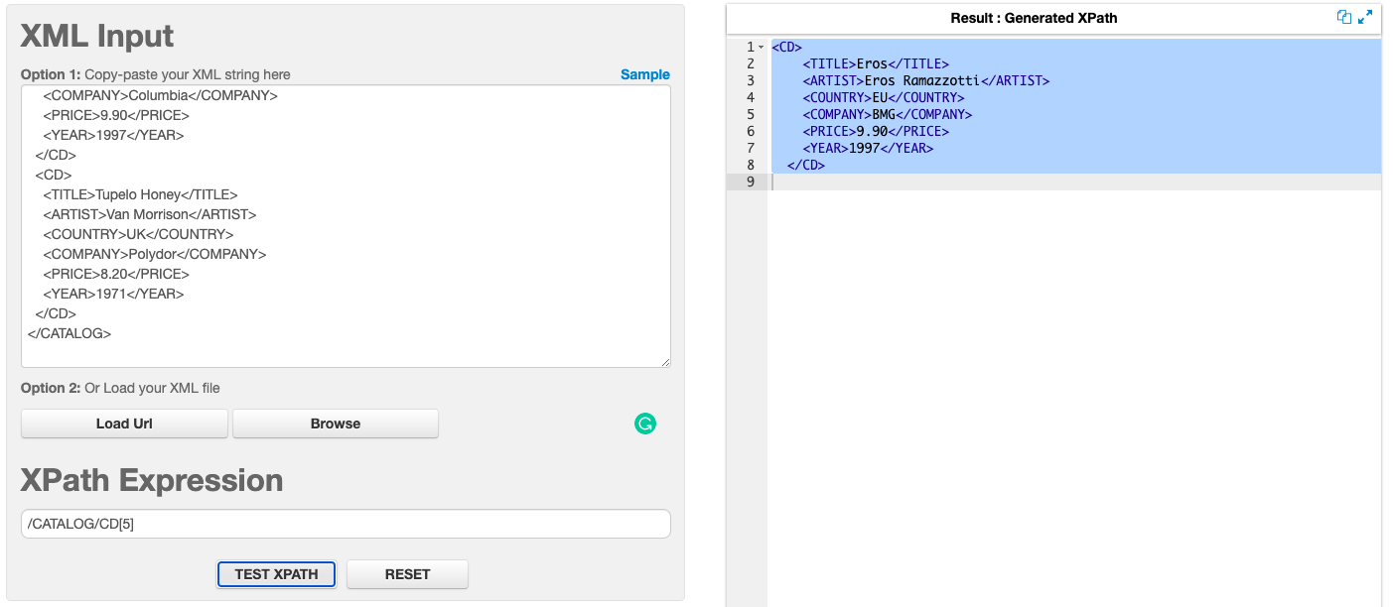

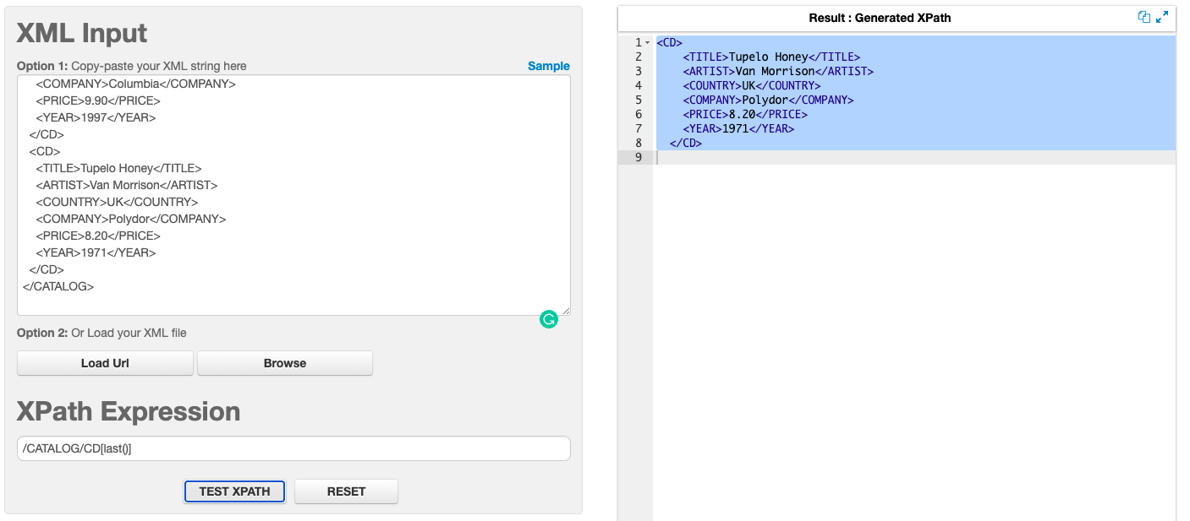

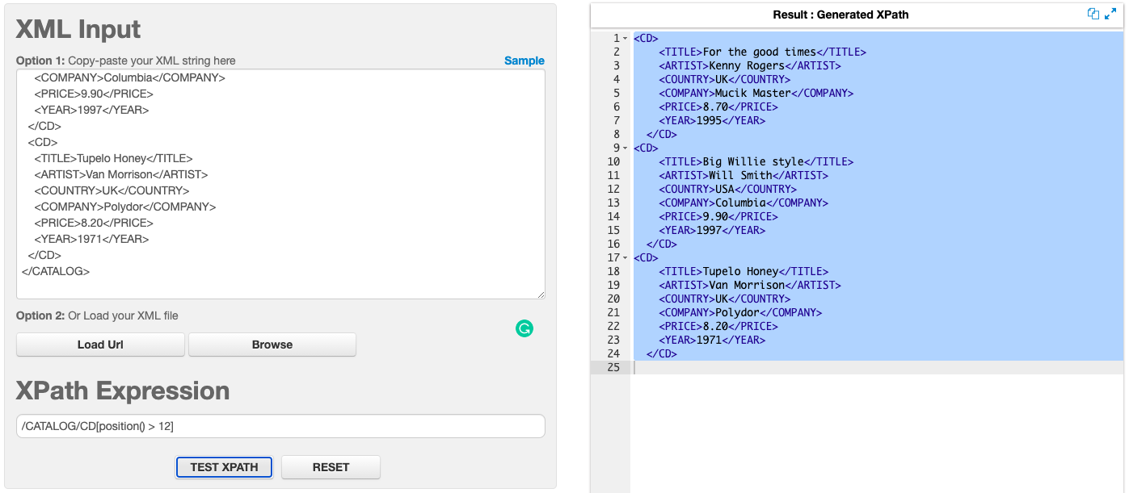

## 

## **Selecting unknown nodes**

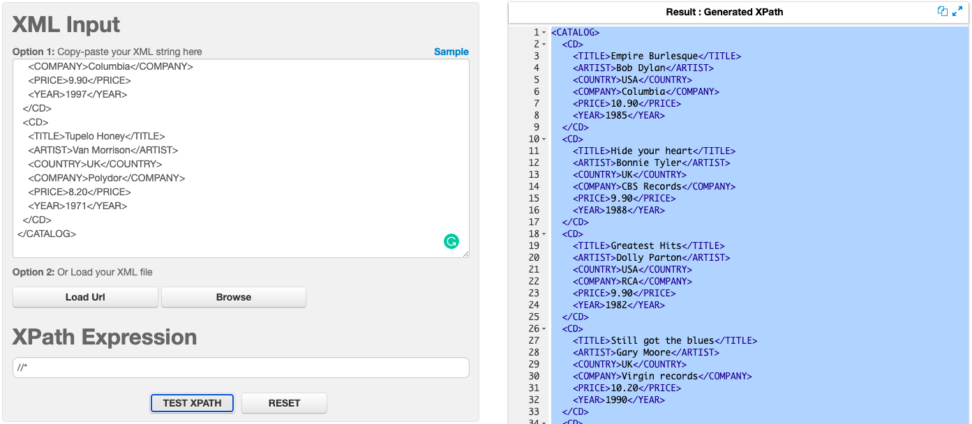

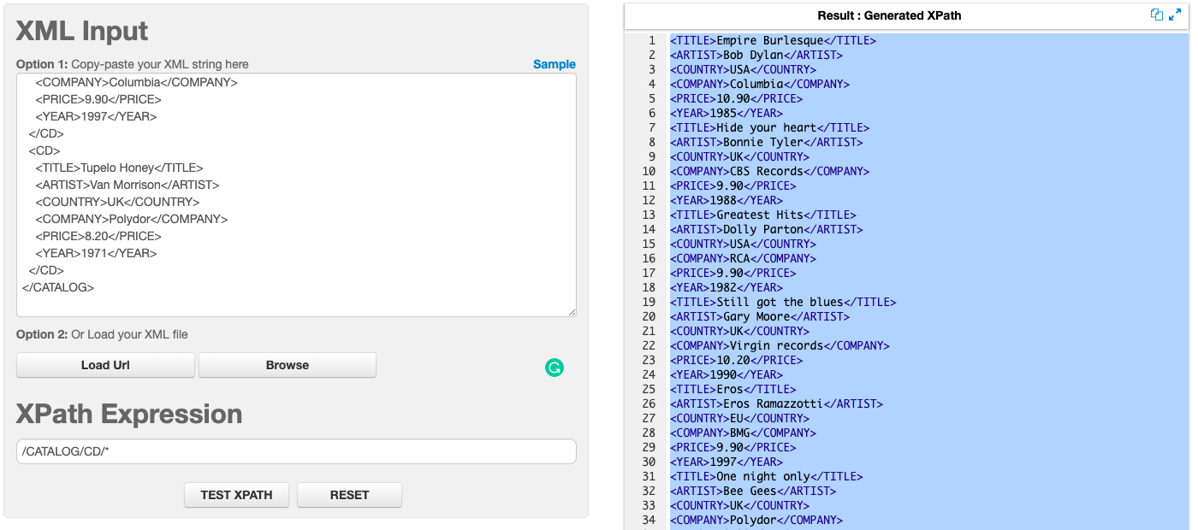

## 

## **Selecting several paths**

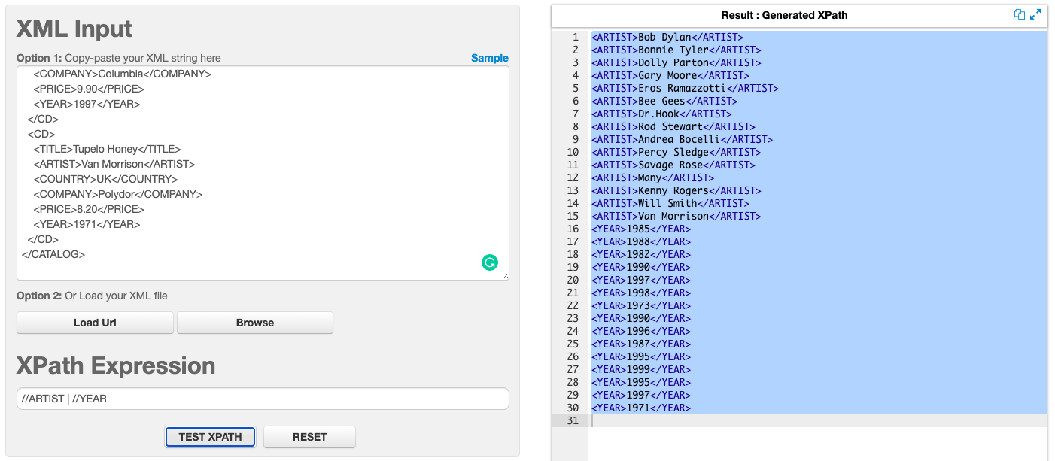

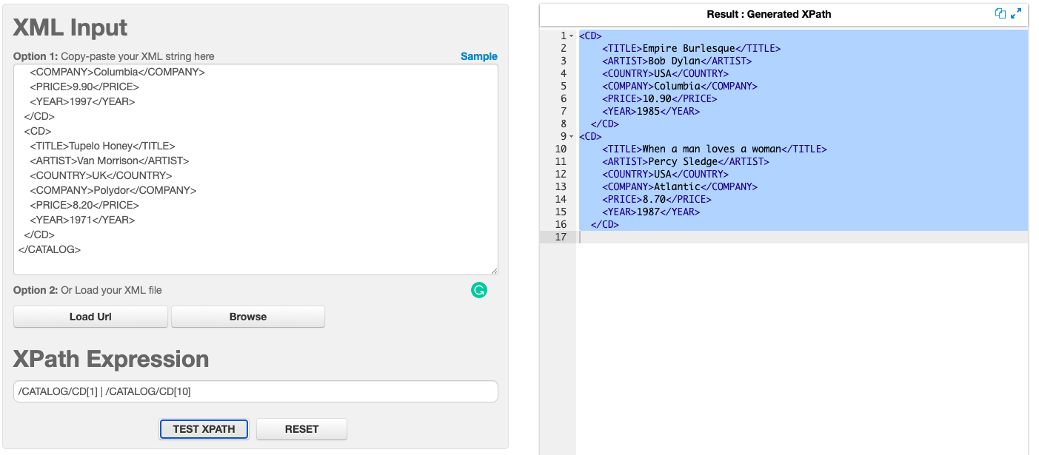

# 4.

## ***records.xml***

<?xml version="1.0" encoding="UTF-8"?>

<?xml-stylesheet type="text/xsl" href="style.xsl"?>

<catalog>

<cd>

<title>Empire Burlesque</title>

<artist>Bob Dylan</artist>

<country>USA</country>

<company>Columbia</company>

<price>10.90</price>

<year>1985</year>

</cd>

<cd>

<title>Hide your heart</title>

<artist>Bonnie Tyler</artist>

<country>UK</country>

<company>CBS Records</company>

<price>9.90</price>

<year>1988</year>

</cd>

<cd>

<title>Greatest Hits</title>

<artist>Dolly Parton</artist>

<country>USA</country>

<company>RCA</company>

<price>9.90</price>

<year>1982</year>

</cd>

<cd>

<title>Still got the blues</title>

<artist>Gary Moore</artist>

<country>UK</country>

<company>Virgin records</company>

<price>10.20</price>

<year>1990</year>

</cd>

<cd>

<title>Eros</title>

<artist>Eros Ramazzotti</artist>

<country>EU</country>

<company>BMG</company>

<price>9.90</price>

<year>1997</year>

</cd>

<cd>

<title>One night only</title>

<artist>Bee Gees</artist>

<country>UK</country>

<company>Polydor</company>

<price>10.90</price>

<year>1998</year>

</cd>

<cd>

<title>Sylvias Mother</title>

<artist>Dr.Hook</artist>

<country>UK</country>

<company>CBS</company>

<price>8.10</price>

<year>1973</year>

</cd>

<cd>

<title>Maggie May</title>

<artist>Rod Stewart</artist>

<country>UK</country>

<company>Pickwick</company>

<price>8.50</price>

<year>1990</year>

</cd>

<cd>

<title>Romanza</title>

<artist>Andrea Bocelli</artist>

<country>EU</country>

<company>Polydor</company>

<price>10.80</price>

<year>1996</year>

</cd>

<cd>

<title>When a man loves a woman</title>

<artist>Percy Sledge</artist>

<country>USA</country>

<company>Atlantic</company>

<price>8.70</price>

<year>1987</year>

</cd>

</catalog>

## *style.xsl*

<?xml version="1.0" encoding="UTF-8"?>

<xsl:stylesheet version="1.0"

xmlns:xsl="http://www.w3.org/1999/XSL/Transform">

<xsl:template match="/"> <!-- match="/" defines the whole document -->

<html>

<body>

<h1 color="6d0000">Record Collection</h1>

<table border="1" bgcolor="FFBA63">

<tr bgcolor="#f43e10">

<th><h3>Title</h3></th>

<th><h3>Artist</h3></th>

<th><h3>Price</h3></th>

</tr>

<xsl:for-each select="catalog/cd"> <!-- selects catalog -->

<xsl:sort select="artist" order="descending"/> <!-- sorts Artists in descending -->

<xsl:if test="price>9"> <!-- checks if price is greater than 9 -->

<tr>

<td><xsl:value-of select="title"/></td> <!-- selects title "records.xml" -->

<xsl:choose> <!-- Chooses artists with record price greater than 10 -->

<xsl:when test="price > 10">

<td bgcolor="#FC8B07">

<xsl:value-of select="artist"/>

</td>

</xsl:when>

<xsl:otherwise>

<td bgcolor="#FFC92E"><xsl:value-of select="artist"/></td>

</xsl:otherwise>

</xsl:choose>

<td><xsl:value-of select="price"/></td>

</tr>

</xsl:if>

</xsl:for-each>

</table>

</body>

</html>

</xsl:template>

</xsl:stylesheet>

