IoT based automated Inventory Management System

Problem Statement:

For businesses that involve movement of inventory between different locations. It is very important to keep a track on how much products are left in the stock. This is usually done manually by humans and to keep a check on inventory on a regular basis which is a very difficult task, and we should not forget errors we may encounter during the logging of goods.

Solution:

In this solution, 2 sensors – RFID sensor and Ultrasonic sensor are used to keep track of the inventory.

The RFID sensor ensures correct unauthorized and authorize item movements are tracked.

When an RFID tagged item is moved, if the RFID tag is authorized, item count for the same will be incremented. Unauthorized items will have a similar logic.

We use the ultrasonic sensor to send and receive reflected sound waves to measure the distance using speed of sound. This will keep track of the total number of items picked up to ensure inventory consistency with RFID data store. Here, the sensor will measure the distance to the closest item box and calculate the number of items moved based on a set box size.

$$numberOfItemsMoved=\frac{distanceToClosestBox}{boxSize}$$

This will give us a fair judgement of what items unauthorized or authorized and moved correctly.

These data values are sent to ThingSpeak for displaying in dashboard and logging.

Architecture Diagram:

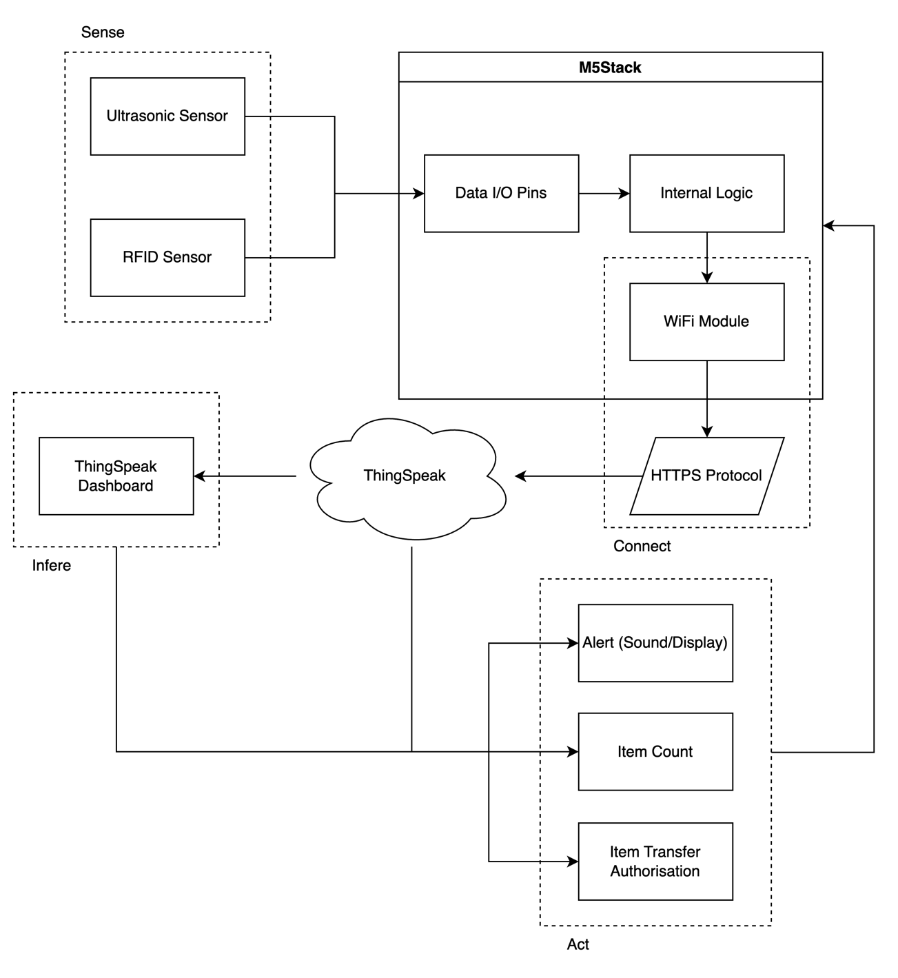

Sensors used:

1. RFID Sensor
2. Ultrasonic Sensor

Connectivity:

1. Sensor to M5Stack: Wired
2. M5Stack to ThingSpeak: Wireless (HTTPS through WiFi)

Communication Protocol:

HTTPS (Hyper Text Transfer Protocol)