IoT based live remote monitoring of goods in a truck

Problem Statement:

Now the product has left the facility, next is to monitor its conditions during its journey to the end location. The products we have shipped are perishable goods that require certain temperature and light conditions to be maintained. We also must track if there are any deviations from a set route or are no long duration stoppages in between the journey.

Solution:

In this solution, 3 components – DHT sensor, LDR sensor and GPS sensor are used to track humidity, temperature, light conditions and movement of the shipment.

The DHT sensor reads the humidity and temperature values in the shipment/truck. M5 stack process this and checks if the values are within safe range or not. These values are further updated and inferred into simpler data such as red lamp showing conditions compromised on ThingSpeak and red display background with relevant information on M5 stack display for the driver.

The LDR sensor reads the light intensity inside the truck i.e., if the shipment was opened or not – if opened light would have entered and hence updating the presence of it on M5 stack to eventually to ThingSpeak and M5 stack display. It can also help the driver keep track if the truck doors were tampered with or opened accidently. A lamp can be used to show current light status and a line chart can be used to track the timeline of light exposure.

The GPS module will track the movement of the truck via satellite communication. GPS coordinates will be processed by M5 stack in form of Latitude and Longitude. Coordinates will be logged on ThingSpeak to monitor path and stops taken by the truck and check it for discrepancies.

Additionally, features like sound-based alerts on the M5 stack can be incorporated as well.

Architecture Diagram:

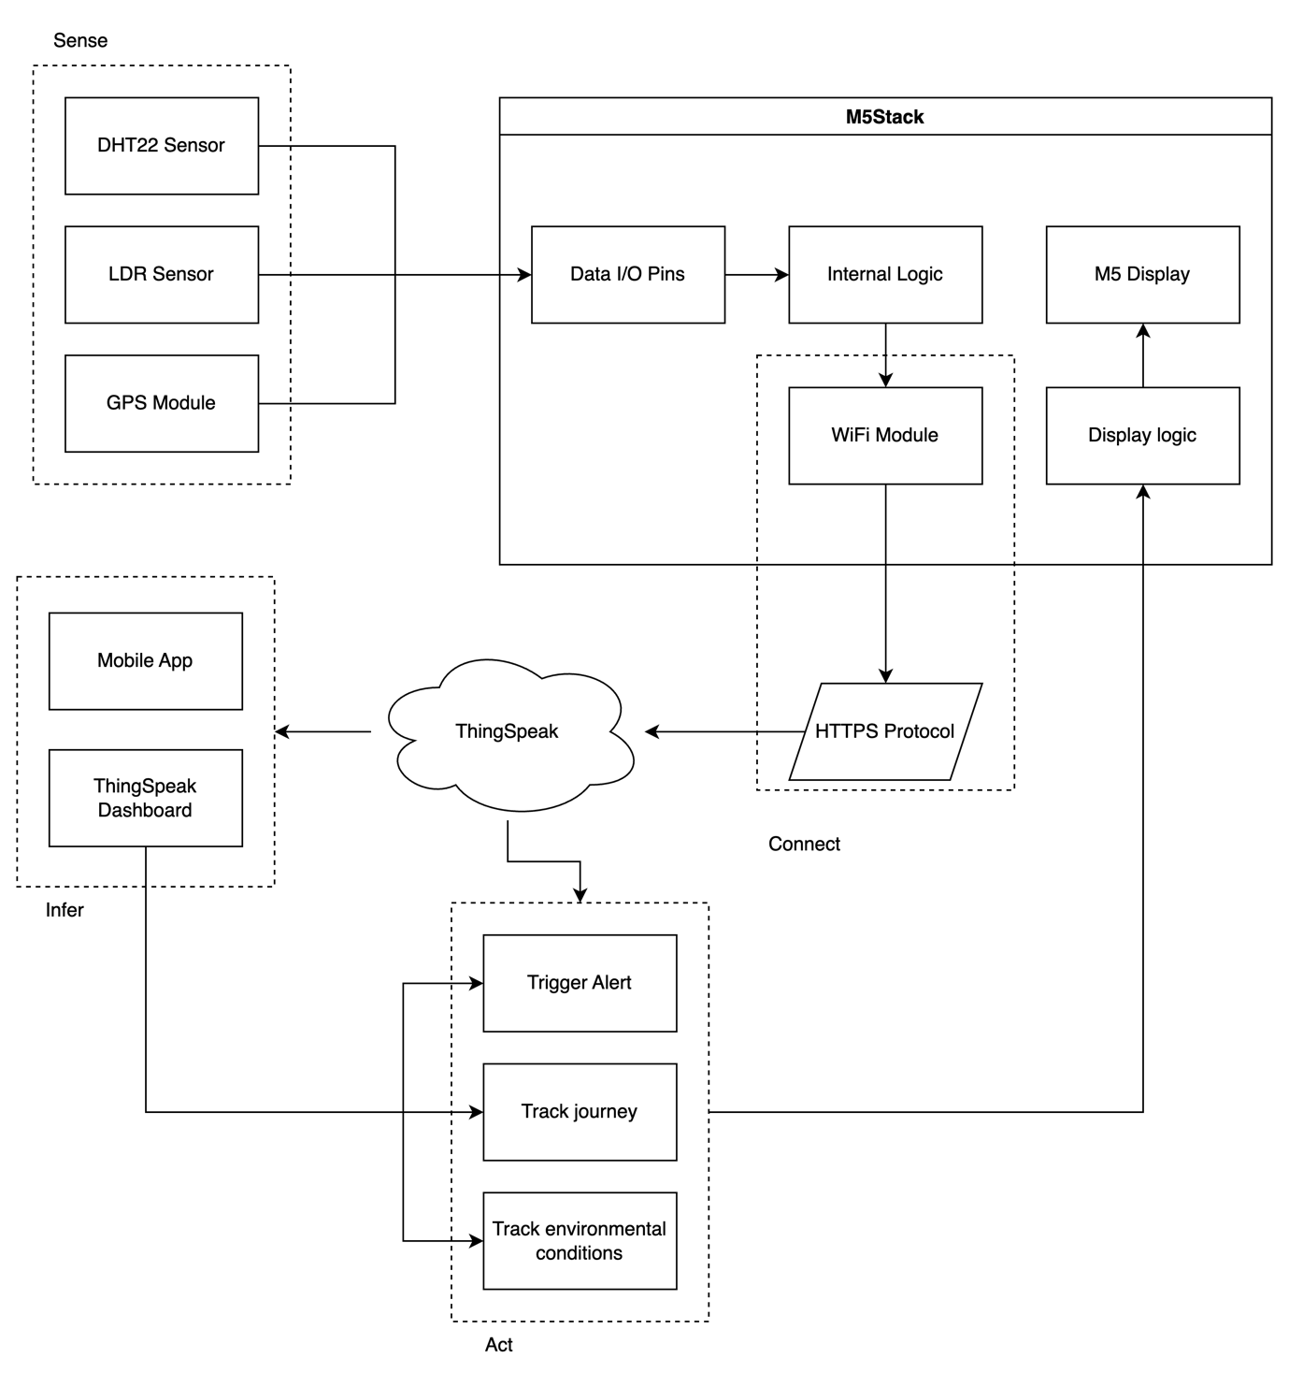

Sensors used:

1. LDR Sensor
2. DHT Sensor
3. GPS Module

Connectivity:

1. Sensor to M5Stack: Wired
2. M5Stack to ThingSpeak: Wireless (HTTPS through WiFi) [Preferred: GSM]

Communication Protocol:

HTTPS (Hyper Text Transfer Protocol)