AMRUTVAHINI COLLEGE OF ENGINEERING, SANGAMNER

DEPARTMENT OF COMPUTER ENGINEERING

2023-2024

LP-V Mini Project report (DL)

# on

‘Color Old Black And White Images To Colorful Image’



# BE Computer Engineering BY

Mr. Gaurav Bhima Chaudhari (4117) Mr. Harsh Sunil Chhajed (4118) **Guided by** - Prof. S. R. Pandit

**Title:** Colorizing Old B&W Images: color old black and white images to colorful images

## Objectives:

* 1. Historical Preservation: One of the primary objectives of colorizing old black and white images is to preserve and enhance historical photographs, bringing them to life for contemporary audiences. By adding color, details that may have been lost or overlooked in the original monochrome images become more apparent, providing valuable insights into the past.
  2. Increased Engagement and Relevance: Colorized images tend to capture the attention of viewers more effectively than their black and white counterparts. By adding color, these images become more relatable and engaging to modern audiences, helping to bridge the gap between past and present and fostering a deeper connection to historical events and figures.
  3. Restoration of Faded Images: Many old black and white photographs have suffered from fading or degradation over time. Colorization can help to restore these images, reviving the vibrancy of the original scene and preserving them for future generations. This restoration process can also involve repairing tears, scratches, and other forms of damage.
  4. Artistic Interpretation and Creativity: Colorizing black and white images is not merely a technical process but also an artistic endeavor. It allows for creative interpretation and expression, as colorists make choices about which colors to apply and how to convey the mood and atmosphere of the scene. This artistic aspect adds depth and richness to the final images, transforming them into works of art in their own right.

## Colorizing the old B&W image System

A colorizing system is a type of system that will take an input black & white image from the user and will color the image & give the result. This type of system will be very useful for artists and designers as they can get a really good idea of colorizing the image. Although this will not give a very accurate result, it can do the task and give the artist an idea.

As an artist and designer take hours and hours for colorizing an image, this system will do the same task within seconds. This system can also be helpful for people who want to colorize their old black & white images but can’t afford an artist or a designer and they don’t know how to use photoshop or they don’t have enough time for photoshopping the image.

## The Model Architecture

In this system, we are using a model pre-trained by Richard Zhang. He used CNN to train his model. The reason for choosing his model over training our own model is because he has trained his model using millions of images. Due to the lack of such a large number of images and lack of computation power to train such a large number of images, we are using his pre-trained model. You can build this model on your own as well but you need to have that much computational power.

So, how this system will work?

We will be using OpenCV in our project. First, we will take the input image, and then using the OpenCV function, we will convert this RGB image into a LAB color space image.

What is this LAB color space?

This is very similar to RGB color space. So, according to RGB, every color can be formed using red, green, and blue colors by taking different intensity values of these 3 colors. So, every color in the universe can be represented using these 3 colors. For example, purple is made of 62.7% red, 12.5% green, and 94.1% blue. In RGB, each parameter can have a maximum value of 255. So the RGB combination of purple is (160,32,240).

Similarly, we have LAB color space. In this, the L channel decides the intensity of the light. ‘A’ decides the red and the green value of the color. Whereas ‘B’ decides the blue and yellow value of the color. In this way, a LAB color is created.

So, the whole idea is to read the input grayscale image and then convert the RGB to LAB color space using an inbuilt function in OpenCV. After that, we apply the model that we imported to the image. The final step is we convert it into RGB color space again. So, this is how the whole colorizing thing is going on.

**Project Prerequisites**

The requirement is Python and the following libraries installed on your computer. I have used a Jupyter notebook for this project. You can use whatever you want.

The required modules for this project are –

**Numpy** – pip install numpy

**OpenCV** – pip install cv2

**Matplotlib** – pip install matplotlib

We are using a pre-trained model in this project. Rest all the functions that we need are already there in OpenCV.

## Implementation

**Code:**

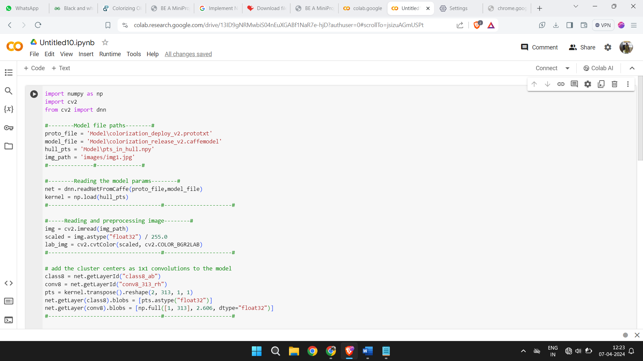

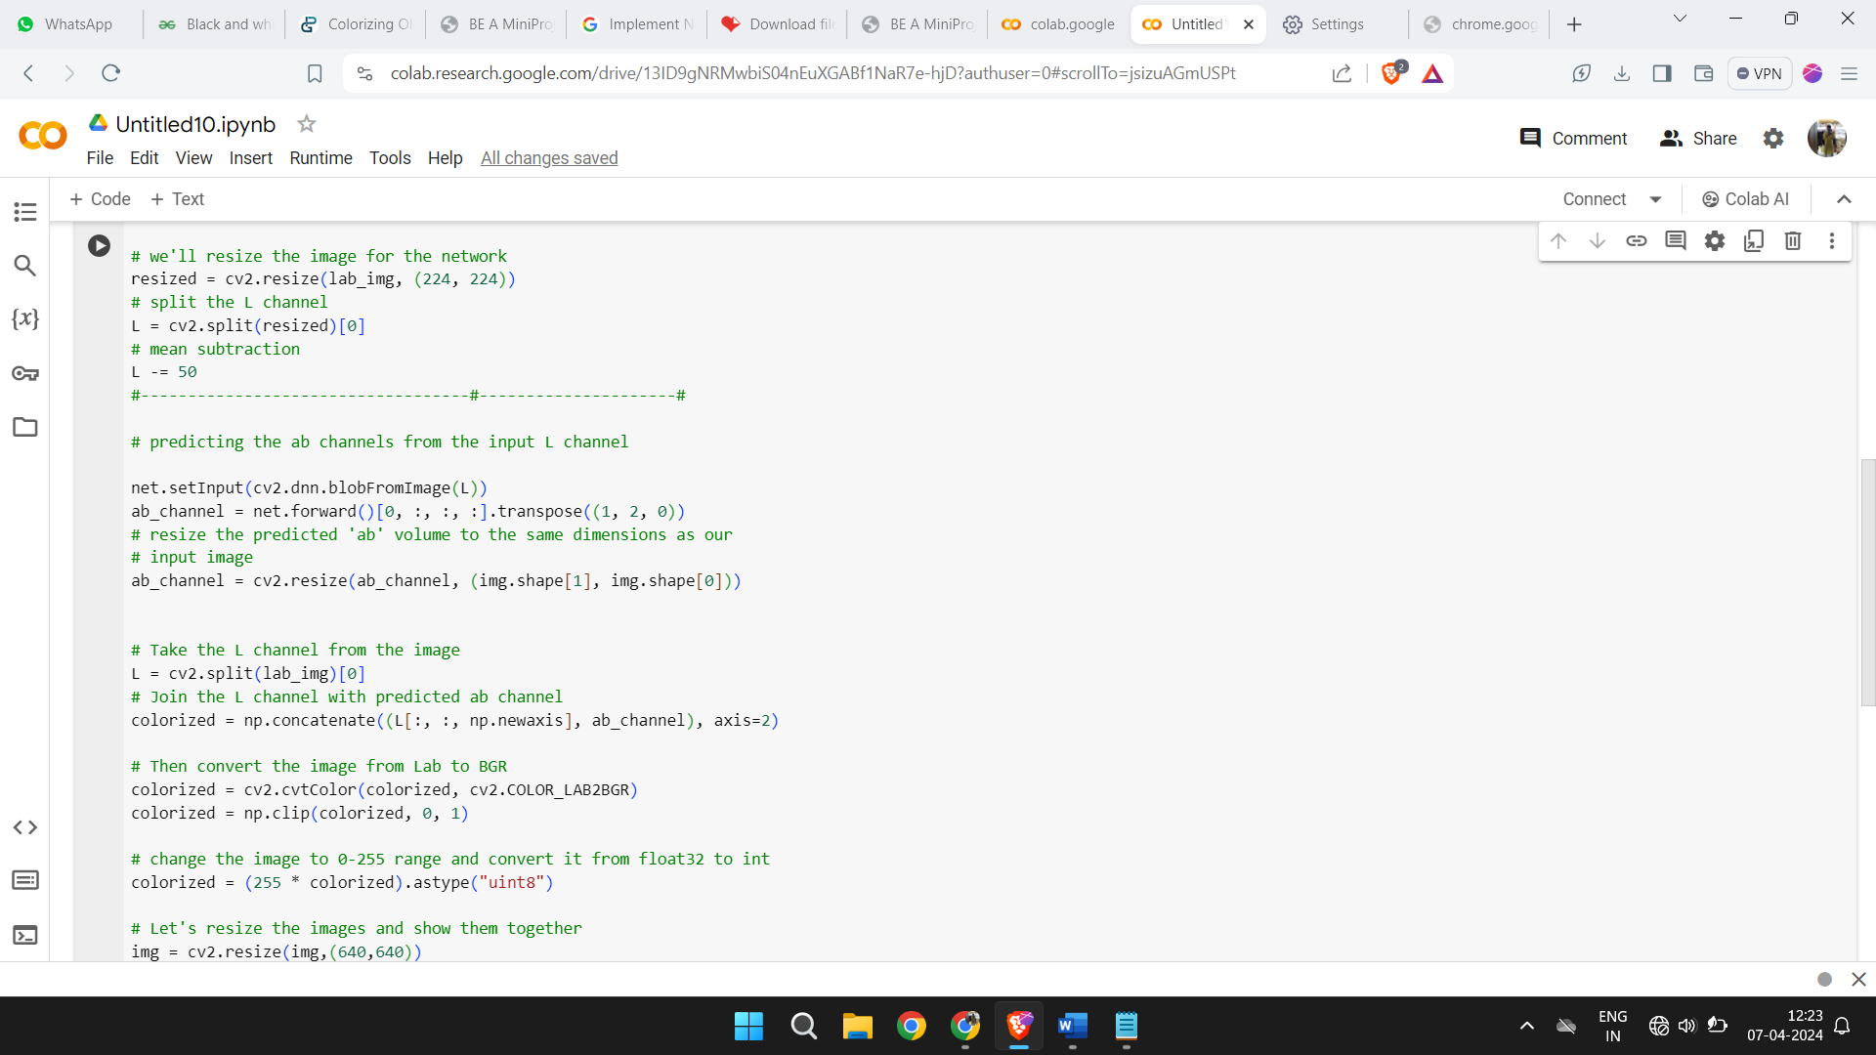

**Result**

