# Task 1

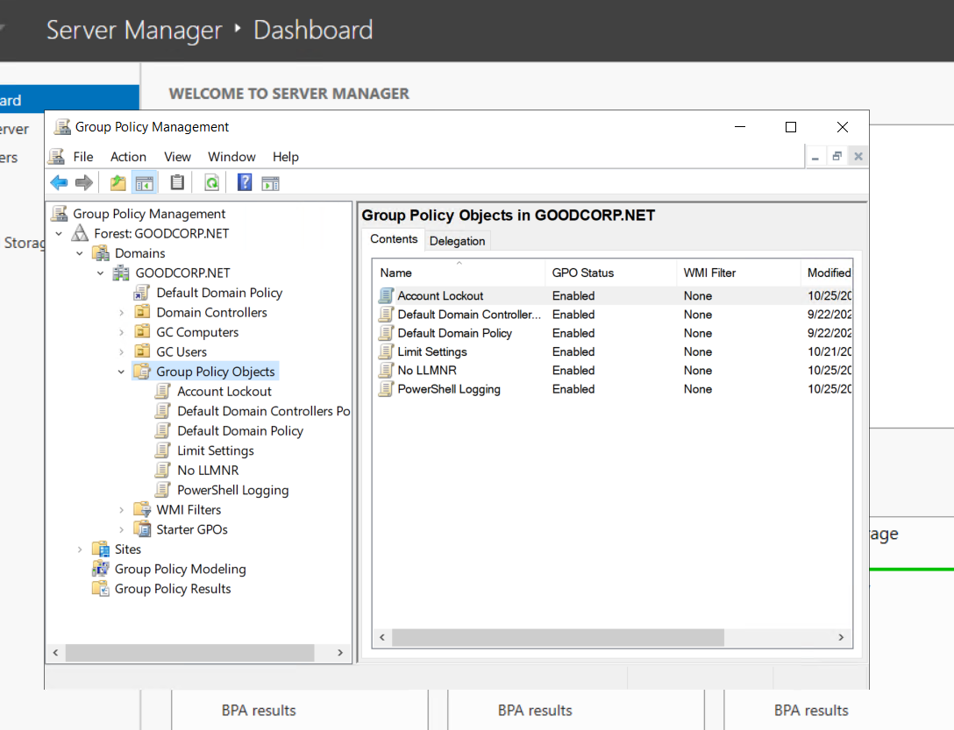

# Task 2

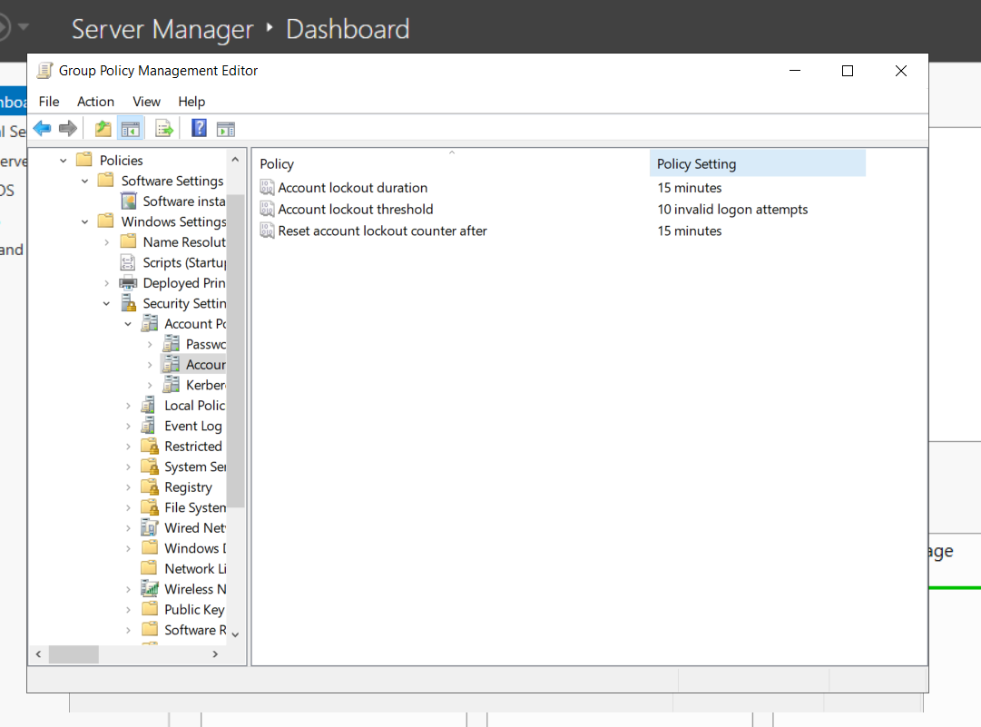

# Task 3

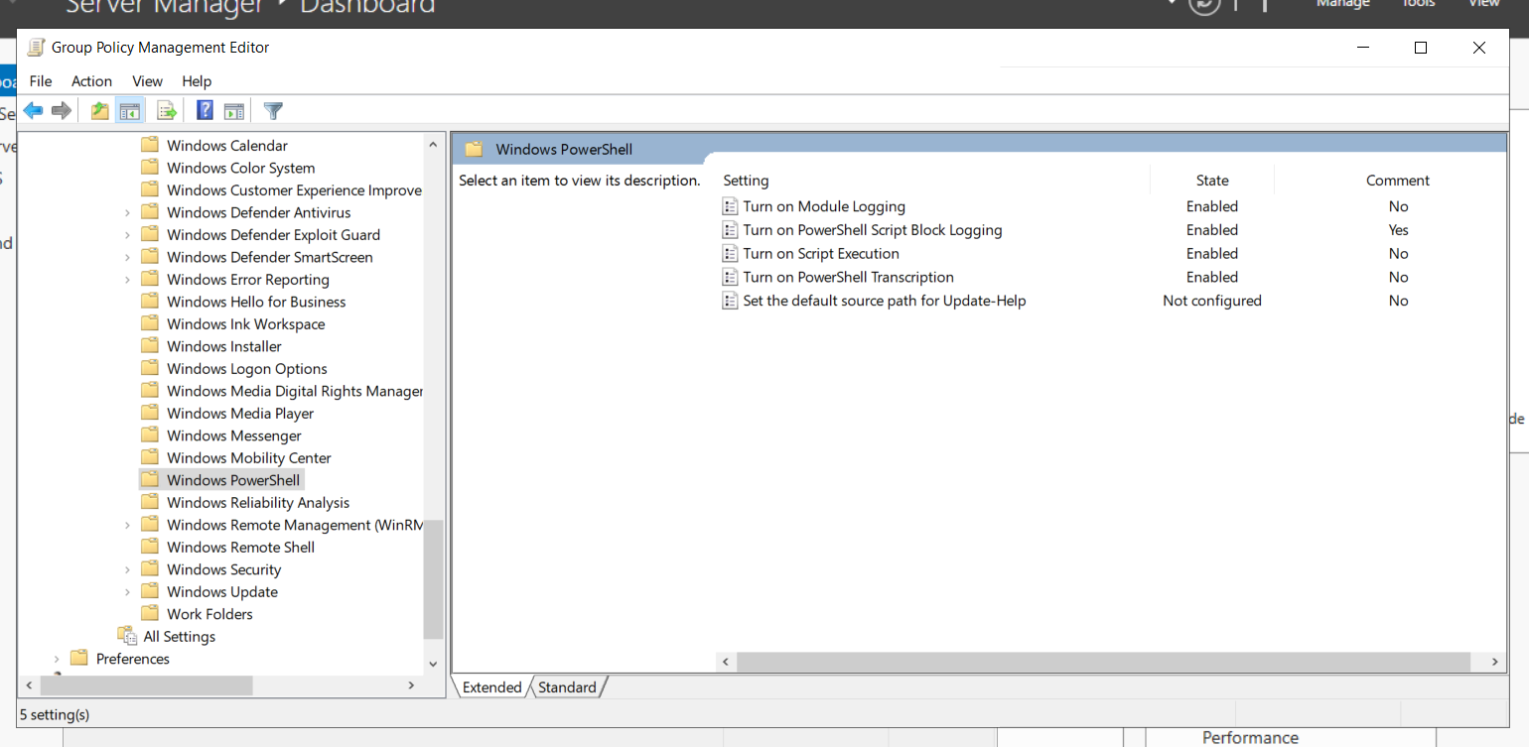

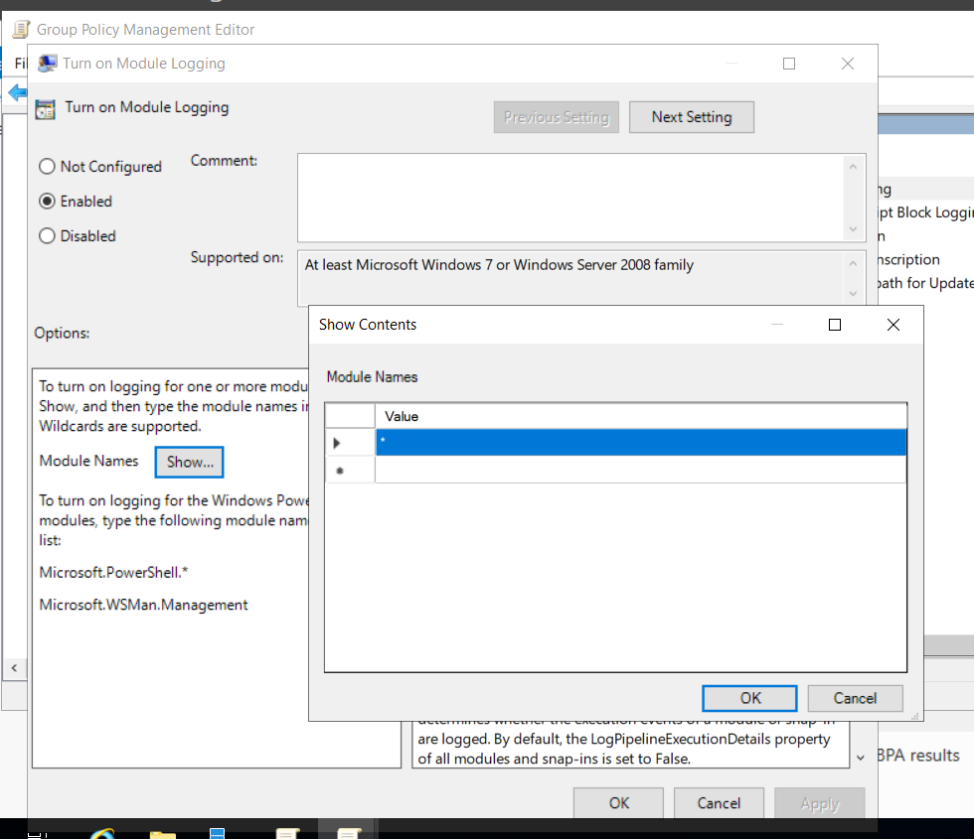

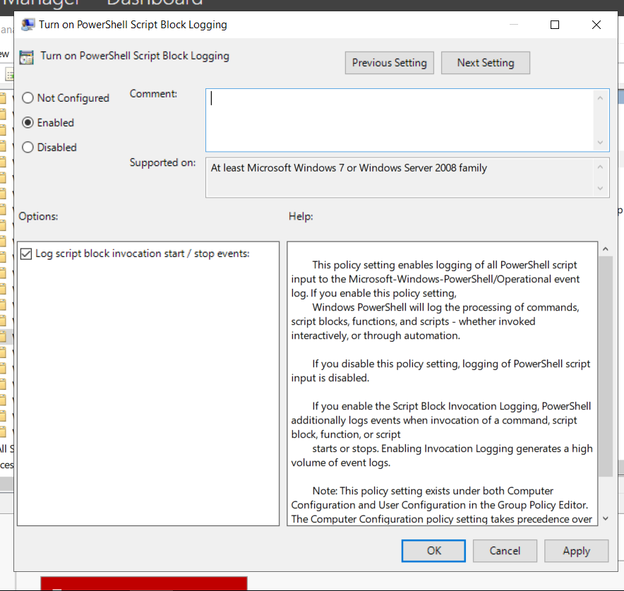

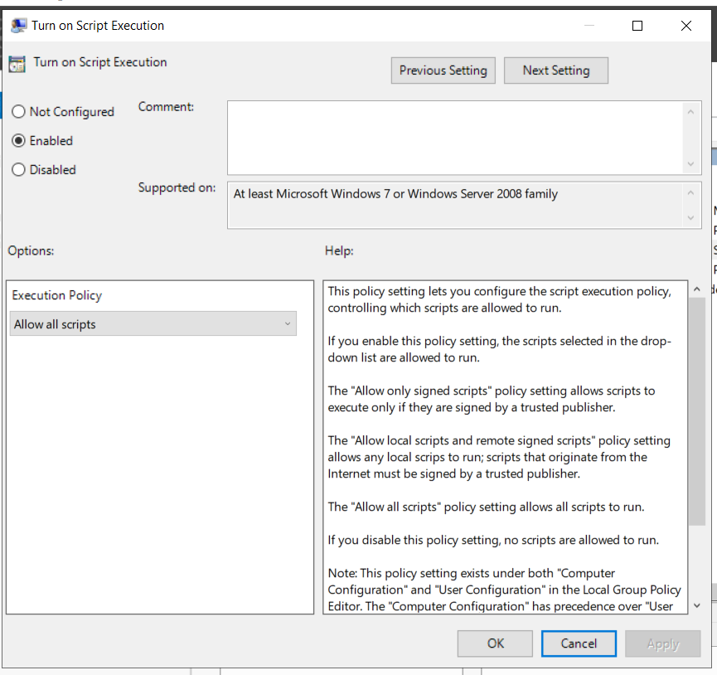

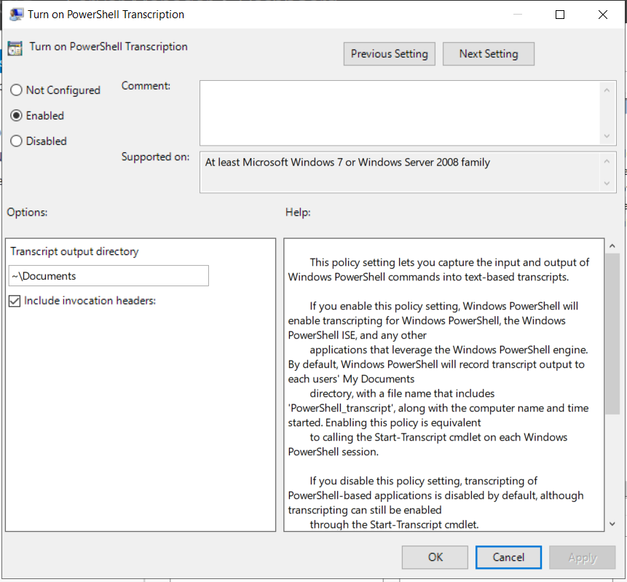

# Task 4

PS C:\Users\n2gau\Downloads\HW> type .\enum_acls.ps1

write-output "running script now!"

$directory = Get-ChildItem -Path . -Exclude enum_acls.ps1

foreach ($item in $directory){

write-output @(Get-Acl $item.Name)

}

# Task 5

**********************

Windows PowerShell transcript start

Start time: 20201026000416

Username: DESKTOP-SITPOTH\sysadmin

RunAs User: DESKTOP-SITPOTH\sysadmin

Configuration Name:

Machine: DESKTOP-SITPOTH (Microsoft Windows NT 10.0.19041.0)

Host Application: C:\Windows\System32\WindowsPowerShell\v1.0\powershell.exe

Process ID: 8956

PSVersion: 5.1.19041.1

PSEdition: Desktop

PSCompatibleVersions: 1.0, 2.0, 3.0, 4.0, 5.0, 5.1.19041.1

BuildVersion: 10.0.19041.1

CLRVersion: 4.0.30319.42000

WSManStackVersion: 3.0

PSRemotingProtocolVersion: 2.3

SerializationVersion: 1.1.0.1

**********************

**********************

Command start time: 20201026000423

**********************

PS C:\Users\sysadmin> cd C:\Windows\

**********************

Command start time: 20201026000428

**********************

PS C:\Windows> .\enum_acls.ps1

Running script to display ACLs!

Directory: C:\Windows

Path Owner Access

---- ----- ------

addins NT SERVICE\TrustedInstaller CREATOR OWNER Allow 268435456...

appcompat NT AUTHORITY\SYSTEM NT SERVICE\TrustedInstaller Allow FullControl...

apppatch NT SERVICE\TrustedInstaller CREATOR OWNER Allow 268435456...

AppReadiness NT AUTHORITY\SYSTEM NT AUTHORITY\Authenticated Users Allow Read, Synchronize...

assembly BUILTIN\Administrators BUILTIN\Administrators Allow FullControl...

bcastdvr NT SERVICE\TrustedInstaller CREATOR OWNER Allow 268435456...

Boot NT SERVICE\TrustedInstaller NT AUTHORITY\SYSTEM Allow -1610612736...

Branding NT SERVICE\TrustedInstaller CREATOR OWNER Allow 268435456...

CbsTemp BUILTIN\Administrators BUILTIN\Administrators Allow FullControl...

Containers NT AUTHORITY\SYSTEM NT SERVICE\TrustedInstaller Allow FullControl...

CSC NT AUTHORITY\SYSTEM NT AUTHORITY\SYSTEM Allow FullControl

Cursors NT SERVICE\TrustedInstaller CREATOR OWNER Allow 268435456...

debug NT AUTHORITY\SYSTEM APPLICATION PACKAGE AUTHORITY\ALL APPLICATION PACKAGES Deny Fu...

diagnostics NT SERVICE\TrustedInstaller NT AUTHORITY\SYSTEM Allow -1610612736...

DiagTrack NT SERVICE\TrustedInstaller CREATOR OWNER Allow 268435456...

DigitalLocker NT AUTHORITY\SYSTEM NT SERVICE\TrustedInstaller Allow FullControl...

Downloaded Program Files NT SERVICE\TrustedInstaller CREATOR OWNER Allow 268435456...

en-US NT SERVICE\TrustedInstaller CREATOR OWNER Allow 268435456...

Fonts NT SERVICE\TrustedInstaller CREATOR OWNER Allow 268435456...

GameBarPresenceWriter NT SERVICE\TrustedInstaller CREATOR OWNER Allow 268435456...

Globalization NT SERVICE\TrustedInstaller CREATOR OWNER Allow 268435456...

Help NT AUTHORITY\SYSTEM NT SERVICE\TrustedInstaller Allow FullControl...

IdentityCRL NT AUTHORITY\SYSTEM NT SERVICE\TrustedInstaller Allow FullControl...

IME NT SERVICE\TrustedInstaller CREATOR OWNER Allow 268435456...

ImmersiveControlPanel NT SERVICE\TrustedInstaller CREATOR OWNER Allow 268435456...

INF NT SERVICE\TrustedInstaller CREATOR OWNER Allow 268435456...

InputMethod NT AUTHORITY\SYSTEM NT SERVICE\TrustedInstaller Allow FullControl...

L2Schemas NT SERVICE\TrustedInstaller CREATOR OWNER Allow 268435456...

LiveKernelReports NT AUTHORITY\SYSTEM NT AUTHORITY\SYSTEM Allow 268435456...

Logs NT AUTHORITY\SYSTEM BUILTIN\Administrators Allow FullControl...

Media NT SERVICE\TrustedInstaller CREATOR OWNER Allow 268435456...

Microsoft.NET NT SERVICE\TrustedInstaller CREATOR OWNER Allow 268435456...

Migration NT AUTHORITY\SYSTEM NT SERVICE\TrustedInstaller Allow FullControl...

ModemLogs NT AUTHORITY\SYSTEM NT AUTHORITY\SYSTEM Allow 268435456...

OCR NT SERVICE\TrustedInstaller NT AUTHORITY\SYSTEM Allow -1610612736...

Offline Web Pages NT SERVICE\TrustedInstaller CREATOR OWNER Allow 268435456...

Panther NT AUTHORITY\SYSTEM NT SERVICE\TrustedInstaller Allow FullControl...

Performance NT SERVICE\TrustedInstaller CREATOR OWNER Allow 268435456...

PLA NT AUTHORITY\SYSTEM NT SERVICE\TrustedInstaller Allow FullControl...

PolicyDefinitions NT SERVICE\TrustedInstaller CREATOR OWNER Allow 268435456...

Prefetch BUILTIN\Administrators BUILTIN\Administrators Allow FullControl...

PrintDialog NT SERVICE\TrustedInstaller CREATOR OWNER Allow 268435456...

Provisioning NT SERVICE\TrustedInstaller CREATOR OWNER Allow 268435456...

Registration BUILTIN\Administrators Everyone Allow ReadAndExecute, Synchronize...

RemotePackages NT AUTHORITY\SYSTEM NT AUTHORITY\Authenticated Users Allow -1610612736...

rescache NT SERVICE\TrustedInstaller NT AUTHORITY\SYSTEM Allow -1610612736...

Resources NT SERVICE\TrustedInstaller CREATOR OWNER Allow 268435456...

SchCache NT AUTHORITY\SYSTEM NT SERVICE\TrustedInstaller Allow FullControl...

schemas NT SERVICE\TrustedInstaller CREATOR OWNER Allow 268435456...

security NT SERVICE\TrustedInstaller CREATOR OWNER Allow 268435456...

ServiceProfiles BUILTIN\Administrators NT SERVICE\TrustedInstaller Allow FullControl...

ServiceState NT AUTHORITY\SYSTEM NT AUTHORITY\SERVICE Allow ExecuteFile...

servicing NT SERVICE\TrustedInstaller NT AUTHORITY\SYSTEM Allow -1610612736...

Setup BUILTIN\Administrators NT SERVICE\TrustedInstaller Allow FullControl...

ShellComponents NT SERVICE\TrustedInstaller CREATOR OWNER Allow 268435456...

ShellExperiences NT SERVICE\TrustedInstaller CREATOR OWNER Allow 268435456...

SKB NT SERVICE\TrustedInstaller CREATOR OWNER Allow 268435456...

SoftwareDistribution NT AUTHORITY\SYSTEM NT SERVICE\TrustedInstaller Allow FullControl...

Speech NT SERVICE\TrustedInstaller CREATOR OWNER Allow 268435456...

Speech_OneCore NT SERVICE\TrustedInstaller CREATOR OWNER Allow 268435456...

System NT SERVICE\TrustedInstaller CREATOR OWNER Allow 268435456...

System32 NT SERVICE\TrustedInstaller CREATOR OWNER Allow 268435456...

SystemApps NT AUTHORITY\SYSTEM NT SERVICE\TrustedInstaller Allow FullControl...

SystemResources NT SERVICE\TrustedInstaller NT AUTHORITY\SYSTEM Allow -1610612736...

SysWOW64 NT SERVICE\TrustedInstaller CREATOR OWNER Allow 268435456...

TAPI NT AUTHORITY\SYSTEM NT AUTHORITY\SYSTEM Allow 268435456...

Tasks NT AUTHORITY\SYSTEM CREATOR OWNER Allow 268435456...

Temp NT AUTHORITY\SYSTEM CREATOR OWNER Allow 268435456...

tracing NT AUTHORITY\SYSTEM NT AUTHORITY\SYSTEM Allow FullControl...

twain_32 NT SERVICE\TrustedInstaller CREATOR OWNER Allow 268435456...

Vss NT AUTHORITY\SYSTEM NT AUTHORITY\LOCAL SERVICE Allow FullControl...

WaaS NT SERVICE\TrustedInstaller NT AUTHORITY\SYSTEM Allow -1610612736...

Web NT SERVICE\TrustedInstaller CREATOR OWNER Allow 268435456...

WinSxS NT SERVICE\TrustedInstaller NT AUTHORITY\SYSTEM Allow -1610612736...

bfsvc.exe NT SERVICE\TrustedInstaller NT AUTHORITY\SYSTEM Allow ReadAndExecute, Synchronize...

bootstat.dat NT AUTHORITY\SYSTEM NT AUTHORITY\SYSTEM Allow FullControl...

DtcInstall.log BUILTIN\Administrators BUILTIN\Administrators Allow FullControl...

EnterpriseEval.xml BUILTIN\Administrators NT AUTHORITY\SYSTEM Allow FullControl...

explorer.exe NT SERVICE\TrustedInstaller NT AUTHORITY\SYSTEM Allow ReadAndExecute, Synchronize...

HelpPane.exe NT SERVICE\TrustedInstaller NT AUTHORITY\SYSTEM Allow ReadAndExecute, Synchronize...

hh.exe NT SERVICE\TrustedInstaller NT AUTHORITY\SYSTEM Allow ReadAndExecute, Synchronize...

lsasetup.log BUILTIN\Administrators NT AUTHORITY\SYSTEM Allow FullControl...

mib.bin NT SERVICE\TrustedInstaller NT AUTHORITY\SYSTEM Allow ReadAndExecute, Synchronize...

notepad.exe NT SERVICE\TrustedInstaller NT AUTHORITY\SYSTEM Allow ReadAndExecute, Synchronize...

PFRO.log BUILTIN\Administrators NT AUTHORITY\SYSTEM Allow FullControl...

regedit.exe NT SERVICE\TrustedInstaller NT AUTHORITY\SYSTEM Allow ReadAndExecute, Synchronize...

splwow64.exe NT SERVICE\TrustedInstaller NT AUTHORITY\SYSTEM Allow ReadAndExecute, Synchronize...

system.ini NT AUTHORITY\SYSTEM NT AUTHORITY\SYSTEM Allow FullControl...

twain_32.dll NT SERVICE\TrustedInstaller NT AUTHORITY\SYSTEM Allow ReadAndExecute, Synchronize...

win.ini NT AUTHORITY\SYSTEM NT AUTHORITY\SYSTEM Allow FullControl...

WindowsUpdate.log NT AUTHORITY\SYSTEM NT AUTHORITY\SYSTEM Allow FullControl...

winhlp32.exe NT SERVICE\TrustedInstaller NT AUTHORITY\SYSTEM Allow ReadAndExecute, Synchronize...

WMSysPr9.prx NT SERVICE\TrustedInstaller NT AUTHORITY\SYSTEM Allow ReadAndExecute, Synchronize...

write.exe NT SERVICE\TrustedInstaller NT AUTHORITY\SYSTEM Allow ReadAndExecute, Synchronize...

**********************

Command start time: 20201026000649

**********************

PS C:\Windows> .\enum_acls.ps1

Running script to display ACLs!

Directory: C:\Windows

Path Owner Access

---- ----- ------

addins NT SERVICE\TrustedInstaller CREATOR OWNER Allow 268435456...

appcompat NT AUTHORITY\SYSTEM NT SERVICE\TrustedInstaller Allow FullControl...

apppatch NT SERVICE\TrustedInstaller CREATOR OWNER Allow 268435456...

AppReadiness NT AUTHORITY\SYSTEM NT AUTHORITY\Authenticated Users Allow Read, Synchronize...

assembly BUILTIN\Administrators BUILTIN\Administrators Allow FullControl...

bcastdvr NT SERVICE\TrustedInstaller CREATOR OWNER Allow 268435456...

Boot NT SERVICE\TrustedInstaller NT AUTHORITY\SYSTEM Allow -1610612736...

Branding NT SERVICE\TrustedInstaller CREATOR OWNER Allow 268435456...

CbsTemp BUILTIN\Administrators BUILTIN\Administrators Allow FullControl...

Containers NT AUTHORITY\SYSTEM NT SERVICE\TrustedInstaller Allow FullControl...

CSC NT AUTHORITY\SYSTEM NT AUTHORITY\SYSTEM Allow FullControl

Cursors NT SERVICE\TrustedInstaller CREATOR OWNER Allow 268435456...

debug NT AUTHORITY\SYSTEM APPLICATION PACKAGE AUTHORITY\ALL APPLICATION PACKAGES Deny Fu...

diagnostics NT SERVICE\TrustedInstaller NT AUTHORITY\SYSTEM Allow -1610612736...

DiagTrack NT SERVICE\TrustedInstaller CREATOR OWNER Allow 268435456...

DigitalLocker NT AUTHORITY\SYSTEM NT SERVICE\TrustedInstaller Allow FullControl...

Downloaded Program Files NT SERVICE\TrustedInstaller CREATOR OWNER Allow 268435456...

en-US NT SERVICE\TrustedInstaller CREATOR OWNER Allow 268435456...

Fonts NT SERVICE\TrustedInstaller CREATOR OWNER Allow 268435456...

GameBarPresenceWriter NT SERVICE\TrustedInstaller CREATOR OWNER Allow 268435456...

Globalization NT SERVICE\TrustedInstaller CREATOR OWNER Allow 268435456...

Help NT AUTHORITY\SYSTEM NT SERVICE\TrustedInstaller Allow FullControl...

IdentityCRL NT AUTHORITY\SYSTEM NT SERVICE\TrustedInstaller Allow FullControl...

IME NT SERVICE\TrustedInstaller CREATOR OWNER Allow 268435456...

ImmersiveControlPanel NT SERVICE\TrustedInstaller CREATOR OWNER Allow 268435456...

INF NT SERVICE\TrustedInstaller CREATOR OWNER Allow 268435456...

InputMethod NT AUTHORITY\SYSTEM NT SERVICE\TrustedInstaller Allow FullControl...

L2Schemas NT SERVICE\TrustedInstaller CREATOR OWNER Allow 268435456...

LiveKernelReports NT AUTHORITY\SYSTEM NT AUTHORITY\SYSTEM Allow 268435456...

Logs NT AUTHORITY\SYSTEM BUILTIN\Administrators Allow FullControl...

Media NT SERVICE\TrustedInstaller CREATOR OWNER Allow 268435456...

Microsoft.NET NT SERVICE\TrustedInstaller CREATOR OWNER Allow 268435456...

Migration NT AUTHORITY\SYSTEM NT SERVICE\TrustedInstaller Allow FullControl...

ModemLogs NT AUTHORITY\SYSTEM NT AUTHORITY\SYSTEM Allow 268435456...

OCR NT SERVICE\TrustedInstaller NT AUTHORITY\SYSTEM Allow -1610612736...

Offline Web Pages NT SERVICE\TrustedInstaller CREATOR OWNER Allow 268435456...

Panther NT AUTHORITY\SYSTEM NT SERVICE\TrustedInstaller Allow FullControl...

Performance NT SERVICE\TrustedInstaller CREATOR OWNER Allow 268435456...

PLA NT AUTHORITY\SYSTEM NT SERVICE\TrustedInstaller Allow FullControl...

PolicyDefinitions NT SERVICE\TrustedInstaller CREATOR OWNER Allow 268435456...

Prefetch BUILTIN\Administrators BUILTIN\Administrators Allow FullControl...

PrintDialog NT SERVICE\TrustedInstaller CREATOR OWNER Allow 268435456...

Provisioning NT SERVICE\TrustedInstaller CREATOR OWNER Allow 268435456...

Registration BUILTIN\Administrators Everyone Allow ReadAndExecute, Synchronize...

RemotePackages NT AUTHORITY\SYSTEM NT AUTHORITY\Authenticated Users Allow -1610612736...

rescache NT SERVICE\TrustedInstaller NT AUTHORITY\SYSTEM Allow -1610612736...

Resources NT SERVICE\TrustedInstaller CREATOR OWNER Allow 268435456...

SchCache NT AUTHORITY\SYSTEM NT SERVICE\TrustedInstaller Allow FullControl...

schemas NT SERVICE\TrustedInstaller CREATOR OWNER Allow 268435456...

security NT SERVICE\TrustedInstaller CREATOR OWNER Allow 268435456...

ServiceProfiles BUILTIN\Administrators NT SERVICE\TrustedInstaller Allow FullControl...

ServiceState NT AUTHORITY\SYSTEM NT AUTHORITY\SERVICE Allow ExecuteFile...

servicing NT SERVICE\TrustedInstaller NT AUTHORITY\SYSTEM Allow -1610612736...

Setup BUILTIN\Administrators NT SERVICE\TrustedInstaller Allow FullControl...

ShellComponents NT SERVICE\TrustedInstaller CREATOR OWNER Allow 268435456...

ShellExperiences NT SERVICE\TrustedInstaller CREATOR OWNER Allow 268435456...

SKB NT SERVICE\TrustedInstaller CREATOR OWNER Allow 268435456...

SoftwareDistribution NT AUTHORITY\SYSTEM NT SERVICE\TrustedInstaller Allow FullControl...

Speech NT SERVICE\TrustedInstaller CREATOR OWNER Allow 268435456...

Speech_OneCore NT SERVICE\TrustedInstaller CREATOR OWNER Allow 268435456...

System NT SERVICE\TrustedInstaller CREATOR OWNER Allow 268435456...

System32 NT SERVICE\TrustedInstaller CREATOR OWNER Allow 268435456...

SystemApps NT AUTHORITY\SYSTEM NT SERVICE\TrustedInstaller Allow FullControl...

SystemResources NT SERVICE\TrustedInstaller NT AUTHORITY\SYSTEM Allow -1610612736...

SysWOW64 NT SERVICE\TrustedInstaller CREATOR OWNER Allow 268435456...

TAPI NT AUTHORITY\SYSTEM NT AUTHORITY\SYSTEM Allow 268435456...

Tasks NT AUTHORITY\SYSTEM CREATOR OWNER Allow 268435456...

Temp NT AUTHORITY\SYSTEM CREATOR OWNER Allow 268435456...

tracing NT AUTHORITY\SYSTEM NT AUTHORITY\SYSTEM Allow FullControl...

twain_32 NT SERVICE\TrustedInstaller CREATOR OWNER Allow 268435456...

Vss NT AUTHORITY\SYSTEM NT AUTHORITY\LOCAL SERVICE Allow FullControl...

WaaS NT SERVICE\TrustedInstaller NT AUTHORITY\SYSTEM Allow -1610612736...

Web NT SERVICE\TrustedInstaller CREATOR OWNER Allow 268435456...

WinSxS NT SERVICE\TrustedInstaller NT AUTHORITY\SYSTEM Allow -1610612736...

bfsvc.exe NT SERVICE\TrustedInstaller NT AUTHORITY\SYSTEM Allow ReadAndExecute, Synchronize...

bootstat.dat NT AUTHORITY\SYSTEM NT AUTHORITY\SYSTEM Allow FullControl...

DtcInstall.log BUILTIN\Administrators BUILTIN\Administrators Allow FullControl...

EnterpriseEval.xml BUILTIN\Administrators NT AUTHORITY\SYSTEM Allow FullControl...

explorer.exe NT SERVICE\TrustedInstaller NT AUTHORITY\SYSTEM Allow ReadAndExecute, Synchronize...

HelpPane.exe NT SERVICE\TrustedInstaller NT AUTHORITY\SYSTEM Allow ReadAndExecute, Synchronize...

hh.exe NT SERVICE\TrustedInstaller NT AUTHORITY\SYSTEM Allow ReadAndExecute, Synchronize...

lsasetup.log BUILTIN\Administrators NT AUTHORITY\SYSTEM Allow FullControl...

mib.bin NT SERVICE\TrustedInstaller NT AUTHORITY\SYSTEM Allow ReadAndExecute, Synchronize...

notepad.exe NT SERVICE\TrustedInstaller NT AUTHORITY\SYSTEM Allow ReadAndExecute, Synchronize...

PFRO.log BUILTIN\Administrators NT AUTHORITY\SYSTEM Allow FullControl...

regedit.exe NT SERVICE\TrustedInstaller NT AUTHORITY\SYSTEM Allow ReadAndExecute, Synchronize...

splwow64.exe NT SERVICE\TrustedInstaller NT AUTHORITY\SYSTEM Allow ReadAndExecute, Synchronize...

system.ini NT AUTHORITY\SYSTEM NT AUTHORITY\SYSTEM Allow FullControl...

twain_32.dll NT SERVICE\TrustedInstaller NT AUTHORITY\SYSTEM Allow ReadAndExecute, Synchronize...

win.ini NT AUTHORITY\SYSTEM NT AUTHORITY\SYSTEM Allow FullControl...

WindowsUpdate.log NT AUTHORITY\SYSTEM NT AUTHORITY\SYSTEM Allow FullControl...

winhlp32.exe NT SERVICE\TrustedInstaller NT AUTHORITY\SYSTEM Allow ReadAndExecute, Synchronize...

WMSysPr9.prx NT SERVICE\TrustedInstaller NT AUTHORITY\SYSTEM Allow ReadAndExecute, Synchronize...

write.exe NT SERVICE\TrustedInstaller NT AUTHORITY\SYSTEM Allow ReadAndExecute, Synchronize...

# Task 5