ACTIAUDIT
Installation for ACTIAUDIT apllication :

- Installed ffmpeg :

-- Open Given Path
C:\ActiAudit\ActiAuditing\Software - 20-07-2018\Download
Open Folder Name - ffmpeg-20180719-9cb3d8f-win64-static
Open Folder Name - bin
Copy all files into bin folder
Create a new folder in C:\ path folder name is ffmpeg
Paste all Bin files into this created new folder

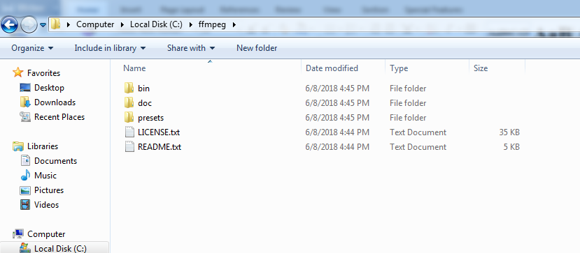

-- Follow given steps

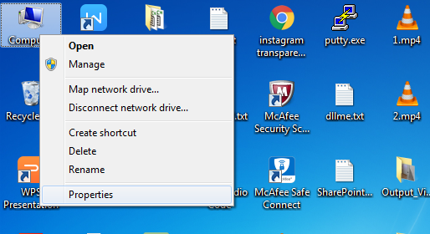

-- Select Properties : Then new windows will open

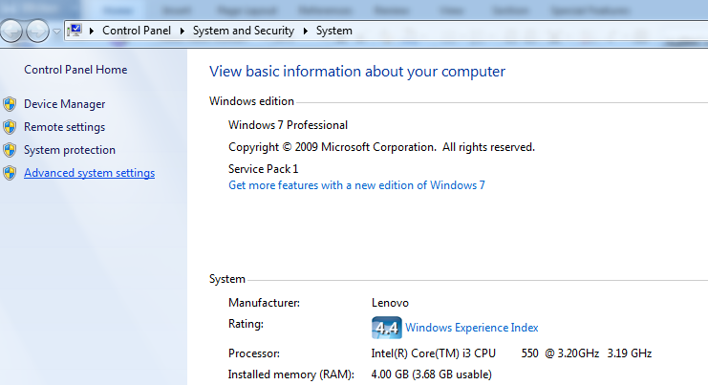

-- Click on Advanced system settings

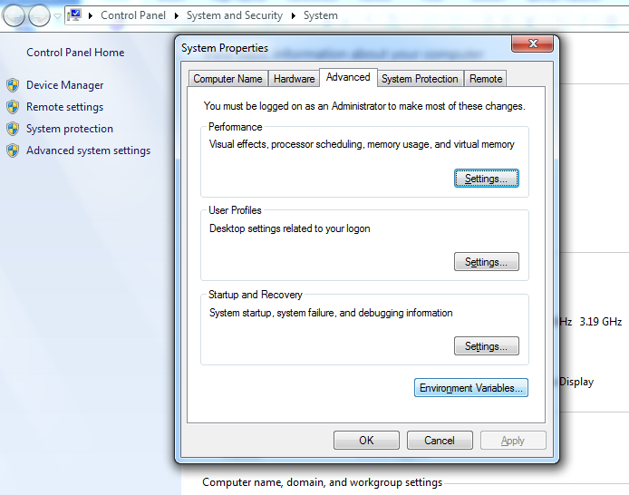

-- Click on Environment Variables

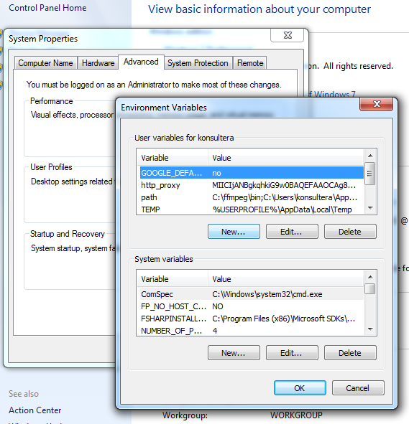

-- Click on New button
Open a small Windows : New User variables Show in below

Set a value
Variable Name : path
Variable Value : C:\ffmpeg\bin

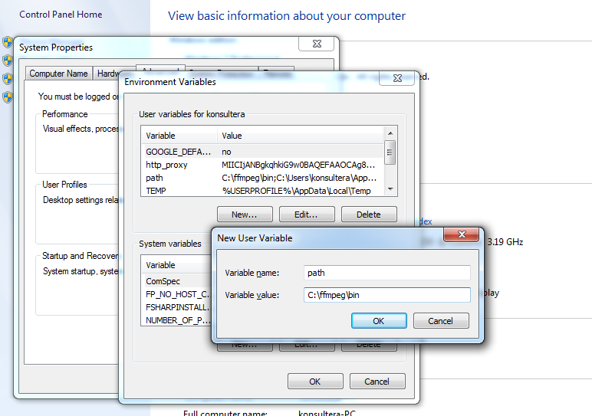

-- Click on OK
-- Complete ffmpeg installation

- Installed : Microsoft .Net framework 4.6

-- Open Given Path
C:\ActiAudit\ActiAuditing\Software - 20-07-2018\Software
Click on NDP46-KB3045560-Web.exe
And Installed it

- Installed : Mysql Connector For .net

-- Open Given path mysql-connector-net-8.0.11.msi
C:\ActiAudit\ActiAuditing\Software - 20-07-2018\Software
Click on NDP46-KB3045560-Web.exe
And Installed it

-- Open Given path
C:\ActiAudit\ActiAuditing
Click on ImageScroller.exe
Your application will be run successfully

