
LA GRANDEE INTERNATIONAL COLLEGE
Simalchaur, Pokhara Nepal
A Project Proposal
On
“One good programming Project”

Submitted to:
Bachelor of Computer Application(BCA) Program
In partial fulfilment of the requirements for the degree of BCA under
Pokhara University
Submitted by:
Name: | Course | Semester | P.U. Registration Number
Ritesh Thapa | BCA | 2nd | 2019-00-00-0000
Generic Name | BCA | 2nd | 2019-00-00-0000
Generic Name | BCA | 2nd | 2019-00-00-0000
Generic Name | BCA | 2nd | 2019-00-00-0000
Generic Name | BCA | 2nd | 2019-00-00-0000

Date:29/09/2020

ACKNOWLEDGEMENT
The satisfaction that accompanies after the successful completion of any task will be incomplete without mentioning the people whose ceaseless and relentless cooperation, constant guidance and encouragement made this project proposal report possible.
We are grateful to our project supervisor Mr Ritesh Thapa, our faculty teacher Mr. Ramesh Chalise, and BCA coordinator Mr Rishi Khanal, for the guidance, inspiration and constructive suggestions that helped us in the preparation of this project.
We are also appreciative among each other and have understood that teamwork, the designation of the task per the skillset one portrays, constant synchronisation and monitoring of progress and instilling new knowledge and skill is imperative for the success of any given work.
Sincerely,
Generic Thapa
Generic Sharma
Generic Gurung
Generic Nepali

DECLARATION FOR
“One good programming Project”

STUDENT’S DECLARATION
We hereby declare that we are the only authors of this work and that no sources other than the mentioned here have been used in this. We assure you that the work we present here is unique to ourselves and resemblances to another similar project are purely coincidental.
Generic Name (PU Exam Roll no): ___________________
Generic Name (PU Exam Roll no): ___________________
Generic Name (PU Exam Roll no): ___________________
Generic Name (PU Exam Roll no): ___________________
Program: BCA, 2nd Semester
Date: 29/09/2020

SUPERVISOR’S DECLARATION
I hereby declare that the project entitled “One good programming Project” has been carried out under my direct supervision by Generic Name (PU Exam Roll no), Generic Name (PU Exam Roll no), Generic Name (PU Exam Roll no), Generic Name (PU Exam Roll no), and Generic Name (PU Exam Roll no) during their second semester for the partial fulfilment of the requirements for the degree of BCA(Bachelors of Computer Application) program under Pokhara University

_______________
Mr Ritesh Thapa
(Project Supervisor)
Date: 29 September 2020

TABLE OF CONTENTS
ACKNOWLEDGEMENT ii
STUDENT’S DECLARATION iii
SUPERVISOR’S DECLARATION iv
1. INTRODUCTION 1
2. PROBLEM STATEMENT 2
3. OBJECTIVES 3
4. METHODOLOGY 4
5. DATA FLOW DIAGRAM 5
6. PROJECT GANTT CHART/ TIMELINE CHART 6
7. DELIVERABLES 7
8. CONCLUSION 8

INTRODUCTION
The Artwork E-commerce Website ‘GAPRIS’ will be a custom-built platform designed to showcase and sell hyperrealism charcoal sketches. This website aims to provide an intuitive and user-friendly interface for art collectors to discover unique pieces inspired by everyday stories and emotions. The primary objective of this project is to address the challenges faced in sharing artwork and managing transactions, enabling a broader audience to engage with the art.
In today’s digital age, having an online presence is essential for expanding visibility and sales opportunities. Presenting artwork effectively on social media can be difficult due to limitations in image quality and character count. Creating a dedicated e-commerce platform will offer a seamless experience for customers to browse detailed descriptions, view high-resolution images, and complete purchases securely.
The need for this project arises from the challenge of repeatedly describing artwork and its details to potential buyers through messages, which can be time-consuming. Additionally, issues related to payment processing and order management highlight the importance of a streamlined solution. The Artwork E-commerce Website will include comprehensive information about each piece, such as the title, inspiration, size, and detailed shots, allowing customers to make informed decisions.
In conclusion, this project aims to fulfill the goal of selling hyperrealism art while providing a digital platform that meets the needs of both artists and art enthusiasts.

PROBLEM STATEMENT
In the current scenario, showcasing and selling artwork is done through social media, which often lowers the quality and details of my hyperrealism charcoal sketches. This makes it hard to show the artwork clearly and limits how much I can describe each piece. Transactions are handled through messages, which can lead to mixed-up information and not enough details for potential buyers.
Keeping track of artwork inventory and customer orders is also hard. It takes a lot of time to communicate back and forth just to finalize a sale, which can take days. This system is not efficient and doesn’t provide a good experience for buyers. There is a clear need for a better way to show the artwork and make payments easier. Creating a dedicated e-commerce website will help solve these problems, making it simpler for both the artist and the customers.
In short, the current methods of showcasing and selling artwork face following challenges:
- Problem in showcasing artwork on social media leads to reduced quality, limiting effective presentation and details.
- Problem in handling transactions through messages creates mixed information, causing slow communication for buyers.
- Problem in managing inventory and orders makes it challenging to keep track of sales and customer details.

OBJECTIVES
The objectives of this project are designed to provide clear, actionable goals that guide the development and implementation of the e-commerce platform. Each objective focuses on enhancing the user experience, improving operational efficiency, and increasing visibility for the artwork. These objectives are specific, measurable, achievable, relevant, and time-bound, ensuring that the project stays on track and meets its overall goals.
Objectives are:
- To build an e-commerce website for hyperrealism charcoal sketches with clear presentations.
- To set up a secure payment system with a good success rate and by project completion.
- To create an inventory management system that reduces order processing time.

METHODOLOGY
The methodology for developing the e-commerce platform will follow an Agile approach, allowing for flexibility and iterative progress throughout the project. The development process will be divided into several key phases, each with specific tasks and goals.
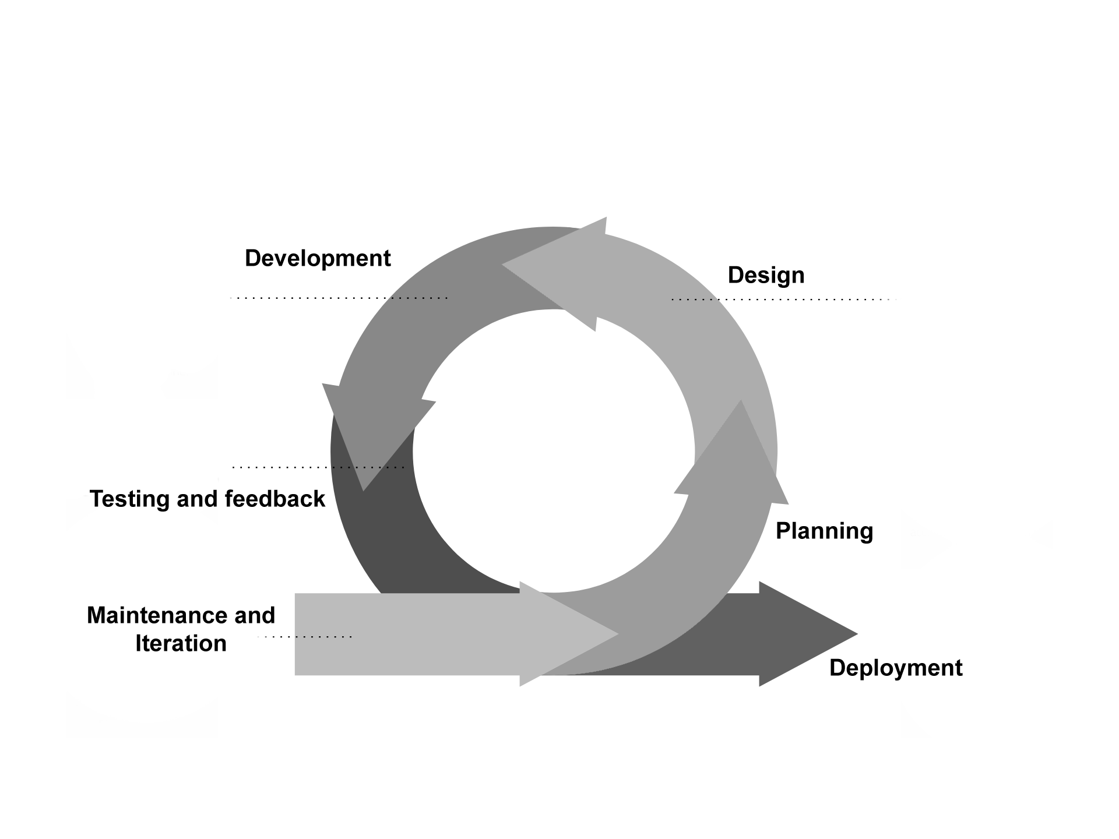I. Planning Phase (Sprint 0)
- Define your project scope:
  - Clarify the website’s purpose (selling artwork), features (admin can list, customers can buy), and long-term vision.
- Create a backlog:
  - List all tasks needed for the project (e.g., user authentication, artwork listing, order management, payment integration).
- Prioritize features:
  - Decide on the minimum viable product (MVP), focusing on basic functionality like viewing and purchasing artwork.
- Set timelines:
  - Define the length of your sprints (typically 1-2 weeks) and assign tasks.

II. Design Phase (Sprint 1)
- UI/UX Design:
  - Sketch wireframes for main pages (artwork listings, product detail page, checkout, admin panel).
  - Focus on usability to ensure an intuitive buying process.
- Database Design:
  - Define your MongoDB schema for users, artwork, orders, etc.
- Backend Design:
  - Plan the structure of your Node.js backend, including how the server will handle requests and communicate with MongoDB.
III. Development Phase (Multiple Sprints)
- Sprint 2: User Authentication & Admin Panel
  - Develop user registration and login functionality (for admin and customers).
  - Build a basic admin panel for adding/editing/removing artwork.
- Sprint 3: Artwork Listing
  - Develop the frontend and backend for displaying artwork.
  - Set up MongoDB to fetch and display artworks.
- Sprint 4: Shopping Cart & Checkout
  - Create a shopping cart feature for customers.
  - Set up a simple order processing system (storing orders in MongoDB).
- Sprint 5: Payment Integration
  - Integrate an online payment API (e.g., Stripe, PayPal).
- Sprint 6: Order History & Notifications
  - Add order history for users.
  - Notify the admin when a new order is placed.

IV. Testing and Feedback Phase (Ongoing)
- Sprint 7: Testing and Bug Fixing
  - Conduct manual and automated tests for each feature (user authentication, artwork listing, order processing, etc.).
  - Fix any bugs or issues identified during testing.
- User Feedback:
  - Collect feedback from early users or testers to improve features or user experience.
V. Deployment Phase (Sprint 8)
- Deploy to production:
  - Move the website to a live server or platform where users can access it.
  - Ensure everything works in the live environment (final testing of payment, database interactions, etc.).
VI. Maintenance and Iteration (Ongoing Sprints)
- Sprint 9 and beyond: Continuous Improvement
  - Based on user feedback and new requirements, continue to add new features (e.g., more payment options, advanced order tracking).
  - Regularly update and maintain the website, ensuring security and performance.

Summary of Agile Breakdown:
Brief description about how the agile method will be used in this project. Summary of Agile Breakdown:
- Planning Phase (Sprint 0)
- Design Phase (Sprint 1)
- Development Phase (Multiple Sprints):
  - User Authentication, Admin Panel (Sprint 2)
  - Artwork Listing (Sprint 3)
  - Shopping Cart & Checkout (Sprint 4)
  - Payment Integration (Sprint 5)
  - Order History & Notifications (Sprint 6)
- Testing & Feedback (Sprint 7)
- Deployment (Sprint 8)
- Maintenance & Iteration (Ongoing)

DATA FLOW DIAGRAM
It is a diagrammatic representation that portrays the flow of data in a system or a process.
Helps communicates the general data flow structure of a proposed system to the system designer, programmer and end-users.
Helps assess the requirements, so a major process for requirement analysis.
Outputs and inputs are clearly defined.
However, there are no decision rules and iteration(loops).
There are 4 basic symbols.

PROJECT GANTT CHART/ TIMELINE CHART
It is a timeline of the project developed by Henry Gantt, also called project schedule chart.
In the vertical axis defines the tasks to be performed, on the vertical axis, and time intervals on the horizontal axis.
The gantt chart contains the following information:
- Start and End data of the project.
- Completed project tasks, which are represented by a unique colored notation, can be shaded, or colored in gray color.
- Duration of the tasks, how many days will it take to complete the tasks.
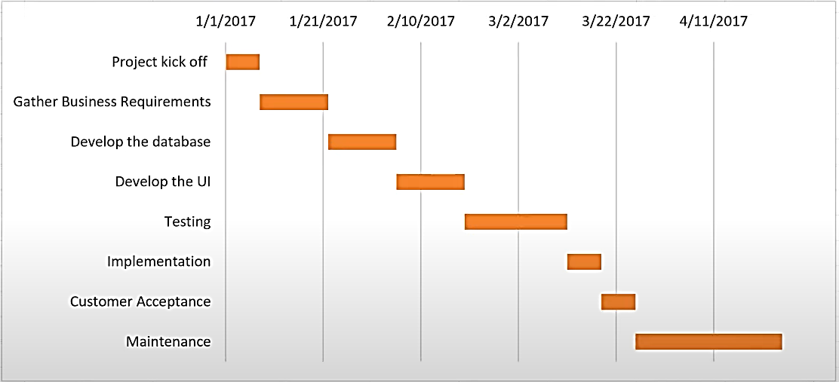
Figure 2: Example of Gantt Chart

DELIVERABLES
It is the products, services, reports, results or anything that is obtained after the completion of the project.
It can also be the outcome, responses from the end-users. Some examples of the deliverables are:
- Project report or project documentation: Explain what summarized contents are there.
- User manual and system requirements: explain it but not in-depth, one or two lines only.
- Software, applications, or digital solutions: explain it but not in-depth, one or two lines only.
- System Design: ERD, DFD, FLOW CHART.
- Log Reports, milestones of the project, project enhancements.

CONCLUSION
Overall summary of the project.

