Nace Api Service Database design and Swagger Testing Data:

1. Database created:

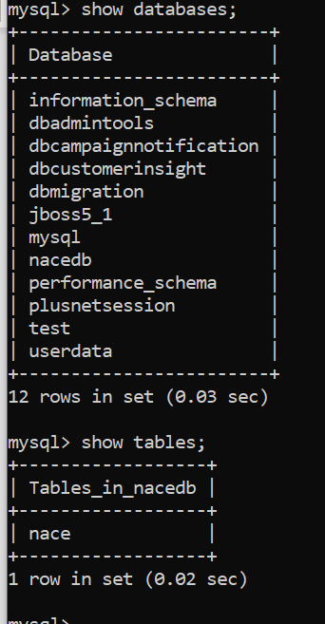

1. Table Created:

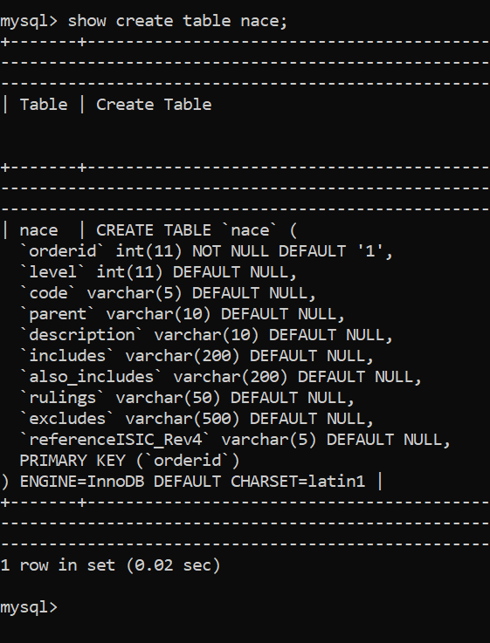

CREATE TABLE `nace` (

`orderid` int(11) NOT NULL DEFAULT '1',

`level` int(11) DEFAULT NULL,

`code` varchar(5) DEFAULT NULL,

`parent` varchar(10) DEFAULT NULL,

`description` varchar(10) DEFAULT NULL,

`includes` varchar(200) DEFAULT NULL,

`also_includes` varchar(200) DEFAULT NULL,

`rulings` varchar(50) DEFAULT NULL,

`excludes` varchar(500) DEFAULT NULL,

`referenceISIC_Rev4` varchar(5) DEFAULT NULL,

PRIMARY KEY (`orderid`)

) ENGINE=InnoDB DEFAULT CHARSET=latin1 |

Data imported in this table from excel file given.

1. Swagger result:

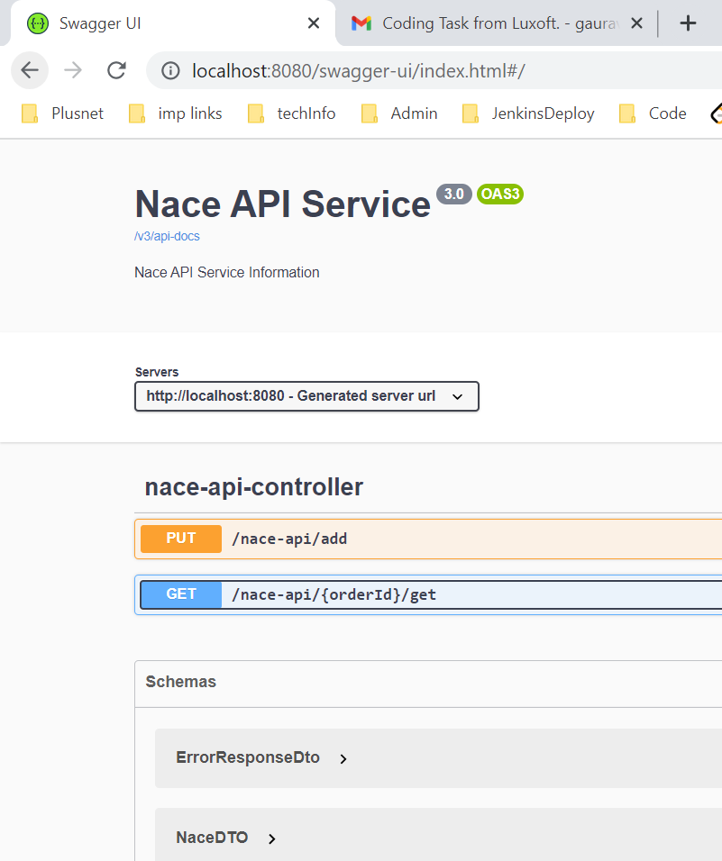

1. Put Service:

New Record added:

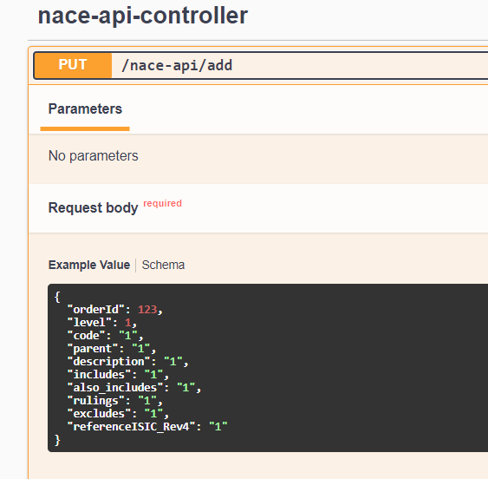

Curl command fired by Swagger and Response received:

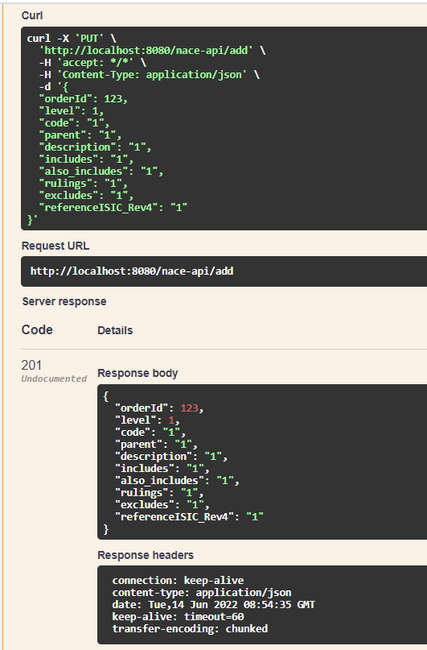

1. Get Service:

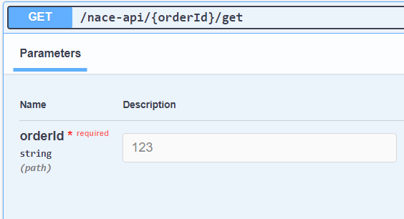

Curl command fired by Swagger and Response received:

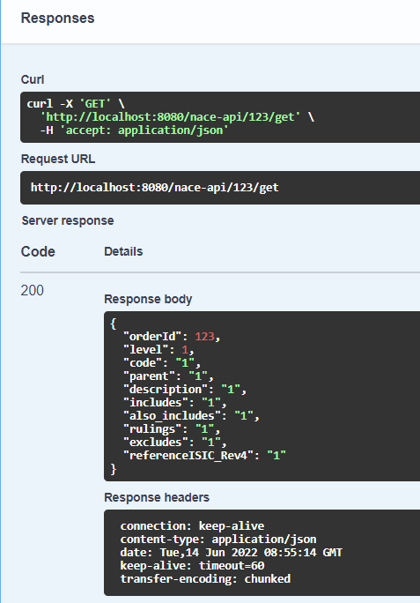

1. If No records available to display:

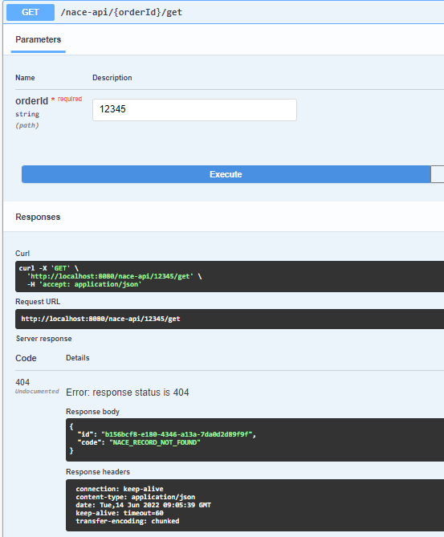

1. If wrong data added:

