Nace Api Service Database design and Swagger Testing Data:

1. Database created:

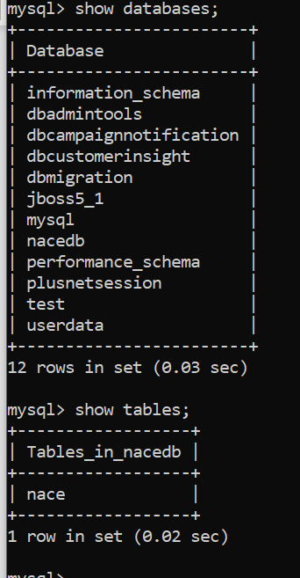

1. Table Created:

CREATE TABLE `nace` (

`orderid` int(11) NOT NULL DEFAULT '1',

`level` int(11) DEFAULT NULL,

`code` varchar(5) DEFAULT NULL,

`parent` varchar(10) DEFAULT NULL,

`description` varchar(500) DEFAULT NULL,

`includes` longtext,

`also_includes` longtext,

`rulings` longtext,

`excludes` longtext,

`referenceISIC_Rev4` varchar(5) DEFAULT NULL,

PRIMARY KEY (`orderid`)

) ENGINE=InnoDB DEFAULT CHARSET=latin1 |

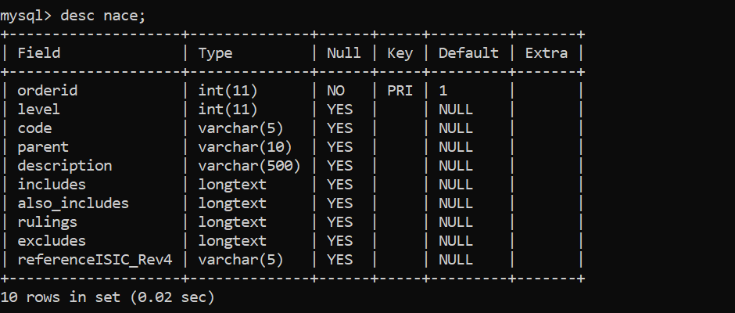

Data imported in this table from excel file given.

1. Swagger result:

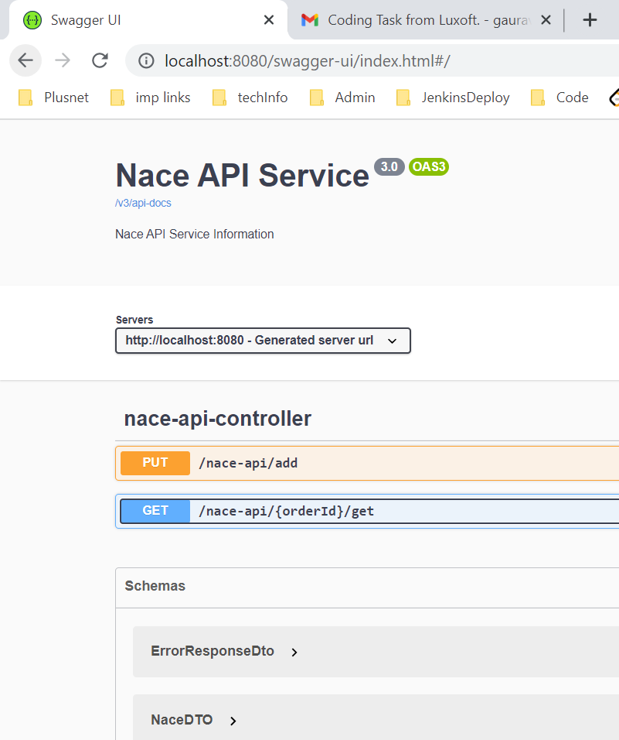

1. Put Service:

New Record added:

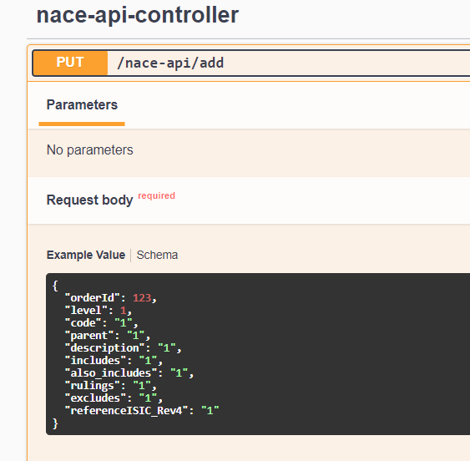

Curl command fired by Swagger and Response received:

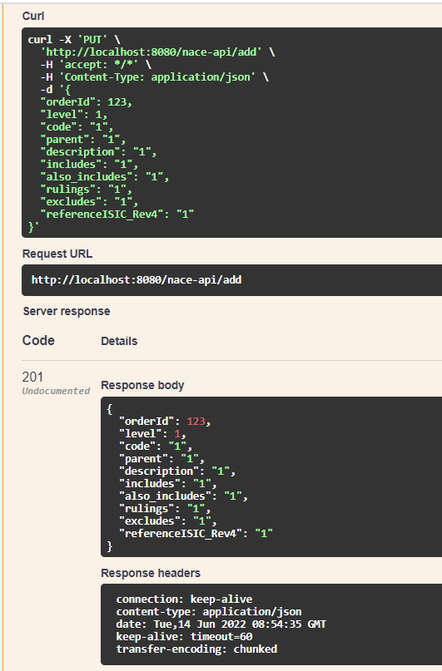

1. Get Service:

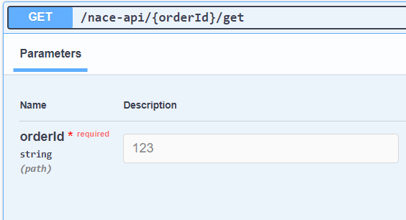

Curl command fired by Swagger and Response received:

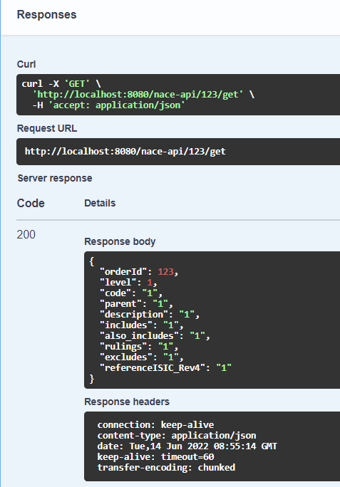

1. If No records available to display:

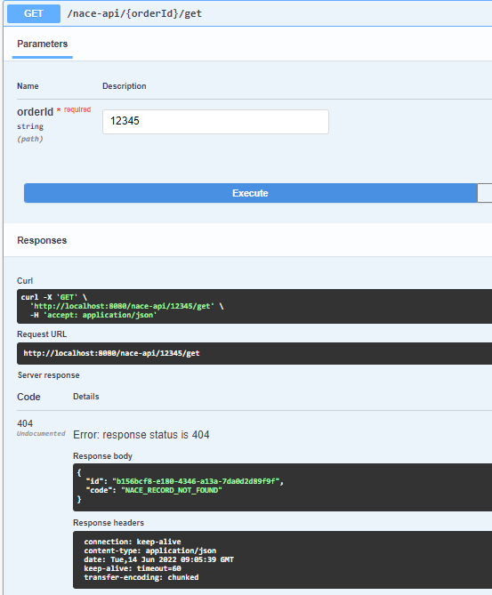

1. If wrong data added:

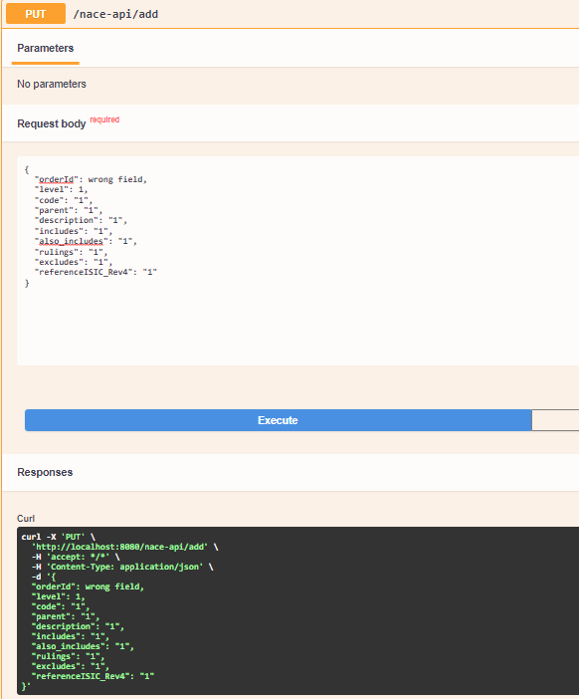

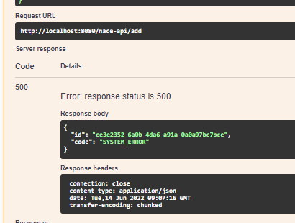

After adding new Api to upload entire csv file:

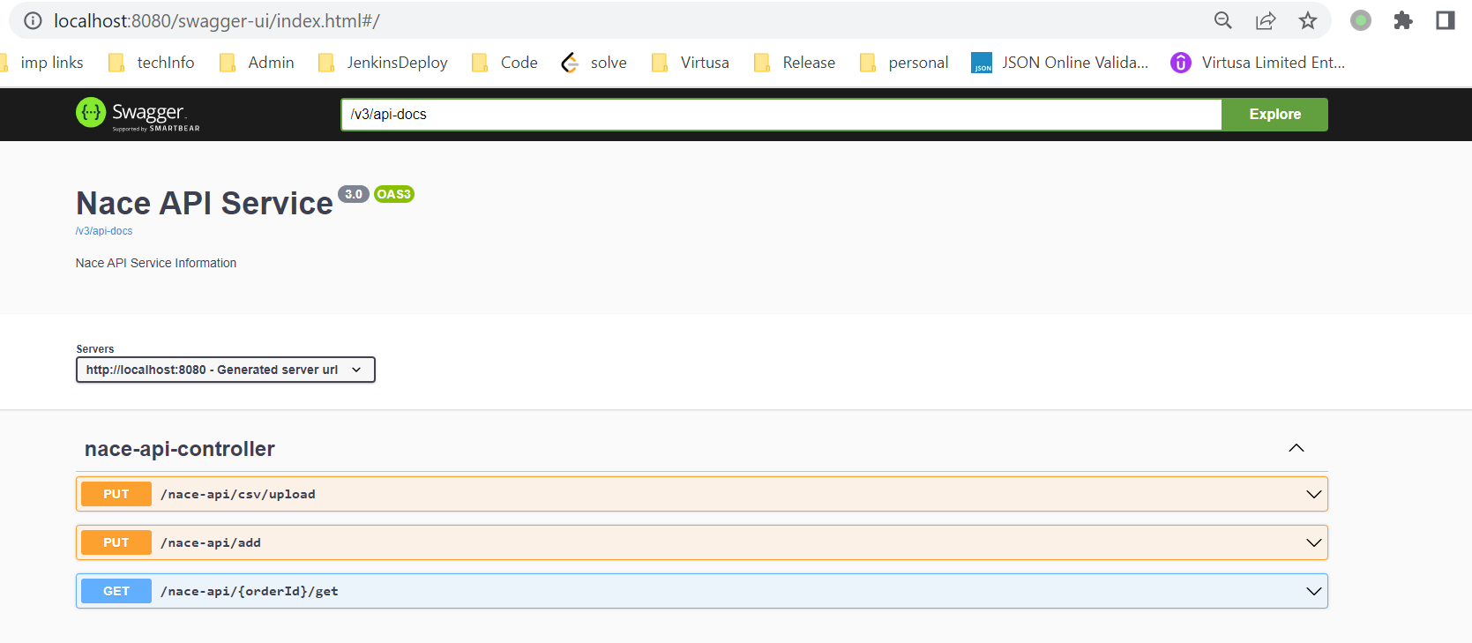

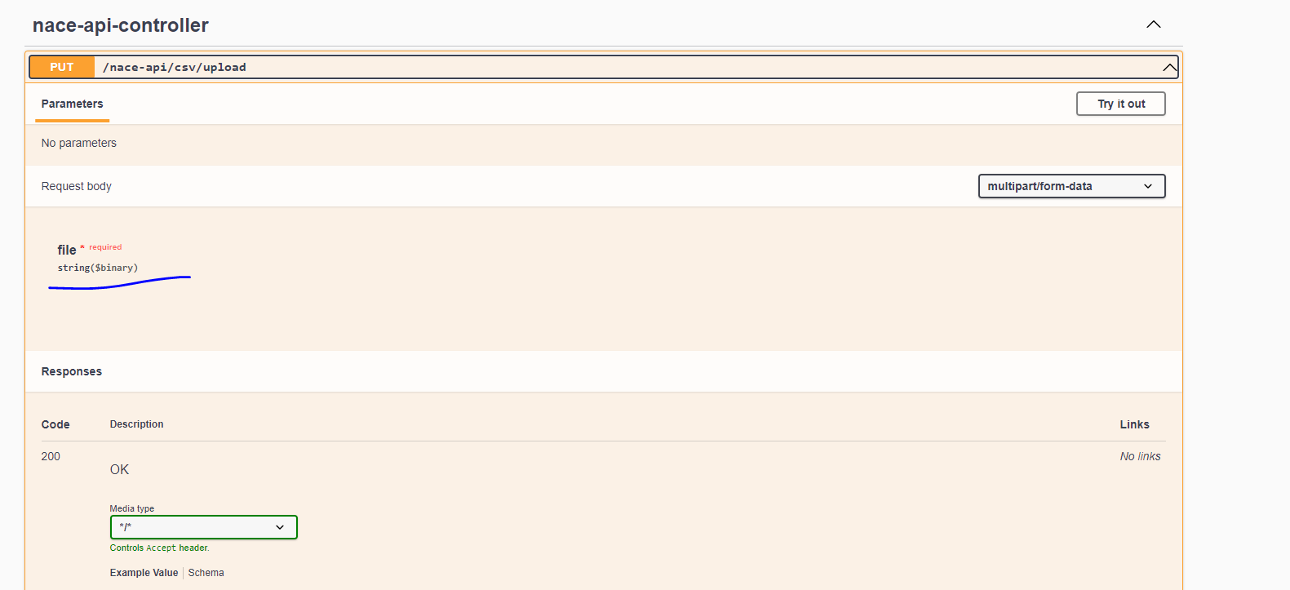

Test:

Database table empty:

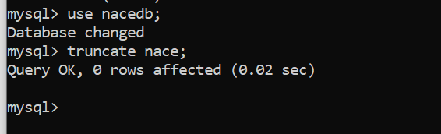

Selecting file to upload on Swagger:

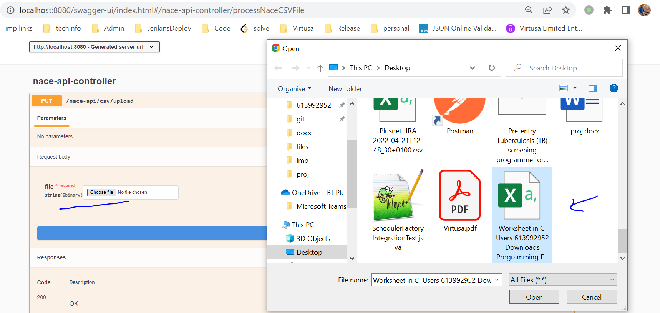

Executing:

Response Received:

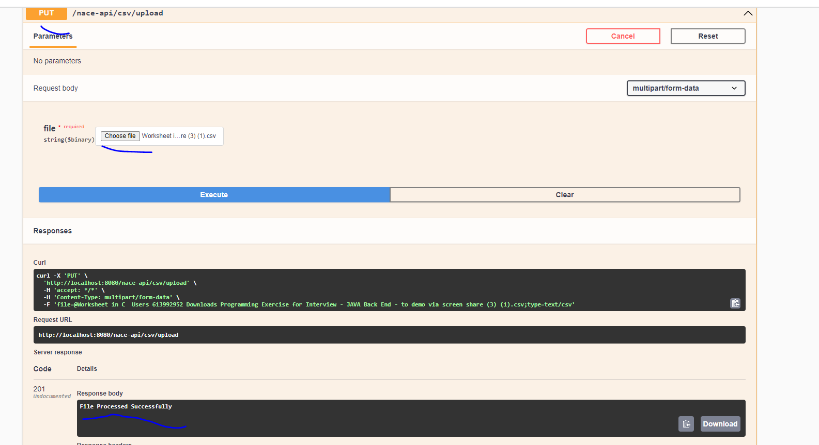

Records added in database:

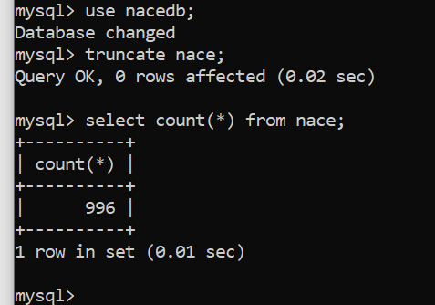

How a Record is added in database?

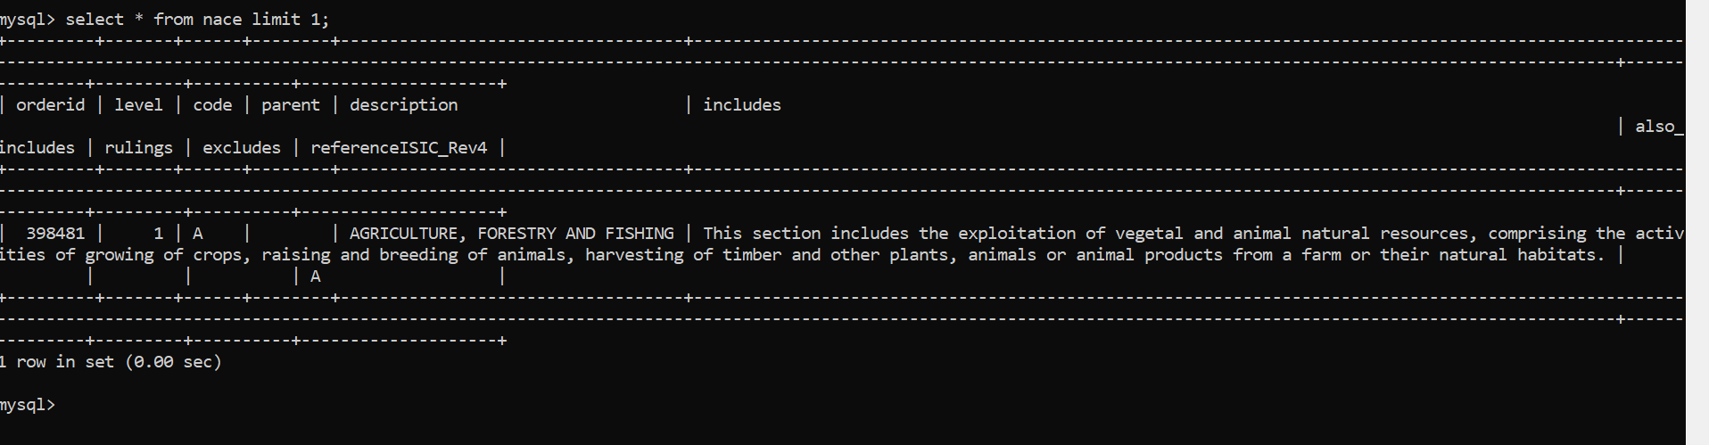

If I select file which is not CSV it throws 400 – BAD REQUEST response:

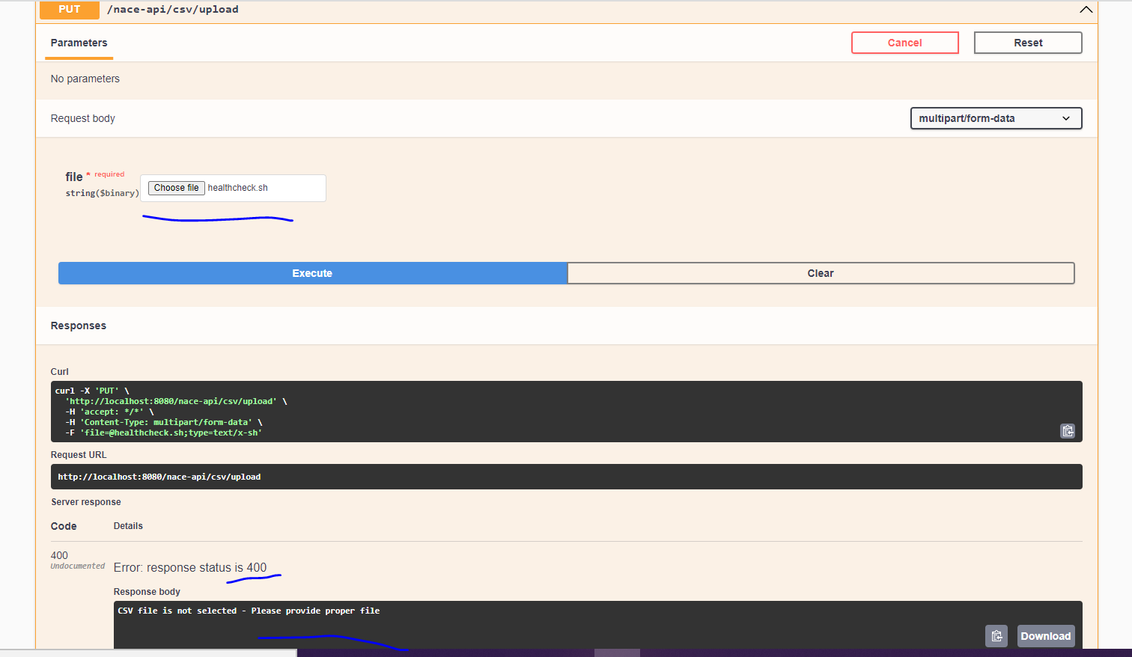

Code Coverage:

