SAP Standard Application UI5+Fiori

* Designed and developed a custom SAP UI5/Fiori application, ensuring seamless
* Functionality and a responsive user experience.
* Leveraged SAP Web IDE for efficient development and testing, optimising iteration cycles.
* Deployed as a BSP application for high performance and accessibility. Integrated with backend SAP systems via
* OData services for real-time data exchange.
* Automated workflows to enhance operational efficiency and reduce manual tasks.
* Ensured adherence to SAP Fiori design guidelines for usability and consistency.
* Conducted performance tuning and user feedback sessions to align with business goals.
* Delivered a scalable, maintainable solution on time with robust features.

(Mobile View)

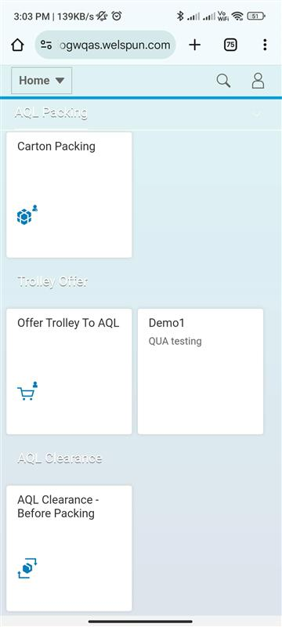 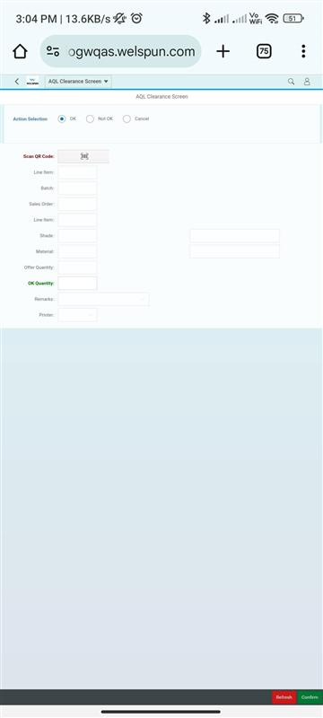 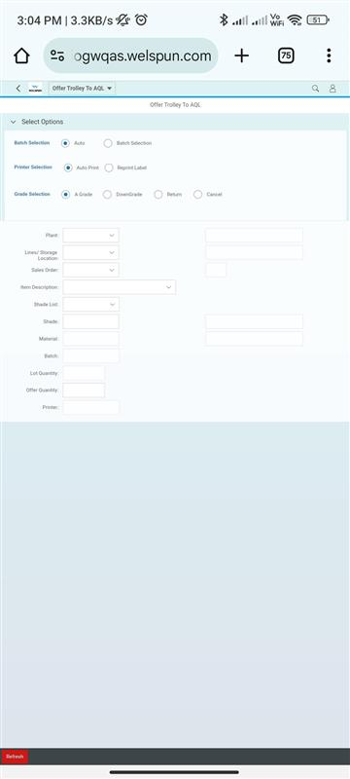 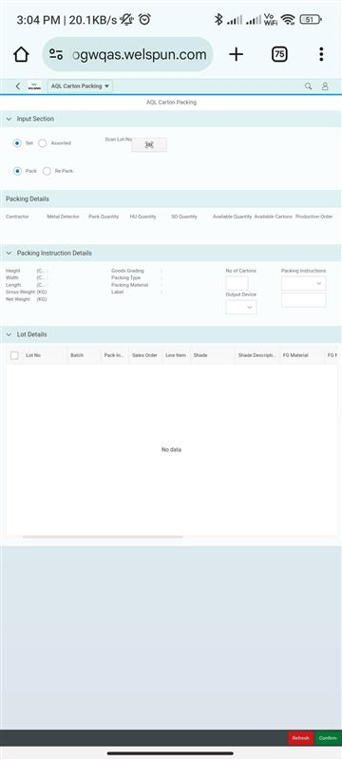

(Laptop View) 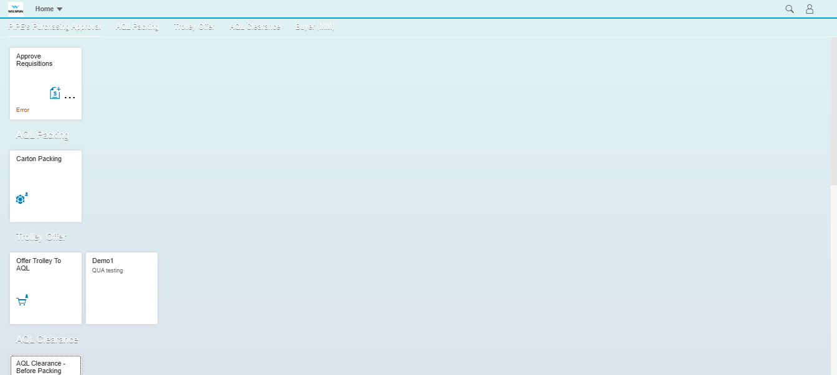 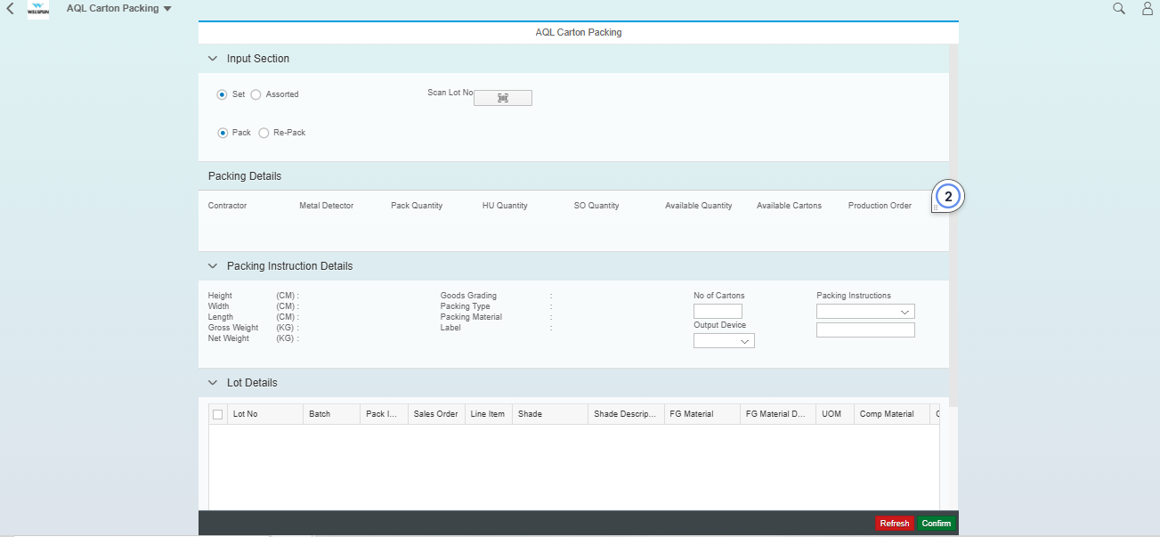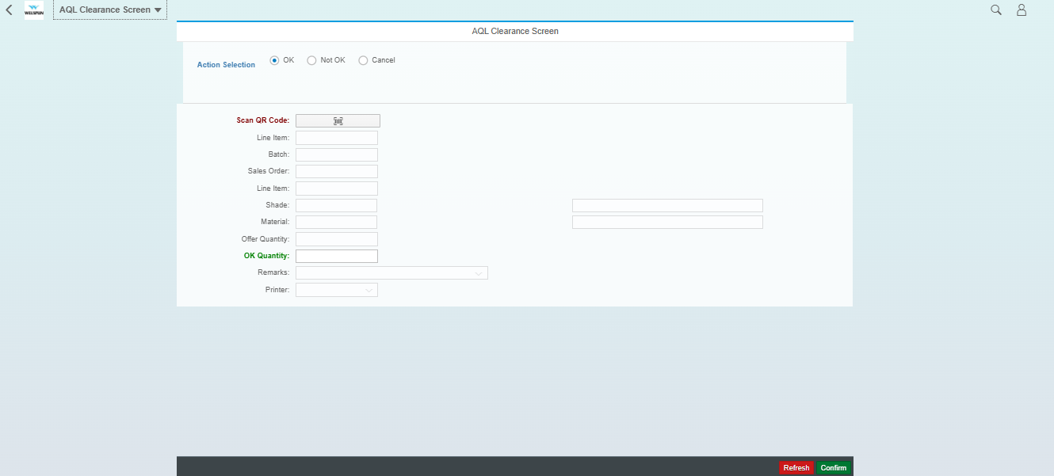

Company Ticketing Tool

The Ticketing Tool is a MERN stack application designed to streamline ticket management by facilitating the assignment of tickets from clients to Team Leads and from Team Leads to Employees, ensuring efficient task allocation and tracking.

(Admin Role)

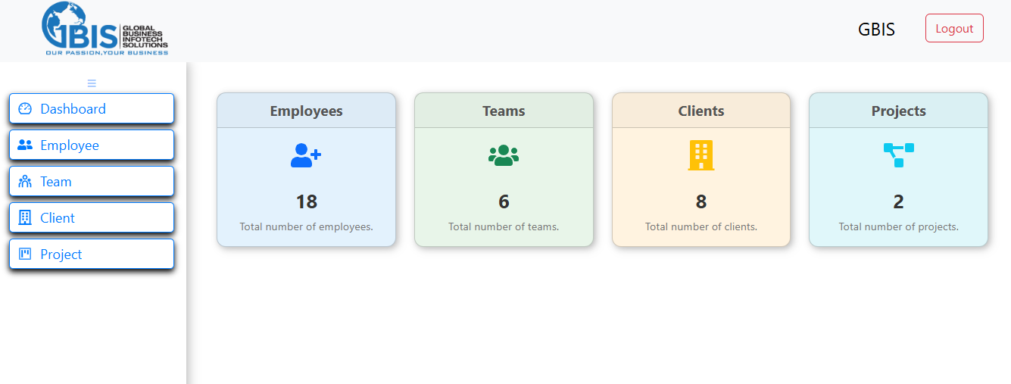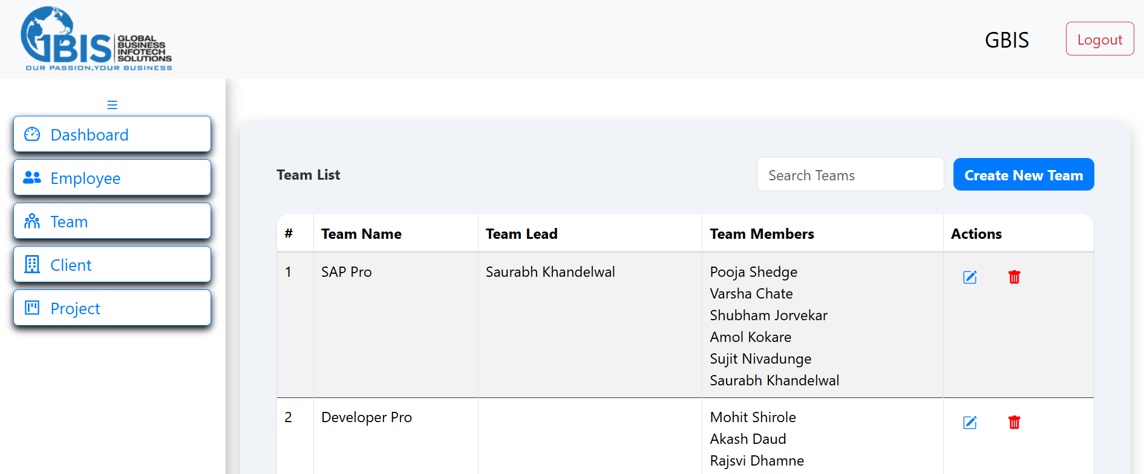

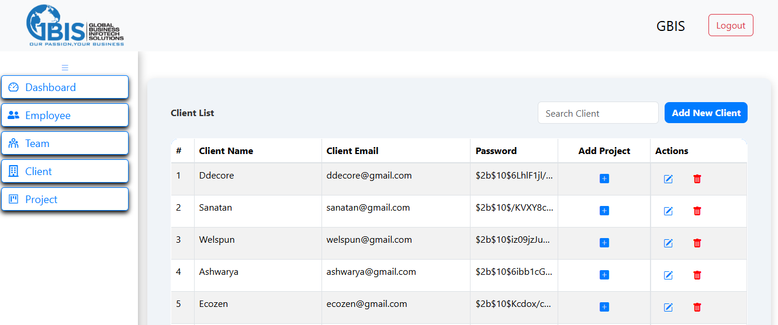 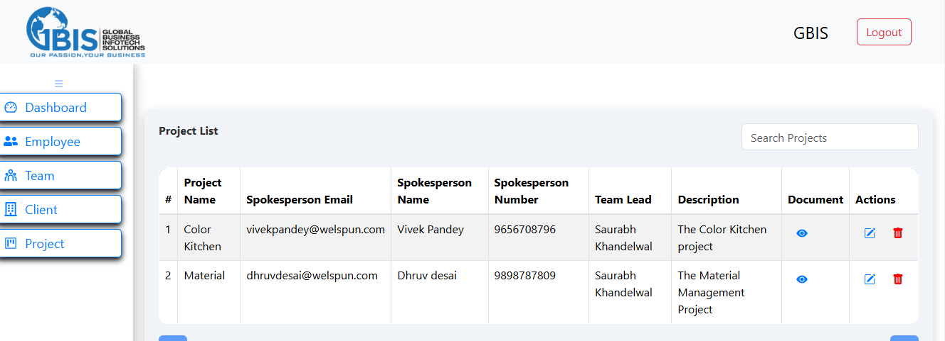

(Team Lead Role)

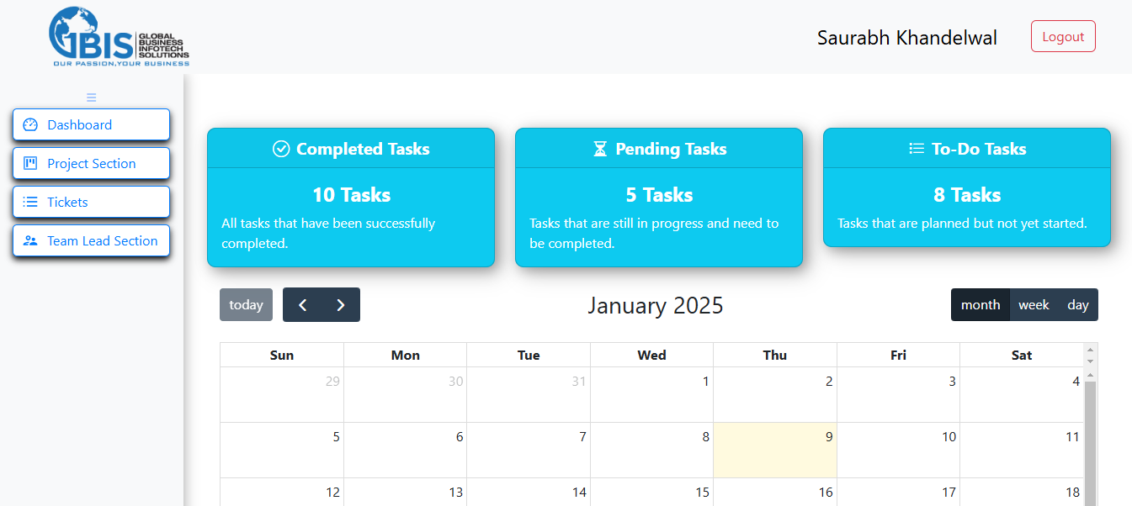 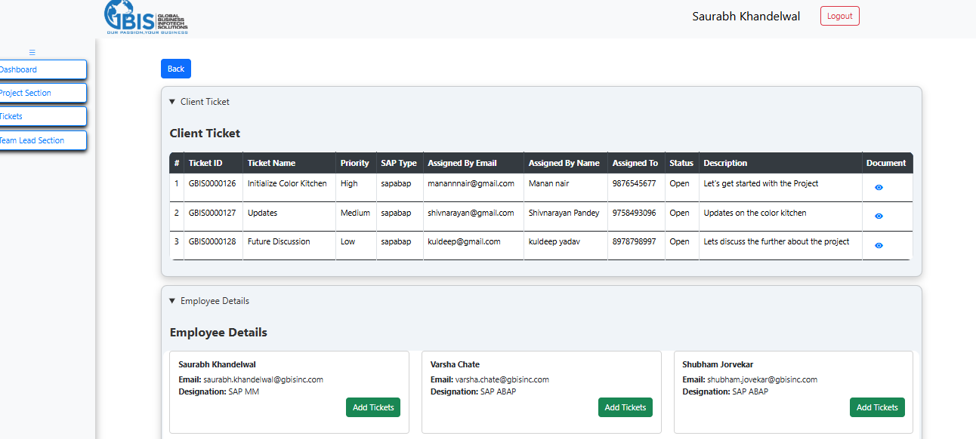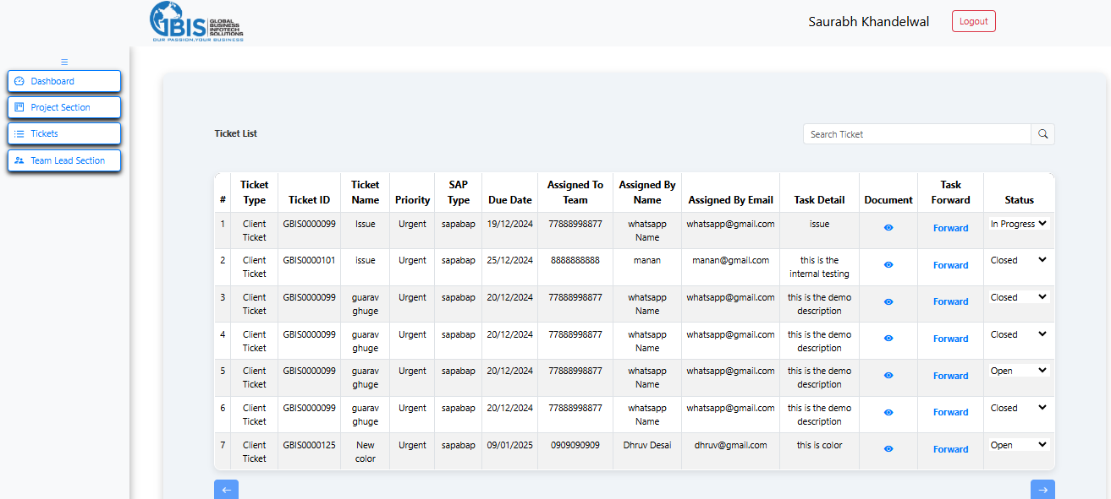

(Client Role)

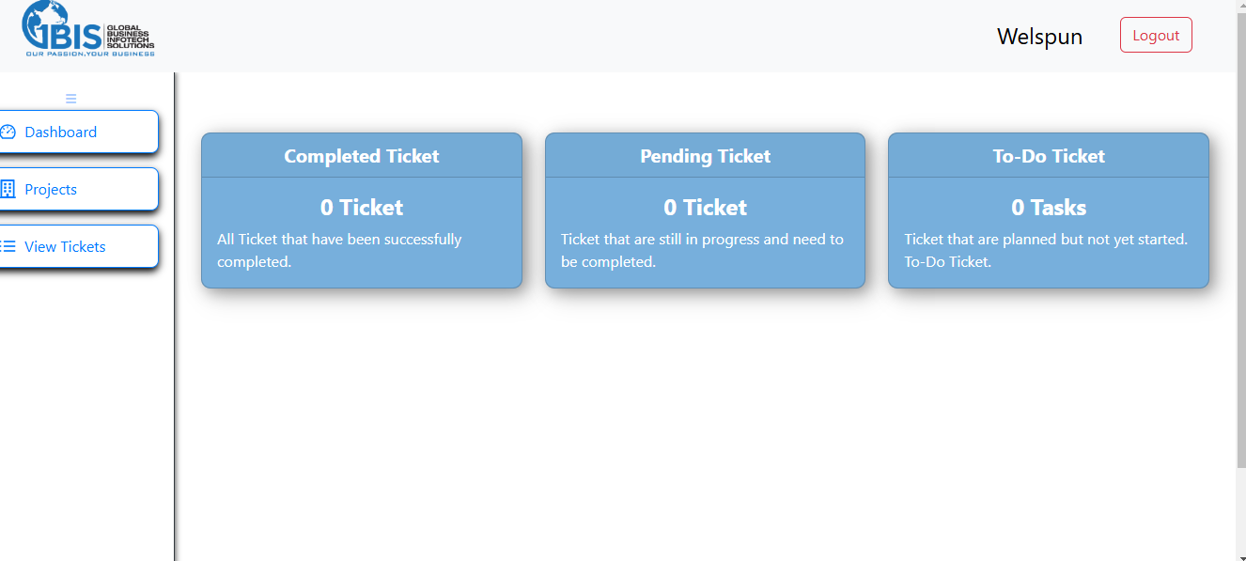 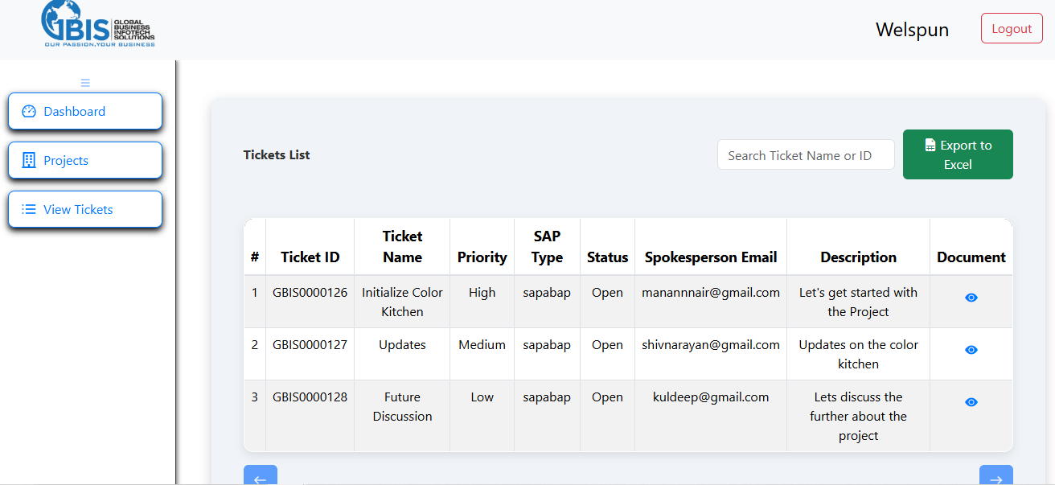

Bhaktinaad Music Application

* Built a music-streaming app using React Native, making it more engaging and stable on iOS and Android.
* Added APIs for real-time updates and smoother functionality, making the app easier and more enjoyable to use.
* Used MySQL for managing data, which helped speed up loading times.

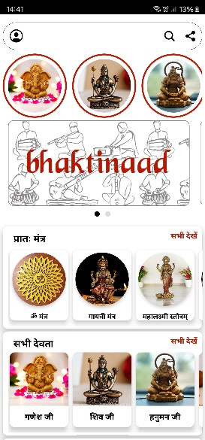 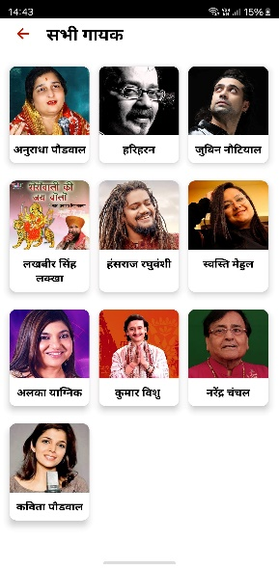 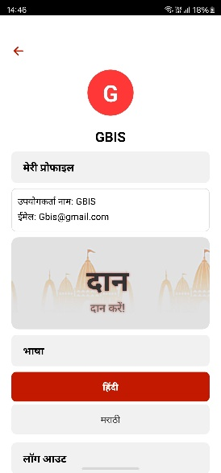 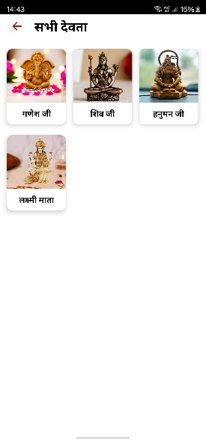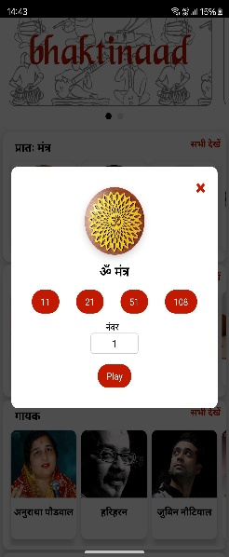

Champ Marathon Website

* The Marathon Website is a MARN stack application designed to facilitate online

marathon event registration and payment processing, providing users with a smooth and efficient way to sign up for

marathons and manage event details.

* The application integrates a secure payment gateway (e.g., Razorpay, Stripe, or PayPal) to process user payments

for marathon registrations, offering various payment methods like credit/debit cards, UPI, and wallets.

