**ISM 6155 – Enterprise Information Systems Capstone: Deliverable 1**

**Summer 2017**

**University of South Florida, Tampa, FL**

**Submitted by Team 2.6:**

Sandeep Kumar Sankepalli

Ramadas Pulapaka

Saketh Kota

Gaurav Kulkarni

Table of Contents

**Section 13**

Team Members3

Project Responsibilities 3

**Section 2 (Initial Problem Definition)4**

Overview of the problem4

User/Customer4

Type of the problem4

Why this is a problem4

Scope/Magnitude of the problem6

An example to demonstrate the problem6

**Section 1:**

**Team Members:**

1. Sandeep Kumar Sankepalli
2. Ramadas Pulapaka
3. Saketh Kota
4. Gaurav Kulkarni

**Project Responsibilities:**

|  |  |  |  |
| --- | --- | --- | --- |
| **Member/Responsibilities** | **Responsibility 1** | **Responsibility 2** | **Responsibility 3** |
| Sandeep Kumar Sankepalli | Develop project plan and manage deliverables according to scheduled plan | Assign tasks to project team members and provide updates | Document technical and business requirement |
| Rama Das Pulapaka | Determine Methodology used in a project | Define needs and recommend solutions | Conduct user research and interviews |
| Saketh Kota | Identify Design problems and design screen interface | Verify the project deliverable meets requirements | Provide updates on project |
| Gaurav Kulkarni | Gather technical and business requirement | Document user requirements and evaluate user feedback | Create storyboards, user and process flows |

**Section 2 (Initial Problem Definition):**

**Overview of the Problem:**

We have chosen a large bank to discuss some of its challenges that it is facing currently.

During the first week, we have had discussions with the bank personnel regarding the challenges and issues that they are currently facing. The bank professionals pointed to an existing issue with the recent implementation of an IT infrastructure in their bank to effectively generate reports and for data collection purposes of their day-to-day business activities. Due to some confidentiality reasons, we are not supposed to discuss the name of the bank, however, please note that the bank which we are talking about is not profit oriented but rather a service oriented enterprise. As a result, the bank did not have sufficient funds and budget to outsource the post-production changes at application level. They were willing to hire as minimal professionals as possible to complete these implementations.

To support the external auditing which is mandatory and happens at regular frequency (for example, weekly/biweekly/monthly/quarterly/half-yearly/annually), the bank would need to appropriately classify all the loans which it sanctions as per the MIS classifications defined by regulator from time to time. Previously, the classifications were done manually at every branch by the branch professionals who were competent enough to understand the banking jargons. These manual classifications were always 100% accurate and correct. These manual classification-reports were later shared by individual branches to the state headquarters of the bank on defined frequencies. The state head-quarters were responsible to collate those reports and submit them to central head-quarters on the said defined frequencies.

The bank never faced any issues with the existing processes. However, in the changing world, they wanted to reap the benefits of Information Technology and software solutions. This led them to a thought of implementing an internal online central banking system for the bank. After implementation of CBS, the expectation was to generate the reports centrally without any manual interventions which was much quicker than the legacy procedures. The banks saw this IT implementation not only to support the regulatory requirements and external auditors but also as a medium to assess their strengths, market spread and understand the areas where they need to focus more.

The data generated from the core banking solution is not serving the purpose of categorization (Personal Loan/ Vehicle Loan/ Education Loan/ House Loan/ Agriculture Loan/ Small and Medium Enterprise Loan/ Business Loan etc.) of its asset generating accounts i.e. Loan Accounts and thereby involving several of its employees in categorization of the accounts manually at distinct levels of its hierarchies. They are unable to utilize the data generated from application for Regulatory Reporting Purposes. We have expressed our interest to know more about this challenge and design a solution for their business problem.

**User/Customer:** A very large bank based in India.

**Type of the Problem:** The existing organizational problem.

**Why this is a Problem:**

Dramatic transformations in banking have been driven by both new regulatory requirements and the technological advancements which aid banks, in meeting and exceeding such requirements. One of the largest challenges faced by banks today is managing data, both for regulatory requirements as well as to gain meaningful insights.

Businesses driven by modern technology operate through many channels which in turn generate large volumes of data that modern banks must support.

Any paper documents anywhere in between the business processes can easily be the source of error as they require manual input into the systems. The applications deployed should be in such a way that the right information should flow and “***it should lead the users and not users leading the application***”.

The data is the heart for any organization and can be utilized for creation of strategies, making important decisions, setting up of goals for the business, to comply regulatory guidelines etc.

In this organization, the bank’s applications have seen major transformations over 3 decades. It had seen manual ledger processes till Core Banking Solution implementations. The customers’ data has been carried forwarded through all these applications. Over a period, regulator has also revised the data requirements exponentially. When banks used to follow manual operations, the customer details were captured at very high level which were sufficient at that point of time. Over the period, by virtue of transformations, banks had to start capturing low level of customer details in order to comply regulatory requirements. The changing regulations by adding in more and more finer details about the account holders for having a better control over financial conditions in the country has been a challenging task for both Core Banking Solution Vendors as well as Banks. The gaps in the requirements from the regulators and the Bank’s IT infrastructures led the practice of preparing the reports manually.

This manual consolidation of reports needs to be replaced with the system generated reports which helps in minimizing the manual effort being spent. For every reporting cycle, a resource must be freed from his usual responsibilities to spend 2 complete days in a week just to categorize the accounts correctly.

The departments who are responsible to submit the reports by consolidating data from all the branches, spends a minimum of two weeks to validate the reports before submitting to Regulatory Authorities.

***The below picture depicts the several concerns leading to operational and infrastructure failures in Bank***:

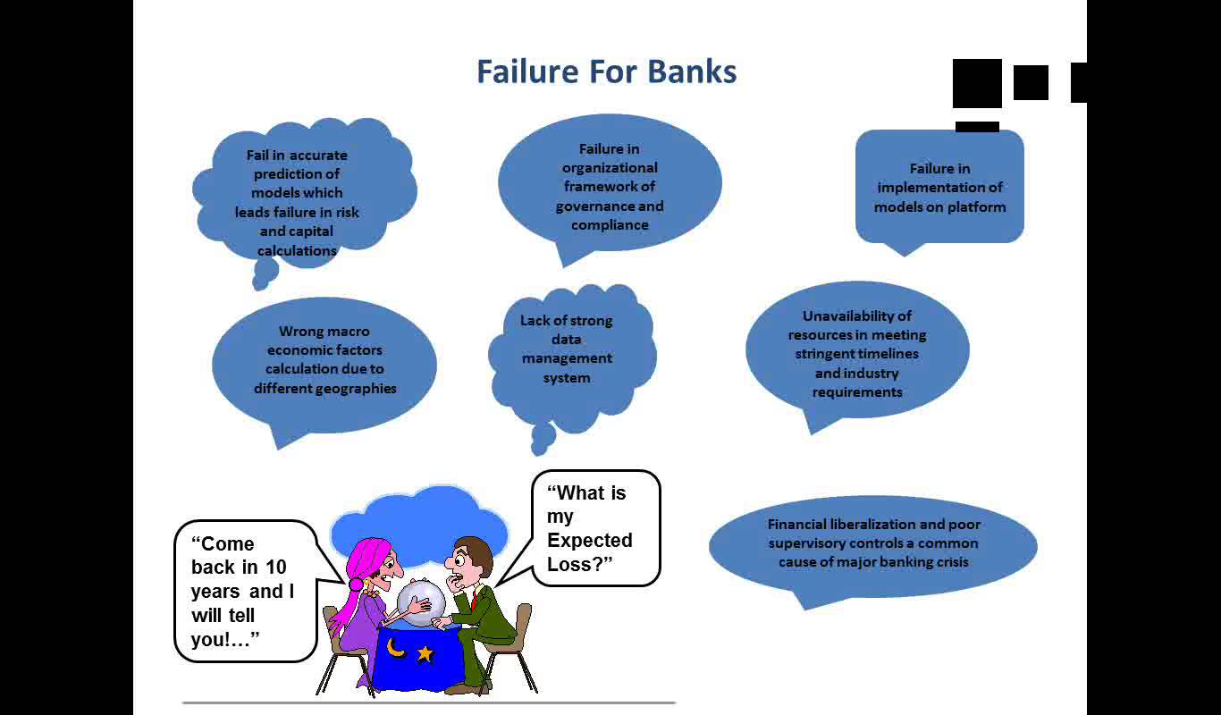

**Scope/Magnitude of the Problem:**

As part of the internal audit exercise, the bank auditors noticed some significant mismatches when they compared the CBS reports with manually consolidated reports. This raised some questions about the reliability on the newly implemented CBS solution.

Due to this deviation noted by the internal audit, the bank started taking some measures to fix this issue. However, in the mean time they are relying on the reports that are generated by manual consolidations. But, after preliminary analysis, it looks like the application was not tested completely.Due to this, the organization is not able to automate report generations.

**An Example to demonstrate the Problem:**

Indian Banks Association(IBA) conducts several surveys across the Banks for presenting Reserve Bank of India (RBI) an analysis on spread of the Government Schemes to the regions for which funding has been sanctioned by Central Government in various categories (viz., Education, Housing, Agriculture, Small and Medium Enterprise etc) to reach the public falling under different economic conditions.

The bank noted that while generating data from the available source systems and categorizing based on system generated data, there have been huge gaps in number of accounts and amounts involved when compared to the reports submitted already to Regulatory Authorities.

To maintain consistency in reporting, the Bank must manually correct the consolidated data to match the numbers already sent to Regulatory Authorities.

This has been a herculean task for the bank personnel to follow with. Since these types of requests are recurring in nature, we can estimate number of man hours being wasted in correcting the data and reporting.