**ISM 6155 – Enterprise Information Systems Capstone: Deliverable 3**

**Summer 2017**

**University of South Florida, Tampa, FL**

**Submitted by Team 2.6:**

Sandeep Kumar Sankepalli

Ramadas Pulapaka

Saketh Kota

Gaurav Kulkarni

**Part 1:**

Based on the user interviews we had, we have come to know that the MIS Classification screen is populating redundant values at various levels.

For instance, please find the proposed flow of MIS levels restricted to the activity as shown under:

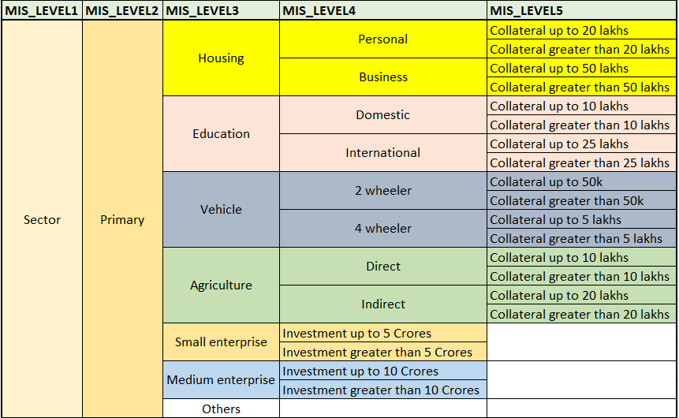

From the above screenshot,

* we can derive that **MIS_Level4** classifications that are pertaining to **Sector🡪Primary🡪Housing** is limited to the activities related to Housing category only.
* Similarly, **MIS_Level4** classifications that are pertaining to **Sector🡪Primary🡪Vehicle/Agriculture/Small Enterprise/Medium Enterprise/Other** are limited to the activities pertaining to related categories only

This approach would definitely fulfil the proper classifying the accounts opened for a particular purpose to fall in the same category, thereby avoiding misclassification of loan accounts.

We have designed an initial prototype UI based on our user interviews:

**Proposed MIS Capturing Screen:**

1. The MIS classification Home Page has 3 main options to deal with MIS records as shown below. We can add, remove or Modify it.

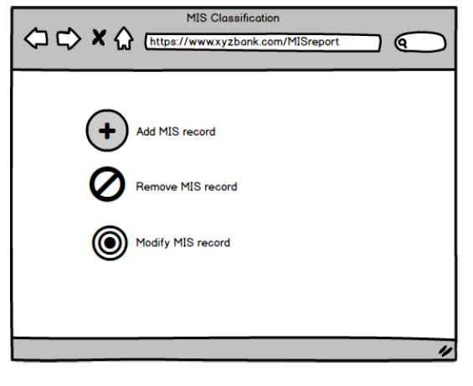

1. Below is the MIS record deletion page. User must enter the account number and fetch the record from the database.

There are two options **‘Remove record’** and **‘Cancel’**. After fetching the account number, clicking on **‘remove record’** will delete the account entry from the database. The **‘cancel’** option will simply navigate user back to the home page.

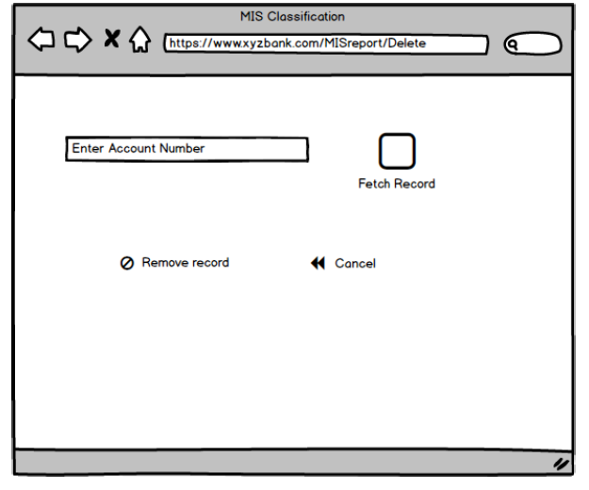

1. The existing MIS classification page of bank has five drop-down menus corresponding to the five MIS levels, however the problem in classification is taking place due to showing all the records for all the levels.

Thus, we have decided to suggest a solution in which each level, based upon the selection of option in the previous level, will fetch and display only the corresponding records to simplify the classification of records at each MIS level. User also advised us in the preliminary discussions to represent the ‘Structure-Tree’ against the drop-down menu corresponding to each of the five MIS levels.

**Example 1:**

We have demonstrated the structure in our solution as shown below. The below page shows how user will be able to navigate and select the MIS classifications for the MIS Level 1 – Sector. On selecting the first level as Sector from drop-down, there are two options in MIS Level 2 as Priority and Non-priority. The MIS level 3 shows following records for Sector and Priority selections in previous levels: Housing, Education, Vehicle, Agriculture, Small Enterprise, Medium Enterprise and others. On selecting the Education, MIS Level 4 shows 2 options as Domestic and International. MIS Level 5 has been classified as ‘<25 lakhs’. User can select an option based on the purpose of the loan availed by the customer.

The MIS sequence here can be shortly viewed as shown under:

**Sector 🡪 Priority 🡪 Education 🡪 Domestic 🡪 <25 lakhs**

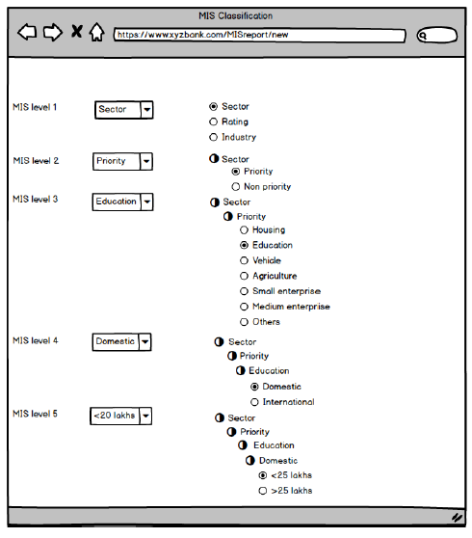

**Example 2:** Another example for demonstrating the application is shown under:

The MIS sequence chosen to demonstrate this as shown under:

**Sector 🡪 Priority 🡪 Agriculture 🡪 Direct 🡪 <10 lakhs**

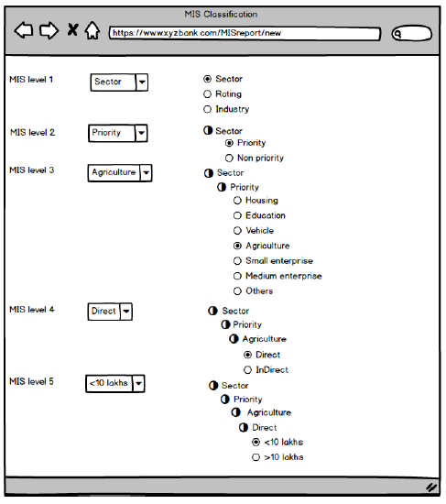

**Example 3:**

The MIS sequence chosen to demonstrate this as shown under:

**Industry 🡪 Services 🡪 Commerce 🡪 Wholesale 🡪 Recorded Video Tapes**

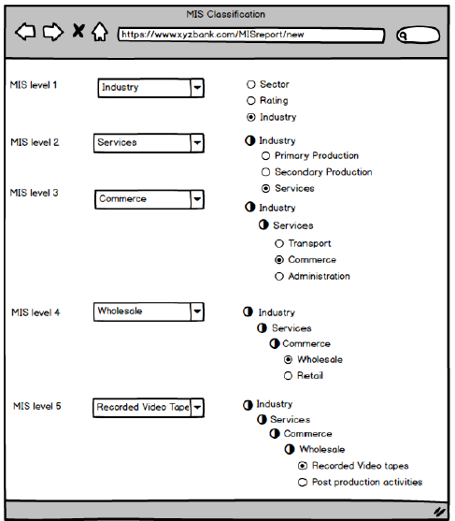

**Example 4:**

The MIS sequence chosen to demonstrate this as shown under:

**Rating 🡪 External 🡪 Fitch India 🡪 1**

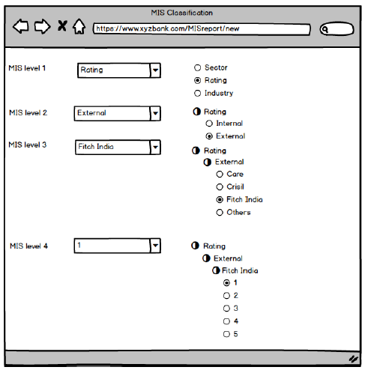

**Part 2:**

Observations from **User 1 (Senior Manager, IT, Risk Management Department):**

**Length of time:** 30 mins

**Problem we studied:**

User 1 consistently expressed the inability of utilizing the data that has been captured by the end-user in the MIS Classification screen due to redundant values populating at various levels.

We have proposed a plan which has the capabilities of validating the MIS classifications based on the purpose of the account and presented our sample screenshot containing the details of classifications and initial prototype.

**Comments from the User:**

The user commented that the proposed logic is the one which they have taken up with the vendor at application level. He expressed interest to know how this can be implemented without the application level changes. We have informed him that this solution can be attained my minor tweaking the current database tables and the same has been shared to DB experts for their reviews.

Observations from **User 2 (IT Expert):**

**Length of time:** 15 mins

**Problem we studied:**

User 2 explained us about the application behaviour in populating the MIS fields in the current infrastructure. We understood the complications in it and designed the proposed solution.

**Comments from the User:**

The user commented that the proposed logic would help in confining the end user to select the appropriate MIS classifications only. But, he commented that the UI prototype is so basic and it did not show him the login screen, branch name, branch code details.

Observations from **User 3 (DB Expert):**

**Length of time:** 45 mins

**Problem we studied:**

User 3 explained us about the database design. We have been introduced to 4 tables via whiteboard session in webinar. We have studied its implications with front end application and observed an issue with Parent Child master code definitions. This table is primarily responsible for showing the MIS classifications at various levels in MIS Capturing Screen. We proposed an idea of preparing all together a new set of codes that would enable restriction of MIS classifications at 5 various levels as per the definitions of product code. We are currently documenting our idea and will be presented to the user during the following week.

**Comments from the User:**

The user expressed interest in receiving the proposed database level changes for review.

Observations from **User 4 (End User):**

**Length of time:** 20 mins

**Problem we studied:**

User 4 explained us the limitations of them with respect to MIS Classifications pertaining to newly introduced product code from the previous meetings. The proposed plan will enable the application to drive even a novice to select the appropriate MIS classifications, since there will not be any redundant MIS classifications that appears in the application.

**Comments from the User:**

The users commented that the proposed plan would look good if they can view the tree structure of the MIS Classifications selected by them. This would enable them to gain confidence over application.