**ISM 6155 – Enterprise Information Systems Capstone: Deliverable 4**

**Summer 2017**

**University of South Florida, Tampa, FL**

**Submitted by Team 2.6:**

Sandeep Kumar Sankepalli

Ramadas Pulapaka

Saketh Kota

Gaurav Kulkarni

**Part 1:**

**Feedback from User 1 (Senior Manager IT, Risk Management Department):**

The design looks good and much better and simple than the previous alpha version. However, we would like to know the plans to implement this? What changes would you be proposing for this application design?

**Feedback from User 2 (IT Expert):**

The UI shown to us this time is far better than the alpha version.

**Feedback from User 3 (DB Expert):**

The proposed database level modifications appear to be doable. But, I would like to present this idea to our peers in analyzing the implementation.

**Feedback from User 4 (End User):**

The UI shared to us looks good now.

We presented the Alpha version of solution to users, took their feedback and worked on their suggestion to deliver Beta version of our solution with better functionality and user interface.

1. User suggested us to add ‘Sign-in’ page in our solution since it exists in the current module of MIS classification of CBS at bank. This page enforces security constraints and both these fields are case sensitive. User can sign-in with correct credentials or click ‘Forgot Password’ button to receive an email to reset password.

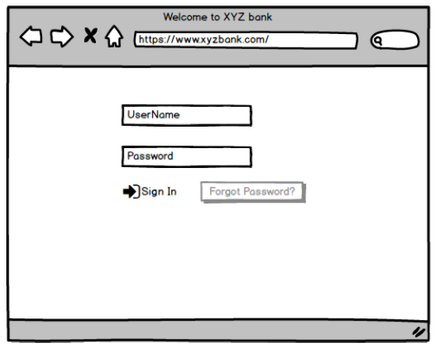

1. The MIS classification Home Page has 3 main options to deal with MIS records as shown below. First, user will need to enter and fetch the Account Number. Then user can add, remove or Modify the MIS record. Once user enters and fetches the account number, these options will be enabled since they are currently kept greyed out.

We added the function to let user sign-out from the current page.

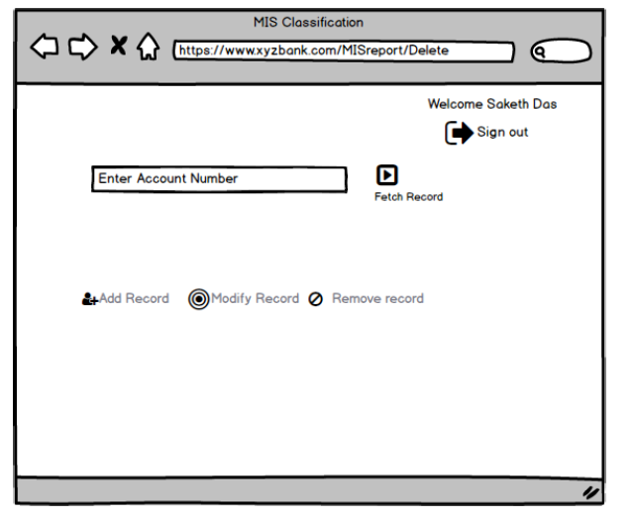

1. Once the Account Number is entered correctly and fetched from the database, the associated Branch Name and Branch Code is populated on the screen of MIS Classification. This screen has all the MIS levels with their drop-down lists and associated categories. Per your suggestion, we added a functionality - ‘Navigate to Reports Section’.

Also, we added three new buttons as ‘Save Changes’, ‘Cancel’ and ‘Authorize Record’. User can save the changes at any point of time applied that he has selected at least MIS level 1. User will also be able to Cancel the classification at any point of time to navigate back to the Home Page. Authorize record is a special functionality which will be enabled only for the Branch Manager who will need to approve the classification activity performed by the user.

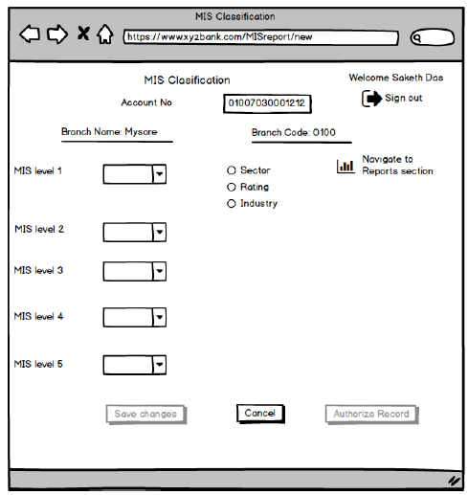

1. We have provided the solution on classification very thoroughly in Beta version. We tried to be as detailed as possible by providing separate screens of MIS level options available and their selections as shown below.

**Example 1:**

The page below shows how user will be able to navigate and select the MIS level records for the

MIS selection as shown under:

**Sector🡪 Priority🡪 Education 🡪 Domestic 🡪 <25 Lakhs**

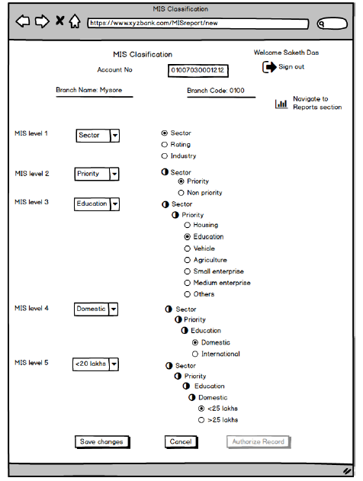

**Example 2:**

The page below shows how user will be able to navigate and select the MIS level records for the

MIS selection as shown under:

**Industry🡪 Services🡪 Commerce🡪 Wholesale🡪 Recorded Video Tapes**

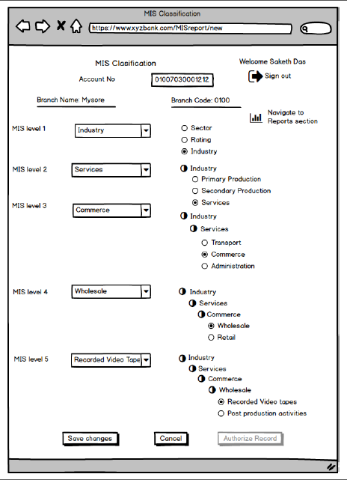

**Example 3:**

The page below shows how user will be able to navigate and select the MIS level records for the

MIS selection as shown under:

**Rating 🡪 External 🡪 Fitch India 🡪 1**

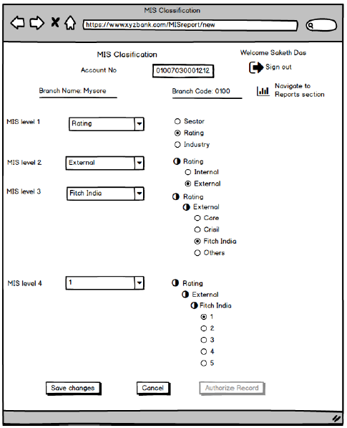

1. Below is the MIS Report screen as advised by users. User can anytime be able to navigate to this page applied that the account number is fetched. Below are the three types of reports can be generated by user:
2. Risk Based Supervision Report
3. Priority Sector Advances Report
4. Sector wise - Industry Wise Advances Reports.

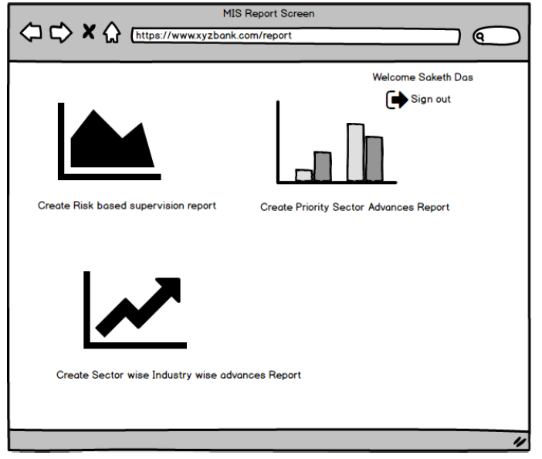

1. Below page displays the report generation options. User will be asked to Select Report Level and Select Report Frequency. Clicking Generate Report will display the requested report. User can hit Cancel to navigate back to the Report Screen.

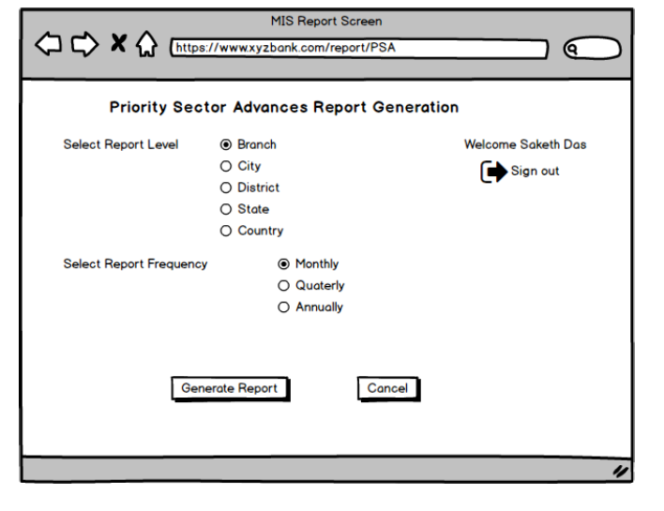

**Part 2:**

As per the discussions we had initially with one of the users, we were informed that there is only one master table catering to the requirements of MIS screen in Core Banking Solution. Later, when we had conversed with other IT experts, we were informed that there are 4 tables involved in the current design.

1. Master Table:

Master table containing MIS Level, MIS Codes and MIS Description.

For Instance:

|  |  |  |  |
| --- | --- | --- | --- |
| Sl. No. | MIS_LEVEL | MIS_CODE | MIS_CODE_DESC |
| 1 | 1 | 101 | Sector |
| 2 | 1 | 102 | Industry |
| 3 | 1 | 103 | Rating |
| 4 | 2 | 101001 | Priority |
| 5 | 2 | 101002 | Non-Priority |
| 6 | 2 | 102001 | Primary Production |
| 7 | 2 | 102002 | Secondary Production |
| 8 | 2 | 102003 | Service |
| 9 | 3 | 101001001 | Housing |
| 10 | 3 | 101001002 | Education |
| 11 | 3 | 101001003 | Vehicle |
| 12 | 4 | 101001001003 | Domestic |
| 13 | 4 | 101001001004 | International |
| 14 | 4 | 101001001001 | Personal |
| 15 | 4 | 101001001002 | Business |
| 16 | 5 | 101001001001001 | Collateral up to 20 Lakhs |
| 17 | 5 | 101001001001002 | Collateral greater than 20 Lakhs |
| 18 | 5 | 101001001001005 | Collateral up to 10 Lakhs |
| 19 | 5 | 101001001001007 | Collateral up to 5 Lakhs |
| 20 | 5 | 101001001001008 | Collateral greater than 50K |

1. MIS Codes linking table containing the hierarchies of MIS codes level wise

This table contains the details of hierarchies of MIS Codes level wise. This defines parent-child MIS Codes at various levels.

For instance:

|  |  |  |  |
| --- | --- | --- | --- |
| Sl. No. | MIS_LEVEL | MIS_PARENT_CODE | MIS_CHILD_CODE |
| 1 | 1 | 101 | 101001 |
| 2 | 1 | 101 | 101002 |
| 3 | 1 | 102 | 102001 |
| 4 | 2 | 101001 | 101001001 |
| 5 | 2 | 101001 | 101001002 |
| 6 | 2 | 101001 | 101001003 |
| 7 | 2 | 101001 | 101001004 |
| 8 | 3 | 101001001 | 101001001001 |
| 9 | 3 | 101001001 | 101001001002 |
| 10 | 3 | 101001001 | 101001001003 |
| 11 | 3 | 101001001 | 101001001004 |
| 12 | 3 | 102001001 | 102001001001 |
| 13 | 4 | 102001001001 | 102001001001001 |
| 14 | 4 | 101001001001 | 101001001001001 |
| 15 | 4 | 101001001001 | 101001001001002 |
| 16 | 4 | 101001001001 | 101001001001003 |
| 17 | 4 | 101001001001 | 101001001001004 |
| 18 | 4 | 101001001001 | 101001001001005 |
| 19 | 4 | 101001001001 | 101001001001006 |
| 20 | 4 | 101001001001 | 101001001001007 |

1. Product code and MIS codes Cross reference table.

This table defines what MIS Parent codes are attached to Product Codes.

For Instance:

|  |  |  |
| --- | --- | --- |
| Sl. No. | PROD_CODE | MIS_CODE_1 |
| 1 | 701 | 101 |
| 2 | 701 | 102 |
| 3 | 701 | 103 |
| 4 | 702 | 101 |
| 5 | 702 | 102 |
| 6 | 702 | 103 |

Where product codes shown above are the facilities enjoyed by the customers. In this case, “701” product code refers to “Housing Loan” and “702” refers “Education Loan”

1. MIS Account Cross reference table

This table contains the details of all the mis details that are entered by the branch users in the MIS Screen of Core Banking Solution.

For instance:

|  |  |  |  |  |  |  |  |
| --- | --- | --- | --- | --- | --- | --- | --- |
| Sl. No | ACCT_NO | MIS_LEVEL1 | MIS_LEVEL2 | MIS_LEVEL3 | MIS_LEVEL4 | MIS_LEVEL5 | DATE_TIME |
| 1 | 01007030001212 | 101 | 101001 | 101001003 | 101001003001 |  |  |
| 2 | 01007020001325 | 103 | 103001 | 103001003 |  |  |  |

Here the MIS details of the account “01007030001212” is

101🡪101001🡪 101001003 🡪 101001003001

This Implies:

Sector 🡪 Priority 🡪 Vehicle 🡪 2-Wheeler

Where 703 refers to “Vehicle Loan” facility

**How does the system and data base work-**

1. The first step in the MIS screen when we are doing some classification would be to enter the account number. The account number contains the product key. The product key in the account number will be mapped to corresponding MIS codes in the table 3 and it picks the corresponding MIS codes which are associated to that product key in the table 3 and displays the description of those MIS codes from table 1 in the first screen.

In our example, the product key is 701 and the associated MIS codes for that product key are 101, 102 and 103 in table 3. So in the first screen on MIS application we can see the descriptions of these MIS codes which are maintained in the table 1 (master table)

In the example, we can see the description of 101, 102 and 103 which is sector, industry and rating. The user will see these 3 options in the MIS screen upon entering the account number.

1. Now the user selects one of the options from the 3 which are displayed in the first screen. Suppose, the user selected sector. The MIS code is 101 for sector. If we observe the table 2 now (the linking table) will have the mapping of parent to child codes. Here, once the user selects sector, the parent code is acted as 101 and all the corresponding child codes for this parent code are displayed in the screen.

In our example, once the user selected sector, the description of all the child codes (from table 1) which are mapped to the parent code (sector) in the linking table. In this case, we can see the description of 101001 and 101002 which is priority or non-priority

1. For now, we have selected the first 2 levels of MIS classification. Now we need to make a choice between priority and non-priority. Once we select priority, which is 101001, then at this point in the screen, 101001 will act as parent code and the corresponding descriptions (from table 1) of the child codes associated with the 101001 in the linking table (table 2) will be the options for the user to select at level 3.
2. Now this process goes on for level 4 and level 5. Table one is the master table, it contains the descriptions of all the MIS codes possible. The linking tables has all the possible mappings of the parent code and child code. For example, here MIS level 1 has a 3 digit code, MIS level 2 has a 6 digit code, Level 3 has 9 digit code etc. 3 digit level 1 code is the parent code at level 1 and the corresponding 6 digit codes mapped to the 3 digit code is the child codes and options available at level 2 and so on.
3. ***We see that the problem is with the linking table.*** This has the parent child mappings made for all the possible values of parent mapped to child, and all the MIS codes have the description in the first table, so we can see all the values at a corresponding level in the screen. For example, if you see table 2, the parent code at level 3 is 101001001 has child codes 101001001001, 10100100001002, 101001001003, 101001001001004 for level 4. Which means we are displaying personal, business, domestic and international when we have housing in level three. Ideally we need to display only personal and business for housing. This happens across level 2, level 3, level 4 and level 5 creating a lot of confusion and displays redundant values when displayed in the front end. ***So we need to fix this linking table.***

**What we learnt from the Database** -

Let us take two scenarios as an example for defining this:

**1)** Branch user selected a housing loan (product code: 701) for classifying MIS in CBS application, let that account number be 01007010001234 (here first 4 digits defines Branch Code, 5th to 7th digit defines Product Code and 8th to 14th digits defines account number), the steps performed by the user are as shown under:

**a.**       Select add option and enter account number in MIS Classification screen

**b.**       Select Sector in first level of MIS (the MIS code for sector in backend is 101)

**c.**      Select Priority in second level of MIS (the MIS code for Priority in backend is 101001)

**d.**      Here the user is provided with options to select any one field from Education/Housing/Vehicle/Agriculture/Small Enterprise/Medium Enterprise/Others (the MIS codes for these are 101001001,101001002,101001003,101001004,101001005,101001006,101001007)

Here the product code is 701 which is corresponding to housing loan at level 3. Ideally, after entering this account number, I should be viewing only the details of Housing Loan and the corresponding MIS details of Housing Loans at Level 4 and Level 5.

**2)**      Branch user selected an education loan for classifying MIS in CBS application, let that account number be01007020004321, the steps performed by the user are as shown under:

**a.**       Select add option and enter account number in MIS Classification screen

**b.**Select Sector in first level of MIS (the MIS code for sector in backend is 101)

**c.**Select Priority in second level of MIS (the MIS code for Priority in backend is 101001)

**d.**       Here the user is provided with options to select any one field from Education/Housing/Vehicle/Agriculture/Small Enterprise/Medium Enterprise/Others (the mis codes for these are 101001001,101001002,101001003,101001004,101001005,101001006,101001007)

Here the product code is 702 which is corresponding to education loan at level 3. Ideally, after entering this account number, I should be viewing only the details of Education Loan and the corresponding MIS details of Education Loans at Level 4 and Level 5.

**Root Cause Analysis:**

From the above two scenarios, it is clearly evident that for both Education and Housing Loan operation flow of selecting MIS classifications is same and user is provided an option to select any one of the option at 3rd level. Understanding the database, we also noticed that this problem is existing at 4th and 5th levels as we have the respected entries in the database.

Looks like, there is some issue with the linking table and its purpose is not being appropriately met.

Let us take the above example in understanding the linking table relevance with the front end application:

**a.**       Ideally, the user has should be in a position to select MIS details directly (application should drive the user) as shown under:

Sector (101) à Priority (101001) à Housing (101001001)

The corresponding details in linking table would be as shown under:

|  |  |  |
| --- | --- | --- |
| MIS_LEVEL | MIS_PARENT_CODE | MIS_CHILD_CODE |
| 1 | 101 | 101001 |
| 2 | 101001 | 101001001 |

**b.**      Whereas the current linking table (in this scenario) shows all MIS Classifications (3rd level, MIS_CHILD_CODE) which is resulting the application to show redundant (with respect to Housing Loans)MIS Classifications.

|  |  |  |
| --- | --- | --- |
| MIS_LEVEL | MIS_PARENT_CODE | MIS_CHILD_CODE |
| 1 | 101 | 101001 |
| 2 | 101001 | 101001001 |
| 2 | 101001 | 101001002 |
| 2 | 101001 | 101001003 |
| 2 | 101001 | 101001004 |
| 2 | 101001 | 101001005 |
| 2 | 101001 | 101001006 |
| 2 | 101001 | 101001007 |

**Probable Issue:** If the user selects Agriculture for housing loan in 1st point and Vehicle for education loan in 2nd point, then the classifications will go wrong.

**Takeaway:** We feel that here is where application must work properly, the application here is not working as intended and it is not solving the business problem.

**Future Scope:** We are going to work with IT experts in the bank this week whether we can do something with backend tables that is enabling the application to populate the fields in front end.

**How to source the data:**

**Table No. 1 🡪** The master table can be updated by database administrators in the bank. The newly introduced categorizations as per RBI guidelines will be added to this table by receiving the request from the Functional Users (Person responsible for Regulatory Compliance) in the bank backed up with RBI Circular.

**Table No. 2 🡪** The MIS linking table will be updated as and when the new codes have been created in the master table (Table No. 1) by database administrators in the bank. The reference for creating these codes are based on the RBI circular backed up by the Functional Users.

**Table No. 3 🡪** Whenever RBI introduces new classifications, a new parent code will be added and attached to all the relevant loan product codes. Database administrators would be performing this task.

**Table No. 4 🡪** Whenever user captures MIS details in the MIS Screen of Core Banking Solution, an entry will be posted to this table. This is replica of user activity in MIS Screen of CBS application.

**Plan to maintain the data:**

The data that is in all the above tables are incremental in nature. The backup of these tables should be available with (t-1) business date.

**Updation of the data:**

Updation of Tables 1,2,3 will be done by database administrators as and when the revised classifications were introduced by the regulator.

The captured details in MIS Screen of Core Banking Solution will be reflected in Table No. 4

**Database Design:**

The database Design is shown under for reference:

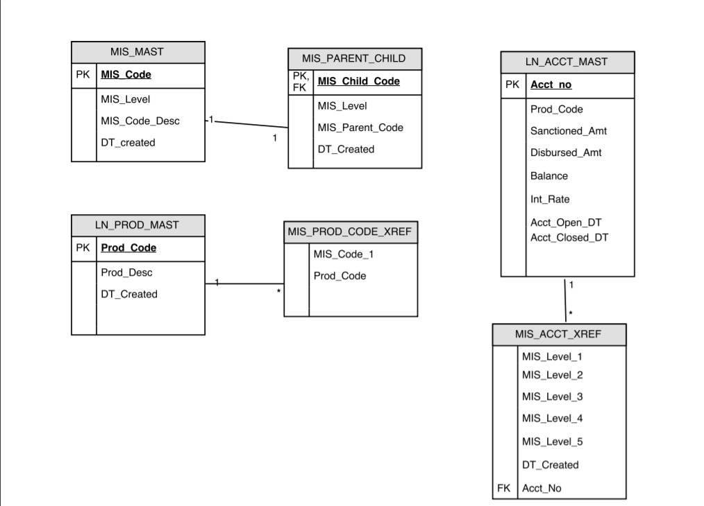

**1)**      **MIS_MAST**

**Table Purpose:**This table is the master table containing the details of MIS Levels, MIS Codes along with the MIS Code Descriptions

**Table Fields Purpose:**

**a)**      MIS_Level:

This field shows the MIS level to which MIS Code belongs to

**b)**      MIS_Code:

This field shows MIS Code defined for the MIS Classification

**c)**       MIS_CODE_Desc:

This field shows the description of MIS Classification

**d)**      DT_Created:

Date of Creation

**2)**      MIS_PARENT_CHILD

**Table Purpose:**This table contains the details of Parent-child relation of MIS Codes at different levels

**Table Fields Purpose:**

**a)**      MIS_Level:

This field shows the MIS level to which MIS Code belongs to

**b)**      MIS_parent_Code:

This field shows MIS Code for the level

**c)**       MIS_child_CODE:

This field shows the sub level MIS Classification of mis parent code

**d)**      DT_Created:

Date of Creation

**3)**      LN_ACCT_MAST

**Table Purpose:**This table contains the details of loan accounts

**Table Fields Purpose:**

**a)**      Acct_no:

This field shows the account number

**b)**      prod_Code:

This field shows the product code of account number

**c)**       Sanction_amount:

This field shows the sanctioned amount to the loan account

**d)**      Disbursed_amount:

This field shows the disbursed amount to the loan

**e)**      Balance:

This field shows the balance of the account as on day

**f)**        Int_rate:

This field shows the interest rate of the account

**g)**      Acct_open_dt:

This field shows the date of opening account

**h)**      Acct_close_dt:

this field shows the date of closure of account

**4)**      MIS_ACCT_XREF

**Table Purpose:**This table contains the MIS details of loan accounts

**Table Fields Purpose:**

a)       MIS_LEVEL1:

This field shows the mis code level 1 of account number

b)      MIS_LEVEL2

This field shows the mis code level 2 of account number

c)       MIS_LEVEL3:

This field shows the mis code level 3 of account number

d)      MIS_LEVEL4:

This field shows the mis code level 4 of account number

e)      MIS_LEVEL5:

This field shows the mis code level 5 of account number

f)        DT_Created:

This field shows the date of creation of record

g)       Acct_no:

This field shows the account number

**5)**      MIS_PROD_CODE_XREF

**Table Purpose:**This table defines the linking of product code with MIS level 1 classification

**Table Fields Purpose:**

1. MIS_Code_1 : - This field defines the MIS classification at level 1
2. Prod_code – This field defines the product code of the loan amount.
3. LN_PROD_MAST

**Table Purpose:**This table defines the product code and its description

**Table Fields Purpose:**

1. Prod_code – This field defines the product code
2. Prod_Desc – This field defnies the desctiption of the product code