**ISM 6155 – Enterprise Information Systems Capstone: Deliverable 5**

**Summer 2017**

**University of South Florida, Tampa, FL**

**Submitted by Team 2.6:**

Sandeep Kumar Sankepalli

Ramadas Pulapaka

Saketh Kota

Gaurav Kulkarni

**Part 1:**

**Feedbacks from the users:**

**User 1 (Senior Manager IT, Risk Management Department):**

**Problem we studied:**

User 1 consistently expressed the inability of utilizing the data that has been captured by the end-user in the MIS Classification screen due to redundant values populating at various levels.

We have proposed a plan which has the capabilities of validating the MIS classifications based on the purpose of the account and presented our sample screenshot containing the details of classifications and initial prototype.

**Feedback:**

The user was satisfied by looking at the interface now. However, as per the previous discussion, the Senior Manger suggested that they are not in a position to make any application level changes and he was interested to know what type of database changes we need to do to achieve the validation at the application screen for selecting the categories. As per the previous conservations, we had informed him that we are in talks with the data base experts and trying to understand if the solution we suggested was appropriate or not which we have completed now.

The database solution was discussed and the senior manager was not completely happy, but he understood that this was the only way he could have done some changes in order to fix the issue. He was concerned that we might need to update the database regularly, but there was no other option left. Also, this operation can be done by the internal IT team, so whenever there is a new field from the reserve bank of India, the bank can have the internal IT team members to add the new records to the table.

The details of the database changes along with the process changes, which we proposed is discussed after this feedback on the beta version.

**User 2 (IT Expert):**

**Problem we studied:**

User 2 explained us about the application behavior in populating the MIS fields in the current infrastructure. We understood the complications in it and designed the proposed solution.

**Feedback:**

The user is now happy at looking at the interface. Previously, he was concerned that the application screen was very basic and did not include account number and branch details. With the latest modifications to the look and feel of the interface, the user was satisfied with the new interface.

**User 3 (DB Expert):**

**Problem we studied:**

User 3 explained us about the database design. We have been introduced to 4 tables via whiteboard session in webinar. We have studied its implications with front end application and observed an issue with Parent Child master code definitions. This table is primarily responsible for showing the MIS classifications at various levels in MIS Capturing Screen. We proposed an idea of preparing all together a new set of codes that would enable restriction of MIS classifications at 5 various levels as per the definitions of product code. We are currently documenting our idea and will be presenting to the user during the following week.

**Feedback:**

We have provided the user with the proposed data base changes, the user had some discussions with us and expressed his positive views about the proposed changes to the data base and the scope with the DB team for any future additions/changes. He felt that the data base changes which were proposed will help the bank overcome the problems with regards to report generations and restricts to the appropriate fields are different MIS levels.

**User 4 (End User):**

**Problem we studied:**

User 4 explained us the limitations of them with respect to MIS Classifications pertaining to newly introduced product code from the previous meetings. The proposed plan will enable the application to drive even a novice to select the appropriate MIS classifications, since there will not be any redundant MIS classifications that appears in the application.

**Feedback:**

The users previous concern was that he wanted to see a tree structure in the application user interface. We have incorporated these changes in the beta version of the UI so that user can see all the available option to select in a tree structure. Looking at this, the user expresses his satisfaction with the new UI design.

**MIS Classification Screenshots –**

1. **Before making the table changes, the column values show the MIS description and its code in the brackets –**

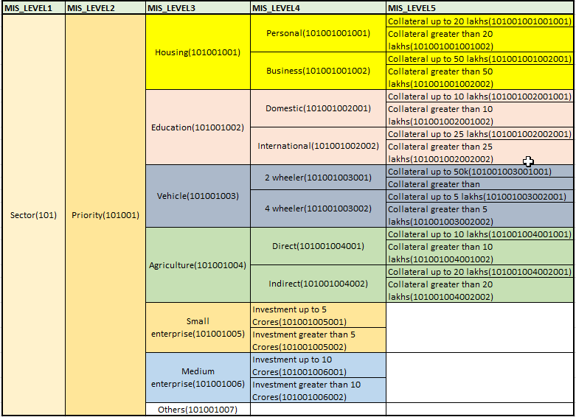

1. **After making the changes to the database, we have shown for product key’s education and housing as an example–**

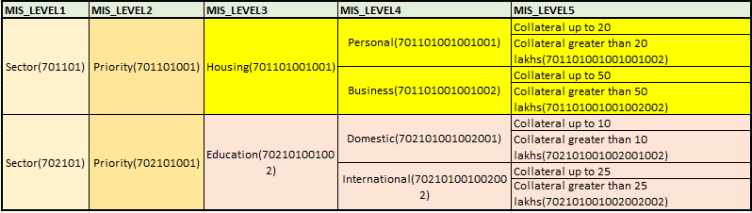

**Proposed Changes to the Database –**

*Before understanding the proposed change to the database, we would like to reiterate the current process and the procedure in which the data base is working –*

1. The first step in the MIS screen when we are doing some classification would be to enter the account number. The account number contains the product key. The product key in the account number will be mapped to corresponding MIS codes in the table 3 and it picks the corresponding MIS codes which are associated to that product key in the table 3 and displays the description of those MIS codes from table 1 in the first screen.

In our example, the product key is 701 and the associated MIS codes for that product key are 101, 102 and 103 in table 3. So, in the first screen on MIS application we can see the descriptions of these MIS codes which are maintained in the table 1 (master table)

In the example, we can see the description of 101, 102 and 103 which is sector, industry and rating. The user will see these 3 options in the MIS screen upon entering the account number.

1. Now the user selects one of the options from the 3 which are displayed in the first screen. Suppose, the user selected sector. The MIS code is 101 for sector. If we observe the table 2 now (the linking table) will have the mapping of parent to child codes. Here, once the user selects sector, the parent code is acted as 101 and all the corresponding child codes for this parent code are displayed in the screen.

In our example, once the user selected sector, the description of all the child codes (from table 1) which are mapped to the parent code (sector) in the linking table. In this case, we can see the description of 101001 and 101002 which is priority or non-priority

1. For now, we have selected the first 2 levels of MIS classification. Now we need to make a choice between priority and non-priority. Once we select priority, which is 101001, then at this point in the screen, 101001 will act as parent code and the corresponding descriptions (from table 1) of the child codes associated with the 101001 in the linking table (table 2) will be the options for the user to select at level 3.
2. Now this process goes on for level 4 and level 5. Table one is the master table, it contains the descriptions of all the MIS codes possible. The linking tables has all the possible mappings of the parent code and child code. For example, here MIS level 1 has a 3-digit code, MIS level 2 has a 6 digit code, Level 3 has 9 digit code etc. 3 digit level 1 code is the parent code at level 1 and the corresponding 6 digit codes mapped to the 3 digit code is the child codes and options available at level 2 and so on.
3. ***We see that the problem is with the linking table.*** This has the parent child mappings made for all the possible values of parent mapped to child, and all the MIS codes have the description in the first table, so we can see all the values at a corresponding level in the screen. For example, if you see table 2, the parent code at level 3 is 101001001 has child codes 101001001001, 10100100001002, 101001001003, 101001001001004 for level 4. Which means we are displaying personal, business, domestic and international when we have housing in level three. Ideally, we need to display only personal and business for housing. This happens across level 2, level 3, level 4 and level 5 creating a lot of confusion and displays redundant values when displayed in the front end. ***So, we need to fix this linking table.***

***Our Proposed Solution –***

1. As we noticed that the first step in the process of application calling the data base will start from the table 3, which has the product key to MIS code mapping. We would like to create new MIS codes for the corresponding product key, which is combination of the key and MIS code. This will be our first step. Below is the example table –

***NOTE – The cells which are highlighted in yellow are the newly added entries in the table.***

|  |  |  |
| --- | --- | --- |
| SI No. | PROD_CODE | MIS_CODE_1 |
| 1 | 701 | 101 |
| 2 | 701 | 102 |
| 3 | 701 | 103 |
| 4 | 702 | 101 |
| 5 | 702 | 102 |
| 6 | 702 | 103 |
| 7 | 701 | 701101 |
| 8 | 701 | 701102 |
| 9 | 701 | 701103 |
| 10 | 702 | 702101 |
| 11 | 702 | 702102 |
| 12 | 702 | 702103 |

1. Now we need to go to the linking table and define the appropriate parent and child code for the newly added MIS codes. Below is the example table –

***NOTE – The cells which are highlighted in yellow are the newly added entries in the table.***

|  |  |  |  |
| --- | --- | --- | --- |
| Sl. No. | MIS_LEVEL | MIS_PARENT_CODE | MIS_CHILD_CODE |
| 1 | 1 | 101 | 101001 |
| 2 | 1 | 101 | 101002 |
| 3 | 1 | 102 | 102001 |
| 4 | 2 | 101001 | 101001001 |
| 5 | 2 | 101001 | 101001002 |
| 6 | 2 | 101001 | 101001003 |
| 7 | 2 | 101001 | 101001004 |
| 8 | 3 | 101001001 | 101001001001 |
| 9 | 3 | 101001001 | 101001001002 |
| 10 | 3 | 101001001 | 101001002001 |
| 11 | 3 | 101001001 | 101001002002 |
| 13 | 4 | 102001001001 | 102001001001001 |
| 14 | 4 | 101001001001 | 101001001001001 |
| 15 | 4 | 101001001001 | 101001001001002 |
| 16 | 4 | 101001001001 | 101001001001003 |
| 17 | 4 | 101001001001 | 101001001001004 |
| 18 | 4 | 101001001001 | 101001001001005 |
| 19 | 4 | 101001001001 | 101001001001006 |
| 20 | 4 | 101001001001 | 101001001001007 |
| 21 | 1 | 701101 | 701101001 |
| 22 | 1 | 701101 | 701101002 |
| 23 | 2 | 701101001 | 701101001001 |
| 24 | 3 | 701101001001 | 701101001001001 |
| 25 | 3 | 701101001001 | 701101001001002 |
| 26 | 4 | 701101001001001 | 701101001001001001 |
| 27 | 4 | 701101001001001 | 701101001001001002 |
| 28 | 4 | 701101001001002 | 701101001001002001 |
| 29 | 4 | 701101001001002 | 701101001001002002 |
| 30 | 1 | 702101 | 702101001 |
| 31 | 1 | 702101 | 702101002 |
| 32 | 2 | 702101001 | 702101001001 |
| 33 | 3 | 702101001001 | 702101001001001 |
| 34 | 3 | 702101001001 | 702101001001002 |
| 35 | 4 | 702101001001001 | 702101001001001001 |
| 36 | 4 | 702101001001001 | 702101001001001002 |
| 37 | 4 | 702101001001002 | 702101001001002001 |
| 38 | 4 | 702101001001002 | 702101001001002002 |

Here we can observe that, previously the table at level 3 (101001001 - Housing) was linked to the child codes (101001001001 – Personal, 101001001102 – Business, 101001002003 – Domestic, 101001002004 - International) etc. Out of these we have redundancy in showing the values such as Domestic and International.

However, with the corrected codes, at level 3 (701101001001 – Housing) is mapped only with (701101001001001 – Personal, 701101001001002 – Business). This set of operations are done for every MIS code at every level with having the relevant values only at different levels.

1. Next would be updating the master table with the descriptions of the newly added MIS codes, as this description at the front-end screen is pulled from the master table.

***NOTE – The cells which are highlighted in yellow are the newly added entries in the table.***

|  |  |  |  |
| --- | --- | --- | --- |
| Sl. No. | MIS_LEVEL | MIS_CODE | MIS_CODE_DESC |
| 1 | 1 | 101 | Sector |
| 2 | 1 | 102 | Industry |
| 3 | 1 | 103 | Rating |
| 4 | 2 | 101001 | Priority |
| 5 | 2 | 101002 | Non-Priority |
| 6 | 2 | 102001 | Primary Production |
| 7 | 2 | 102002 | Secondary Production |
| 8 | 2 | 102003 | Service |
| 9 | 3 | 101001001 | Housing |
| 10 | 3 | 101001002 | Education |
| 11 | 3 | 101001003 | Vehicle |
| 12 | 4 | 101001002001 | Domestic |
| 13 | 4 | 101001002002 | International |
| 14 | 4 | 101001001001 | Personal |
| 15 | 4 | 101001001002 | Business |
| 16 | 5 | 101001001001001 | Collateral up to 20 Lakhs |
| 17 | 5 | 101001001001002 | Collateral greater than 20 Lakhs |
| 18 | 5 | 101001002001002 | Collateral up to 10 Lakhs |
| 19 | 5 | 101001002001001 | Collateral up to 5 Lakhs |
| 20 | 5 | 101001003001001 | Collateral greater than 50K |
| 21 | 2 | 701101001 | Priority |
| 22 | 2 | 701101002 | Non-Priority |
| 23 | 3 | 701101001001 | Housing |
| 24 | 4 | 701101001001001 | Personal |
| 25 | 4 | 701101001001002 | Business |
| 26 | 5 | 701101001001001001 | Collateral up to 20 Lakhs |
| 27 | 5 | 701101001001001002 | Collateral greater than 20 Lakhs |
| 28 | 5 | 701101001001002001 | Collateral up to 50 Lakhs |
| 29 | 5 | 701101001001002002 | Collateral greater than 50 Lakhs |
| 30 | 2 | 702101001 | Priority |
| 31 | 2 | 702101002 | Non-Priority |
| 32 | 3 | 702101001002 | Education |
| 33 | 4 | 702101001002001 | Domestic |
| 34 | 4 | 702101001002002 | International |
| 35 | 5 | 702101001002001001 | Collateral up to 10 Lakhs |
| 36 | 5 | 702101001002001002 | Collateral greater than 10 Lakhs |
| 37 | 5 | 702101001002002001 | Collateral up to 25 Lakhs |
| 38 | 5 | 702101001002002002 | Collateral greater than 25 Lakhs |

1. In table 3, now we need to unlink the previous version of mappings between the product code and MIS code so that those MIS codes are never called for that particular product code from the application in the future. So, the final table 3 looks like –

All the values in the below table are as per the latest revision of the table.

|  |  |  |
| --- | --- | --- |
| SI No. | PROD_CODE | MIS_CODE_1 |
| 1 | 701 | 701101 |
| 2 | 701 | 701102 |
| 3 | 701 | 701103 |
| 4 | 702 | 702101 |
| 5 | 702 | 702102 |
| 6 | 702 | 702103 |

**Part 2 –**

1. ***System Integration –*** In our project, there will not be any system integration issues. We have provided a solution for the existing data base architecture. We have not proposed to add any new features such as tables, applications, or new systems to their IT infrastructure. The design and system integrations will remain the same, our solution will just add few rows in each tables of their data base and remove some mappings in one table. Also, our tables are just reference tables (only referred to show the corresponding mappings and options at next MIS levels and the corresponding descriptions in the front), so the size of the table will not increase drastically, the increased levels in the table will not cause any extra cost or create any performance issues.
2. ***Business Process Changes –*** Even after implementing the suggested solution, we would still need to add new records into the database. These entries will be done as per the latest RBI rules and requirements. We have tried to define a process around this, as these changes or additions will now be performed by the bank’s internal IT team (DBAs) and the requirements of addition of the new fields will be defined by the functional users would like to formalize the process by using a ticketing tool like JIRA or Remedy for documenting and tracking changes. The access to the database must be restricted only to the DBAs. Additionally, log tracking has to be enabled for better control over database activities.
3. ***Change Management -*** We would like the user to be less dependent on the guides and understand the concept of classification by using the loan application form. As a result, we would like to provide the end users (clerks) with the detailed documentation regarding how to analyze and understand the loan application form so that the user is aware of the different MIS classifications in the MIS screen. Additionally, based on the product code we would like the users to have detailed documentation including the screenshots of the application for all the possible classifications for that product code. So, once the user has the product code from the account number, he can directly navigate to the page corresponding to that product code and understand the classification better. Also, we notice that the bank is circulating the hard copies of revised documents of instructions to all the branches after every addition/modification of MIS classification as advised by RBI. We would suggest the functional department to circulate the soft copies of instructions immediately to the branches after receiving the confirmation of implementation from DBAs.