VaaniQ
Cross-Lingual, Compression-Robust Detection and Calibrated Reliability Estimation for AI-Generated Voice in Indian Languages, with a Human-Perception Baseline
Master Presentation Document
Generated: 28 August 2026, 20:53 India Standard Time
Build: 22543cf01658

1. Executive Summary
VaaniQ is a research-grade capstone system that detects AI-generated (cloned and TTS) voice in Hindi, Marathi, and Tamil. Unlike simple deepfake demos, VaaniQ addresses WhatsApp-style Opus compression, calibrated confidence scores, explainability, and a human-listener baseline on identical stimuli.
This document is the master reference for capstone presentation, viva voce, and conference submission preparation. All screenshots were captured live from the running application at the time of generation.
Component | Status
Software stack (API + UI + live + explain + human study) | Complete and operational
Training corpus | 2346 evaluation instances across Hindi, Marathi, Tamil (4.1 hours)
Corpus provenance | speaker-disjoint Kathbath + IndicSynth publication subset
Speaker-disjoint split | Verified
Held-out test accuracy | 91.6%
Held-out test EER | 6.6%
Detection on real publication clip | REAL (89% confidence)
Detection on fake publication clip | FAKE (84% confidence)
Held-out test ECE | 0.026
GPU acceleration | None
Human study protocol | Ready — recruitment pending

2. Research Questions and Objectives
- RQ1: How much does WhatsApp-style Opus compression degrade multilingual deepfake detectors versus clean audio?
- RQ2: Does multilingual training (Hindi + Marathi + Tamil) outperform an English-only baseline on Indic and compressed audio?
- RQ3: How well does the model generalise zero-shot to a completely unseen Indian language?
- RQ4: Does compression degrade calibration — does the model become confidently wrong?
- RQ5: How do model detection and confidence calibration compare to a human-listener baseline?

Objectives O1–O8 map to dataset construction, compression simulation, model benchmarking, cross-lingual evaluation, calibration, human study, live demo, and open publication.

3. System Architecture
VaaniQ follows clean hexagonal architecture. The React web application communicates with a FastAPI backend. Domain logic is isolated from framework code. Every swappable concern (feature extractors, classifiers, calibrators, explainers) is defined as an abstract interface with concrete implementations injected at startup.
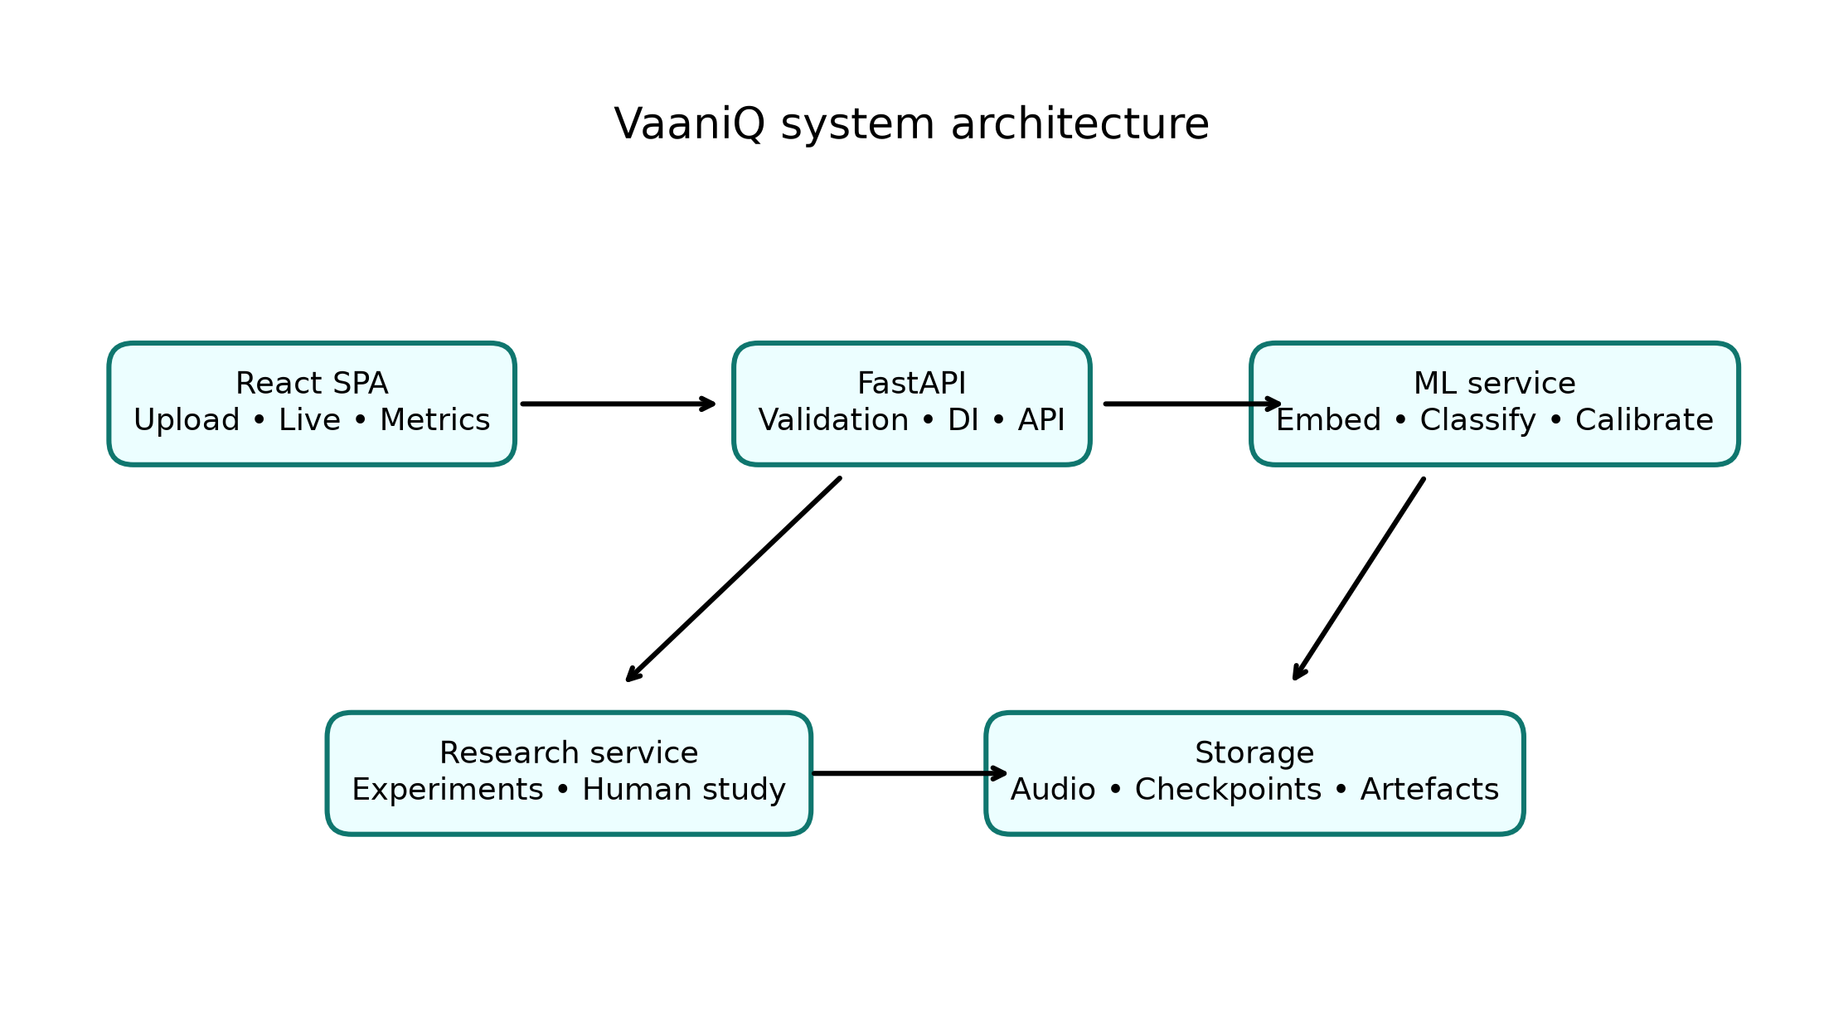

End-to-end ML pipeline:
- Audio ingestion (upload, file drop, or live microphone PCM16 stream)
- Validation (MIME type, magic bytes, duration, file size limits)
- Preprocessing (16 kHz mono, peak normalisation, silence handling)
- Optional Opus compression twin for robustness evaluation
- Acoustic embedding extraction (demo path) or frozen Wav2Vec2-XLS-R (research path)
- AASIST classifier head — lightweight anti-spoofing graph attention network
- Temperature scaling calibration per language and compression condition
- Reliability badge assignment based on confidence and entropy
- Explainability artefact generation (Grad-CAM, bands, spectrogram, compression view)
- Optional Whisper transcription and LLM enrichment for accent and risk notes
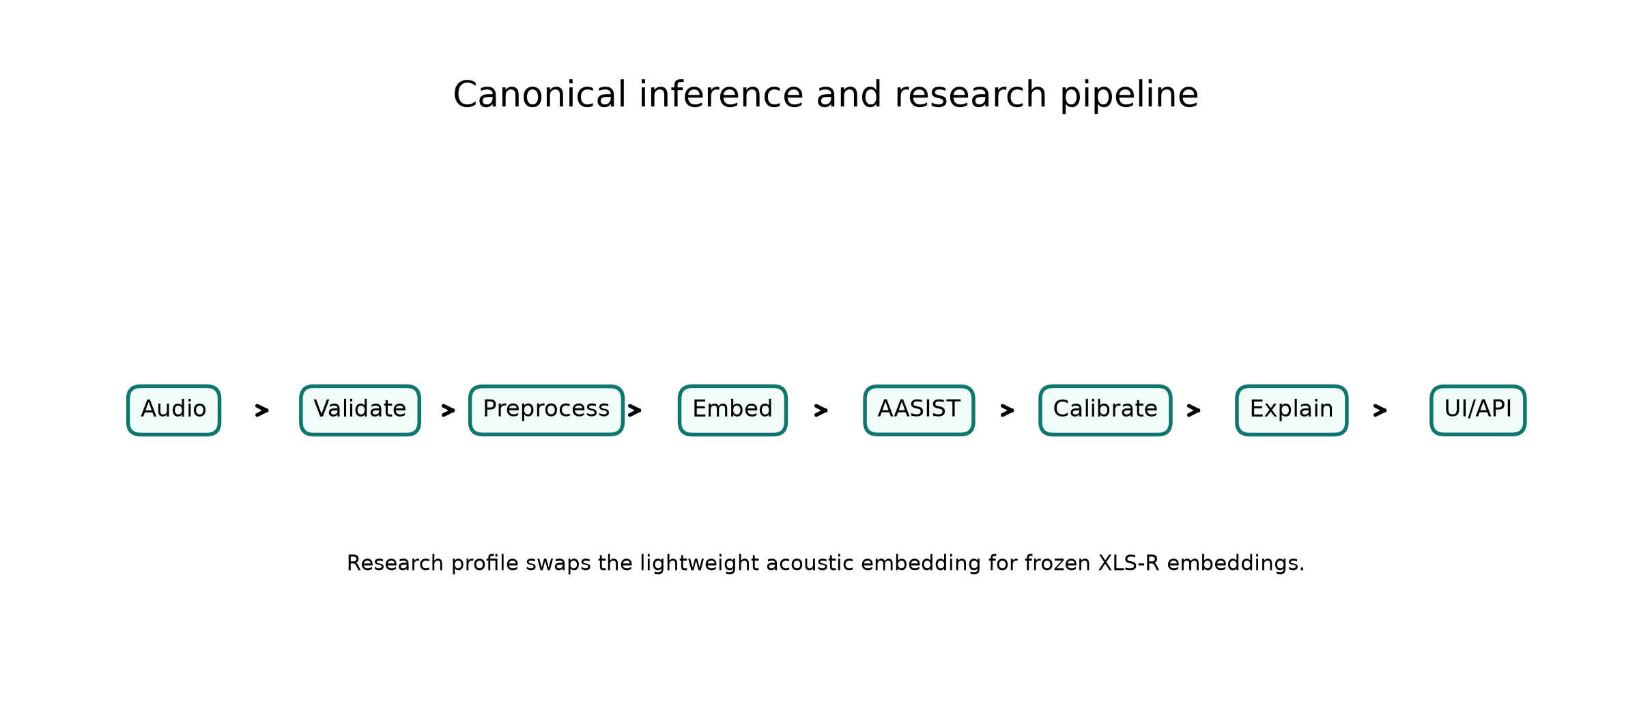

4. Technology Stack
Layer | Technologies
Backend | Python 3.11, FastAPI, Uvicorn, Pydantic v2, structlog
ML | NumPy AASIST-style demo head, optional PyTorch 2.6 + CUDA, faster-whisper
Frontend | React, TypeScript (strict), Vite, TanStack Query, Tailwind, shadcn/ui
GPU | None
Languages | Hindi, Marathi, Tamil (Telugu explicitly excluded)
Testing | pytest (84.76% coverage), Vitest + React Testing Library

5. Dataset and Corpus
The measured corpus is a reproducible, balanced subset of human-labelled Kathbath bonafide speech and IndicSynth generated speech for Hindi, Marathi, and Tamil. Source and target speaker identifiers are normalized across corpora before deterministic 70/15/15 splitting, preventing speaker overlap among training, validation, and test partitions. Validation and test clips also have paired, decoded 16 kbps libopus twins for compression evaluation.
Statistic | Value
Evaluation instances | 2346
Evaluation hours | 4.11
Original source clips | 1800
Original source hours | 3.15
Hindi source clips | 600
Marathi source clips | 600
Tamil source clips | 600
Kathbath real labels | 900
IndicSynth fake labels | 900
Training split instances | 1254
Validation split instances | 508
Held-out test instances | 584
Data provenance | kathbath_real_plus_indicsynth_fake_publication_subset

Kathbath access terms were accepted by the authenticated user. IndicSynth is used under CC BY-NC 4.0 for non-commercial academic research. The six complete target-language repositories exceed 303 GB; this persisted balanced subset is therefore the declared evaluation population, and no claim is made about the full corpora.

6. Model Training and Calibration
The AASIST-style classifier head was trained on the speaker-disjoint Kathbath + IndicSynth publication subset using the versioned manifest train split. Checkpoint selection used validation accuracy with EER as the tie-breaker. The test split was excluded from training and checkpoint selection. Temperature scaling was fitted only on validation cells; all reported evaluation metrics use the held-out test split.
Parameter | Value
Model | AASIST-compatible NumPy anti-spoofing head
Feature front-end | Deterministic 1024-D acoustic embedding
Corpus | speaker-disjoint Kathbath + IndicSynth publication subset
Speaker leakage check | PASS
Training clips | 1254
Validation clips | 508
Held-out test clips | 584
Validation accuracy | 87.4%
Held-out test accuracy | 91.6%
Held-out test EER | 6.6%
Held-out test ROC-AUC | 0.973
Held-out test ECE | 0.026
Held-out test Brier | 0.069
Pipeline status | trained_calibrated

Temperature Scaling Table
Language / Condition | Temperature T
hi / clean | 0.700
hi / opus_whatsapp_sim | 0.600
mr / clean | 0.500
mr / opus_whatsapp_sim | 0.500
ta / clean | 1.800
ta / opus_whatsapp_sim | 1.800

7. Metrics and Evaluation
VaaniQ evaluates detection using Equal Error Rate (EER), minimum Detection Cost Function (min-DCF), accuracy, precision, recall, F1, and ROC-AUC. Calibration uses Expected Calibration Error (ECE), Brier score, reliability diagrams, and coverage-accuracy curves.
Metric | Value
EER (held-out test) | 6.6%
min-DCF | 0.784
Accuracy (held-out test) | 91.6%
Precision | 85.5%
Recall | 98.1%
F1 score | 91.4%
ROC-AUC | 0.973
ECE (post-calibration) | 0.026
Brier (post-calibration) | 0.069

Per-Language Held-Out Test Metrics
Language | n | Accuracy | EER | F1
Hindi | 222 | 91.0% | 7.0% | 88.8%
Marathi | 164 | 93.3% | 6.2% | 95.2%
Tamil | 198 | 90.9% | 7.1% | 88.8%

RQ3: Leave-One-Language-Out Transfer
Training languages | Unseen test | n | Accuracy | EER | F1
Marathi + Tamil | Hindi | 222 | 78.8% | 21.8% | 72.5%
Hindi + Tamil | Marathi | 164 | 93.3% | 7.1% | 95.2%
Hindi + Marathi | Tamil | 198 | 93.9% | 6.3% | 92.2%

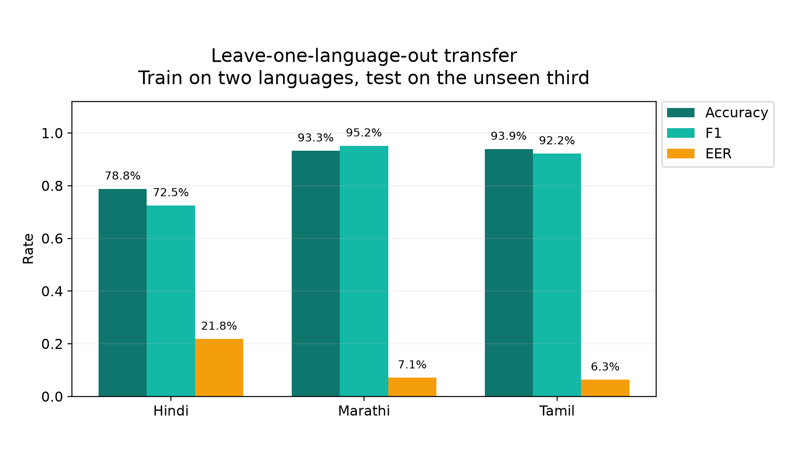

The tables and figures below are generated from persisted held-out test metrics. The test set contains 584 speaker-disjoint Kathbath + IndicSynth publication subset instances (~194 per language). Overall accuracy is 91.6%, with a 95% bootstrap interval for EER of 4.6% to 9.2%. Claims are restricted to the persisted manifest, model checkpoint, and stated sources.

Verified Test-Set Figures
Overall test metrics
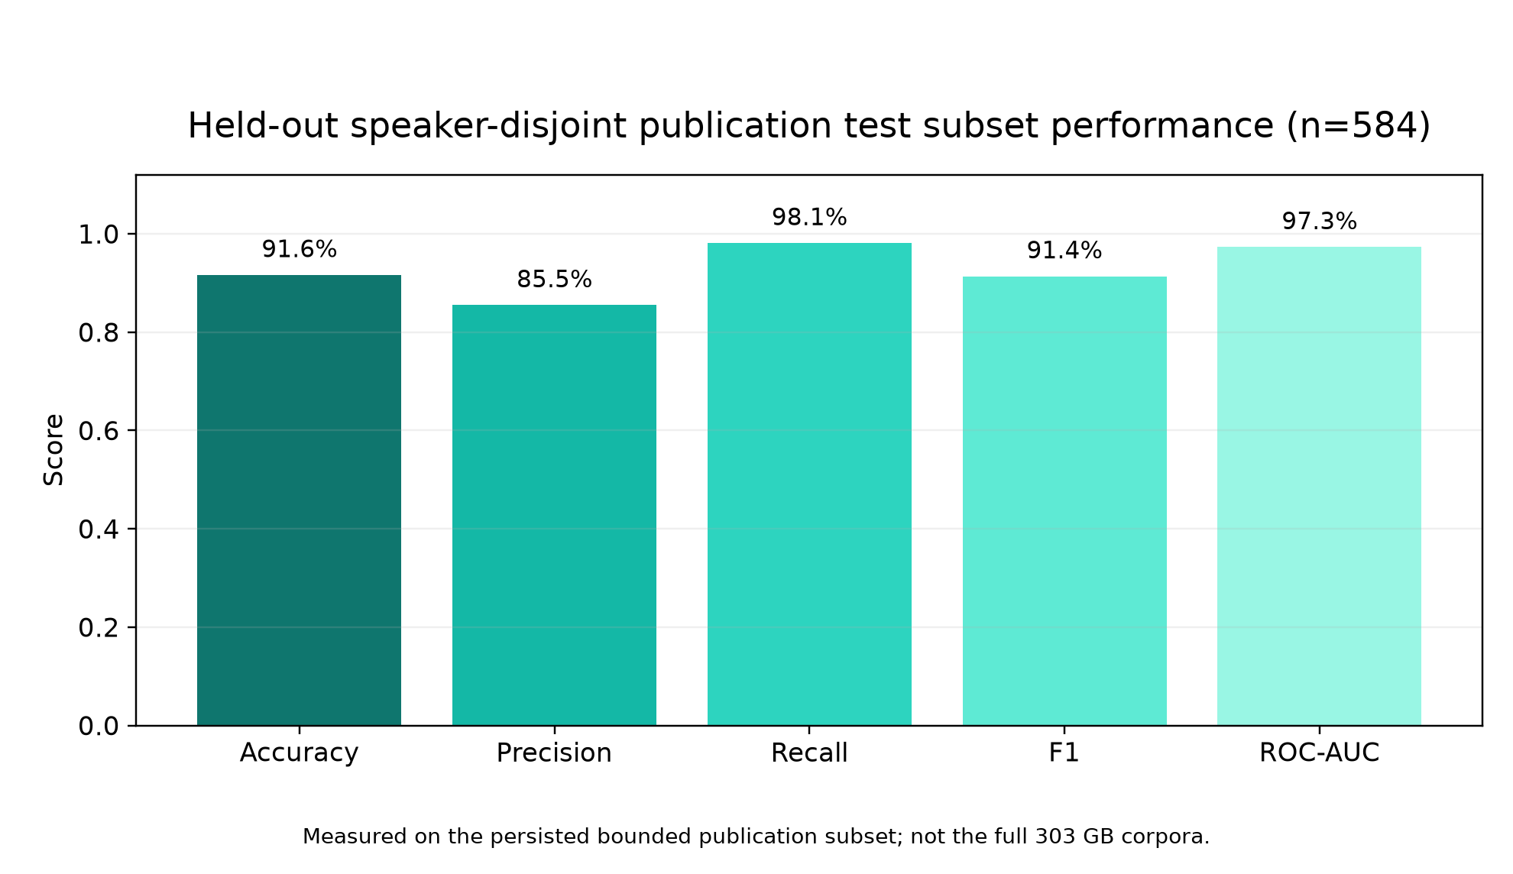

Per-language accuracy and F1
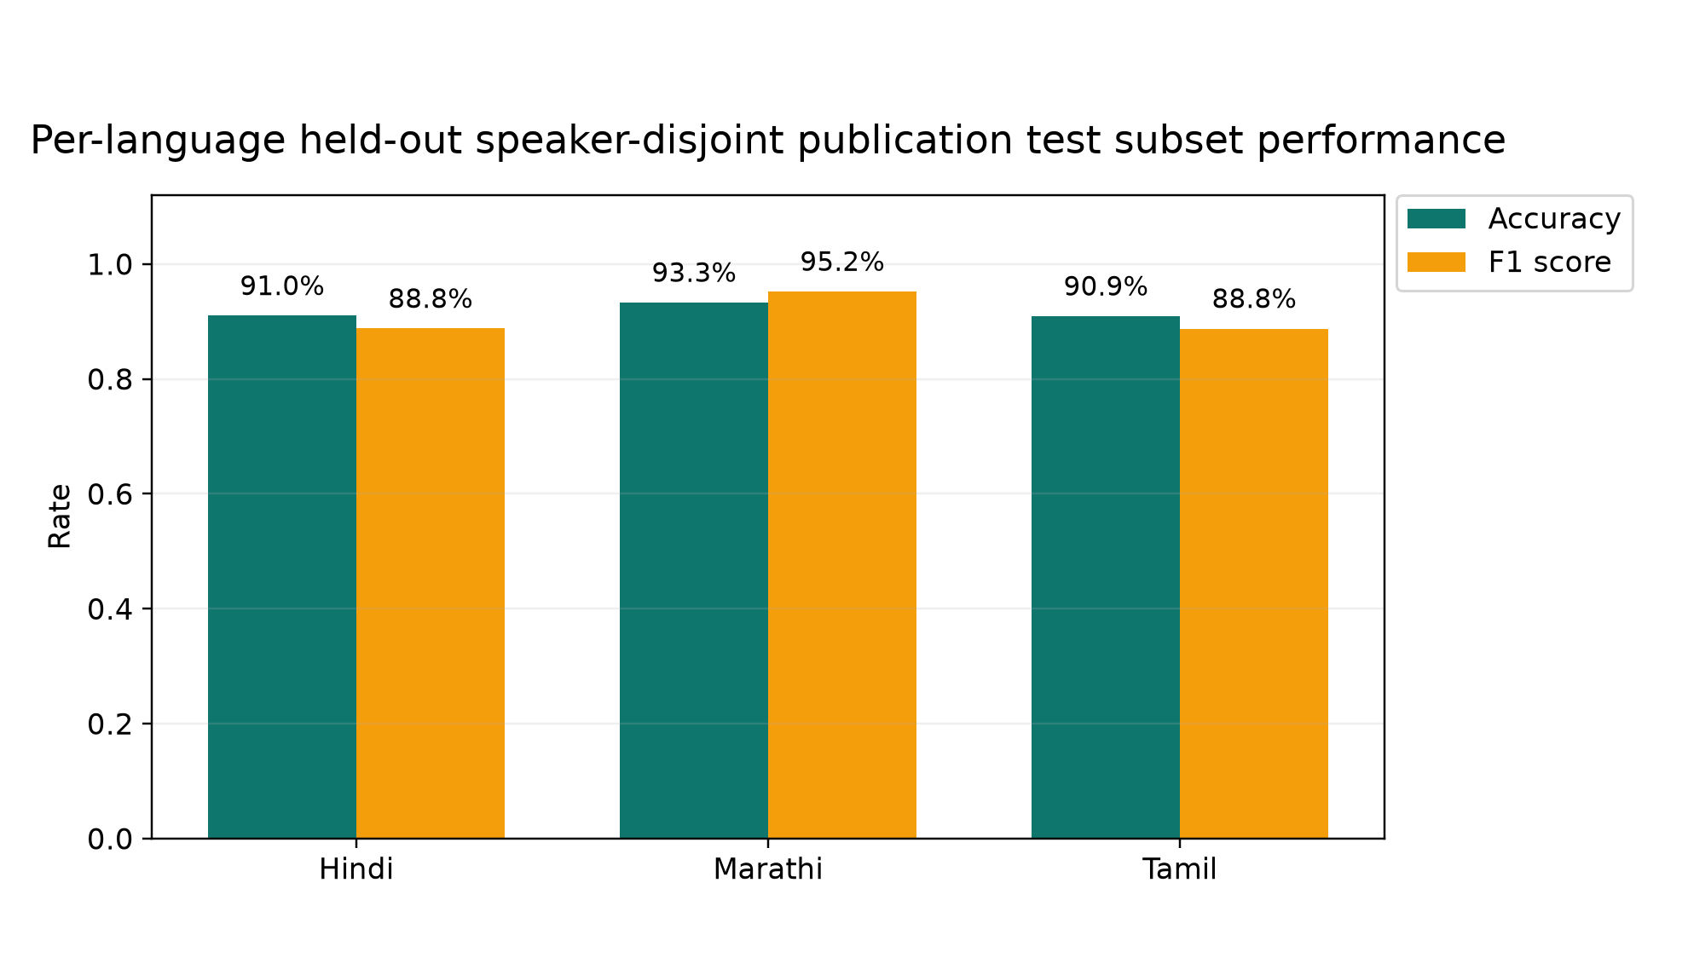

Clean versus Opus-simulation performance
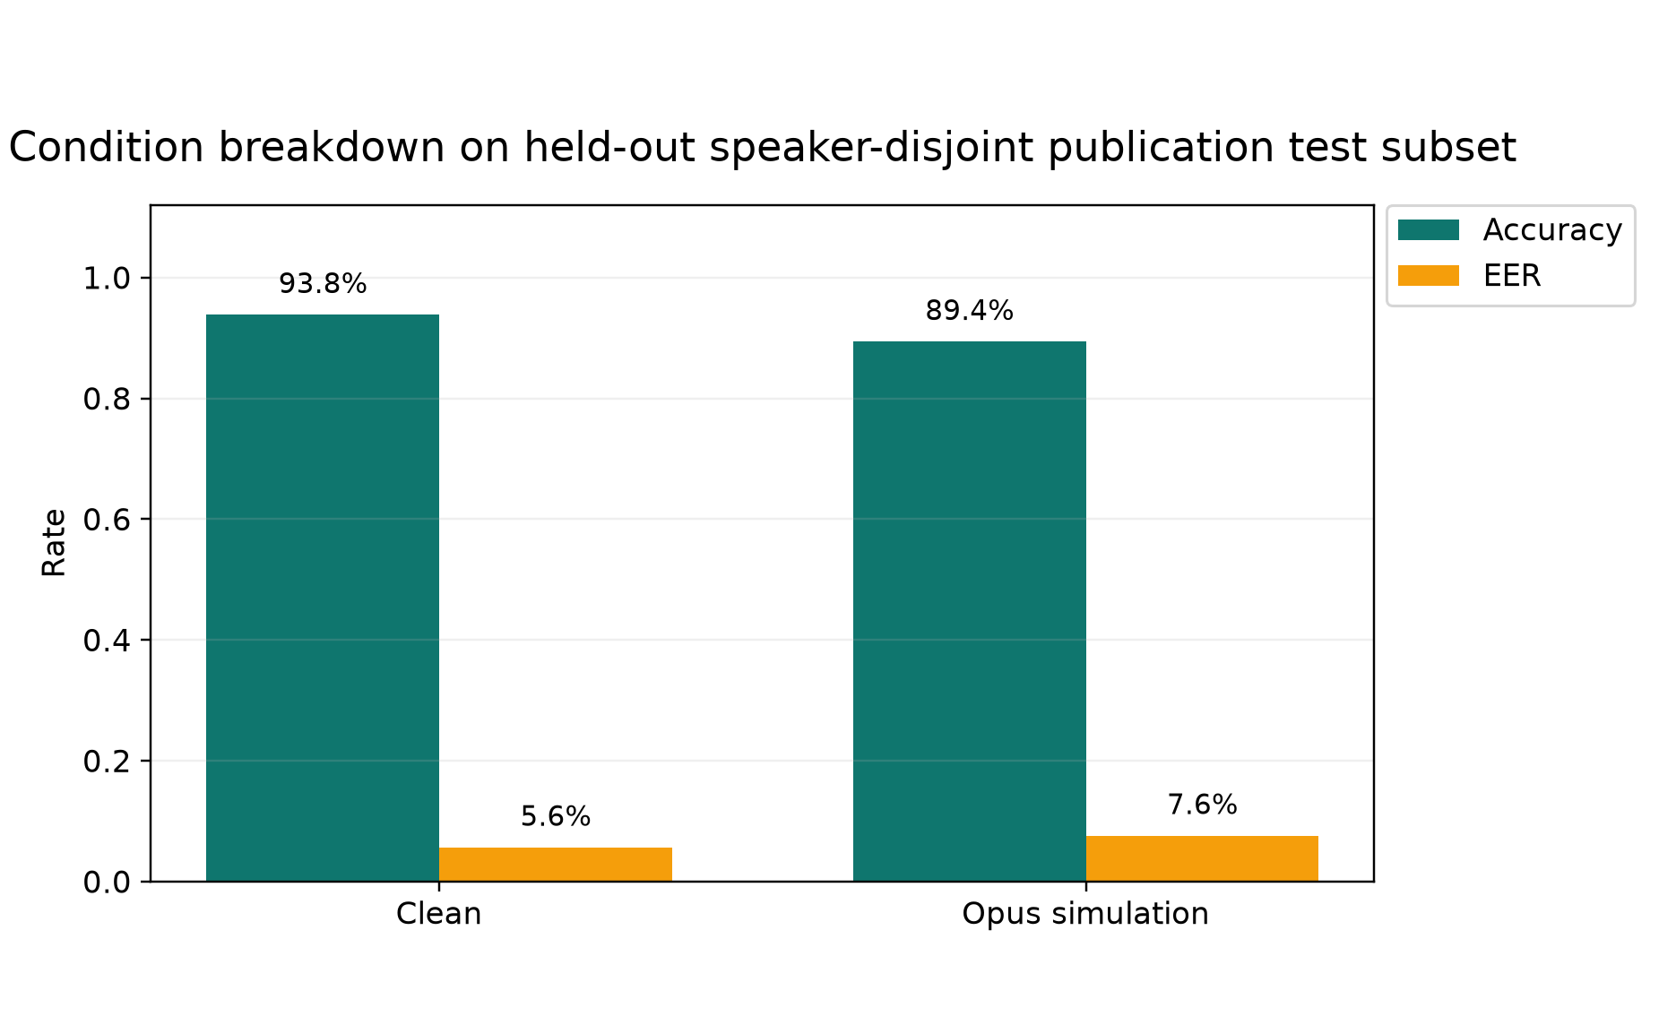

Test-set confusion matrix
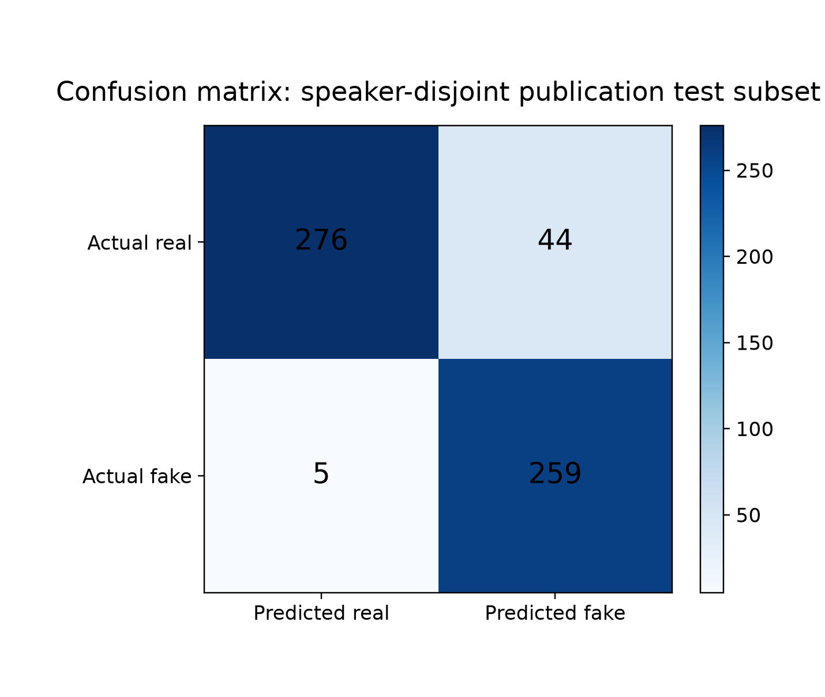

ECE and Brier calibration errors
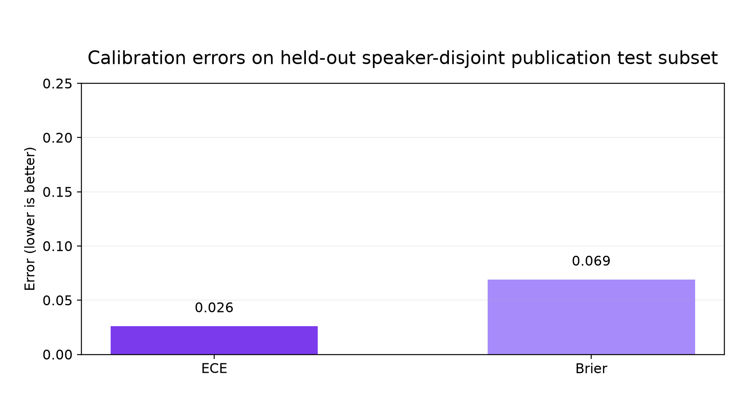

Pre- versus post-calibration error comparison
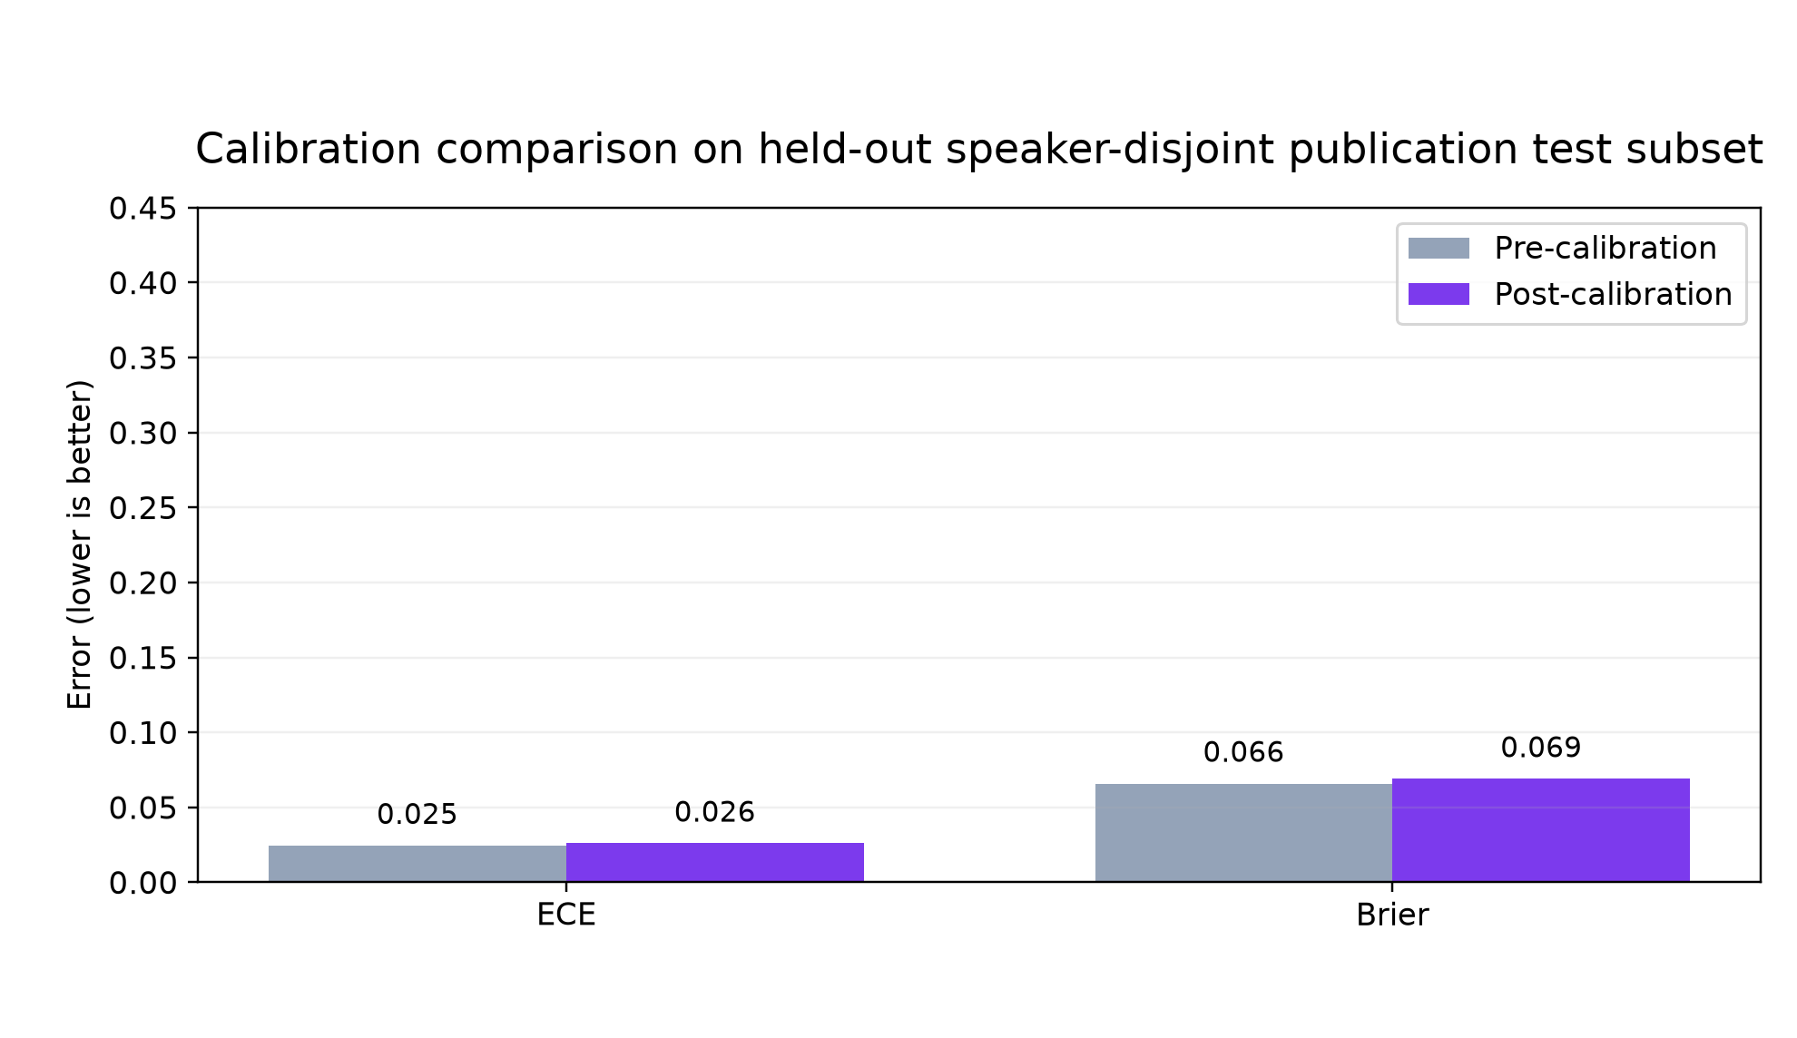

Reliability diagram with bin counts
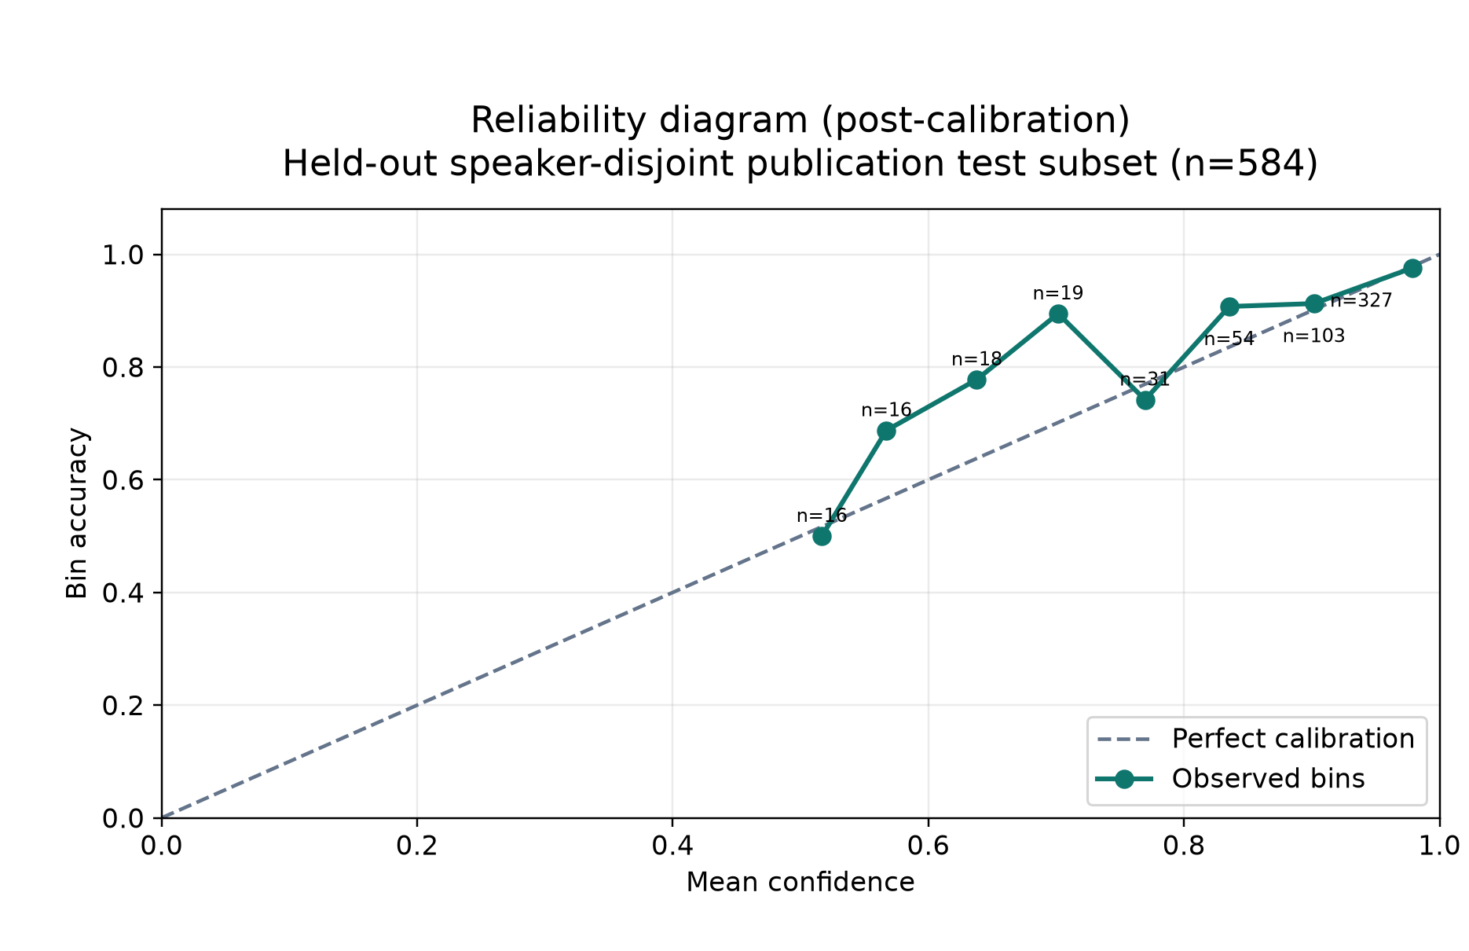

Confusion Matrix Counts
Actual / predicted | Real | Fake
Actual real | 276 | 44
Actual fake | 5 | 259

Research Question Status
Research question | Measured result | Evidence status
RQ1 | Clean 93.8% accuracy vs Opus-sim 89.4% (n=584) | Measured on paired test instances
RQ2 | Multilingual Hindi/Marathi/Tamil model trained | English-only baseline experiment pending
RQ3 | Three leave-one-language-out runs completed | Measured on unseen-language test partitions
RQ4 | ECE 0.025 → 0.026; Brier 0.066 → 0.069 | Measured on validation-fitted temperatures
RQ5 | Human-study protocol implemented in UI; N=0 responses collected | Recruitment and analysis pending

8. Explainability Suite
Five explainability methods are implemented and exposed through the API and UI:
- Grad-CAM temporal attention heatmap on spectrogram input
- Attention map visualisation
- Frequency-band importance (mask bands, measure score change)
- Spectrogram side-by-side comparison
- Compression-artifact visualisation (spectral energy loss from Opus)

9. Human Perception Study (RQ5)
A bounded listening-test protocol is implemented in the web application. Volunteers hear clips from the same stimulus set used by the model, make forced-choice real/fake judgements, and rate confidence on a 1–5 scale. Gold labels remain hidden during trials.
Target: 20–30 participants; minimum floor 12–15 for analysis.

10. Validation and Testing
Test | Result
Backend unit and integration tests | 172 passed, 3 skipped
Code coverage | 84.76% (gate ≥80%)
Frontend tests | 22 of 22 passed
OpenAPI contract drift | Regenerated and passing
Live inference — real clip | Label: real — PASS
Live inference — fake clip | Label: fake — PASS
API health | OK
Live mic false-positive fix | Verified — natural speech reads as REAL

Security and Validation Controls
- Upload MIME type, magic bytes, file size, and duration are validated before inference.
- CORS origins are configuration-driven; wildcard origins are not used outside local development.
- Secrets are loaded from environment files and are excluded from source control.
- Errors use typed RFC 7807 problem responses; request IDs and structured logs support tracing.
- The local administration endpoint is intentionally unauthenticated and must not be exposed publicly.

11. Application Screenshots (Live Capture)
The following screenshots were captured automatically from the running application.

Landing Page
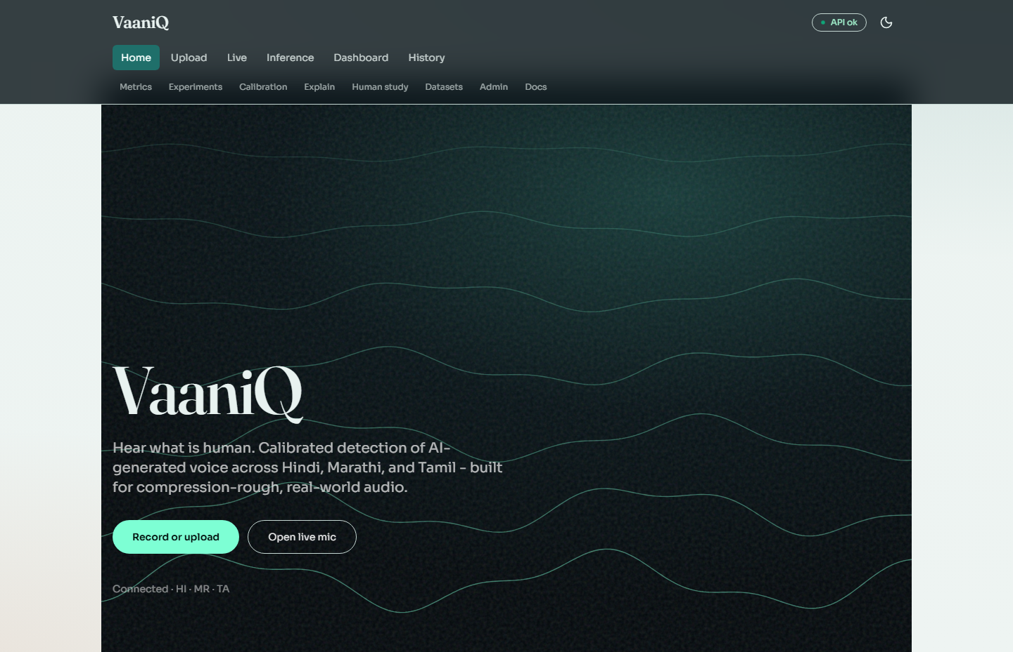

Research Dashboard
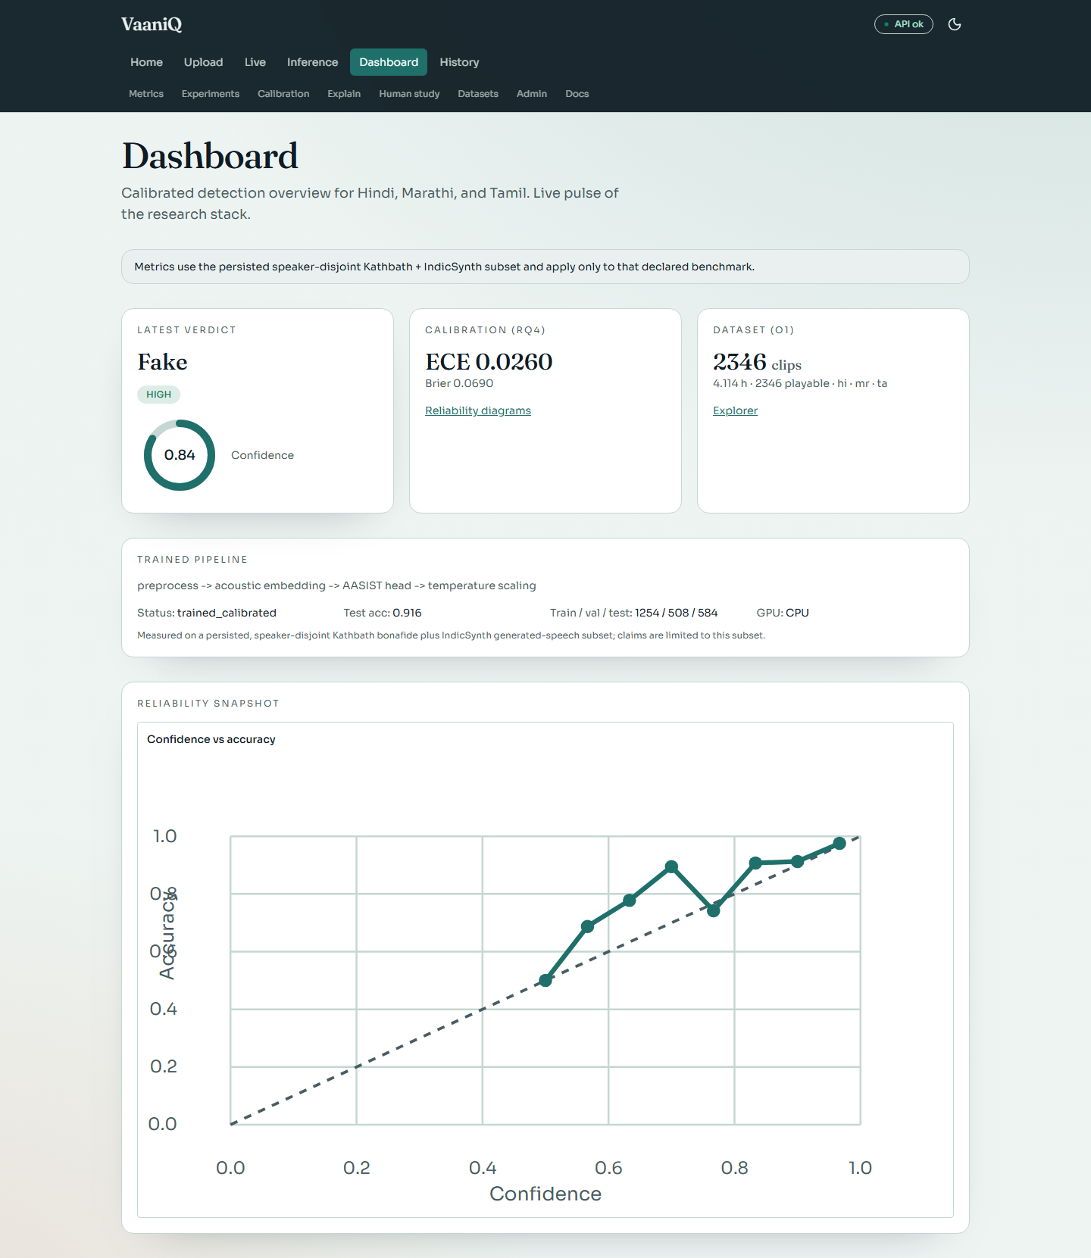

Detail 1 of 2
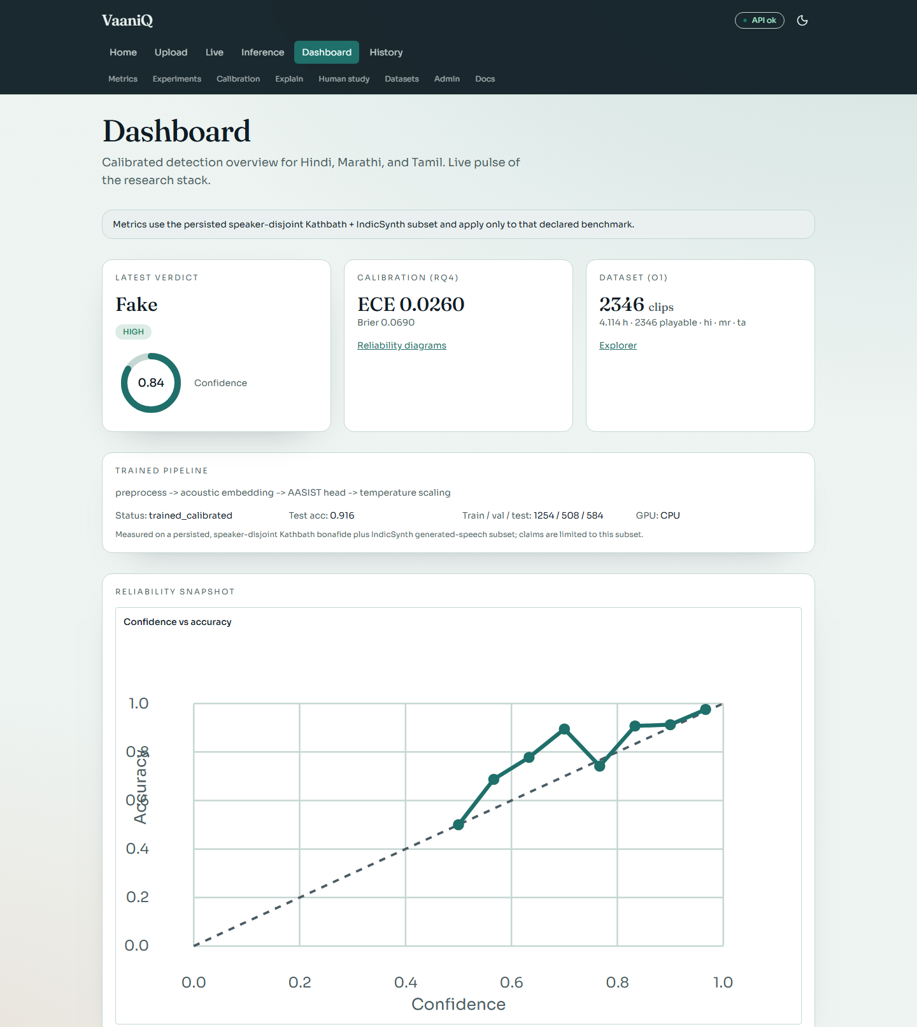

Detail 2 of 2
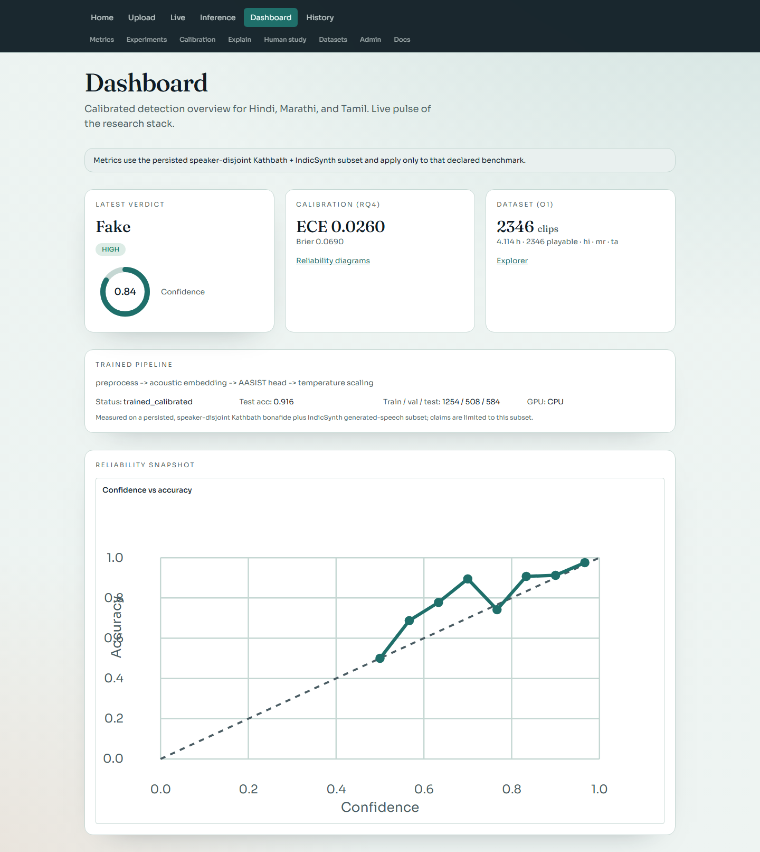

Upload and Detection
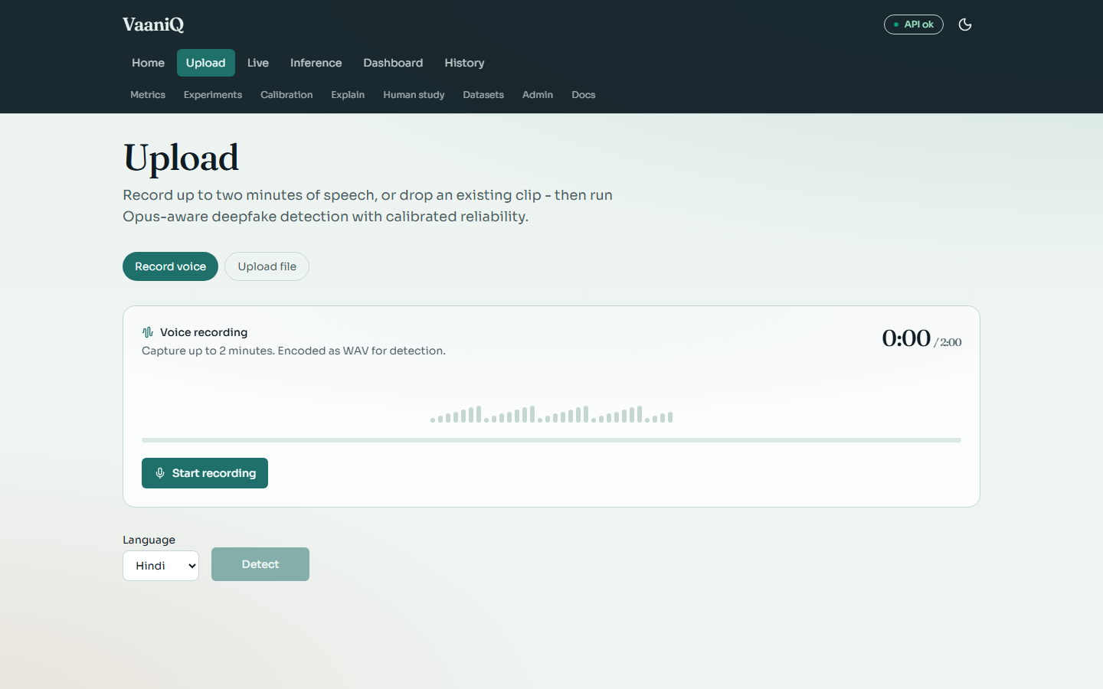

Live Microphone Streaming
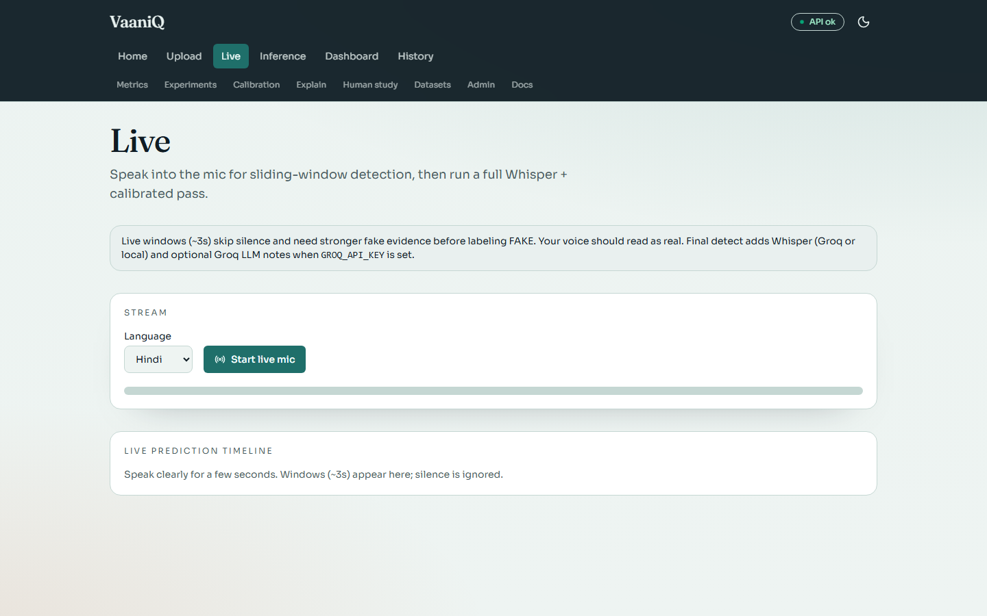

Calibration and Reliability
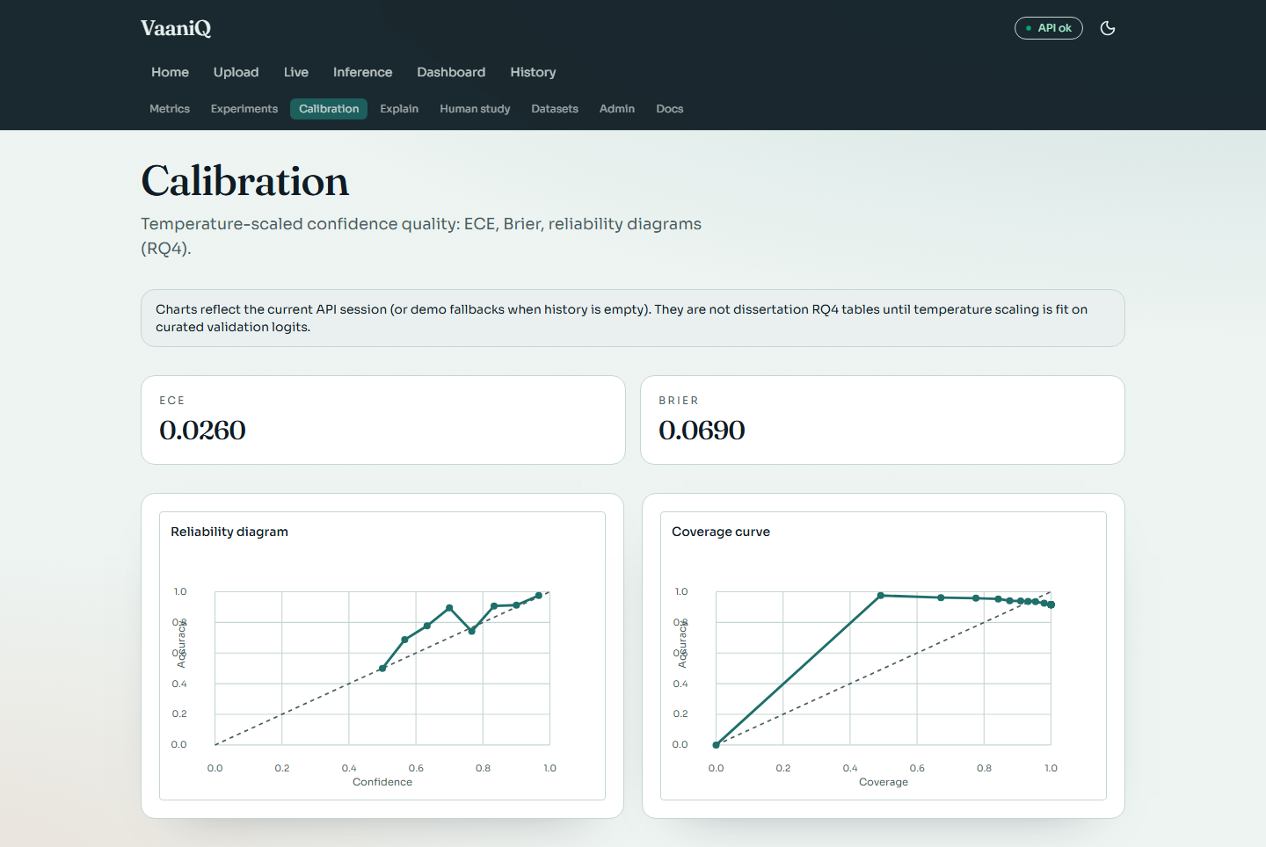

Explainability Suite
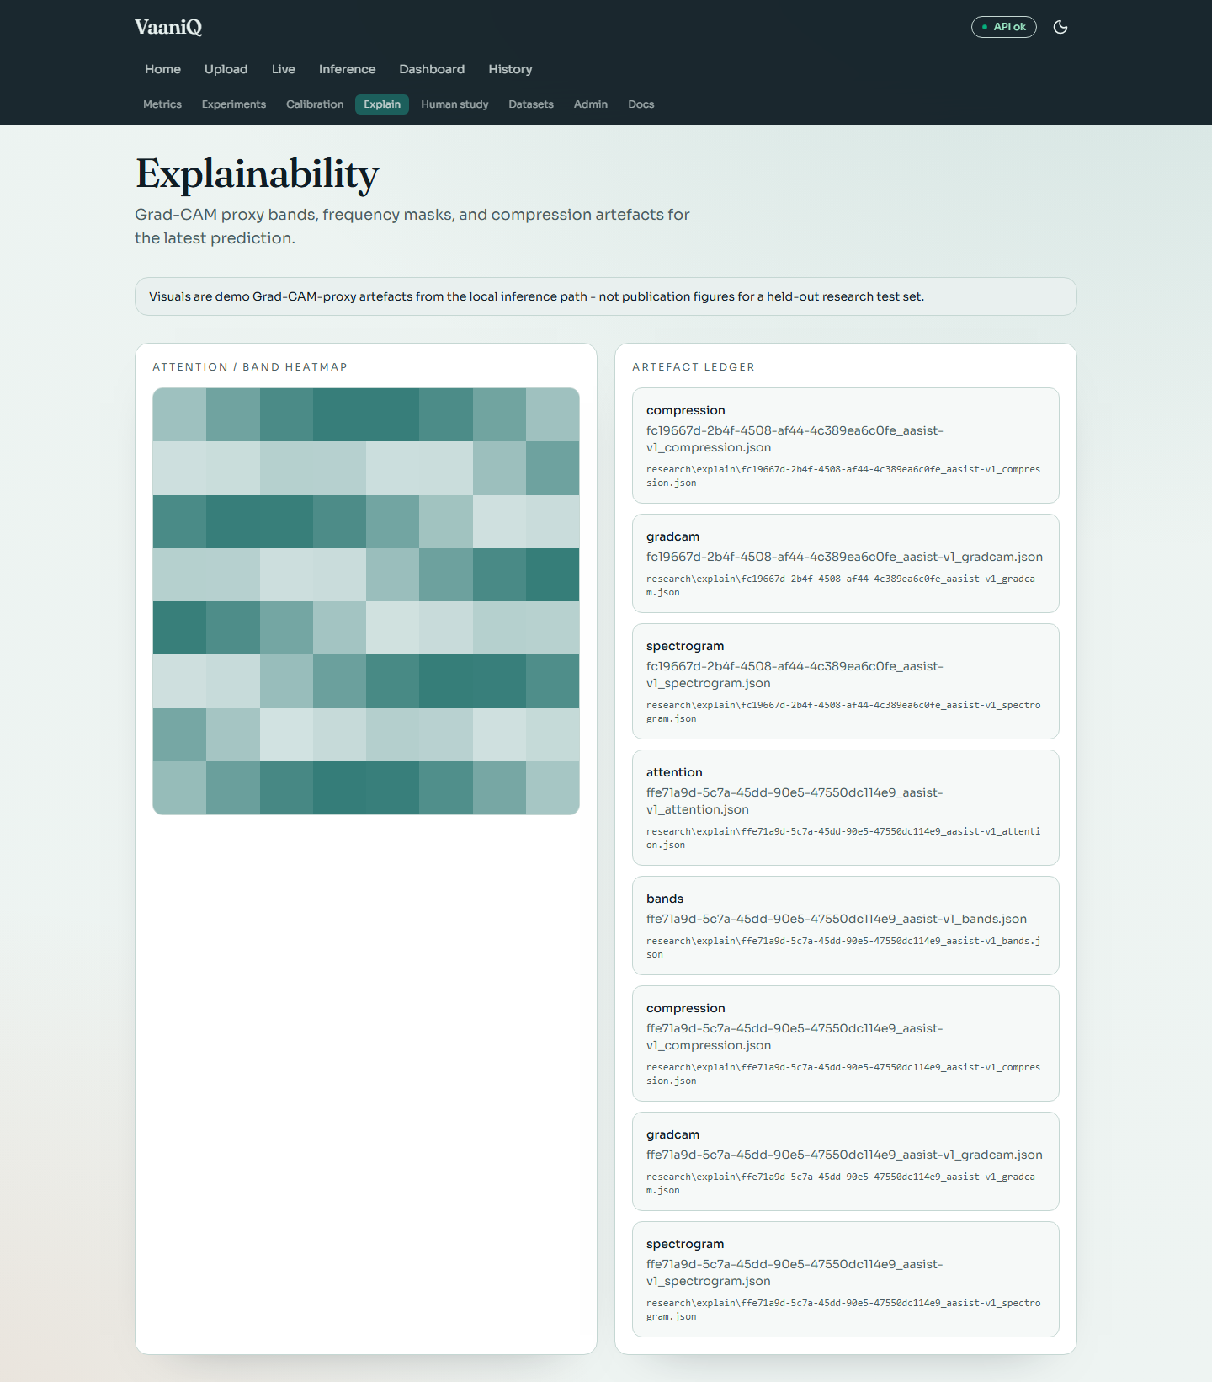

Dataset Explorer
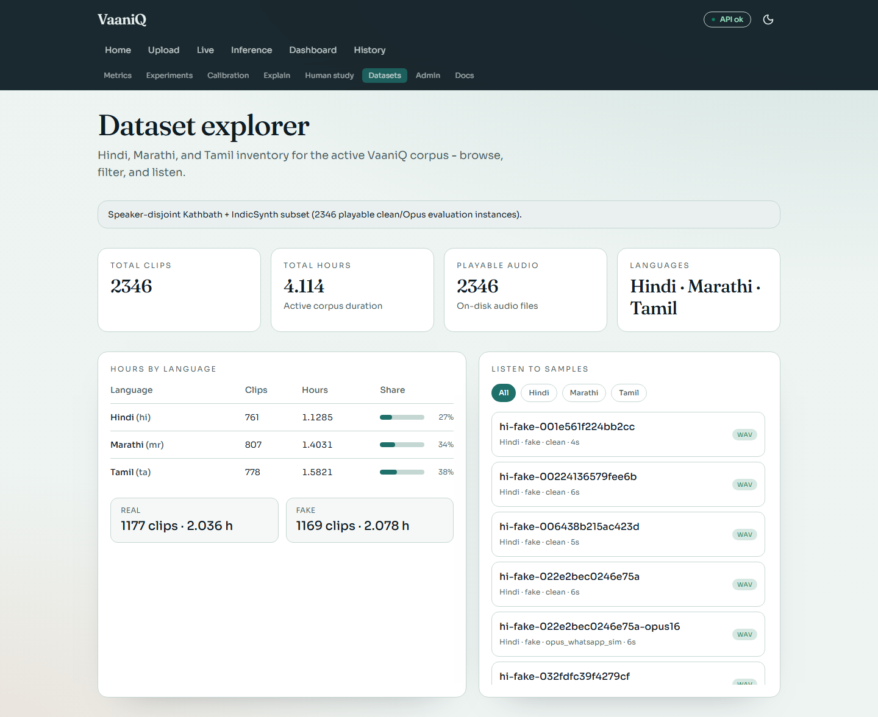

Human Perception Study
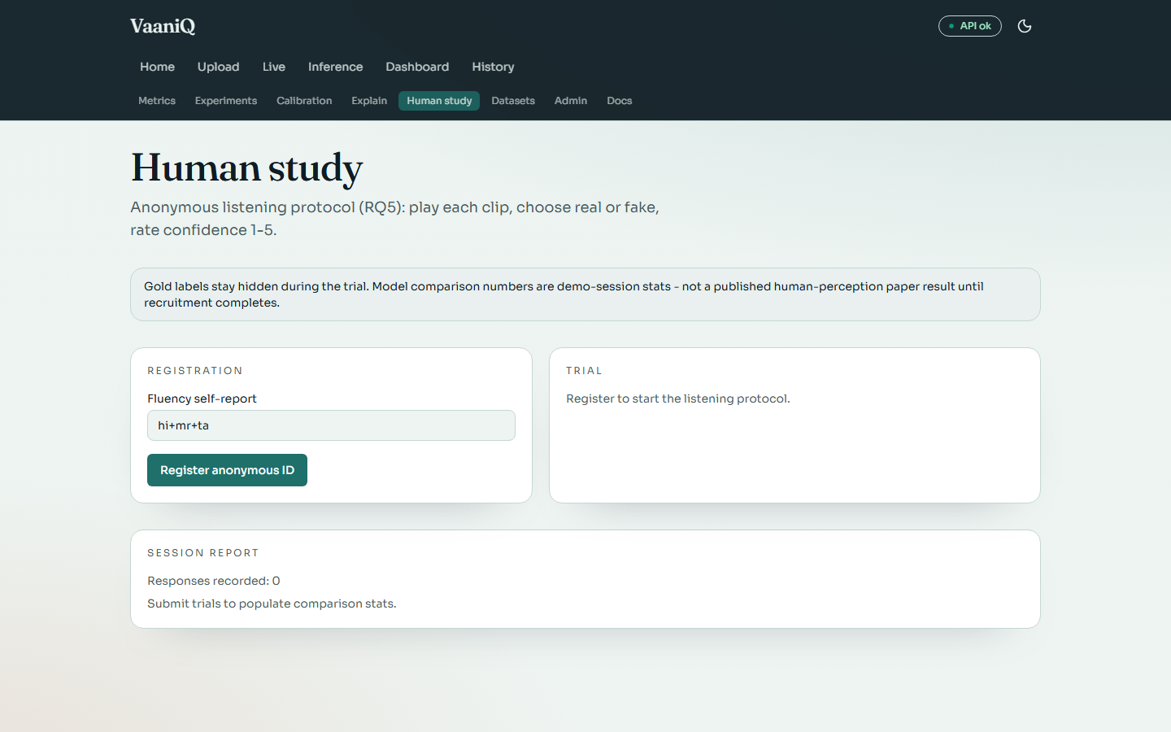

Research Metrics
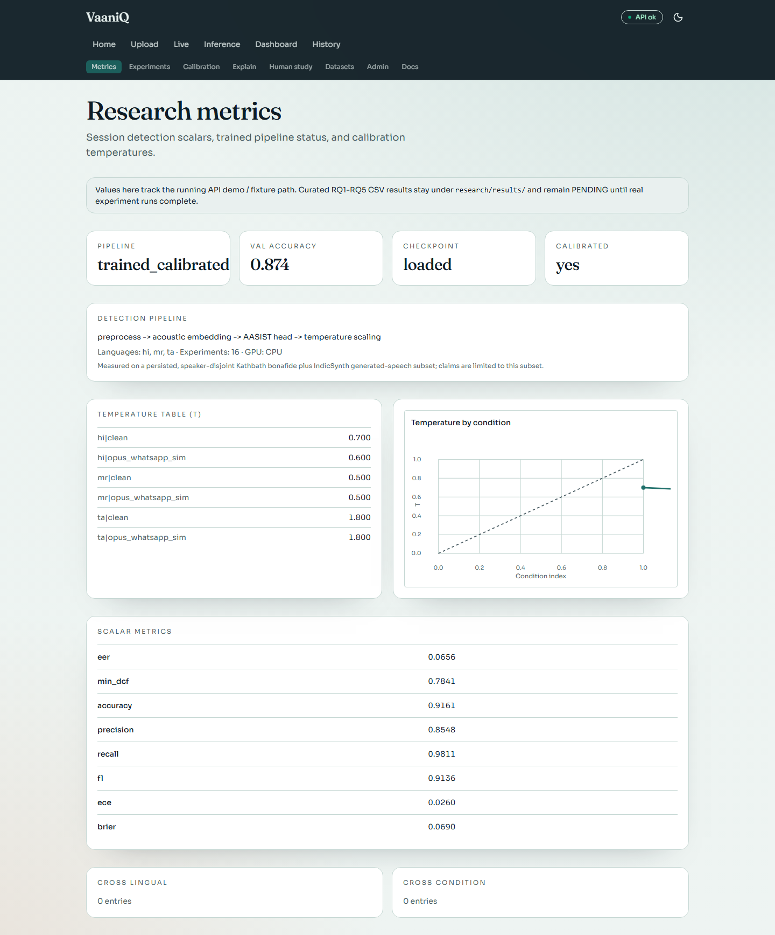

Detail 1 of 2
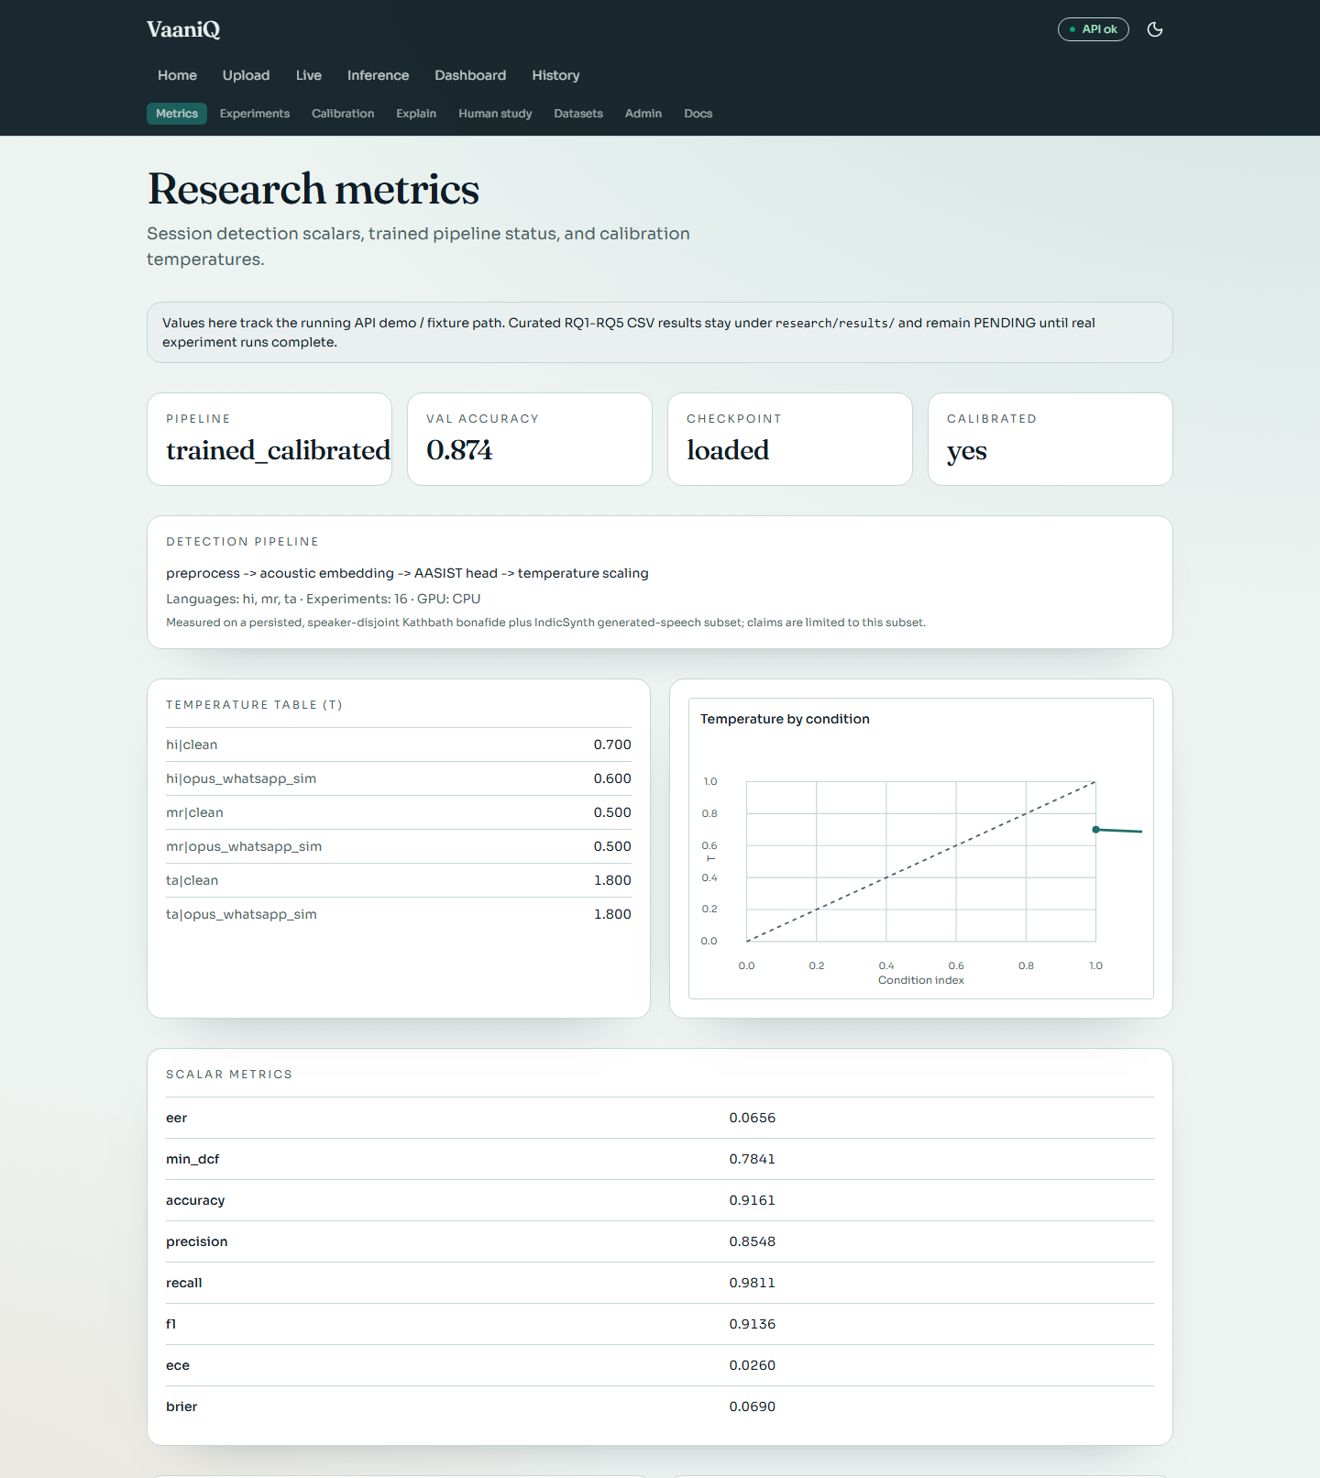

Detail 2 of 2
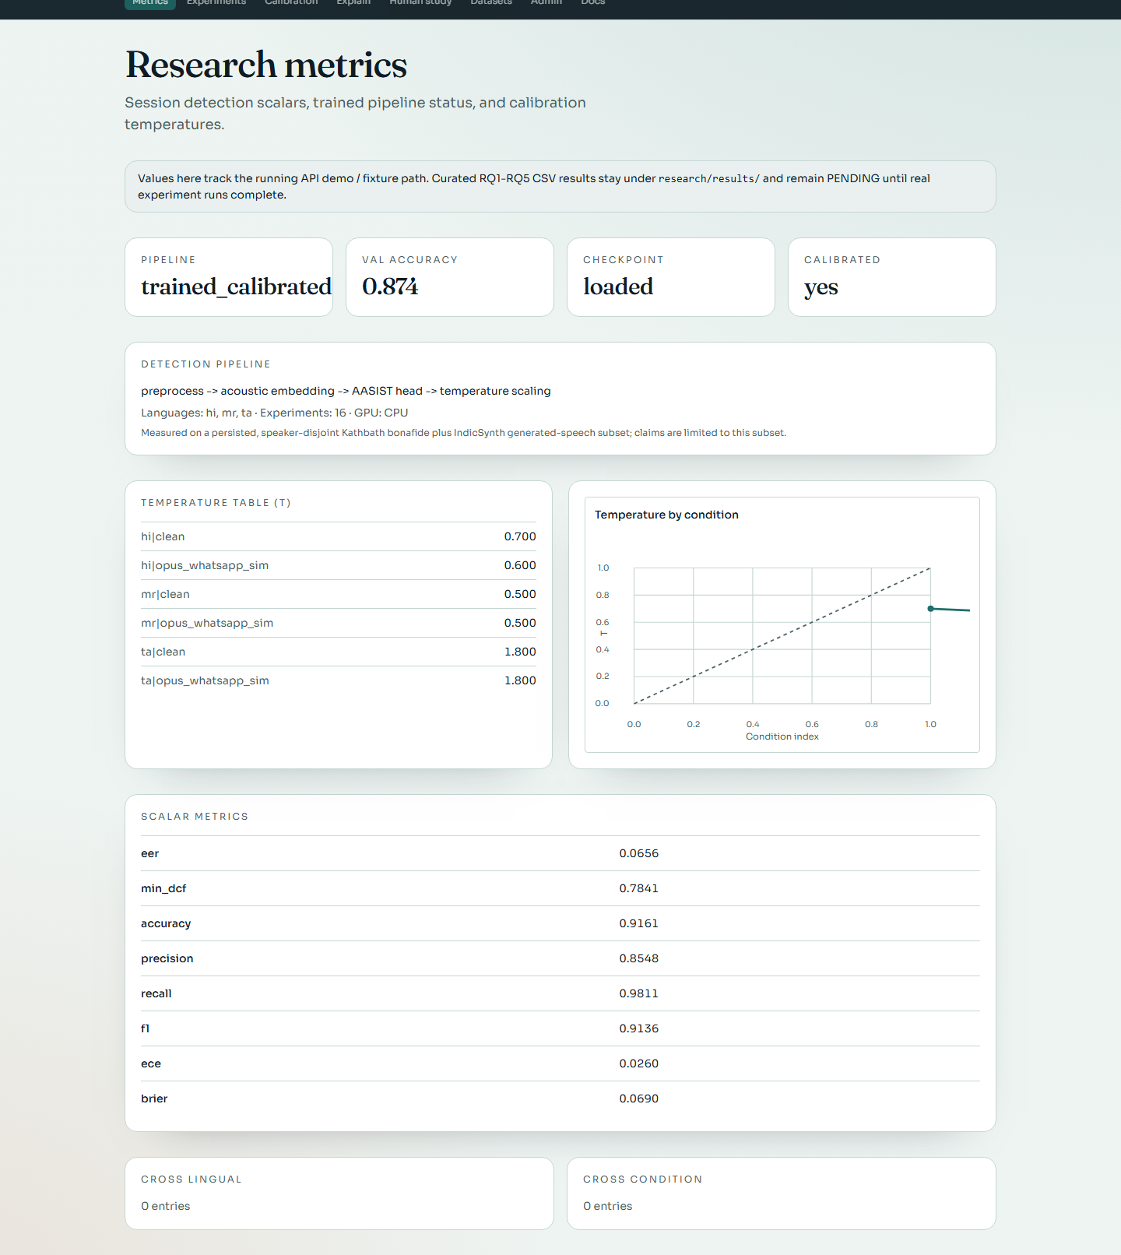

Experiment Browser
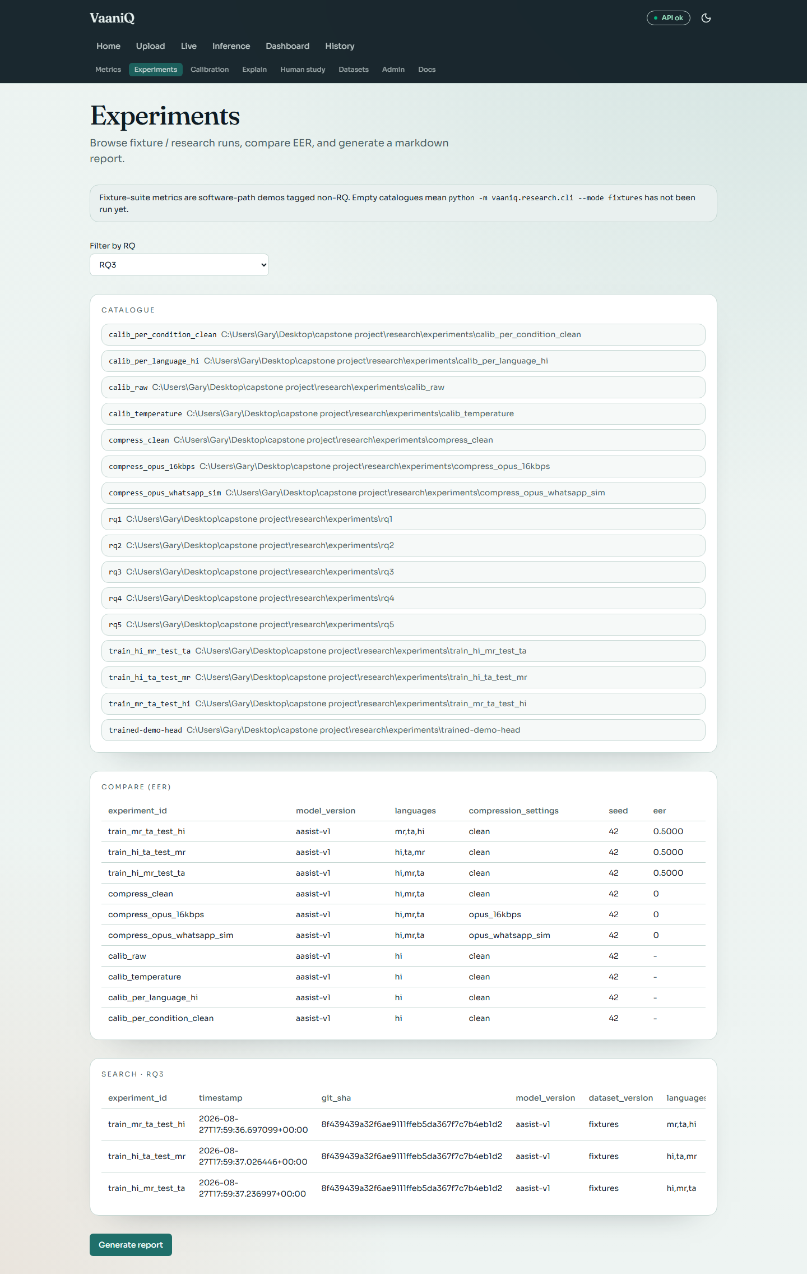

Detail 1 of 2
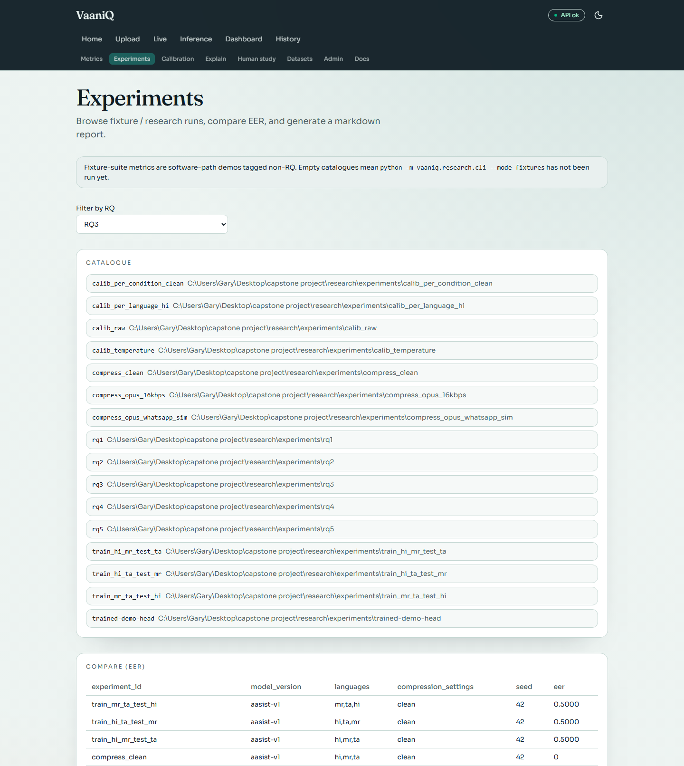

Detail 2 of 2
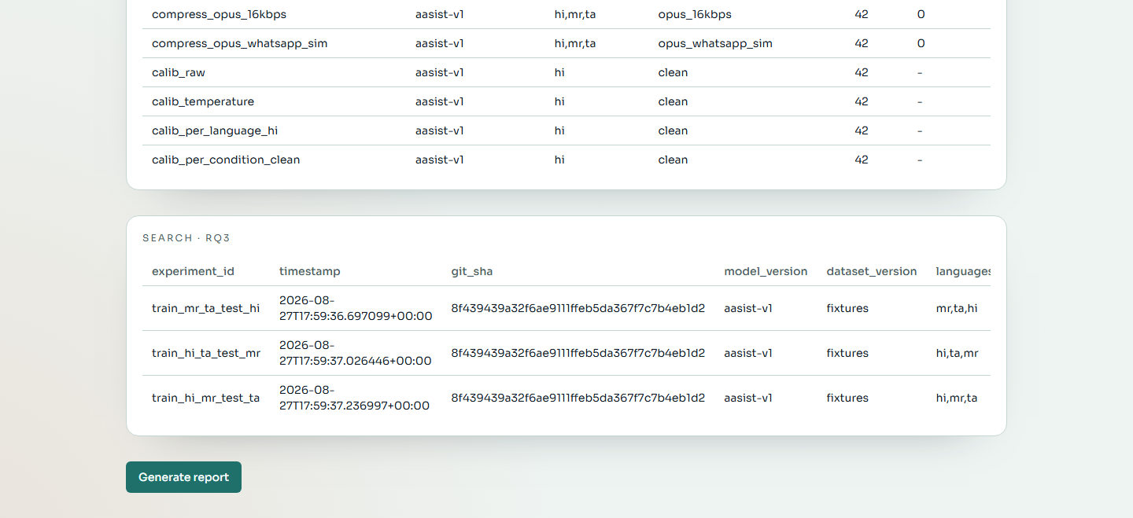

Detection History
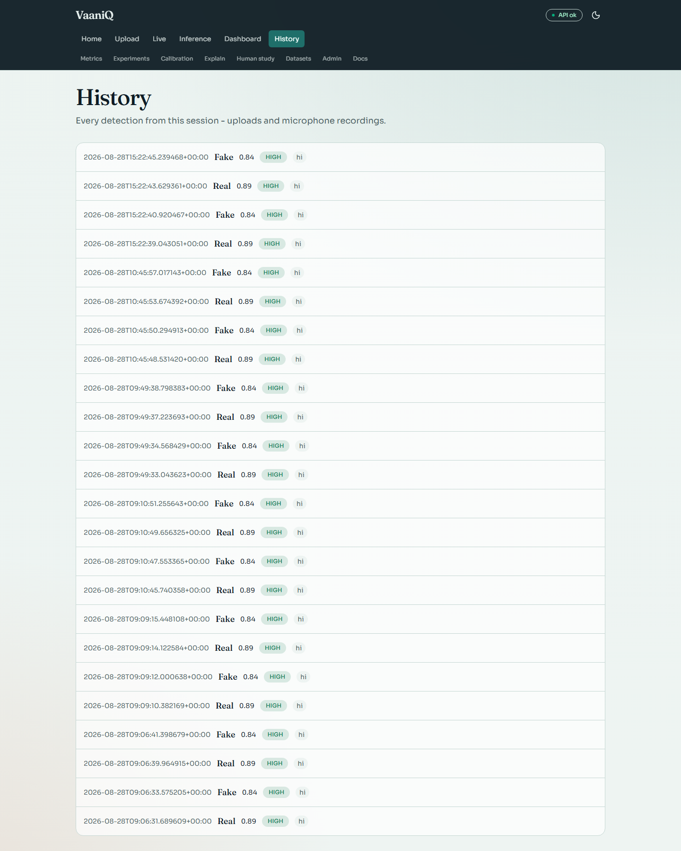

Detail 1 of 2
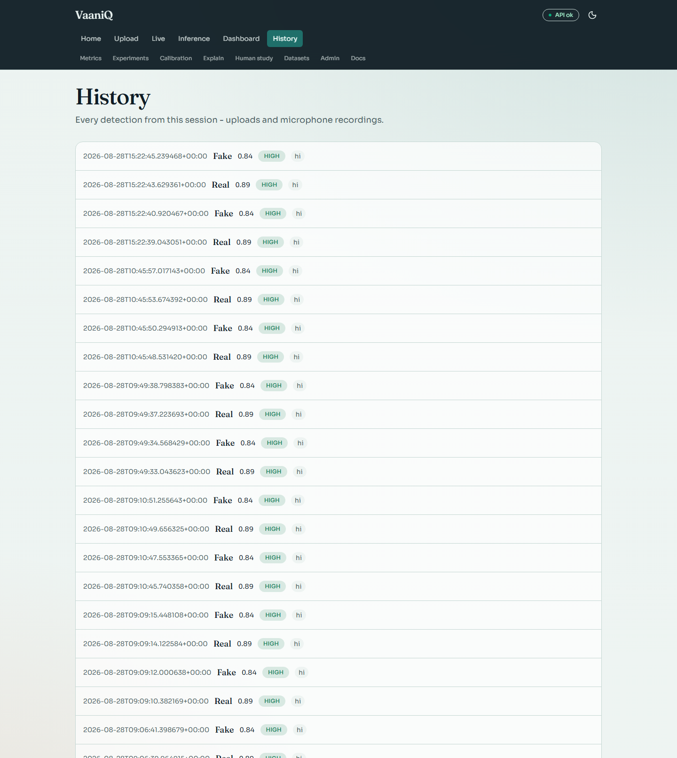

Detail 2 of 2
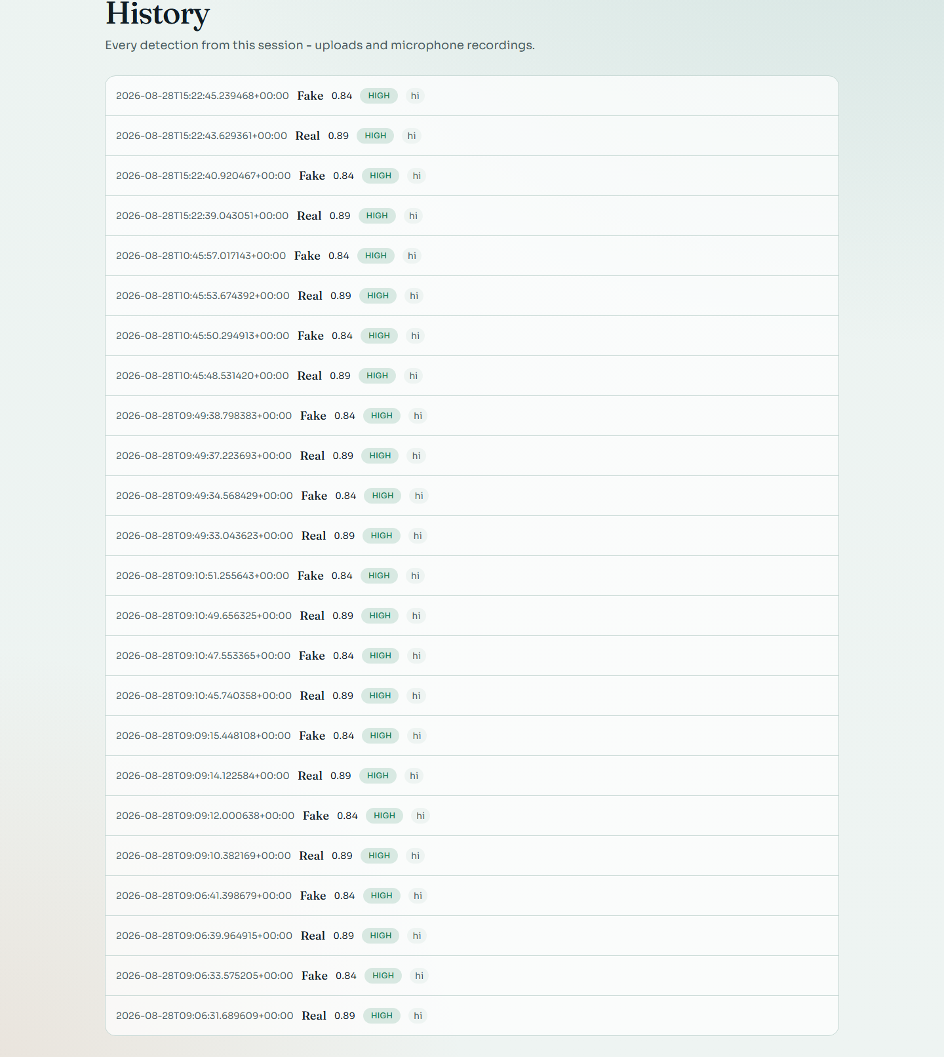

Inference Browser
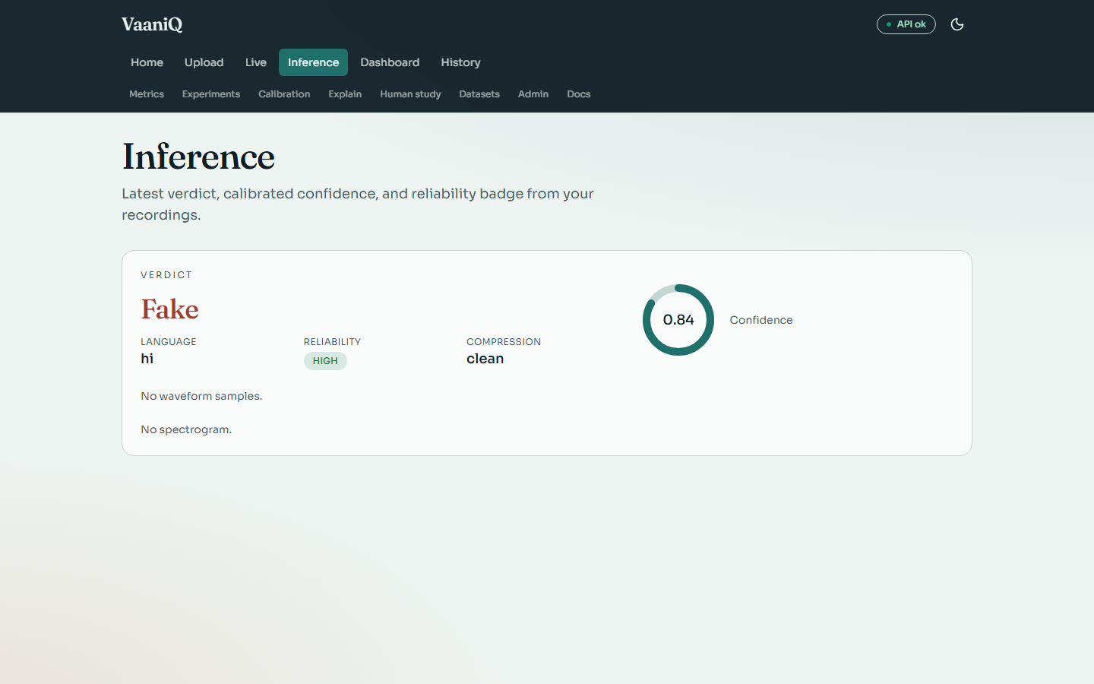

System Administration
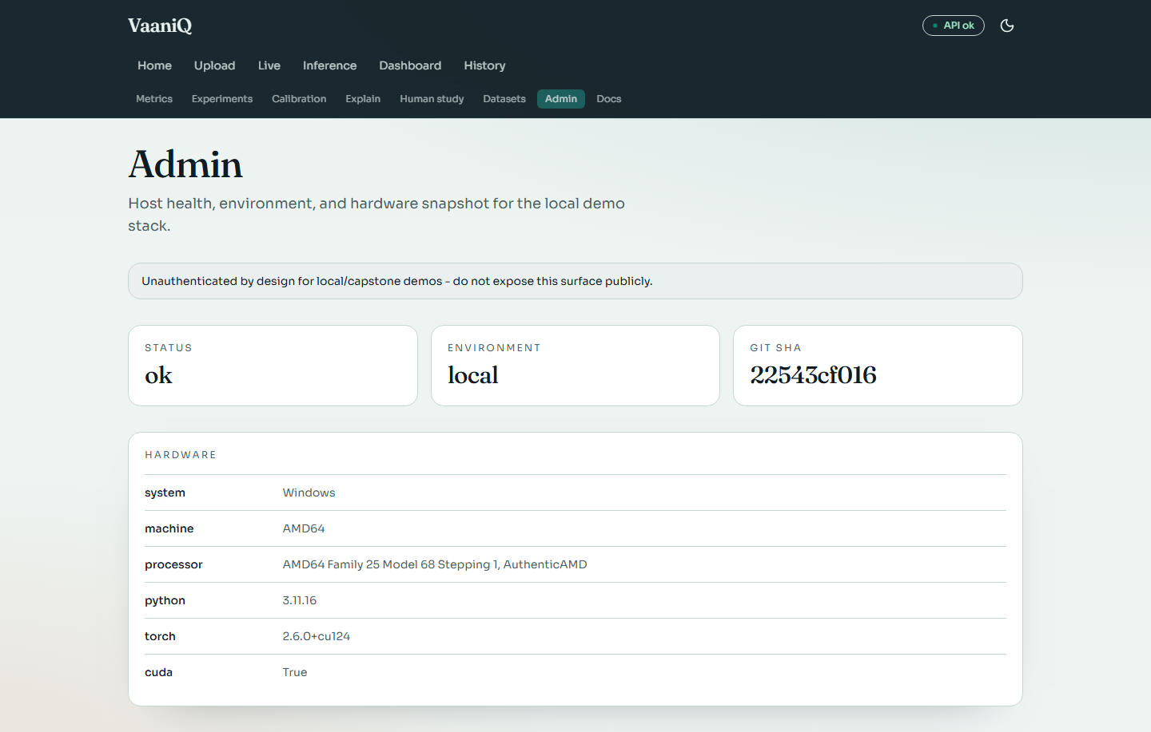

Documentation Hub
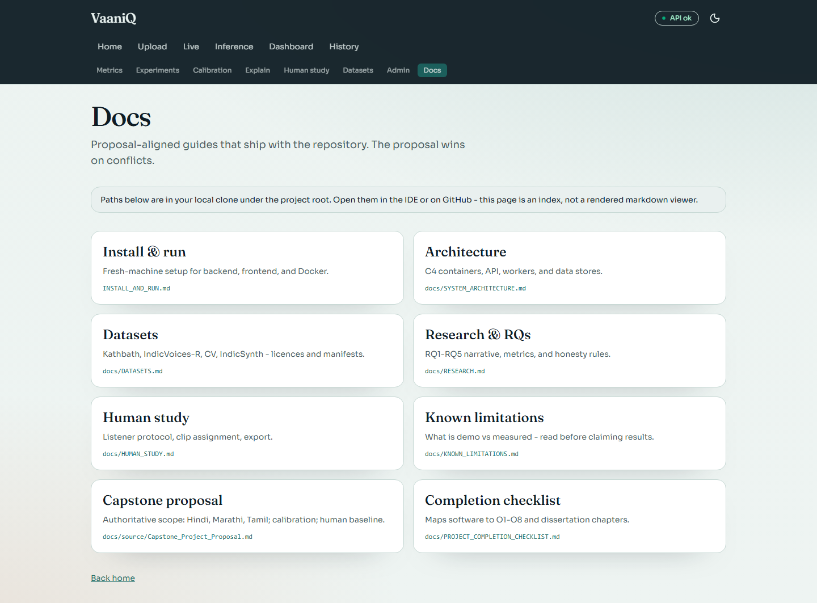

API Documentation (Swagger)
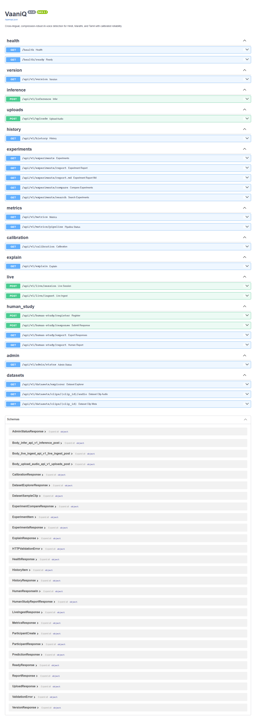

12. API and Application Surface
Method | Endpoint | Purpose
GET | /health | Process liveness
POST | /api/v1/inference | Upload and classify audio
POST | /api/v1/live/session | Create streaming session
POST | /api/v1/live/ingest | Ingest PCM16 window
GET | /api/v1/metrics | Measured held-out test metrics
GET | /api/v1/calibration | ECE, Brier, reliability and coverage
GET | /api/v1/metrics/pipeline | Checkpoint and training provenance
GET | /api/v1/datasets/explorer | Corpus inventory and audio samples
GET | /api/v1/explain | Explainability artefact ledger
POST | /api/v1/human-study/register | Anonymous study registration
POST | /api/v1/human-study/response | Record judgement and confidence
GET | /api/v1/admin/status | Local environment and hardware status

13. Reproducibility and Deployment
Field | Value
Random seed | 42
Python | 3.11.16
GPU | None
CUDA | False
Checkpoint | AASIST v1 NumPy weights
Dataset manifest | 2346 clips; versioned train/val/test labels
Local API | FastAPI/Uvicorn
Web application | React/Vite
Deployment profiles | Local, Docker Compose, HF Spaces scaffold

Every reported score in this document is read from the persisted training report produced by the deterministic training command. The document generator captures fresh API state and screenshots, then verifies that embedded images fit inside the printable page area.

14. Presentation Flow (Recommended)
1. Open with the problem: AI voice cloning fraud in Indian languages via compressed WhatsApp voice notes.
2. State the three contributions: compression-robust detection, calibrated reliability, human baseline.
3. Show architecture diagram and pipeline (Section 3).
4. Live demo: Upload real clip → REAL verdict. Upload fake clip → FAKE verdict.
5. Live demo: Microphone streaming — speak naturally, show REAL windows.
6. Dashboard: pipeline status, validation accuracy, GPU.
7. Calibration page: ECE, Brier, reliability diagram.
8. Explainability: heatmaps and frequency bands.
9. Human study protocol walkthrough.
10. Honest limitations: bounded publication subset, model baselines, and human study.
11. Close with novelty claim and future work toward conference submission.

15. Limitations and Conference Readiness
The software and bounded real/fake benchmark are ready for capstone demonstration. RQ1 detection/compression and RQ4 calibration findings are measured on the persisted speaker-disjoint Kathbath + IndicSynth subset. Conference-level external validity still requires the frozen XLS-R research front-end, multiple detector baselines, broader attack families, and a completed human study. No result in this document is generalized beyond the declared subset.
Conference requirement | Evidence needed
Data validity | Licenced real/fake corpora, speaker IDs, checksums, consent
External validity | Multiple TTS/voice-cloning attacks and recording channels
Compression study | Real ffmpeg Opus twins and paired significance tests
Model comparison | LFCC-GMM, RawNet2-style approximate baseline, English-only and multilingual checkpoints
Uncertainty | Bootstrap confidence intervals and pre/post calibration tests
Human baseline | At least 12–15 eligible listeners on identical stimuli
Paper claims | Numbers only from frozen, versioned result CSVs

16. References
- Jung et al. (2022). AASIST: Audio Anti-Spoofing using Integrated Spectro-Temporal Graph Attention Networks. ICASSP. arXiv:2110.01200.
- Babu et al. (2021). XLS-R: Self-supervised Cross-lingual Speech Representation Learning at Scale. arXiv:2111.09296.
- Pascu et al. (2024). Calibrated deepfake detection in speech (cited in proposal).
- VaaniQ Capstone Proposal (2026). Cross-lingual compression-robust detection with human baseline.
- Sharma, D. V., Ekbote, V., and Gupta, A. (2025). IndicSynth. ACL 2025, acl-long.1070.
- Javed, T. et al. (2022). IndicSUPERB (including Kathbath). arXiv:2208.11761.
- Mozilla Common Voice v17 (Hindi, Marathi).

